Bob Sarvey Intervenor
501 W. Grantline Rd
Tracey, CA 95376
(209) 835-7162
STATE OF CALIFORNIA
Energy Resources Conservation
and Development Commission

In the Matter of: ) Docket No. 01-AFC-16
)
Application for Certification for the ) Written Testimony of Mike Boyd
GWF TRACY PEAKER PROJECT ) on Compliance, General Conditions,
IN SAN JOAQUIN COUNTY ) Air Quality, Public Health, Etc.

Introduction

This "written testimony" is provided in the form of a series of questions and answers under each of the topic areas to make it easier for everyone concerned to understand Intervenor’s testimony and provide a list of questions for staff, applicant, and other Intervenor witnesses, in advance of the evidentiary hearing. It should be clearly understood, however, that intervenor's good faith effort to comply with CEC regulations does not constitute approval or acceptance of the adequacy of CEC's rules and procedures. On the contrary, intervenor's position is that there is an ample, growing body of objectively-based information and evidence in this project's administrative record (as expressly defined by CEQA) to demonstrate that Intervenor and other members of the public have been and our continuing to be deprived of their statutory right to well informed and meaningful participation, and their constitutional right to the benefits bestowed on the public by the CEQA statutory scheme, along with but not limited to equal protection and procedural due process (no fair hearing being provided) violations.

Compliance and General Conditions

Has the applicant provided substantial evidence of compliance with all applicable LORS, particularly air pollution district regulations, thus ignoring potentially significant environmental impacts, among other things?

The applicant's ability or willingness to comply with conditions to project approval, mitigation measures and similar obligations depends on the good faith of the applicant to carry them out even if left unsupervised. The applicant has not proposed any measures to address this circumstance, such as monitoring by an independent, qualified non-public organization selected in fair fashion with ample public input. CEC should require that this potentially devastating enforcement problem be addressed. In a way, this is an area of potentially significant environmental impact under CEQA. The failure to adequately monitor and enforce the performance of project conditions and mitigation measure will surely have a potentially significant, if not overwhelming, impact on the environment. After all, the very fact a mitigation measure was identified is proof a potentially significant impact exists, and if the mitigation measure is abandoned, the adverse impact will occur for sure.

For example, and without limitation, the applicant should be mandated to identify and adopt beefed up or additional, continuous emission monitoring measures to specifically address compliance problems that this very applicant has encountered in constructing and operating other CEC-approved powerplants. There is a growing body of solid information and evidence to reasonably infer that this applicant will continue having enforcement problems. If the enforcement problems are not addressed, it is reasonably foreseeable that potentially significant adverse impacts on the environment will surely occur. At the very least, therefore, a worst case CEQA analysis taking into account the failure to monitor and mitigate mitigation measures in specific areas, and in regard to specific impacts, must be conducted. For example, what impacts will occur if applicant fails to install or update a particular piece of equipment? Are there additional mitigation measures for these non or inadequate enforcement impacts (e.g., monitoring by an independent non-governmental group). The failure to address these matters is an obvious, inexcusable prejudicial abuse of discretion.

Strong and sure measures must be employed to deal with the monitoring-enforcement problem. This requires additional information about the applicant's problems at other powerplants. To assist in this vital task, intervenor has obtained and herein presents further information and evidence of the applicant’s poor track record in complying with Conditions of Operation at other facilities. For example, under the topic Air Pollution Impacts, below, there is evidence of continued violation of the air pollution district’s regulations and standards at the GWF-operated Thermal Energy Development Corporation facility.

Figure 1 GWF Air Emission Compliance Record Notice of Violations 1996 - 2001
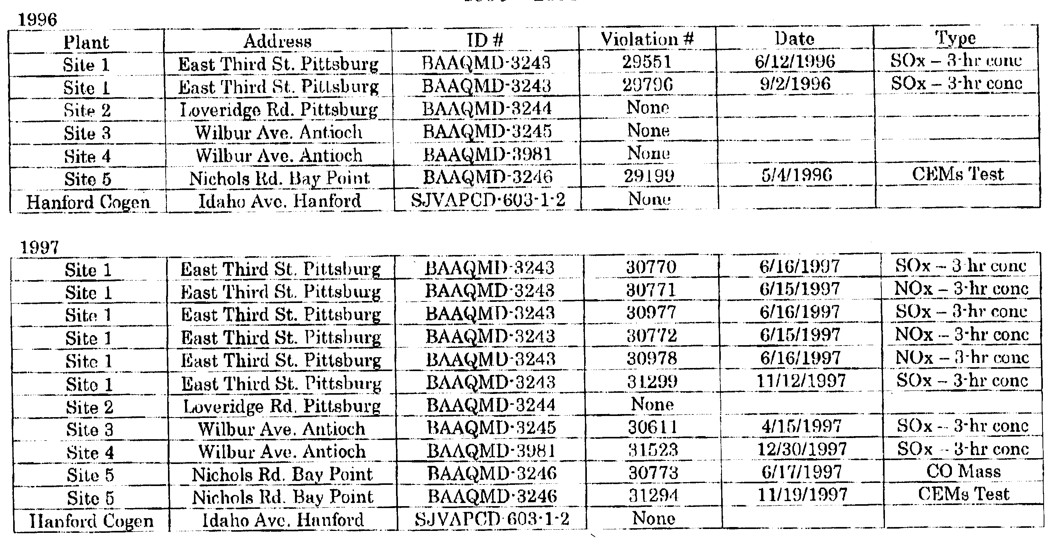
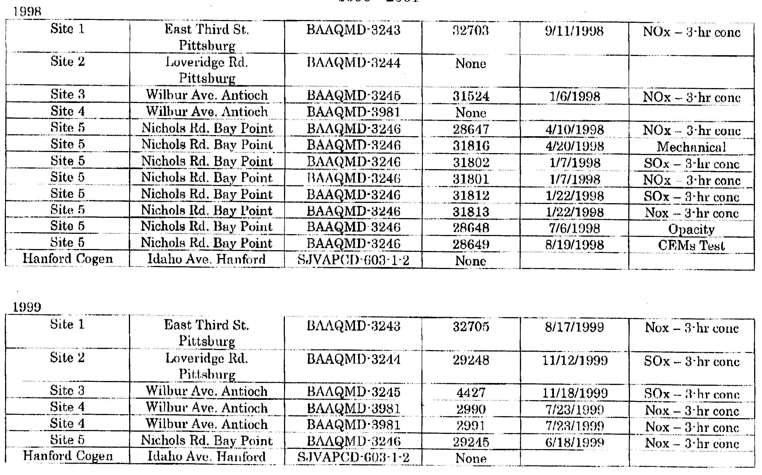
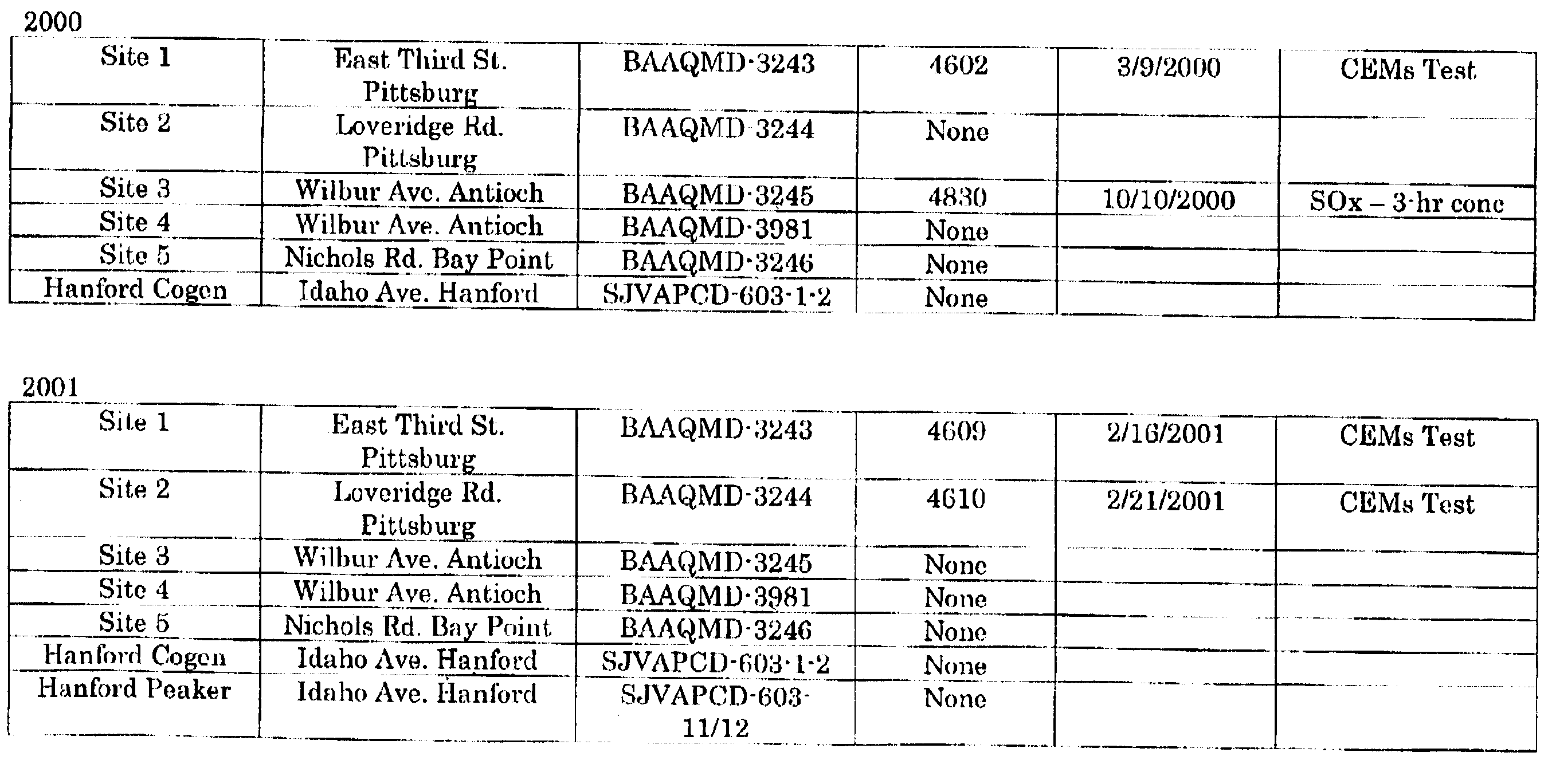

Air Pollution Impacts

Has the applicant provided any evidence of recent compliance with air district LORS?

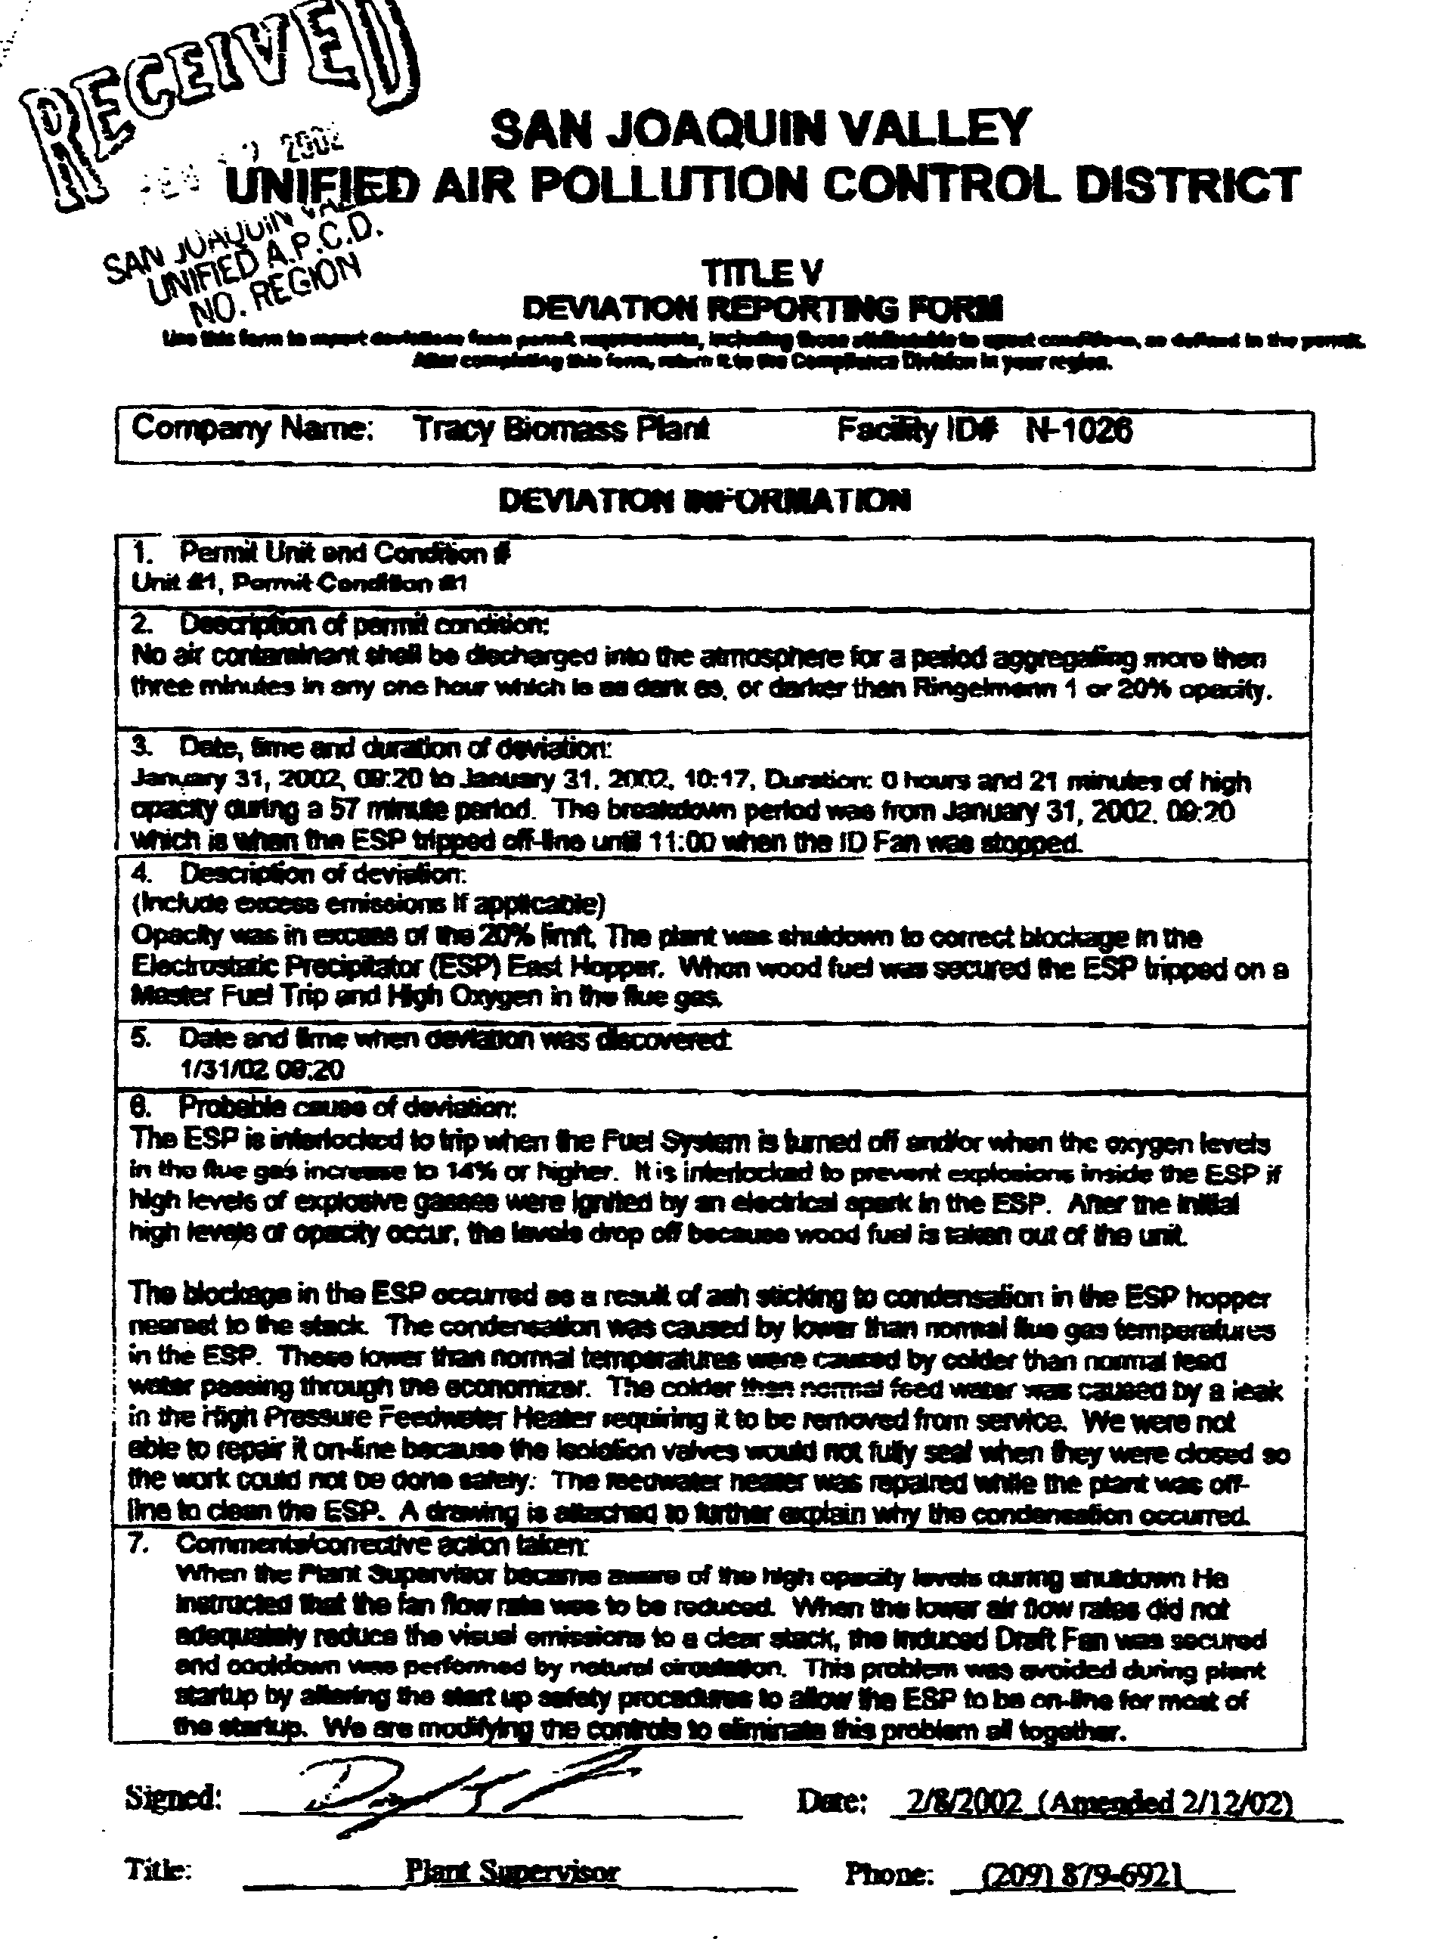
Solid information and evidence of the applicant’s poor track record of compliance with the Conditions of Operation of GWF-owned and operated facilities establishes, at the very least, that CEC must require the matter be looked into further, and action must then be taken (or at the very least attempted). The nature and extent of the Tracy Peaker Project’s conflicts with LORS have not been identified and assessed, undermining the need for overriding the project’s LORS violations. In particular, the FDOC fails to acknowledge and address numerous conflicts between the project and the San Joaquin Valley Unified Air Pollution Control District’s (“SJVUAPCD’s”) Rules. For example, the project violates the SJVUAPCD’s Rule 2201-4.14.3, which forbids approval of new major air emission facilities unless the applicant provides a current certification that all of its major facilities within California are either in compliance, or on a schedule of compliance, with all applicable state and federal emission limitations and standards.
Figure 2 Title V Deviation Report of Opacity violation and possible explosive conditions in the Tracy Biomass Plant’s Electrostatic Precipitator (ESP) dated 2/12/02

4.14.3 Compliance by Other Owned, Operated, or Controlled Source: The owner of a proposed new Major Source or Title I modification shall demonstrate to the satisfaction of the APCO that all major Stationary Sources owned or operated by such person (or by any entity controlling, controlled by, or under common control with such person) in California which are subject to emission limitations are in compliance or on a schedule for compliance with all applicable emission limitations and standards.

The evidence intervenor is providing in this written testimony (to which intervenor will add if deemed necessary in the future in accordance with the public participation rights afforded by CEQA and the Warren-Alquist Act), shows a pattern of violation at the applicant's Tracy Biomass Plant. While there is ample evidence of violations at the plant, from which it may be reasonably inferred that the violations are continuing and expanding (with the reasonable inferences thus themselves becoming additional evidence), so far nothing in the record shows what steps, if any, have been taken or planned to cure or mitigate the enforcement defects (not to mention defects that have as yet to be uncovered) and the potentially significant adverse economic effects the defects may cause. For example, neither CEC nor applicant proposed, required or applied for a "compliance schedule" pursuant to the District’s Rule 5050. Therefore, the APCO has not had an opportunity to impose or approve a compliance schedule for continuing Opacity violations at the plant. Intervenor is thus forced to insist that CEC condition project approval on a binding and enforceable agreement to permanently shut down the Thermal Energy Development Corporation facility (Tracy Biomass Plant). Again, the failure to do so is a prejudicial abuse of discretion making it necessary to seek judicial review.

The present project also violates SJVUAPCD Rule 2201-5.3 and Rule 2201-5.9.1.8, which directs APCO to not take final action on any project on which an EIR (or its functional equivalent) has been prepared until a final EIR for the project has been certified, analyzed and evaluated by APCO.

5.3 Final Action: Within 180 days after acceptance of an application as complete, or within 180 days after the lead agency has approved the project under the California Environmental Quality Act, whichever occurs later, the APCO shall take final action on the application after considering all written comments.

5.9.1.8 Within 180 days after acceptance of an application as complete, or within 180 days after the lead agency has approved the project under the California Environmental Quality Act, whichever occurs later, the APCO shall take final action on the application after considering all written comments.

In this case, APCO issued the FDOC without lead agency/CEC approval, a clear LORS violation that must be rectified to avoid having a court mandate this be done.

What are the existing ambient air conditions for criteria pollutants (e.g. NOx, CO, VOC, SOx, & PM)?

As is well known, ambient air conditions demonstrate continued violation of federal and state air quality attainment standards for ozone and particulate matter. SJVUAPCD’s Rule 2201 (New and Modified Stationary Source Review Rule) only allows for new stationary sources like the TPP “without interfering with the attainment or maintenance of Ambient Air Quality Standards” and precludes “net increase in emissions above specified thresholds from new Stationary Sources of all non-attainment pollutants and their precursors”.

1.0 Purpose
The purpose of this rule is to provide for the following:

1.1 The review of new and modified Stationary Sources of air pollution and to provide mechanisms including emission trade-offs by which Authorities to Construct such sources may be granted, without interfering with the attainment or maintenance of

Ambient Air Quality Standards; and

1.2 No net increase in emissions above specified thresholds from new and modified Stationary Sources of all non-attainment pollutants and their precursors.

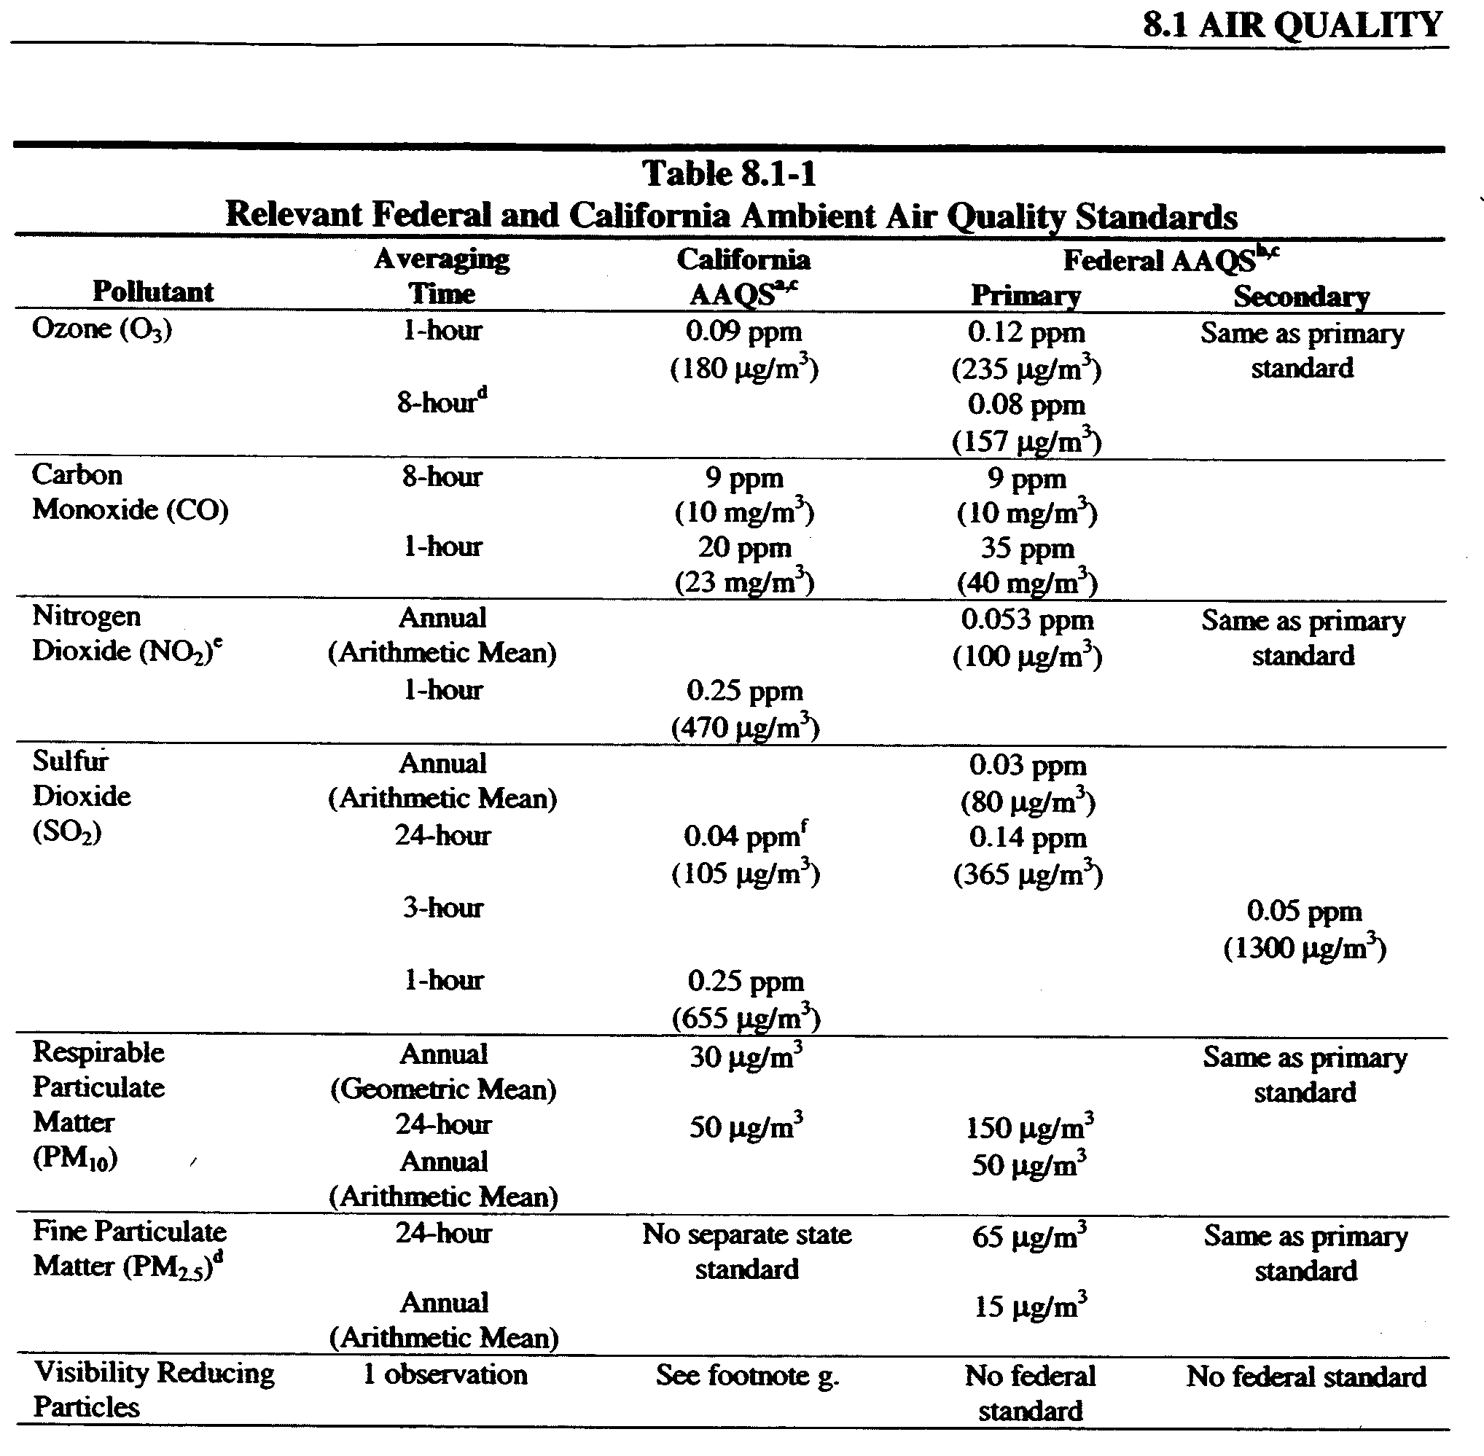
Figure 3 from applicant’s AFC Table 8.1-1 demonstrates that current state, and federal, ambient air quality standards (AAQS) for ozone are 0.09 ppm and 0.12 ppm respectively, and the AAQS for PM10 is 50 μg/m³ and 150 μg/m³ respectively.
Figure 3 State and Federal Air Quality Attainment Standards

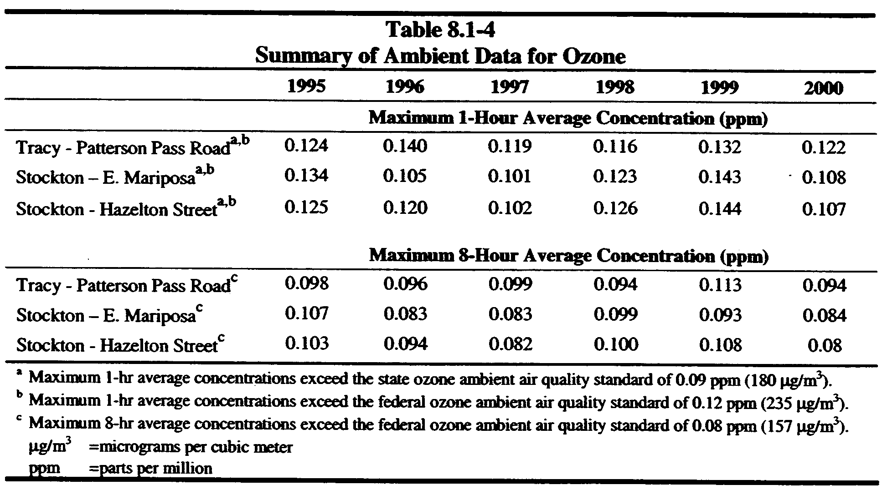
Figure 4 from the Applicant’s AFC Table 8.1-4 demonstrates that Tracy’s Patterson Pass Road monitor has measured non-attainment for both state and federal ambient air quality standards 1 hour ozone concentration since 1995.
Figure 4 Table 8.1-4 demonstrates that Tracy’s Patterson Pass Road monitor has exceeded both State and Federal Ambient Air Quality Standards
Figure 5 from the Applicants AFC Table 8.1-18 demonstrates that construction activities from the project alone will induce an exceedance of federal ambient air quality standards for PM10 “above specified thresholds from new … Stationary Sources of all non-attainment pollutants,” in this case PM10 which is already at the Federal “threshold” of 150 μg/m³.
Figure 5 demonstrates construction related impacts from the project significantly exceeds the federal threshold for PM10 of 150 μg/m³
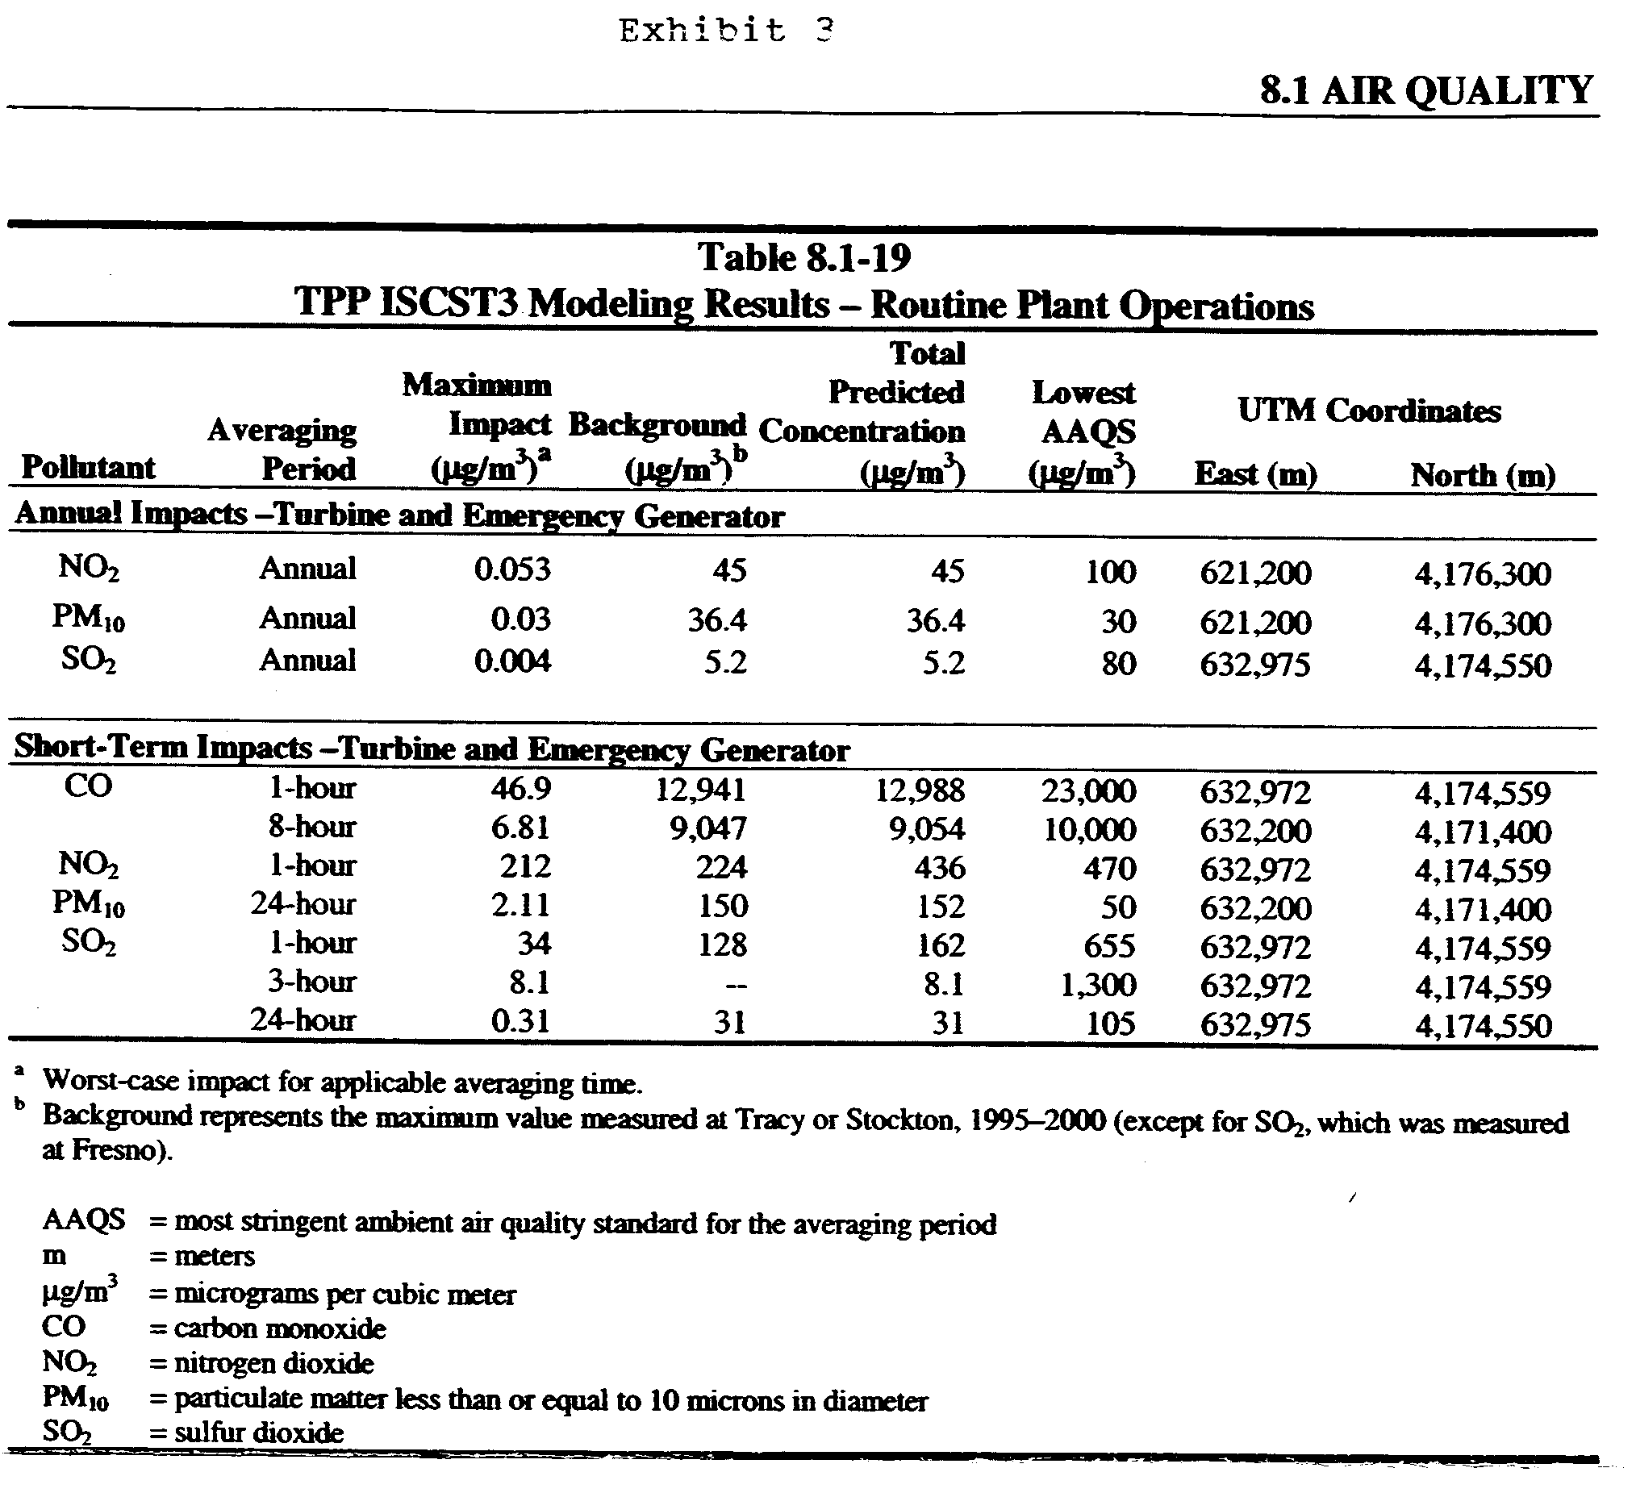
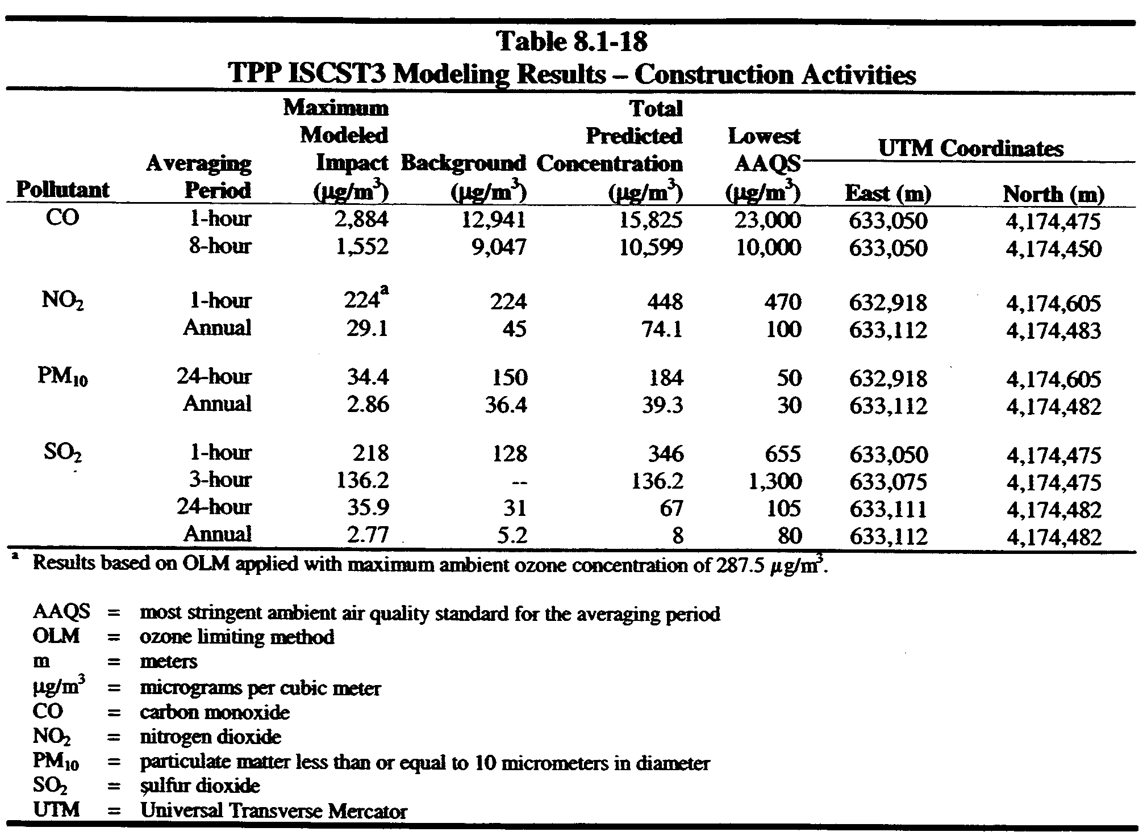
Figure 6 Demonstrates that the Tracy Peaker Project will induce an exceedance of Federal Ambient Air Quality Standards for PM10
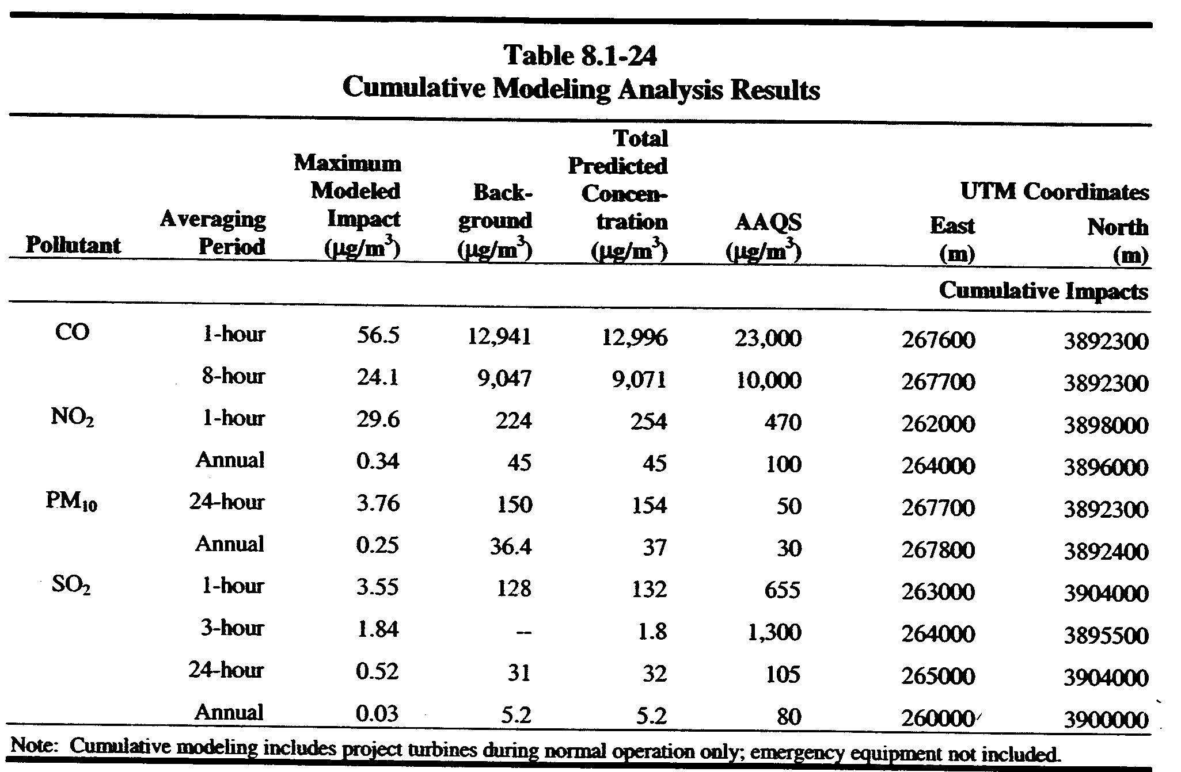
Figure 6 from applicant’s AFC Table 8.1-19 demonstrates that routine plant operations from the project alone will induce an exceedance of federal ambient air quality Standards for PM10 “above specified thresholds from new … Stationary Sources of all non-attainment pollutants” in this case PM10 which is already at the Federal “threshold” of 150 μg/m³. As demonstrated in Figure 7 from the Applicant’s AFC Table 8.1-24 cumulative impacts from other power generation facilities under consideration by the CEC perpetrate additional exceedance of Federal Ambient Air Quality Standards for PM10.
Figure 7 Cumulative impacts of other power generation facilities perpetrate additional exceedance of Federal Ambient Air Quality Standards for PM10

What is the efficiency of emission control technology (i.e.; SCR vs. SCONOx)?

EPA Region IX has not delegated PSD permitting authority to the SJVUAPCD. Irrespective the project is a major source whose emissions trigger PSD requirements for NOx, PM10, and CO. Any major modification subject to PSD must conduct an analysis to ensure that best available control technology ("BACT") is used. This requirement is set forth in section 165(a)(4) of the federal Clean Air Act, in federal PSD regulations at 40 C.F.R. § 52.21(j), and in federal regulations providing the requirements for State implementation plan (SIP) approval of a State PSD program, at 40 C.F.R. § 51.166(j). For PSD purposes, BACT is “an emissions limitation… based on the maximum degree of reduction for each pollutant subject to regulation under [the] Act which would be emitted from any proposed major stationary source….” (40 CFR § 52.21(b)(12).) A proper top-down analysis would almost certainly conclude that SCONOx is BACT for this project, even if it achieved exactly the same emission limit as SCR , because it offers a number of important advantages over SCR alone, with no offsetting disadvantages. First, SCONOx uses a single catalyst to simultaneously remove NOx, CO, VOCs, and toxics. Second, it uses no ammonia or other hazardous materials and thus requires no ammonia slip, eliminating the many significant impacts associated with ammonia use (e.g., transportation accidents, unloading accidents, site releases, PM10 generation). Third, the SCONOx system operates effectively at temperatures ranging from 300ºF to 700ºF, making it well suited for merchant operation and providing better control during startups and shutdowns than achieved with other competing catalytic technology (e.g., SCR, CO oxidation catalyst). Fourth, unlike other catalytic systems, the SCONOx catalyst is continuously regenerated, assuring continuous maximum catalyst effectiveness. Finally, notwithstanding the forgoing benefits, SCONOx has achieved much lower NOx and CO levels than other competing technologies and, therefore, is de facto BACT for this project. The SCONOx system has been demonstrated to achieve 2 ppmvd averaged over 3 hrs or 2.5 ppmvd averaged over 1 hr on the 32 MW combined cycle (25 MW LM2500 gas turbine plus 7 MW steam turbine) Federal Cogeneration facility in Vernon, California (“Federal Facility”). (South Coast AQMD Staff Report, p. 3-4.) The South Coast AQMD has concluded that SCONOx/water injection is “achieved-in-practice” technology for natural gas-fired turbines with rated capacities of 3 MW or greater. EPA Region 9 has also concluded that the Federal Facility “has, based on data submitted to EPA for the six-month period from June 28, 1997 to December 28, 1997, ‘demonstrated in practice’ NO_{x} emissions rates that are consistently at or below 2.0 ppmvd based on a 3-hour rolling average.” (Haber 3/23/98.) EPA has recently acknowledged that this same facility is currently meeting 1 ppm NOx. In addition, SCONOx has been operating on a 5-MW Solar Taurus 60 gas turbine at the Genetics Institute facility in Andover, Massachusetts since August 1999, likewise meeting 1 ppm. SCONOx simultaneously removes NOx, CO, and VOCs. The nine months of recent CEMs data indicate that the Federal Facility routinely achieves a CO limit of 1.0 ppm averaged over 1 hour, and 0.7 ppm averaged over 3 hours. What significance does the SCR vs. SCONOx controversy have under CEQA?

The issue is feasibility, and it's a question of complying with the appropriate standards and requirements, more than a matter of policy. In other words, there is unanimous agreement that mitigation measures must be adopted if they are feasible. Feasibility is a broad, complex and uncertain concept under CEQA. The starting point of the analysis is the fundamental rule that, like other findings, a determination of what factors to use and what weight to give them must be based on substantial evidence in the record. In other words, CEC can't simply conclude that powerplants, like development in general, are beneficial to the affected public. Specific benefits and costs--economic, social, environmental, etc.--must be identified, explored and an effort must be made to quantify them to make it how the ultimate decisions are arrived at. The lead agency may have discretion in weighing and balancing the feasibility components, but the specific procedure required by CEQA must be followed. To date, there is nothing in the record indicating the CEQA process has been properly followed. There is no indication of what factors were selected for the analysis, or what substantial evidence supports the identification of and weight given each factor. This must be done to comply with CEQA.

To get back to the SCR vs. SCONOx dispute, there is no identification nor analysis of what substantial evidence in the record supports the decision to accept applicant's self-serving contentions that SCONOx is an infeasible technology. Even if there were evidence showing the cost is significantly higher, and applicant profits are significantly lower, this is the start, not the end of the inquiry. For example, in determining that the cost of SCONOx is significantly higher enough to make it infeasible, what criteria was used? Was the cost/benefit determination based on the gross revenue the applicant stands to take in over the life of the powerplant? On profits made over the same period? On funds the applicant may be required to pay back to the state for having unconscionably gouged the state during the so-called energy crisis and through long-term energy contracts with the DWR making the crises permanent? These are all questions that must be answered to comply with CEQA, and CEQA must be complied with under the Warren-Alquist Act.

What is "Enrongate" and must its effects be investigated?

Enrongate refers to the colossal, well-publicized financial (and most probably criminal) entanglements Enron has gotten itself in after years of perpetrating scams on the public, on honest members of the energy industry, and on governmental entities going as high as the White House and Congress. Enron is having perhaps the greatest, most widespread adverse impact on various areas of American life than any other major event except September 11. Does this mean Enrongate will affect the siting, construction and operation (particularly the sale and distribution of electrical power) of powerplants in California, and may this lead to conditions that are apt to have adverse impacts on the environment which must be identified, investigated and evaluated? The question is rhetorical. Of course the effects of Enrongate on the proposed project, the applicant and CEC itself must be investigated. Indeed, the investigation must go even further. The effect of current conditions and recent events must also be looked at. For example, the Governor issued executive orders specifically to deal with the so called energy crisis by expediting the siting, construction and operation of new powerplants. We have seen this strong policy implemented by the constant change in CEC regulations and procedures, which have made it virtually impossible to implement CEQA in a manner that maximizes environmental protection, as the statutory scheme is intended to do. But this was not done by the Legislature, through elected representatives that could have given the public meaningful participation and input. In violation of the constitutional separation of powers doctrine, it was done by the Governor, who until this election year has remained well insulated from public concern and pressure. Now, however, it appears conditions have changed. There is broad consensus that if there ever was one, now there is no longer an energy crisis of emergency proportions. There is no longer any reason to continue sacrificing the environment to build more powerplants. What effect is this having on CEC rules, regulations and procedures? Is consideration being given to undoing the numerous amendments made at the height of the perceived crisis? These and many other related questions abound and must be addressed to comply with CEQA, the Warren-Alquist Act and other LORS seeking to give some modicum of assistance to the goal of protecting the environment. Intervenor respectfully demands that proper steps be taken to rectify having ignored these matters in the past. At the very least, a threshold investigation is necessary immediately.

What is the effect of partial loads (start-up/shut-down) on criteria pollutant and TAC emissions?

Partial load emission/emission factors (for air quality and public health) in CEC staff's calculations, summarized in the amended SA, suggest that the total cancer risk is less than the significance threshold of one in one million. These calculations assume that both turbines are operating simultaneously at full load. However, emissions of some toxic compounds are substantially higher during reduced loads, such as occur during startup, shutdown, and partial load operation, than during routine operation. The TPP operating scenario is based on 250 start and shutdowns annually. The Gas Research Institute investigated the effect of load on criteria and toxic pollutant emissions from nine gas turbines including a large Frame 7 GE turbine. This study, the contents of which are fully incorporated by this reference, found that emissions of benzene, toluene, formaldehyde, methane, and total non-methane hydrocarbons decrease with load. Emissions of formaldehyde, a carcinogen, increased dramatically, by up to a factor of 343 when the load was reduced from 100% to 20%. For the 750 MW GE Frame 7, the formaldehyde emission factor increased by a factor of 503, and the formaldehyde emissions increased from 0.11 to 16.08 tons/yr or by factor of 146, when the load was reduced from 100% to 30%. (GRI 8/96, Table S-5.) This substantial increase in formaldehyde emissions during reduced load operation was not taken into account in the Applicant's risk calculations. Acrolein is the most toxic compound emitted by the gas turbines. It is a double-bonded aldehyde which causes eye, nose and throat irritation. It has the lowest acute and chronic reference exposure level among all of the substances emitted by the turbine. Therefore, very small concentrations of acrolein, much smaller than any other compound emitted by the Project, will result in significant health impacts. CARB has recently published an advisory that states: "any data or results, based on the use of M430 to determine acrolein...are suspect and should be flagged as nonquantitative wherever they appear." (CARB 4/28/00.) This method has been validated for only formaldehyde and acetaldehyde and substantially underestimates acrolein concentrations.

What are the cumulative impacts of Thermal Energy Development Corp and Owens-Brockway Co. on local and regional air emissions in combination with the operation of the proposed plant?

Applicant’s and staff’s cumulative impacts analysis failed to examine the cumulative impacts of Thermal Energy Development Corp and Owens-Brockway Co on local and
Figure 8 Facility Cumulative Impact Summary (tons/yr) for
Owens-Brockway Co Year Thermal Energy Year TPP Year
PM 89.8 1998 51.53 1999 82.4 n/a
CO 42.8 1998 92.21 1999 71.8 n/a
SOx 218.6 1998 18.62 1999 5.64 n/a
NOx 564.7 1998 92.21 1999 154 n/a
VOC 2.91 1998 0.33 1999 13.36 n/a
PM 90.8 1997 53.4 2000
CO 18.2 1997 188.5 2000
SOx 271.5 1997 19.54 2000
NOx 750.7 1997 98.42 2000
VOC 2.79 1997 0.87 2000

regional air emissions in combination with the construction and operation of the proposed project. As demonstrated in Figure 8, cumulative impacts from the adjacent facilities (which are near major emission sources) were neither examined nor considered in the Applicant’s and Staff's cumulative impact analysis. The existence of these facilities provides applicant with an opportunity to utilize Contemporaneous Emission Reduction Credits (CERCs) in the form of a binding and enforceable agreement to permanently shut down the Thermal Energy Development Corporation facility (Tracy Biomass Plant). Additionally, CERCs may be secured through the Applicant’s funding of more efficient emission controls for the Owens-Brockway Co facility.

Figure 9 demonstrates applicant’s cumulative impact analysis failed to consider the regional emissions of these two facilities. Further the cumulative impact analysis for the FDOC also failed to analyze the Tracy Hills, South Shulte, and Mountain House residential development projects, which are approved under the Planned Development Plan.
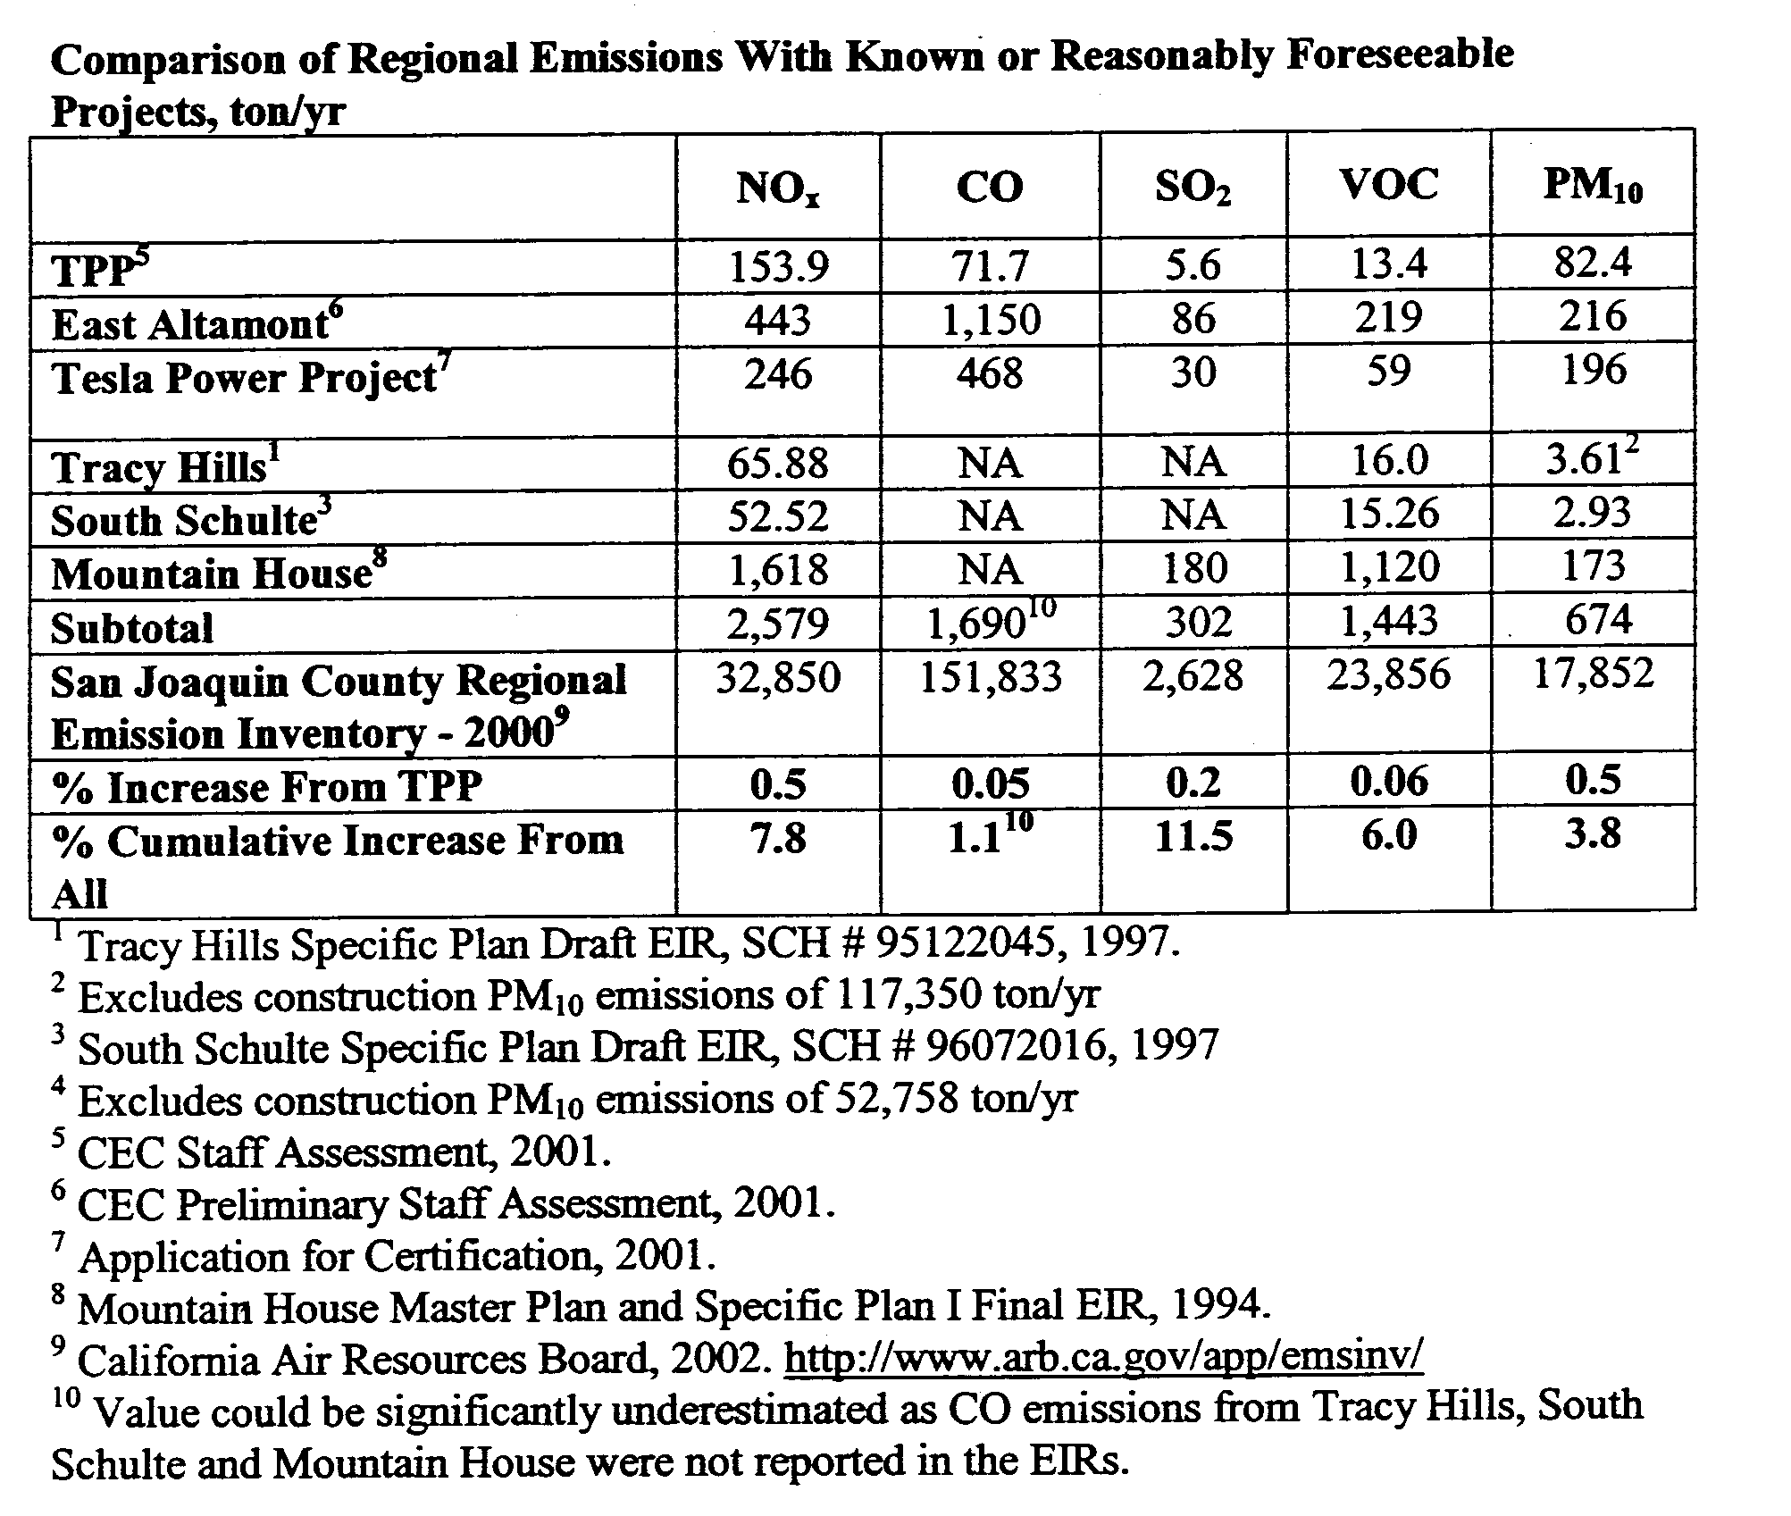
Figure 9 Applicant’s Cumulative Impact Analysis
Public Health
What are the health effects of particulate air pollution?
More than two-dozen community health studies since 1987 have linked particulate pollution to reductions in lung function, increased hospital and emergency room admissions, and premature deaths. Recently, two major epidemiological studies (by the American Cancer Society and Harvard University), the contents of which are fully incorporated by this reference (copies will be made available on request) were published showing that people living in more polluted cities had an increased risk of premature death compared to those in cleaner cities.
How does mortality attributable to particulate pollution compare to total cardiopulmonary mortality?
NRDC estimates that at current levels of pollution, approximately 64,000 premature deaths from cardiopulmonary causes may be attributable to particulate air pollution each year. That represents 6.5% of all cardiopulmonary deaths, which total 986,000 per year. The national estimate of mortality attributable to smoking is 418,690 for 1990.
Who is at greatest risk?
The elderly and those with heart and lung disease (i.e., those members of what is supposed to be an englightened society who require the most assistance) are at greatest risk of premature mortality due to particulate air pollution. One to two years on average in more polluted areas might shorten their lives.
How do particles cause harm to human health?
The exact toxicological mechanisms are not well understood, but researchers have a number of theories. For instance, studies show that particulate matter causes respiratory symptoms, changes in lung function, alteration of mucociliary clearance, and pulmonary inflammation, which can lead to increased permeability of the lungs. Increased permeability might precipitate fluid in the lungs in people with heart disease. In addition, mediators released during an inflammatory response could increase the risk of blood clot formation and strokes.
Particulate exposure might also increase susceptibility to bacterial or viral respiratory infections, leading to an increased incidence of pneumonia in vulnerable members of the population. Potential mechanisms could include impairment of clearance mechanisms or immune system function. In the presence of pre-existing heart disease, acute bronchiolitis or pneumonia induced by air pollutants might precipitate congestive heart failure.
Particulate air pollution might also aggravate the severity of underlying chronic lung disease, causing more frequent or severe exacerbation of airways disease or more rapid loss of lung function.

Has a cause-and-effect relationship been demonstrated?
Evaluation of epidemiological studies requires consideration of a number of factors such as strength of the association, consistency of the association, dose-response relationship, biological plausibility, and coherence with other known facts. Based on these factors, a number of prestigious international panels including a British Committee on the Medical Effects of Air Pollutants and a Committee of the Health Council of Netherlands have concluded that there is a cause-and-effect relationship between particulate pollution and mortality.

What exactly is particulate matter?

Particulate matter includes a wide range of pollutants -- road dust, diesel soot, fly ash, wood smoke, ammonium nitrate, and sulfate aerosols that are suspended as particles in the air. These particles are a mixture of visible and microscopic solid particles and minute liquid droplets known as aerosols.

Where do fine particles come from?

Combustion of fossil fuels is the principal source of fine particle emissions, including the burning of coal, oil, diesel fuel, natural gas, gasoline, and wood in transportation, power generation, and space heating. Old coal-fired power plants, industrial boilers, diesel and gas-powered vehicles, and wood stoves are the worst culprits. High temperature industrial processes such as metal smelting and steel production are also significant sources.
What level of exposure to particulates is considered unhealthy? Is there a threshold?

Epidemiological studies have reported a linear relationship between exposure and effects. In other words, the higher the concentration of particles, the greater the effect on the health of populations. Effects have been demonstrated at levels well below the current National Ambient Air Quality Standards. Scientists have not been able to identify a threshold below which health effects do not occur. While not a threshold, the long-term epidemiology studies show that the risk of premature deaths starts to increase at annual average concentrations of PM2.5 of 10 g/m3, according to the World Health Organization.

How did Natural Resources Defense Council come up with its mortality estimates?
NRDC used a methodology suggested by prominent research scientist Dr. Joel Schwartz of the Harvard School of Public Health. NRDC applied the findings of a 1995 study by the American Cancer Society (ACS) and Harvard Medical School to local data to gauge the extent of the particulate pollution problem. The ACS study was the largest, most comprehensive long-term epidemiologic study examining the effect of ambient air pollution on human health. The study used statistical techniques to adjust for age, and to control for the effects of smoking, body weight, occupational exposure, and other risk factors.
There were four steps to NRDC's analysis: 1) Analysis of EPA particulate monitoring information for metropolitan statistical areas; 2) Tabulation of data from the National Center for Health Statistics on adult mortality rates from selected cardiopulmonary causes; 3) Calculation of a risk coefficient per microgram of particle pollution from data presented in the ACS study; and 4) Application of the risk coefficient to city-specific monitoring and mortality data. Although NRDC's analysis relies on several assumptions, a sensitivity analysis based on alternative assumptions shows that the estimates are reasonable.
Table 1 identifies Metropolitan Statistical Areas in the state of California. For each MSA, the table shows PM-10 concentration and NRDC's estimate of air pollution attributable deaths.
The table shows the average annual mean PM-10 concentration in each MSA over the five-year period, 1990 through 1994. The higher the PM-10 concentration, the greater the risk of premature mortality from heart and lung disease
For each MSA, we present point and range estimates of the annual adult cardiopulmonary deaths attributable to air pollution The estimates are derived by applying a risk factor reported in a study of an American Cancer Society cohort to MSA-specific information on PM-10 concentrations and mortality from selected causes. The range estimates are derived from the confidence intervals for the risk ratio reported in the ACS study.
For the purposes of comparison, the table also shows the total number of cardiopulmonary deaths in the MSA and the number of deaths from car accidents. The nearest MSA is Stockton with a 93 deaths attributable to particulate matter exposure per 100,000 population.
Table 1 Deaths attributable to particulate matter exposure
Metropolitan  Statistical Area | Average  Annual Mean  PM-10  Concentration  (1990-1994)  (ug/m³) | Estimated Annual Cardiopulmonary  Deaths Attributable to  Particulate Air Pollution
Metropolitan  Statistical Area |  | Point  Estimate | Range | - | Range | Deaths per  100,000  Population | Adult  Cardio-  Pulmonary  Deaths  (1989) | Deaths  from  Auto  Accidents  (1989)
ANAHEIM-SANTA ANA, CA | 38.1 | 1,053 | 632 | - | 1,433 | 55 | 7,429 | 369
BAKERSFIELD, CA | 54.8 | 464 | 284 | - | 618 | 115 | 2,005 | 163
CHICO, CA | 33.1 | 104 | 62 | - | 143 | 72 | 924 | 59
FRESNO, CA | 51.7 | 488 | 298 | - | 653 | 95 | 2,265 | 212
LOS ANGELES-LONG BEACH, CA | 43.8 | 5,873 | 3,550 | - | 7,933 | 79 | 33,825 | 1,458
OXNARD-SIMI VALLEY-VENTURA, CA | 30.6 | 182 | 108 | - | 251 | 34 | 1,864 | 110
REDDING, CA | 28.3 | 58 | 34 | - | 80 | 50 | 683 | 60
RIVERSIDE-SAN BERNARDINO, CA | 48.1 | 1,905 | 1,158 | - | 2,560 | 122 | 9,685 | 748
SACRAMENTO, CA | 31.9 | 488 | 290 | - | 669 | 48 | 4,625 | 260
SALINAS-SEASIDE-MONTEREY, CA | 19.4 | 29 | 17 | - | 40 | 10 | 1,019 | 62
SAN DIEGO, CA | 34.8 | 999 | 597 | - | 1,365 | 54 | 8,147 | 412
SAN FRANCISCO-OAKLAND, CA | 28.7 | 1,270 | 752 | - | 1,748 | 39 | 14,694 | 414
SAN JOSE, CA | 32.8 | 447 | 266 | - | 612 | 35 | 4,015 | 179
SANTA BARBARA-SANTA MARIA-LOMPOC, CA | 30.5 | 124 | 74 | - | 171 | 41 | 1,278 | 53
SANTA CRUZ, CA | 13.2 | 0 | 0 | - | 0 | 0 | 881 | 37
SANTA ROSA, CA | 20.0 | 52 | 31 | - | 73 | 17 | 1,600 | 86
STOCKTON, CA | 44.8 | 321 | 194 | - | 433 | 93 | 1,794 | 125
VALLEJO-FAIRFIELD-NAPA, CA | 28.2 | 120 | 71 | - | 165 | 36 | 1,437 | 67
VISALIA-TULARE-PORTERVILLE, CA | 60.4 | 302 | 186 | - | 402 | 123 | 1,277 | 167
YUBA CITY, CA | 37.4 | 65 | 39 | - | 89 | 64 | 472 | 37
Table California: Particulate Air Pollution Attributable Mortality
Point estimates are derived from the risk ratio reported in the ACS study. Ranges are derived from 95-percent confidence intervals around the risk ratio in the ACS study. Metropolitan Statistical Areas are as defined by the Office of Management and Budget for 1980, except for New England, where areas are New England County Metropolitan Areas.

What are the effects and adequacy of the applicant’s and Commission’s health risk assessment in regards to partial load emissions from the plant?

The Gas Research Institute ("GRI") investigated the effect of load on criteria and toxic pollutant emissions from nine gas turbines including a large Frame 7 GE turbine. This study found that emissions of Toxic Air Contaminants (TACs) like benzene, toluene, formaldehyde, methane, and total non-methane hydrocarbons decrease with load. Emissions of formaldehyde, a carcinogen, increased dramatically, by up to a factor of 343 when the load was reduced from 100% to 20%. For the 750 MW GE Frame 7, the formaldehyde emission factor increased by a factor of 503, and the formaldehyde emissions increased from 0.11 to 16.08 tons/yr or by factor of 146, when the load was reduced from 100% to 30%. Partial load induced TAC emissions with a health risk for cancer of greater than 1 in a million are reasonably foreseeable, and have not been adequately identified in the Applicant’s and Staff’s health risk assessment. The FDOC, SA, Applicant’s testimony failed to properly assess the additional health risks associated with 250 startup and shutdowns annually.

Request for correction of errors regarding data presented by intervenor, and effects of failure to respond.

Intervenor has identified the source of the technical and scientific data discussed and cited in this written testimony. Many of the materials cited are already in the administrative record. Those that are not, if cited and relied upon by intervenor, will be made available to anyone who requests. As a member of the public entitled to well informed and meaningful participation, intervenor respectfully requests that CEC or applicant respond to our comments by pointing out any claimed errors in our citations and their subject matter. If corrections are not pointed out, the silence in the face of circumstances that a reasonable person would deem to require a response shall be deemed as admissions that errors do not exist and intervenor's statements and interpretations are true and correct. (See Estate of Nielson (1962) 57 Cal.2d 733, 746, 747.)

Biological Resources

Intervenor will provide written testimony of the local and regional cumulative impacts of emissions from the project on biological resources. Questions for witnesses are provided with attached expert testimony herein for witnesses with Dr. Smallwood’s consent to include his answers. Intervenor attaches Dr. Smallwood’s written testimony and herein incorporates it by reference as if fully set forth here.

Does this environmental review process allow for public participation on biological impacts?
Dr. Smallwood: “The piecemeal release of environmental review documents prevented a comprehensive and maximally effective public review and participation with the planning process”

How does the CEC Staff’s review in this peaking plant differ from that of a base-load plant?
Dr. Smallwood: “By replacing the typical sequence of PSA ⇨ FSA with the Staff Assessment ⇨ Supplement to Staff Assessment, the CEC further deviated from the CEQA process by forcing the public to obtain and crosswalk between both documents in order to approach the level of understanding of the project that one would get from an EIR under CEQA”

Was public input allowed on the biological resource impact mitigation plan for the TPP?
Dr. Smallwood: “The applicant escaped review of its detailed mitigation plan by not releasing its BRMIMP until after the Supplement to the Staff Assessment (to this date, it is still unavailable to the public, so the applicant enjoys an exclusive mitigation planning process)”

How was the San Joaquin County Multi-Species Habitat Conservation and Open Space Plan (SJMSP) impacted by the TPP?
Dr. Smallwood: “The applicant escaped public review of its biological mitigation and monitoring plans altogether by claiming that it will pay into the San Joaquin County Multi-Species Habitat Conservation and Open Space Plan (SJMSP), which did not plan for impacts stemming from such a Power Plant and which still requires approval of the Joint Powers Authority and a major amendment to the SJMSCP”

Is it possible the Applicant and CEC Staff missed any special status species in their analysis?
Dr. Smallwood: “The impacts assessment failed to include special-status species that I observed on the lay-down area immediately upon my arrival when I provided a cursory site visit from the Delta Mendota Canal”

Did the Applicant’s and Staff’s Analysis adequate identify all the impacted special status species?
Dr. Smallwood: “The staff assessment of biological resources was grossly inadequate by failing to address 76% of the wildlife species that occur in the vicinity of the proposed Peaker Project site, and that very well could be adversely affected by the tons of pollution to be generated by the Project”

Is adequate compensation being provided for the “take” of special status species?
Dr. Smallwood: “The only biological impact being compensated with a mitigation measure is the conversion of 22 acres into the facility, thereby neglecting the impacts caused by lights, noise, tall structures (stacks), and the thousands of acres upon which pollutants generated by the Project will deposit, which collectively represent a major deviation from the land use and foreseen impacts of the SJMSP”

Would the impact zone of emissions from the TPP include a large enough geographical area to assess the impact on special status species?
Dr. Smallwood: “The cumulative impacts analysis arbitrarily encompassed only a 6 mile radius around the Tracy Peaker Plant, rather than the entire air basin into which the pollution will be injected”

Did the analysis of cumulative biological resource impacts include the Thermal Energy Development Corp and Owens-Brockway Co?
Dr. Smallwood: “9. The cumulative impacts analysis inappropriately neglected to include on-going impacts caused by existing generators of pollution and other existing on-going impacts on wildlife caused by energy generation in the region”

Land Use

To the best of his ability, intervenor will provide evidence of the project's non-compliance with LORS governing land use. However, intervenor requests adequate time for further discovery on these important matters. At this time, intervenor plans to retain Mike Boyd to coordinate the assistance of the County and City in preparing the administrative record in this matter in organized presentation of witnesses at the March 13, 2002 Evidentiary Hearing on Land Use.

Respectfully submitted,
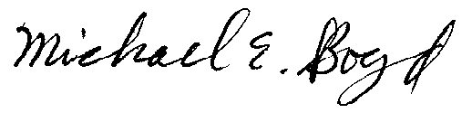
3-5-02

In number of other siting cases before this Commission an emission limitation of 2.5 ppm for NOx has been required by the CEC.
? The South Coast AQMD concludes that 2 ppmvd averaged over 3 hrs is equivalent to 2.5 ppmvd averaged over 1 hr. (South Coast AQMD 5/12/98, p. 3-4).
Letter from Matt Haber, Chief, Permits Office, U.S. EPA, to Robert Danziger, President, Goal Line Environmental Technologies, March 23, 1998.
TTP FDOC at Page 2.
Gas Research Institute, Gas-Fired Boiler and Turbine Air Toxics Summary Report, Final Report, August 1996.
Letter from William V. Loscutoff, Chief, Monitoring and Laboratory Division, to All Air Pollution Control Officers/Executive Officers, Re: Advisories to Limit the Use of ARB Method 430 (M430) Determination of Formaldehyde and Acetaldehyde in Emissions from Stationary Sources, April 28, 2000.
Applicant’s February 13, 2002 Testimony provided by David A. Stein, P.E.

