CAlifornians for Renewable

Energy, Inc. (CARE)_____
C/o Michael Boyd_______
821 Lakeknoll Dr._______
Sunnyvale, CA 94089____

State of California
Energy Resources Conservation
And Development Commission

In the Matter of: )
) Docket No. 00-AFC-1
) PETITION FOR INTERVENTION
Application for Certification for the ) WITH FINANCIAL HARDSHIP
Contra Costa Power Plant Project )
[Southern Energy Delta LLC] )
___________________________________ )

In behalf of CARE, Michael Boyd, hereby petitions to be excused from

☑ Filing 12 Copies with the Commission Docket Unit.

- Serving its papers on all other parties of record.

Petitioner, Michael E. Boyd representing, CAlifornians for Renewable Energy, Inc (CARE) states:
- Petitioner, Michael E. Boyd, in behalf of, CARE, petitions to intervene in the above-entitled proceeding.
- Petitioner has an interest in the proceeding in that he represents a not for profit organization, CARE, established to insure that new renewable energy supplies are developed in preference to non-renewable energy supplies. Additionally this organization is established in order to protect the residents of the state of California from adverse environmental and socioeconomic impacts associated with new non-renewable energy sources.
- On June 23, 2000 in the Metcalf Energy Center (99-AFC-3) the Commission approved CARE’s electronic filings due to financial hardship. CARE requests the same terms and conditions as stated in this order, to apply to this matter.
“Intervenor CARE may serve its future filings by Internet e-mail upon those appearing on the Proof of Service list who have e-mail addresses indicated. CARE must continue to provide paper copies of all its filings to the other parties, and must provide the Commission Docket Unit with one original paper copy and one electronic copy of all filings.”
- Petitioner does does not wish to reserve the right to present evidence and cross-examine witnesses.
- Michael E. Boyd will represent petitioner.
11-8-00 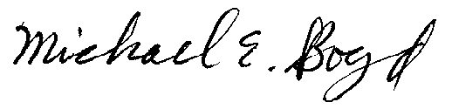
___________________ _________________________________________________________
Date Signature

