Bob Sarvey Intervenor
501 W. Grantline Rd
Tracey, CA 95376
(209) 835-7162
STATE OF CALIFORNIA
Energy Resources Conservation
and Development Commission

In the Matter of: ) Docket No. 01-AFC-16
)
Application for Certification for the ) Motion to Re-open the record
GWF TRACY PEAKER PROJECT ) on Biological Resources to allow
IN SAN JOAQUIN COUNTY ) Testimony of Dr. Shawn Smallwood

At the March 6, 2002 Evidentiary Hearing on Biological Resources Intervenor requested that the prepared written testimony of Intervenor’s biological resources consultant expert Dr. Shawn Smallwood (Docketed March 5, 2002) be entered into evidence at the evidentiary hearing on biological resources. Intervenor’s request to have Dr. Smallwood’s testimony incorporated into the evidentiary record was denied. The hearing officer offered to make this testimony hearsay public comment, which Intervenor declined. Intervenor’s position is that this is expert testimony and you ignore such at your own risk.

At the March 7, 2002 Evidentiary Hearing on Air Quality and Public Health CEC Staff provided contour maps of the NOx and PM10 deposition, as well as other maps under the purported title “Visual Aids to be used by Staff during Evidentiary Hearing (Docketed March 5, 2002)”. Intervenor formally objected to making the “Visual Aids” part of the evidentiary record as they violated the “no-surprise rule” and because Staff and Applicant had objected, and the hearing officer had sustained, objection to making Dr. Smallwood’s written testimony part of the evidentiary record.

Despite the Staff’s prejudicial underhanded attempt to deny Intervenor’s expert witness Dr. Smallwood an opportunity to examine the Staff’s purported “Visual Aids” in the form of contour maps of the NOx and PM10 deposition, Dr. Smallwood was instructed to review these maps and provide further written testimony on the spatial area of California red-legged frog habitat that would likely be degraded and in which frogs may be harmed as a result of the deposition of nitrogen oxides and fine particulate matter generated by the GWF Tracy Peaker Project, as well as by the other proposed energy projects included within the CEC’s cumulative impacts assessment. This information is relevant to this case because such information has a direct bearing on the level of mitigation required to offset impacts on biological resources. At this time, absent Intervenor’s expert testimony the evidentiary record is incomplete, and your exclusion of such information, under the present circumstances, is a prejudicial abuse of discretion. Intervenor hereby by this motion, or what ever reasonable procedural device you find appropriate, demands that the Evidentiary record on Biological Resources be reopened to include Dr. Smallwood’s prior and most recent expert testimony on biological resource impacts.

Intervenor strongly objects to the efforts to make it appear to members of the general public that they have the right or the opportunity to intelligently and meaningfully participate in your proceedings when, in fact, they do not and could not do so, as evinced by your failure to incorporate Dr. Smallwood’s expert testimony while allowing both Staff’s and Applicant’s testimony and exhibits into the record after imposing prejudicial deadlines to file such information on Intervenors. Giving or allowing such an appearance to be given is fraudulent in nature and adversely taints the entire proceedings because such an assertion is, at best, incomplete, inaccurate and grossly misleading.

As an offer of “good faith” to provide a level playing field without surprise to the Applicant and CEC Staff, Intervenor is willing to make Dr. Smallwood available for cross examination at the March 13, 2002. Intervenor’s disclaimer is that you must provide Intervenor at least four hours advanced warning of an opportunity for direct testimony by Dr. Smallwood to provide ample time for his travel from Davis to Tracy California.

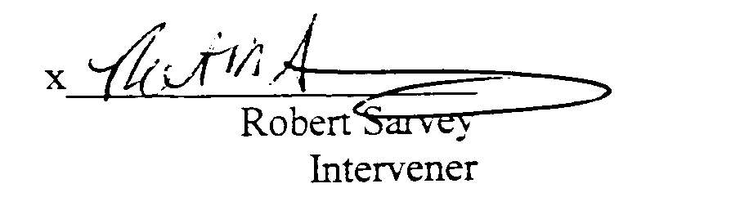
Thank you for your consideration.

INTERVENOR
3-12-0

Intervenor attaches Dr. Smallwood’s estimate of spatial areas impacted by NOx and PM10 which we incorporate here by reference as if fully set forth here.

