Bob Sarvey Intervenor
501 W. Grantline Rd
Tracey, CA 95376
(209) 835-7162
STATE OF CALIFORNIA
Energy Resources Conservation
and Development Commission

In the Matter of: ) Docket No. 01-AFC-16
)
Application for Certification for the ) Request for Reconsideration
GWF TRACY PEAKER PROJECT ) of Biological Resources Testimony
IN SAN JOAQUIN COUNTY ) of Dr. Shawn Smallwood

At the March 6, 2002 Evidentiary Hearing on Biological Resources Intervenor requested that the prepared written testimony of Intervenor’s biological resources consultant expert Dr. Shawn Smallwood (Docketed March 5, 2002) be entered into evidence at the evidentiary hearing on biological resources. Intervenor provided staff and Committee members, copies of photographic evidence of special status species not reported in Staff’s, and Applicant’s analysis. Intervenor’s request to have Dr. Smallwood’s testimony incorporated into the evidentiary record was denied. The hearing officer offered to make this testimony hearsay public comment, which Intervenor declined. Intervenor’s position is that this is expert testimony. Dr. Smallwood is also qualified as an expert because of his prior expert testimony in the Metcalf Energy Center (99-AFC-3), Contra Costa Power Plant (00-AFC-1), and the Blythe Energy Project (99-AFC-8). Two of these projects are the subject of two CEQA actions against the CEC regarding biological resource impacts on special status species, one currently under appeal in the appeals court, and the second with appeal in preparation. Intervenor offered to stipulate to Staff’s and Applicant’s rebuttal by the evidentiary hearing scheduled for March 13, 2000, but the Hearing Officer also declined this offer. The testimony was then made as an “offer of proof” which was also declined. Intervenor advised that the Committee “ignored this testimony at their own risk”. On March 7, 2002, subsequent to the Hearing the Tracy Press published the front-page article titled Peaker Hearing takes on Animal Impact, headlining the evidence Intervenor attempt to incorporate into your evidence. Intervenor again provides this copy of this article as an “offer of proof” of the importance of Dr. Smallwood’s testimony. Intervenor further advises that you ignore this evidence in your administrative record, as well as the public record, in these evidentiary hearings at your own risk.

As an offer of “good faith” to provide a level playing field without surprise to the Applicant and CEC Staff, Intervenor is willing to make Dr. Smallwood available for cross examination at the March 13, 2002.

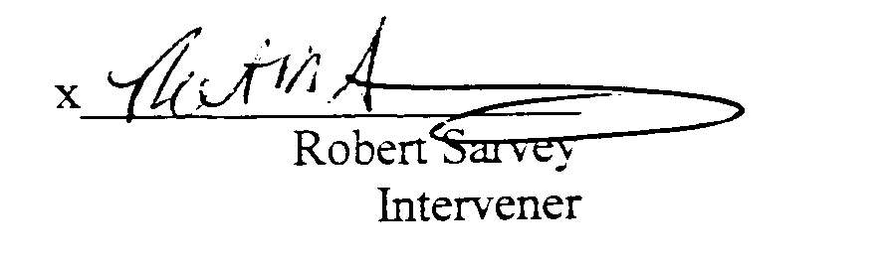
Thank you for your consideration.

INTERVENOR 3-6-02
