To: State of California Energy Resources

Conservation and Development Commission
Docket No. 01-EP-9
Application for Certification for the
Pegasus Power Project, Chino Emergency Peaker Project
CALIFORNIA ENERGY COMMISSION
DOCKET UNIT, MS-4
Attn: Docket No. 01-EP-9
1516 Ninth Street
Sacramento, CA 95814-5512

From: CAlifornians for Renewable Energy, Inc. (CARE)
821 Lakeknoll Drive
Sunnyvale, CA 94089
(408) 325-4690

NOTICE OF OBJECTION TO APPROVAL OF PEGASUS POWER PROJECT, AND CALIFORNIA PUBLIC RECORDS ACT REQUEST IN CEC DOCKET #01-EP-9

PLEASE TAKE NOTICE CARE, a non profit public benefit corporation vitally interested in the siting, construction and operation of powerplants (particularly during the ongoing energy crisis which has been declared an emergency by the Governor), its members individually, and other members of the public, be they individuals or entities, hereby object to approval of the Pegasus Power Project on grounds that include the failure to conduct and adequate administrative review that includes a proper CEQA or CEQA-equivalent review, generally, and more particularly the failure to give proper notice and allow adequate public participation to individuals and groups that may be adversely impacted by the project, including in regard to health & safety. This objection is being made on behalf of those persons, which include guards and prisoners at the California Men's Institute at Chino. The objection is being made specifically to preserve the right of those persons to obtain judicial review of approval of the project without proper notice or adequate opportunity for public participation.

We respectfully demand that before granting project approval the CEC, at the very least, conduct an investigation to determine if any effort has been made to give notice of the administrative review of the Pegasus Power Project to guards and prisoners who will be exposed to the sharply reduced degree of environmental (including health & safety) protection as a result of the expedited procedures used to approve the project.

In addition, under the California Public Records Act, CARE, its members individually and other members of the public, request that the CEC compile and make available all materials pertaining to all public notices given in regard to the Pegasus Power Project since its application was submitted.

Thank you kindly,

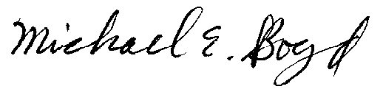
President-CARE (408) 325-4690
DATED: May 22, 2001.

