UNITED STATES OF AMERICA
FEDERAL ENERGY REGULATORY COMMISSION

San Diego Gas & Electric Company
Complainant,

- Docket EL00-95 et.al.
EL00-95-12
EL00-95-31
EL00-95-45
Sellers of Energy and Ancillary Service Into
Markets Operated by the California
Independent System Operator Corporation
and the California Power Exchange
Respondents

Investigation of Practices of the California Docket Nos. EL00-98-030
Independent System Operator and the California EL00-98-033
Power Exchange EL00-98-042

California Independent System Operator Docket Nos. RT01-85-000
Corporation RT01-85-001

Investigation of Wholesale Rates of Public Utility Docket Nos. EL01-68-000
Sellers of Energy and Ancillary Services in the EL01-68-001
Western Systems Coordinating Council

CAlifornians for Renewable Energy, Inc. Docket No. EL01-2-000
(CARE)
Complainant
v.

Independent Energy Producers, Inc. and All Sellers
of Energy and Ancillary Services into the Energy
and Ancillary Services Markets Operated by the
California Independent System Operator Corporation
and the California Power Exchange; All Scheduling
Coordinators Acting on behalf of the Above Sellers;
California Independent System Operator Corporation;
and California Power Exchange Corporation

Respondents

CAlifornians for Renewable Energy, Inc. Docket No. EL01-65-000
(CARE)
Complainant

v.
BC Hydro, PowerEx, Southern Co.
Energy Marketing, now called Mirant,
and the Bonneville Power Administration
CARE'S PROVIDES EVIDENCE AGAINST INDEPENDENT ENERGY PRODUCERS ASSOCIATION (“IEPA”), AND THE CALIFORNIA PARTIES INCLUDING
EVIDENCE OF VIOLATIONS OF TITLE VI (CIVIL RIGHTS ACT OF 1964) AND REQUEST FOR APPROPRIATE RELIEF

CARE has notified you of the economic turmoil resulting from the so-called “energy crises” at the state, national, and international level and the resulting plethora of power plants being sited in California’s communities-of-color. CARE is a party in intervention in the Federal Energy Regulatory Commission (“FERC) docket EL00-95 et.al. (San Diego Gas & Electric Company v. Sellers of Energy and Ancillary Services, 95 FERC 61,418). As a party to these proceedings CARE has provided FERC corroborative evidence of the State of California, and specifically the California Energy Commission’s intent to discriminate in the permitting of new power plants in California in communities of low-income, native peoples, and peoples-of-color. CARE herein provides substantial corroborative evidence of the California Parties acting in concert with IEPA to discriminate with intent in the form of the attached November 2001 Report of the Latino Issues Forum titled POWER Against the PEOPLE? Moving Beyond Crisis Planning in California Energy. CARE herein provides a copy of the report and additionally includes the resume of one of its authors Torri Estrada. CARE will provide additional resumes and individual declarations of their professional qualification and experiences from the authors of this report in the near future to further corroborate their qualifications as expert witnesses in the preparation of this report
With all due respect, our understanding is that it is you as the administrative agency, and not CARE or other members of the public, that are responsible to conduct a full and fair investigation of matters as to which you have been put on notice by the submission of objectively-based, reasonably credible information, such as the information we have been providing you.
We also understand that in order to preserve our legal rights to challenge your decision in regards to the issues of discrimination we have to notify you in advance of your decision of the alleged discriminatory practices, in this case involving the siting and construct of peaking power plants on an expedited basis in California’s communities-of-color. It is also our understanding that your failure to act on our notification of such discrimination may be used to establish your intention to discriminate in any ensuing judicial review. This is to formally notify you that your continued participation with the State of California in these discriminatory and illegal practices will be interpreted by CARE as admission that you also have such “intent to discriminate” in this regard.
In joining with other interveners and parties participating in the present or related proceedings in seeking appropriate and just relief from the misconduct and illegalities previously or elsewhere described, and by this reference incorporating all such requested relief as though fully set out here, and in specifically reserving the right to present and request any other remedies deemed appropriate as a result of information provided in these and related proceedings, CARE requests that the provisions be given proper consideration and adopted. Any certifications, license, permits, or other entitlements given the IEPA or under consideration by the state, particularly the California Energy Commission in regard to the siting, construction or operation of powerplants in California after or while engaging in the unlawful conduct violating California or federal law previously described. This should specifically include an order that revocation proceedings be initiated and conducted by the appropriate agency or agencies or judicial tribunal.

Respectfully submitted,
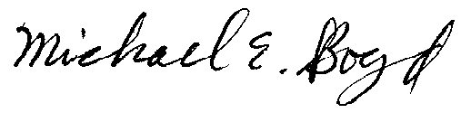
President, CARE, 821 Lakeknoll Dr., Sunnyvale, CA 94089 (408) 325-4690

POWER Against the PEOPLE?
Moving Beyond Crisis Planning in California Energy

A Report of the Latino Issues Forum
November 2001

Prepared by Karen DeGannes, Estrada ECOnsulting and Associates, and Robin Saha

ower Against the People: Moving Beyond Crisis Planning in California Energy Policy is a study that was commissioned by the Latino Issues Forum based on a concern that the State of California’s rush to build gas-fired power plants as a solution to the energy crisis was at odds with its mandates to protect public health, the environment, and ensure environmental justice for people of color and the poor. The study analyzed the California Energy Commission’s (CEC) expedited plant siting processes to uncover defects in public participation, environmental review, financing incentives, and other areas. Another objective of the study was to determine the extent to which new power plants being approved in California are disproportionately located in communities comprised predominately of people of color and low-income households. Based on its findings, the study presented a number of recommendations to ensure that measures prescribed during the height of a crisis do not continue to afflict California energy policy.
P

Methodology: The study was conducted on 18 power plant facilities, the majority (17) of them peaker plants, for which specific location data were available to the public on the CEC Web site as of June 30, 2001. The lack of precise data regarding power plants is a problem itself that should be addressed. There were many more power plants proposed as of that date, and more proposed since that date, so that the full magnitude of the continuing problem may not be entirely captured in this report. However, the analysis was performed using even more accurate demographic data than that used in CEC analyses.

A Crisis in California Energy Policy: Governor Gray Davis and many legislators have posited that the energy “crisis” is a problem of a lack of supply to which the solution is the construction of new energy capacity in California. In fact, the Governor’s formal declaration of a state of emergency through December 31, 2001 assumes that there is a high probability that this electricity supply shortage will continue to cause rolling blackouts and pose a threat to public health, safety, and welfare. By using his emergency powers to address the “crisis,” the Governor was able to prescribe policies and take actions without the typical public debate and administrative or legislative process. These actions included the issuing of several executive orders that suspend existing state laws and policies related to environmental review, including those policies related to protecting public health and ensuring environmental justice, for the purpose of expediting energy facility siting.
“all reasonable conservation, allocation, and service restriction measures will not alleviate this energy supply emergency”
– Gov. Gray Davis

Key Problems with the Expedited Review Process. The most troubling of the new energy policies has been the institution of expedited processes for considering and granting permits for new power plants. Whereas in the past such a process took 12 months, the Legislature authorized expedited processes of 4 months and 6 months. Governor Davis’ emergency orders created “streamlined” procedures for these fast-track power plant permitting processes. Asserting the authority of the executive orders and its own statutory emergency powers, the CEC created an “emergency” 21-day permitting process. Our analysis of the 4-month peaking power and 21-day emergency permit processes, which operate in conjunction with the Governor’s executive orders (especially D-26-01 and D-28-01), reveals a siting process that creates racial and socio-economic disparities, as evidenced in our demographic analysis described below. The key problems with the CEC’s implementation of the expedited (4-month) and emergency siting (21-day) processes are:

- Evasion of the California Environmental Quality Act (CEQA): CEQA is the law that allows Californians to be informed and voice their opinion about projects that may affect their environment. CEQA requires a review of the environmental impacts of projects.
- Proposed projects under the 21-day process are exempt from CEQA; no CEQA environmental review at all under this process.
- Using the authority of Governor Davis’ executive orders, CEQA environmental review is evaded for the 4-month process as well.
- No evaluation of cumulative impacts nor mitigation of all significant impacts as mandated in CEQA.

  - Failure to Perform an Environmental Justice Analysis:
  - Projects under the 4-month and 21-day processes are not required to conduct any environmental justice analysis, especially under the Governor’s executive orders.
  - As indicated below, 16 of 18 plants in this study are located in areas that contain 50% or more people of color, much higher than the state average.

    - Public Participation and Due Process: Failure to ensure legally-mandated public participation and due process in siting review and decision-making.
    - Very limited public review and community hearings are required by the CEC.

      - Submission and Access to Public Information: Failure to require applicants to submit complete and accurate information about proposed power plant projects and to make them readily available to the public and review agencies in a timely matter.
      - Public access to siting review records and information is extremely limited and regularly unavailable during even the early stages of the review process.
      - Accuracy and quality of information available to the public is poor: There were many instances where information about a project was entirely missing, inaccurate, or misleading.

      - Failure to Comply with Federal, State, and Local Laws, including:
      - Executive Order D-40-01 allows gas-fired plants to operate with no regard for air quality regulations, even in non-attainment areas, where air pollution is particularly high.
      - SB 110 removed the requirement that the CEC determine whether there is even a need for proposed power plant and what other alternatives exist to met any determined need.
      - Title VI of the Civil Rights Act of 1964 requires the CEC to identify and address any disproportionately high and/or adverse human health, socioeconomic, or environmental impacts of their programs, policies, and actions on minority and/or low-income populations.

  - The Potential Peaker Power Plant Siting Analysis: This Analysis targets “brownfield” areas for plant siting, thus perpetuating siting policies that are very likely to concentrate peaker plants in low income, people of color communities.
  - Targets existing power plant and substation sites, sites proposed by power plant developers, oil and gas industry sites, sites previously analyzed by the CEC in their review of an earlier application for certification, sites identified by local governments for this purpose, state-owned sites, managed by various agencies, and Department of Defense sites or those managed by other federal agencies – likely to be brownfields.
  - The potential peaking plant siting analysis failed to meet the “without compromising environmental quality” guideline identified in that same report.
  - Environmental justice issues were not properly considered in the analysis.

W
ho is bearing the burden of environmental hazards? When it comes to environmental quality and issues of public health, not all communities are treated equally. Evidence clearly shows that communities of color suffer from a disproportionate number of environmental hazards. A recent study in Southern California showed that there are persistent racial differences in estimated cancer risks associated with ambient hazardous air pollutant exposures, even after controlling for well-known causes of pollution such as population density, income, land use, and a proxy for political power and assets (home ownership). Other studies indicate that 89% of all toxic air releases are located within 1 mile of disproportionately “minority” census tracts in metropolitan Los Angeles and that being a person of color in Los Angeles is the best predictor of living next to a hazardous waste treatment, storage and disposal facility. Making the situation worse by adding to the cumulative impacts of these environmental hazards are proposed power plants.
1 out of every 3 people of color in Southern California live in a high cancer risk neighborhood

esults of the study. As will be demonstrated more fully in the section of the report presenting the demographic analysis, the proposed power plants analyzed by this study disproportionately impacted California’s most vulnerable populations: communities of color, low-income communities, children, and the elderly. The findings include:

R

● The majority of power plants considered by the CEC are planned for or being built in neighborhoods populated by people of color – especially Latinos & African-Americans:
- For 16 out of 18 (89%) of the plants in the study, within six miles of the facilities, more than 50% of the population is people of color, much higher than the state average.
- Latinos are highly over-represented in the populations living near these plants, followed by Blacks. In the case of approximately 80% of these plants, the Latino population living nearby exceeds the 32.4% of the state’s population that is Latino.

● Most of the plants are planned for or being built in poor communities
- For 15 of the 18 facilities (83%), the average household income within six miles of the plant is less than $25,000 per annum.
- Mean household income for the populations surrounding the 18 energy facilities was much lower than the California state average of $69,979 per annum.

Who lives within a ½ mile radius of Peaker Plants?
● Calpine Corporation, King City = 94.4% Latino within ½ mile of the plant
● Ramco Inc., Chula Vista = 77.3% Latino within ½ mil of the plant
● La Jolla Energy, Baldwin Hills = 79.8% Black within ½ mile of the plant
● Electricity Provider Inc., Lancaster = 76.5% households within a ½ mile earn less than $25,000 per year

R

ecommendations

General Statement
As the throes of the energy “crisis” are behind us, giving us the advantage of thoughtful reflection, we strongly urge the Governor, Legislature and relevant state agencies such as the CEC, Consumer Power and Conservation Financing Authority and Department of Water Resources to make a firm and meaningful commitment to taking a mid-course evaluation of utility market deregulation and the stopgap policies the Governor and Legislature were forced to make in response to the crisis. Many of these policies have produced unintended social and environmental impacts that must be considered as we move forward in planning for California’s energy future. It is imperative for the these government decision-makers to make a serious commitment to demand-side strategies, renewable and alternative energy sources, and the retrofit of existing inefficient and environmentally inferior power plants (including those disproportionately located in communities of color) as part of an integrated resource planning process. There should also be a strong effort on their part to educate the public on these issues, especially those communities that are most impacted by these policies, and to make every effort necessary to afford the people of California full and meaningful participation in energy policy decision processes.

The Governor should immediately rescind all emergency executive orders associated with power plant siting that negatively impact environmental quality, environmental justice, and meaningful public participation. Specifically, Governor Davis should immediately rescind Executive Orders D–24–01, D–25–01. D–26–01, D–27–01, D–28–01, and D–40–01 so that low-income, people of color communities do not unnecessarily bear a disproportionate burden of the health, environmental, and safety impacts of energy production. The CEC must then enforce all environmental and public health protection procedures in its permitting process.

The Governor and legislature should revisit AB 970 and initiate an Integrated Resource Planning process for the State of California. Peaker plants should be an avenue of last resort for California energy policy.

The Governor and Legislature should make a firm commitment to retrofit and clean up of existing inefficient and environmentally inferior power plants, which are disproportionately located in communities of color, as part of an integrated resource planning process.

The Governor and CEC should develop new criteria for identifying potential power plant sites. Existing criteria, due to historical processes, concentrates these facilities in low income, people of color communities.

The CEC must be directed to develop and enforce effective environmental justice guidelines in all facility siting and permitting decisions, instead of utilizing inadequate ad hoc procedures. In addition, the CEC must enforce and implement all environment, health, and environmental justice laws.

The Governor and Legislature should place a moratorium on all present and future gas-fired generation development until the CEC completes full and detailed environmental justice impact analyses and comprehensive environmental reviews of existing and proposed energy facilities. There should also be increased investment in sustainable and renewable energy in low-income communities to address the low penetration rates of sustainable, energy efficiency technologies there. Any such investment program should be designed in such a way that builds job skills, creates jobs and provides opportunities for clean, healthy economic development in those communities.

The Governor and legislature must commit to a serious, aggressive sustainable energy implementation plan, not just 20/20 or Flex Your Power. There needs to be a substantial state government investment in lasting energy infrastructure programs that are not only run or controlled by a few monopoly utility firms. Clean, distributed generation and non-utility administration of efficiency programs should be strongly supported with components of such programs targeted to the most adversely impacted low-income and people of color communities.

The CEC must require applicants to provide the most recent, accurate socio-economic and demographic data relevant to the site for a proposed facility. The CEC should release the actual proposed location of facilities to the public as soon as it becomes available or is announced whichever comes first. This agency should also significantly improve upon its methods for conducting environmental justice analysis of plant siting applications.

The CEC must develop appropriate disparate impact mitigation performance standards for various power plant siting scenarios.

The Department of Water Resources’ long-term, power purchase contracts signed by the Governor should be renegotiated in the context of full and meaningful public participation. The contracts should be redesigned to emphasize and encourage development of clean and renewable generation sources.

Mobilization of Affected Communities. The communities that are most significantly impacted by these policies, namely Latinos/as and Afro-Americans, and other low income and people of color groups, must mobilize to better understand the nature of these issues and appropriate avenues for intervention. For instance, Latino non-governmental and community-based organizations need to become more directly involved in energy policy issues, should build bridges with other groups who are committed to a sustainable and just energy future, and should mobilize Latino and other people of color legislators to actively work to ameliorate the targeting of low income, people of color communities for power facilities. These organizations and communities must also push for the State’s investment in clean, renewable generation sources and policies that support them. Most importantly, there needs to be a concerted effort to bring such clean technologies to low income, people of color communities.

D
emographic Analysis: Are the Poor and People of Color Disproportionately Burdened with the Environmental Consequences of Power Plant Siting Policies?
Introduction
This section reports our findings from the demographic analysis. We examined the proximity of people of color to power plants that were recently brought online, approved, and in-review, especially peaker plants approved as part of the California Energy Commission’s (CEC) emergency and fast-track, plant siting processes and the Governor’s executive orders. Apart from race and ethnicity, we also examine other demographic characteristics, including age, employment status, and income level. Our disparate impact analysis provides a picture of who is living in the communities that are within a range of a half-mile to six miles from these power plant facilities.
We chose the outer (distance) boundary of six miles to correspond to the CEC’s six- and 12-month process regulations for assessing demographic and socio-economic impacts. These regulations require project applicants to use the most recent demographic data available, by census tract, to determine the number and percentage of people of color and low-income populations living within a six-mile radius of the proposed facility. The regulations also call for maps at a 1:24,000 ratio, showing the distribution of people of color and low-income population, and significant pollution sources. Significant pollution sources include sites on the Environmental Protection Agency’s (EPA) Toxic Release Inventory list, or those that are permitted by the California Department of Toxic Substances Control or the local air quality management district. Applicants are also required to identify and report available studies of the health status of populations within the six-mile boundary of the given plant.
Sample, Data and Method
We selected 18 power plant facilities, the majority (17) of them peaker plants, for which specific location data were available to the public on the CEC’s Web site as of June 30, 2001. These plants are shown in Table 1. We culled plant location and other relevant information from the applications for certification (AFCs) posted on the CEC Web site. Precise location data, such as the latitude and longitude of the sites, were not provided in the AFCs we surveyed. Locations of the power plant facilities included in this study were geocoded using census 2000, digitized, (TIGER) street files obtained from proximity.com, when adequate location data such as address information were provided in the AFCs. When the location data were incomplete and/or inadequate, we selected a location based on the site maps included in the AFC and used the building or stack location provided in these maps. This latter procedure was employed to geocode seven of the plants in our study. The absence of more precise data such as latitude and longitude information increases the likelihood of some error in our geocoding of these sites, however, the best available techniques have been used, given the limited location data provided in the AFCs and time constraints.
The demographic analysis was completed using Arc View 3.2, a geographic information system (GIS) software application and its Xtools extension. Census block boundary files corresponding to the geographic locations of the 18 plants in our sample were downloaded from the Environmental Systems Research Institute, Inc. (ESRI) Web site. Census 2000 (TIGER) county boundary files were obtained from Geolytics Census CD+Map CD–ROM. These nine counties include: San Bernardino, San Diego, Santa Clara, Monterey, Kings, Los Angeles, San Mateo, Riverside, and Solano counties. We employed 2000 Block Group Estimates from Geolytics CD+Maps ^{(TM)} CD–ROM, Version 4.0. Census Block groups are larger than blocks. They are different units and there are 20+ blocks in a block group. Blocks do not correspond to city blocks, they may include four or more city blocks and block groups are designed to contain 250–550 housing units with an ideal size of 400 units.
We used 2000 Block Group Estimates to derive the income, age, and employment variables for our analysis since census 2000 data for these variables were not yet released at the detailed level of geography required for this analysis (i.e., block groups as opposed to county level data). Race and ethnicity variables, however, were derived from the unadjusted 2000 census redistricting data available on the Census Bureau’s Web page. Although we also completed a race analysis using the Block Group Estimates (population estimates based on 1990 census and updates), we selected the former analysis in consideration of data quality/accuracy issues. We found the Census Bureau’s unadjusted redistricting data to be a more reputable source for current, block level race data. Methodologies for providing estimates vary from provider to provider. Areas and population densities were calculated using Lambert’s Conformal Conic Projection.
Separate contiguous circles ranging from a half-mile to six miles in radius were generated for each plant location. These circle buffers were combined with the census block coverages (boundary files) from ESRI. Demographic data for blocks completely contained within a circle were merged and tabulated. For blocks that were only partially within a circle boundary or buffer, population parameters were estimated by using the proportion of the total block area contained – a method of spatial area weighting. Thus, if a block had 100 persons of which 20 are people of color, and only 10 percent of that block was included within the half-mile circle, then the number of persons and people of color for that block was estimated to be ten and two, respectively. Demographic data for these partially contained blocks were combined with those that were completely contained within the circle for the analysis (dissolved boundaries). These spatial geo-referenced data, obtained using Arc View, were then exported and tabulated using the Statistical Package for the Social Sciences (SPSS) 9.1 and MS Excel, in order to produce the final results shown in tables, maps and narrative in this report. We also completed an analysis of non-contiguous bands or donuts, at increments of half-mile radius from the location of the plant. The procedures for this aspect of the analysis were similar to those described above. These data are not reported here but may be reported in a subsequent analysis and are available upon request.
It is important to note that “Latino” is not a race category in the 2000 census but is rather presented as an ethnicity. Consequently, respondents who identified as Latino also had the opportunity to identify with a range of racial categories, including Asian, White, Black, and Native American, among other choices. We employed the most restrictive definition of the non-White or people of color populations possible from the available 2000 census redistricting data. We excluded from the category “non-White” any respondents who identified themselves as White, even if they classified themselves as multi-racial by identifying with one or more other racial groups. Therefore, the results presented in the section below represents a very conservative set of estimates of the people of color populations living within a six-mile radius of the 18 energy facilities in our sample.

Results

Race
Race is by far the most significant variable associated with the siting of the 18 power facilities in our analysis. Our study showed that 66.66 percent (2/3) of the plants contained 50 percent or over people of color at the 6-mile radius from the plant. When we include all distances within 6 miles, 88 percent of the plants in the study (16 out of 18) contained 50 percent or over people of color. Of the non-White or people of color populations located within close proximity of these plants, Latinos are highly over-represented, followed by Blacks. At the CEC’s 6-mile boundary, 38.88 percent of the plants failed the agency’s environmental justice standard, based on the Latino population alone. At two of the plants, Calpine King City and Ramco Chula Vista, the Latino populations exceed 77 percent within the first half-mile. Calpine King is by far the most egregious case with 94.4 percent of Latinos within a half-mile of the facility (Table 1).
In approximately 80 percent of these cases, the Latino population near these plants outstrips the 32.4 percent of the state’s population that is Latino. The data show that only in one case does the Black population alone exceed the 50 percent or more CEC standard – at the now withdrawn La Jolla Baldwin plant. Fifty percent of the sites, however, have Black populations at the six-mile boundary in excess of the average Black population of the state, which is 6.7 percent. Given time and other resource constraints, we were unable to report the statistic for other racial categories here, though they were considered in our analysis. The most significantly impacted groups were Latinos and Blacks.

Other Demographic Variables: Population Density, Age, Employment and Low-income Status
Population density ranged from zero to 5,567 population within the first half-mile of the plant. La Jolla Baldwin, CENCO Electric, Magnolia and El Segundo, respectively have the highest concentrations of population within a six-mile radius. When we examined all of the populations surrounding the 18 plants in our sample, approximately 44 percent were employed. Low employment rates were only evident for a few cases, including Calpeak Border where the employment rate was only 6.3 percent within the first two miles of the energy facility and increased to 35.6 percent at the six-mile boundary. Employment figures were also very low within the first three miles of the Wildflower Larkspur facility (ranging from 6.3 to 16.9 percent). Overall, there was a minor employment effect associated with the siting of these facilities to the extent that 48.5 percent of Californians are employed, compared to just over 44 percent of the populations near these plants, based on 2000 Block Group Estimate data.
Mean household income for the populations surrounding the 18 energy facilities was also lower than the California state average of $69,979 per annum. Eighty three percent of the population at the six-mile boundary from these facilities had mean household incomes below the state average. This proportion varied widely within the half-mile to six-mile boundaries from each plant. The La Jolla Baldwin, Calpeak Escondido, El Segundo, Valero, and Golden Gate facilities were among those with the highest mean household incomes within a half-mile of the facility.
Fifty percent of the plants were co-located with populations that had household incomes of $25,000 or less per annum, at the six-mile boundary. Eighty-three percent of the facilities are associated with populations within a half-mile to six miles of the plant, where the household income is less than $25,000 per annum. The Lancaster Energy facility was associated with the highest proportion of households at or below $25,000 per annum, 76.5 percent of households within a half-mile of that facility fell below the low-income threshold. Similar levels of poverty were found within a half-mile of the Wildflower Indigo (64.3 percent), Calpine King (52.7 percent), Wildflower Larkspur (42.1 percent) and Calpeak Border (42.1 percent) plants.
Two-thirds of the 18 plants were associated with populations of persons 65 years and above that were greater than the state average of 11.2 percent. The Wildflower Indigo, Calpeak Escondido and La Jolla Baldwin plants were associated with the highest proportions of elderly persons, age 65 and above. The Wildflower Indigo plant was also co-located with a high proportion of poor persons, as stated above. Seventy-two percent of these 18 facilities were also associated with proportions of youth population (persons under 18 years) that were higher than the state average. Based on 2000 Block Group Estimates, 27.2 percent of California’s population is less than 18 years of age. Our analysis showed that the populations within a half-mile to six miles of the 18 facilities studied had youth populations that were higher than the state average. The Alliance Drews, Calpeak Escondido, Calpine Gilroy, Calpine King, GWF Hanford, and Lancaster Energy facilities all have estimated youth populations of 30 percent or more within a half-mile of the plant.
These results indicate that the siting of these 18 plants is associated with high levels of racial disparities. To the extent that data from the 2000 Block Group Estimates are accurate, there are also indications of income, employment, and possibly age effects associated with the CEC’s most recent power plant siting decisions. Further analyses are needed to verify these results, however, we think that they provide sufficient indication of a problem to warrant further study, the notification of the affected communities, decision makers, and the general public. This analysis supports a call for a carefully devised, rational, and just energy policy.

Map #1
Alliance Drews and Century Peakers, Colton

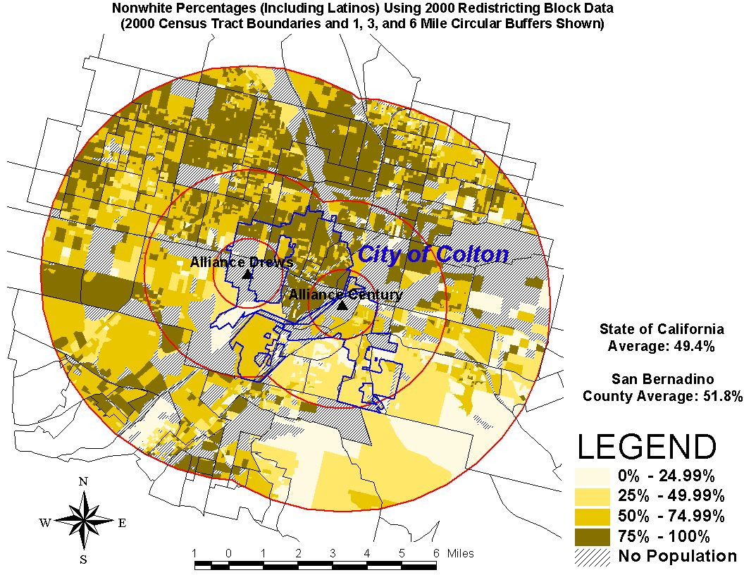

Project Name | %Nonwhite 6 Mile Circle | % Latino 6 Mile Circle | % Low Income 6 Mile Circle | % Under 18 Yrs 6 Mile Circle
Alliance Century | 70.2% | 52.1% | 39.0% | 33.7%
Alliance Drews | 72.2% | 56.6% | 37.7% | 34.9%
Statewide Avg. | 49.4% | 32.4% | 27.4% | 27.2%

Map #2
Calpeak Border, Ramco Chula Vista II, and Wildflower Larkspur Peakers, San Diego

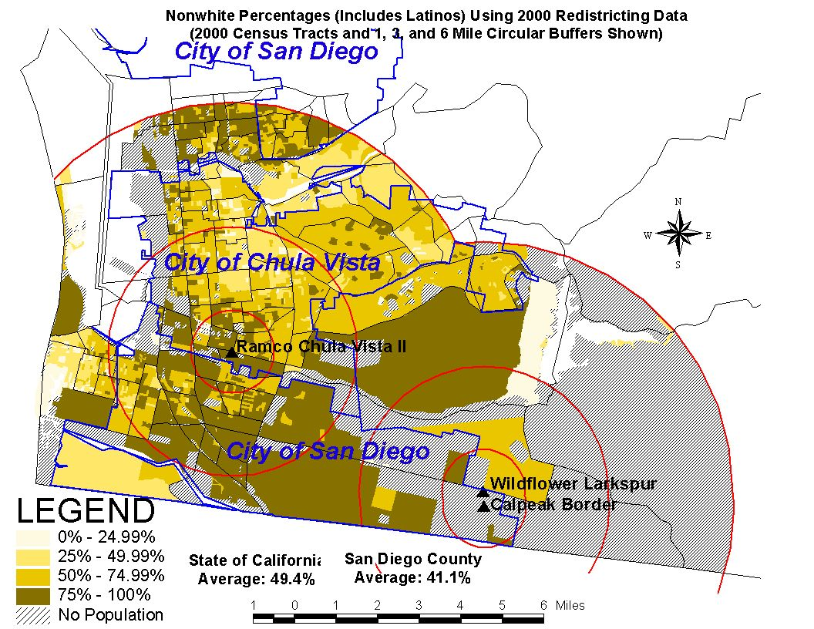

Project Name | %Nonwhite 6 Mile Circle | % Latino 6 Mile Circle | % Low Income 6 Mile Circle | % Under 18 Yrs 6 Mile Circle
Calpeak Border | 71.5% | 46.6% | 25.5% | 30.0%
Ramco Chula Vista II | 68.7% | 54.4% | 32.6% | 31.2%
Wildflower Larkspur | 69.6% | 47.6% | 21.0% | 31.0%
Statewide Average | 49.4% | 32.4% | 27.4% | 27.2%

Map #3
Calpine King City Peaker, King City

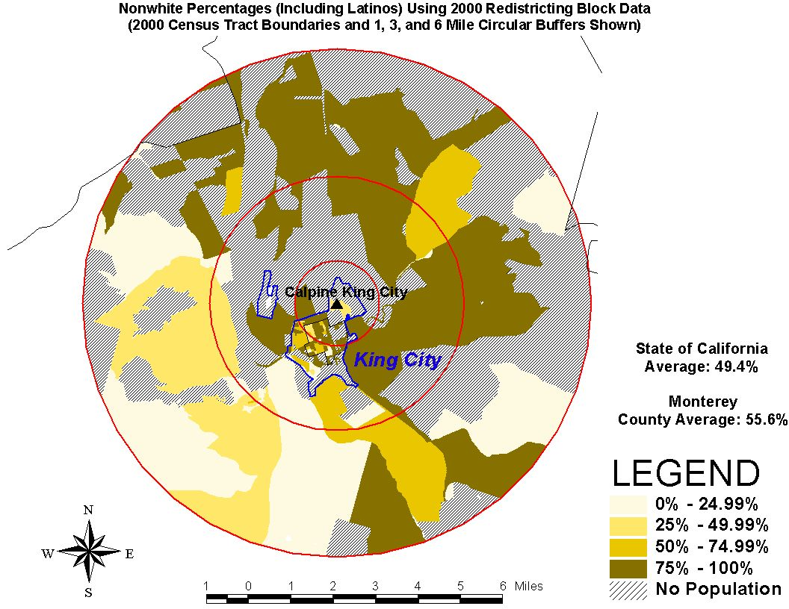

Project Name | % Nonwhite 6 Mile Circle | % Latino 6 Mile Circle | % Low Income 6 Mile Circle | % Under 18 Yrs 6 Mile Circle
Calpine King City | 74.6% | 74.9% | 37.1% | 35.1%
Statewide Average | 49.4% | 32.4% | 27.4% | 27.2%

Map #4
Pegasus Peaker, Chino

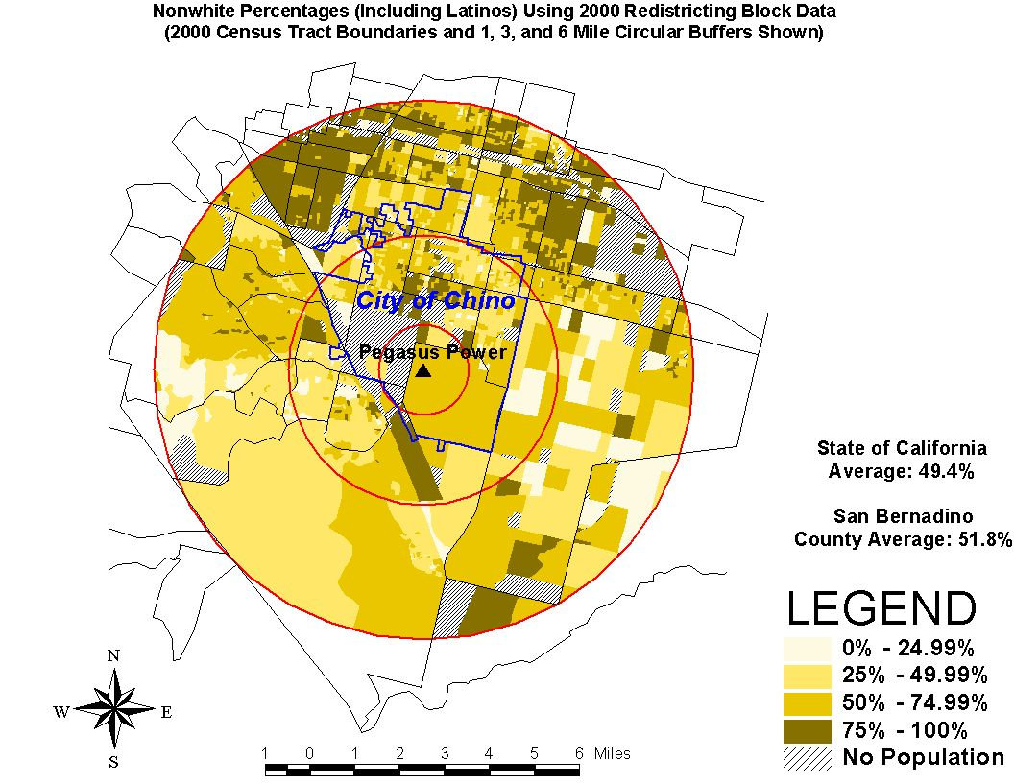

Project Name | %Nonwhite 6 Mile Circle | % Latino 6 Mile Circle | % Low Income 6 Mile Circle | % Under 18 Yrs 6 Mile Circle
Pegasus | 66.7% | 52.9% | 23.7% | 33.3%
Statewide Average | 49.4% | 32.4% | 27.4% | 27.2%

How Many Power Plants Reviewed by the CA Energy Commission Had More Than 50% People of Color Living within a 6-Mile Radius?

Project Name CEC Estimate Power Against the People
% People of Color

- Alliance Drews >50% 70.2%
- Alliance Century >50% 72.2%
- Blythe Peaker 54% N/A
- Calpeak Border >50% 71.5%
- Calpeak Escondido <30% 40.4%
- Calpine Gilroy, Phase I >50% 55%
- Calpine Gilroy, Phase II > 50% N/A
- Calpine King City >50% 74.6%
- CENCO N/A 70.7%
- Contra Costa Unit 8 31% N/A
- Delta Energy 33% N/A
- El Segundo Modernization 58% 56.9%
- Elk Hills 34% N/A
- Golden Gate Phase I 58% 60.5%
- Hanford Energy Park >50% 48.4%
- High Desert 37% N/A
- Huntington Beach >50% N/A
- LaJolla Baldwin Hills 56% 73.3%
- La Paloma 34% N/A
- Lancaster Energy Facility #1 34% 42.6%
- Magnolia N/A 50.2% ( ½ mile)
- Metcalf >50% N/A
- Midway-Sunset 6-10% N/A
- Moss Landing 59% N/A
- Mountain View 57% N/A
- Pastoria 19% N/A
- Pegasus >50% 66.7%
- Pittsburg 50% N/A
- Otay Mesa 58% N/A
- Ramco Chula Vista II >50% 68.7%
- Sunrise Cogeneration 43% N/A
- Sutter 30% N/A
- Three Mountain 5% N/A
- Valero Cogeneration 54% 43.5%
- Wildflower Indigo 0% 63.3% (3 miles)
- Wildflower Larkspur 0% 69.6%

Total Number Over 50% People of Color = 25 of 36 or 69%

Certificate of Services

I hereby certify that I have this day served the foregoing document upon each person designated on the official restricted service list, via electronic mail, compiled by the Secretary in this proceeding in Docket EL00-95 et.al. Rule 2010(f)(3) provides that you may serve pleadings by email. I further certify that those parties without electronic mail have been served this day via US mail.

Dated at this 7th day of December 2001.

Respectfully submitted,
President, CARE
(408) 325-4690
821 Lakeknoll Dr,
Sunnyvale, CA 94089

CAlifornians for Renewable Energy, a non-profit public benefit corporation, which is the only citizen group intervener in these FERC proceedings acting for the exclusive benefit and on behalf of the general public.
Independent Energy Producers Association. IEPA members include those members of an unlawful “trust” identified in Exhibit C of CARE’s original FERC complaint in docket EL01-2. These power suppliers specifically include Duke Energy, CalEnergy, Enron, Calpine, Dynegy, Reliant, and Mirant (formally known as Southern Company). Unless specified otherwise, all further reference to IEPA include its members, acting individually or in concert with others.
The California Parties are the State of California, California Electricity Oversight Board, California Public Utilities Commission, California Department of Water Resources (intervener CARE’s alleged IOU “designated representative” in the purchase of power), and Investor Owned Utilities San Diego Gas and Electric Company and Southern California Edison. Additionally the California Energy Commission is listed for the purposes of this notice of Comment or Protest and is a party to the alleged discrimination in question. Pacific Gas and Electric has continued to act as an independent party in these proceedings.
Peaker power plants are usually employed to produce power during the peak demand period of the day or when there is not enough energy available in the state’s energy system to meet statewide demand. Simple-cycle peaker plants are typically twice as polluting as combined cycle baseload plants, and have been recently permitted to run all year as if they were baseload plants. The pollutants emitted by peaker plants are associated with the inefficient burning of natural gas. Nitrogen oxide (NO_{x}) emissions can be substantial from peaker plants; other pollutants emitted from peakers include carbon monoxide, particulate matter, volatile organic compounds, and sulfur dioxide.
Web addresses for CEC peaker plant siting cases and documents: http://www.energy.ca.gov/sitingcases/peakers/index.html and http://www.energy.ca.gov/sitingcases/index.html
Morello-Frosch, Rachel, et. al. “Environmental Justice and Southern California’s ‘Riskscape’: The Distribution of Air Toxics Exposures and Health Risks among Diverse Communities,” in Urban Affairs Review, Vol. 36, No. 4, March 2001, pps.551-578.
Sadd, James L., et. al. "Every Breath You Take...": The Demographics of Toxic Air Releases in Southern California,” in Economic Development Quarterly, May 1999, pps. 107-123.
Boer, J. T., et. al.. “Is there Environmental Racism? The Demographics of Hazardous Waste in Los Angeles County,” in Social Science Quarterly, Volume 78, Number 4, 1997, pps. 793-810.
“Low-income” is defined as income values that are below the federal poverty level. The 2001 federal poverty level for a family of four within the 48 contiguous states and DC is $17,650.00. SOURCE: Federal Register, Vol. 66, No. 33, February 16, 2001, pp. 10695-10697. See also, http://aspe.hhs.gov/poverty/01poverty.htm
California Code of Regulations, Title 20, Section 2022, (b) (4) (A, B and C).
“[g]eocode - A code associated with a spatial element which describes its location. An example would be a coordinate such as longitude or latitude.” Source: http://dynamo.ecn.purdue.edu/~biehl/SiteFarming/glossary.html
URL for 2000 tract and block boundaries (for Arc View): http://www.proximityone.com/06.maps.htm
Plant ID numbers: 2, 3, 4, 6, 9, 17 and 18 (Alliance Drews, Calpeak Border, Calpeak Escondido, Calpine King, Golden Gate Phase 1, Wildflower Indigo, and Wildflower Larkspur, respectively).
GIS – “System of computer hardware, software, and procedures designed to support the compiling, storing, retrieving, analyzing and displaying of spatially referenced data for addressing planning and management problems.” Source: http://dynamo.ecn.purdue.edu/~biehl/SiteFarming/glossary.html
URL for ESRI Web site: http://www.esri.com/data/online/index.html
URL for 2000 Block Group Estimats, from Geolytics: http://www.geolytics.com
URL for the Census Bureau: http://www.census.gov/clo/www/redistricting.html
URL for further documentation on the Block Group Estimates from claritas.com: http://www.connect.claritas.com/learnmore/demographic.htm
For more information on this projection method, see: http://gmt.soest.hawaii.edu/gmt/doc/html/GMT_Docs/node43.html and http://www.giconnections.vic.gov.au/content/docs/vicgrid/vic14.htm
Spatial geo-referencing refers to “[A] coordinate system keeping track of specific points on the Earth’s surface. Examples of such a system are the Universal Transverse Mercator system (UTM) and the State Plane Coordinate System. Source: http://dynamo.ecn.purdue.edu/~biehl/SiteFarming/glossary.html

