CAlifornians for Renewable Energy, Inc. (CARE)
821 Lakeknoll Dr.
Sunnyvale, CA 94089
(408) 325-4690
To: Governor Gray Davis
From: Michael E. Boyd –President, CARE
Ref: California Producer Contrived Energy Crises and How to Keep the Lights on this Summer

Dear Governor Davis,

As you know CARE’s program is to provide assistance to low-income and minority communities disparately impacted by the development of gas-fired combined cycle turbine generators. The current technology fossil fuel power plants being permitted in Northern California as well as Southern California are California’s largest point sources for NOx, CO, and particulate matter. These plants use massive quantities of water, with a Metcalf size project using up 3500 acre-feet annually. In low-income and minority agricultural communities like Sutter and Blythe this threatens not only continuing agriculture uses, but also farm laborer jobs. CARE has been active in California power plant siting. The January 28. 20001 Sacramento Bee article titled All kinds have foiled new plants demonstrates CARE’s involvement where it states,

“The Bee's review suggests two groups tend to raise objections more than others.

One is Californians for Renewable Energy, run by Mike Boyd, a Sunnyvale activist who dogs nearly every power project. “

CARE with its limited budget is doing the best we can to protect the civil rights of the people least able to protect them selves as well as the environment from the effects of power plant siting. CARE is obviously no friend of the Independent Energy Producers in the state.

CARE with its limited budget has also tried to do what it can to protect low-income people of the bay area from the power cartel that threatens to destroy California’s economy if not the entire nation’s and the world’s. In an article published Tuesday, October 3, 2000, in the San Jose Mercury News titled State helped cause blackouts in June, consumer group claims it states,

“A Sunnyvale consumer group accused state energy officials Monday of helping cause the June 14 blackouts in the Bay Area to justify new power plant construction and ``drive up the price of electricity'' at the behest of power generating companies.

Mike Boyd, president of the non-profit group, said he can't prove that electricity was shipped out of state because California officials have refused to give his organization the data it needs to make that assessment.

Nonetheless, he said, government data his group has obtained indicates that 3,675 megawatts -- enough for about 3.7 million homes -- was scheduled to be shipped to Oregon on June 14. He criticized state officials for failing to declare a Stage 3 statewide emergency on that day because such a declaration would have given those officials authority to halt the transfer of that electricity, he said.

``Basically, they did some things wrong when they turned off the power,'' Boyd said. ``I think they have to be held accountable.''

The group accused the Independent System Operator, which oversees the state power grid, and the Power Exchange, which runs an electricity auction house, of having ``contrived the June 14, 2000, rolling outage'' to ``maximize generator profits.'' The complaint seeks a federal investigation of the blackout and asks the commission to ensure that consumers are refunded for any expenses they incurred as a result of the incident. “

Once again CARE has created a substantial administrative record, which is the prerequisite to a legal challenge. Once CARE has exhausted its administrative remedies with the FERC, we would like to pursue litigation on this matter. I have come to your office twice asking for help with no response. Things are continuing to spin out of control therefore we need your leadership to protect our communities, state, and nation from a threat to our economy, environment, and way of life.

This is a very difficult thing for me to say, but we must make tough decisions now, before it is too late to save the state’s economy. I know you share my strong feelings about what the independent energy producers are doing. In its December 15, 2000 FERC ordered the $150 “soft price cap” which was established on the basis that this was the “marginal” cost of production for older fossil fuel power plants in California. California energy producers are continuing with hold production to increase the price they receive for power with between 10,000 MW and 15,000 MW being with held daily. You must take immediate action to stop this power (lock-out) before the summer arrives.

What I am proposing I call this my “carrot and stick” approach to the problem. I provide some graphics to demonstrate my idea. Please bare with me on this, and don’t get mad at me for telling the truth (even though I don’t like it any better than you).

Figure 1 shows California Independent Energy Producers chasing the “Carrot” twenty cents per kilowatt-hour price. This provides producers the incentive they need (profit) to continue producing power and not with hold it. Any rate below roughly sixteen cents a kilowatt-hour does not provide sufficient incentive for producers to run their older power plants, as they need at least fifteen cents a kilowatt-hour to break even. This “marginal cost” is based on the FERC’s December 15, 2000 Order. As you know I have
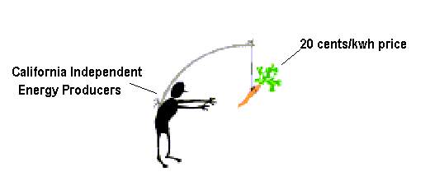
Figure 1 The $0.20/kwh provides producers an incentive to sell their power ~5 cents over cost
the gift (curse) of foresight. If you do not approve at least a 20 cents/kwh rate we will be paying 75 cents/kwh this summer, and we still will have rolling blackouts. I know this rate increase will drastically impact low-income consumers throughout California. You must structure the rate plan to protect these consumers. Unfortunately it doesn’t look like rates will be able to drop below 15 cents/kwh for several years.

The producers need to be punished for their continuing to with hold power, this is where my “stick” comes into play. The Cal-ISO needs to adopt a tariff which charges a

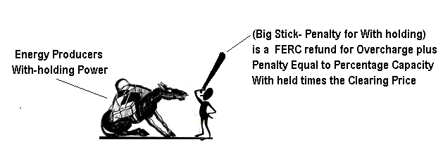
Figure 2 Penalty for with holding power

penalty to energy producers who with hold power to drive the price up. My proposal is to assess a penalty in the form of additional refunds from producers, in additions to those FERC has authority to order under the Federal Power Act. Basically the penalty is the percentage of generating capacity with held times the market-clearing price of the power sold. This means if a producer sells power at $750/MWh with a marginal cost and opportunity cost of $500, under the current FERC refund process a $250/MWh refund would be order. If this producer with held 10% of their production capacity the penalty refund (additional) would be $75/MWh, or the total refunds ordered would be $250/MWh + $75/MWh or $325/MWh. This type of pricing penalty does two things. One it provides an incentive for producers not to bid their prices to high above cost. Second it provides an incentive (loss of profit) to not with hold generating capacity.

This is my idea – please consider this – and know, I really hate to always bring you bad news,

Respectfully submitted,
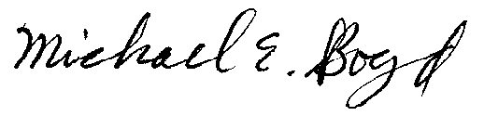
Michael E. Boyd, President 3-26-01

