UNITED STATES OF AMERICA
FEDERAL ENERGY REGULATORY COMMISSION

San Diego Gas & Electric Company, Docket No. EL00-95-031
EL00-95-045

Complainant

v.

Sellers of Energy and Ancillary Service Into
Markets Operated by the California Independent
System Operator Corporation and the California
Power Exchange,
Respondents

Investigation of Practices of the California Docket Nos. EL00-98-030
Independent System Operator and the California EL00-98-033
Power Exchange EL00-98-042

California Independent System Operator Docket Nos. RT01-85-000
Corporation RT01-85-001

Investigation of Wholesale Rates of Public Utility Docket Nos. EL01-68-000
Sellers of Energy and Ancillary Services in the EL01-68-001
Western Systems Coordinating Council

CAlifornians for Renewable Energy, Inc. Docket No. EL01-2-000
(CARE)
Complainant

v.

Independent Energy Producers, Inc. and All Sellers
of Energy and Ancillary Services into the Energy
and Ancillary Services Markets Operated by the
California Independent System Operator Corporation
and the California Power Exchange; All Scheduling
Coordinators Acting on behalf of the Above Sellers;
California Independent System Operator Corporation;
and California Power Exchange Corporation

Respondents

AUGUST 7, 2001 PROTECTIVE ORDER & NON-DISCLOSURE CERTIFICATE

The Honorable David P. Boergers
Secretary
Federal Energy Regulatory Commission
888 First Street, N.E.
Washington, D.C. 20426

Dear Mr. Boergers:

Pursuant to the Protective Order adopted August 7, 2001 by the Chief Judge in this proceeding, please find enclosed copies of the Non-Disclosure Certificate submitted by the following representative of CAlifornians for Renewable Energy, Inc. (CARE).

Michael Boyd
President of the Board of Directors (CARE)
821 Lakeknoll Drive
Sunnyvale, CA 94089
Phone: (408) 325-4690
Fax: (408) 325-2262 (must call first)

It is the public policy that public agencies exist to aid in the conduct of the people's business and that the proceedings of public agencies be conducted openly so that the public may remain informed. It is the intent of the law that actions of public agencies be taken openly and that their deliberation be conducted openly. The people do not yield their sovereignty to those agencies that serve them. The people, in delegating authority, do not give their public servants the right to decide what is good for the people to know and what is not good for them to know. The people insist on remaining informed so that they may retain control over the instruments they have created.

In filling out the attached non-disclosure certificate I was informed that this form was necessary to obtain information (Protected Materials) from you. I do so with the clear understanding that in doing so I do not waive any rights and privileges to full disclosure of and compliance with the law, for myself, CARE, its members, and other members of the public.

Respectfully submitted,
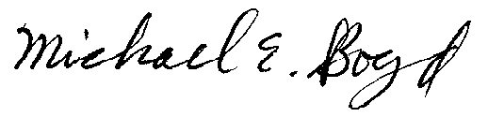
Michael E. Boyd 8-28-01

President, CARE
821 Lakeknoll Dr.
Sunnyvale, CA 94089
(408) 325-4690

UNITED STATES OF AMERICA
FEDERAL ENERGY REGULATORY COMMISSION

San Diego Gas & Electric Company, Docket No. EL00-95-031
EL00-95-045

Complainant

v.

Sellers of Energy and Ancillary Service Into
Markets Operated by the California Independent
System Operator Corporation and the California
Power Exchange,
Respondents

Investigation of Practices of the California Docket Nos. EL00-98-030
Independent System Operator and the California EL00-98-033
Power Exchange EL00-98-042

NON-DISCLOSURE CERTIFICATE

I hereby certify my understanding that access to Protected Materials is provided to me pursuant to the terms and restrictions of the Protective Order in this proceeding, that I have been given a copy of and have read the Protective Order, and that I agree to be bound by it. I understand that the contents of the Protected Materials, any notes or other memoranda, or any other form of information that copies or discloses Protected Materials shall not be disclosed to anyone other than in accordance with that Protective Order. I acknowledge that a violation of this certificate constitutes a violation of an order of the Federal Energy Regulatory Commission.

By: _______________________
Title: President of the Board ___
Representing:_(CARE)________
Date:____8/28/01____________

PETITION FOR INTERVENTION WITH FINANCIAL HARDSHIP AND REQUEST FOR COMPENSATION FOR PARTICIPATION EXPENSES

In behalf of CARE, Michael Boyd, hereby petitions to be excused from

☑ Filing 14 Copies with the Commission Docket Unit.

☑ Serving its papers on all other parties of record.

Petitioner, Michael E. Boyd representing, CAlifornians for Renewable Energy, Inc
(CARE) states:

1. Petitioner, Michael E. Boyd, in behalf of, CARE, has petitioned and been accepted by FERC Order on August 13, 2001 to intervene in the above-entitled proceeding.

2. The Commission may, under rules promulgated by it, provide compensation for reasonable attorney's fees, expert witness fees, and other costs of intervening or participating in any proceeding before the Commission to any person whose intervention or participation substantially contributed to the approval, in whole or in part, of a position advocated by such person. Such compensation may be paid only if the Commission has determined that (16 USC Sec. 825q-1)

(A) the proceeding is significant, and

(B) such person's intervention or participation in such proceeding without receipt of compensation constitutes a significant financial hardship to him.

3. CARE simply does not have the resources to obtain legal counsel or other expert assistance, to fully, fairly, knowledgeably and meaningfully participate in your statutorily mandated administrative process. Therefore, CARE respectfully requests that your agency provide us with all available compensation or other assistance to facilitate our public participation, including but not limited to an explanation of the administrative steps we must take in order to preserve and protect all our legal rights, particularly the right to have the issues we raise heard by a court of law in a legal proceeding to enforce our statutory and constitutional rights.

4. Petitioner has an interest in the proceeding in that he represents a not for profit organization, CARE, established to insure that new renewable energy supplies are developed in preference to non-renewable energy supplies. Additionally this organization is established in order to protect the residents of the state of California from adverse environmental and socioeconomic impacts associated with new non-renewable energy sources.

5. CARE is seeking leave by this Commission to file its documents via the FERC’s E-filing system as it has done with its comments to the above-cited FERC dockets in this case.

6. Petitioner ☑ does □ does not wish to reserve the right to present evidence and cross-examine witnesses.

7. Michael E. Boyd will represent petitioner at this time with supplemental representative legal counsel and expert witnesses to be provided upon issuance of Commission’s leave for compensation of such.

Respectfully submitted,
Michael E. Boyd 8-28-01

President, CARE
821 Lakeknoll Dr.
Sunnyvale, CA 94089
(408) 325-4690

MOTION SEEKING ORDER OR STAY CANCELING OR SUSPENDING CALIFORNIA DEPARTMENT OF WATER RESOURCES LONG-TERM ENERGY CONTRACTS AND ASSOCIATED IOU RATE SCHEDULES FOR LACK OF PROPER NOTICE UNDER THE FPA

Pursuant to Rules 212 of the Rules and Practices and Procedures of the Federal Energy Regulatory Commission (“FERC”), 18 C.F.R. 385.212, CAlifornians for Renewable Energy, Inc. (“CARE”), moves for the Commission’s consideration and action to remedy the illegal execution of long-term energy contracts by the California Department of Water Resources (“DWR”) in regards to the CARE and other party’s complaints in EL00-95 et.al. Under section 205(c) of the Federal Power Act (49 Stat. 851; 16 U.S.C. 824d(c)) the DWR long-term energy contracts recently disclosed through legal action by the California legislature and press requires that these contracts “shall be tendered for filing with the Commission and posted not less than sixty days nor more than one hundred-twenty days prior to the date on which the electric service is to commence.” We contend that DWR has failed to comply with the requirements of the FPA in this matter. The remedy CARE seeks is for the Commission to issue an Order or Stay canceling or suspending such long-term energy contracts and associated IOU rate schedules (yet to be submitted to the Commission) pursuant to FPA section 205 (c).

DWR disputes its requirements to provide proper notice prior to execution of said long-term contracts to all the parties to this case and to the public who have in a statutory and constitutional right to comment on expenditures of the public’s funds in this manner by DWR. In response to CARE’s CPRA request DWR states the “Department’s purchases and sales of power are exempt from the Federal Power Act because DWR is a state agency. Section 201(f). To the extent that the Department engages in purchases or sales with counterparties who are subject to Federal Power Act jurisdiction, any obligation to file with FERC or otherwise comply with the Act lies with the counterparty to the contract, and not the department.”

CARE contends that DWR is acting as an “designated representative” for the Investor Owned Utilities (“IOUs”) in the purchase of energy in California, pursuant to 18 CFR 35.1 (a), without authorization by the Commission.

“In cases where two or more public utilities are required to file rate schedules or certificates of concurrence such public utilities may authorize a designated representative to file upon behalf of all parties if upon written request such parties have been granted Commission authorization therefore.”

CARE contends these actions by DWR violated the requirements of 18 CFR 35.1 (4)(e).

“No public utility shall, directly or indirectly, demand, charge, collect or receive any rate, charge or compensation for or in connection with electric service subject to the jurisdiction of the Commission, or impose any classification, practice, rule, regulation or contract with respect thereto, which is different from that provided in a rate schedule required to be on file with this Commission unless otherwise specifically provided by order of the Commission for good cause shown.”

CARE contends that ample evidence of DWR’s acting as the California IOU’s “designated representative” is provided by DWR’s request to the California Public Utilities Commission (“PUC”) for a Revised Revenue Requirement and Power Purchase Costs Pursuant to Water Code Section 80110 and Public Utilities Code Section 451 , which is further illustrated by the PUC’s Administrative law Judge’s Ruling on the August 7, 2001 Revenue Requirement of the DWR regarding the IOU S.D.G. & E. applications 01-01-044, and 01-01-0045 to the PUC , which states:

“SDG&E shall present alternative calculations of the required system average rate increases that (1) collect the DWR-related rate increases over the remaining 5 quarters of the revenue requirement period set forth in Table A-6 (i.e., the fourth quarter of 2001 and the four quarters of 2002), (2) collect the DWR–related rate increases over the next 8 quarters (i.e., the fourth quarter of 2001, the four quarters of 2002, and the first three quarters of 2003), and (3) collect the DWR–related rate increases over the period from September 1, 2001 through December 31, 2002.”

Clearly it is the intent of the DWR to act as the IOU’s “designated representative” to seek approval from the PUC “to collect the DWR-related rate increases”.

CARE reiterates, it is the public policy that public agencies exist to aid in the conduct of the people's business and that the proceedings of public agencies be conducted openly so that the public may remain informed. It is the intent of the law that actions of public agencies be taken openly and that their deliberation be conducted openly. The people do not yield their sovereignty to those agencies that serve them. The people, in delegating authority, do not give their public servants the right to decide what is good for the people to know and what is not good for them to know. The people insist on remaining informed so that they may retain control over the instruments they have created. DWR has breached its public duties by failing to provide for myself, CARE, its members, and other members of the public, our statutory and constitutional right to comment or protest these long-term energy contracts executed by DWR, the associated expenditures of the public’s funds, and associated rate increases to California energy consumers.

In conclusion the Remedy CARE seeks is for the Commission to issue an Order or Stay canceling or suspending such long-term energy contracts and associated IOU rate schedules (yet to be submitted to the Commission) pursuant to FPA section 205 (c), or under what ever statutory authority as you deem appropriate.

Respectfully submitted,
Michael E. Boyd President, CARE 8-28-01
Exhibit A
CAlifornians for Renewable Energy, Inc. (CARE)
821 Lakeknoll Dr.
Sunnyvale, CA 94089
(408) 325-4690
Oscar Hidalgo, ohidalgo@water.ca.gov
Public Information Officer, CERS Division,
California Department of Water Resources
3310 El Camino Ave, Suite 120
Sacramento, CA 95821

Dear Oscar,
We hereby submit this written request under the California Public Records Act to allow us to review and copy each and every document in your possession regarding notice to the Federal Energy Regulatory Commission (FERC) of “all contracts which in any manner affect or relate to such rates, charges, classifications, services, rules, regulations or practices, as required by section 205(c) of the Federal Power Act (49 Stat. 851; 16 U.S.C. 824d(c)).” Under the FPA the DWR long-term energy contracts recently disclosed through legal action by the legislature and press requires that these contracts “shall be tendered for filing with the Commission [FERC] and posted not less than sixty days nor more than one hundred-twenty days prior to the date on which the electric service is to commence.” We contend that DWR has failed to comply with the requirements of the FPA in this matter, and therefore your failure to respond to this request shall be interpreted as an admission that no documentary evidence of compliance with the FPA exists. Recognizing the uniqueness of the forum, we are willing to work with you in facilitating the location and production of the requested materials as required.
PLEASE TAKE NOTICE OF THE FOLLOWING LEGAL AUTHORITY ON WHICH CSPP IS RELYING AND WILL RELY REGARDING THE CPRA:
- The CPRA requires a determination by an agency receiving a written request, with notice to the CPRA requestor of the determination, within 10 days of the request. (Gov. Code sec. 6253(a).)
- The CPRA defines the public record as "any writing containing information relating to the conduct of the public’s business prepared, owned, used or retained by any state or local agency regardless of physical form or characteristics." (Gov. Code sec. 6252(d).)
- A CPRA request may not be limited or ignored even when discovery is available to obtain the requested public records, regardless of the requestor’s purpose for seeking the information requested.
- In enacting the CPRA, the California Legislature has expressly stated that "access to information concerning the conduct of the people’s business is a fundamental and necessary right of every person in this state." (Gov. Code sec. 6250.) And the California Supreme Court has held that the explicit purpose of the CPRA is to increase freedom of information by giving the public access in possession of public agencies, which requires a narrow construction of the CPRA exemptions with the burden on the agency to prove those exemptions exist in a particular case. (Fairley v. Superior Court (1998) 66 Cal.App.4th 1414, 1419-20; see also Times Mirror Co v. Superior Court (1991) 53 Cal.3d 1325.)

President-CARE 6-22-01

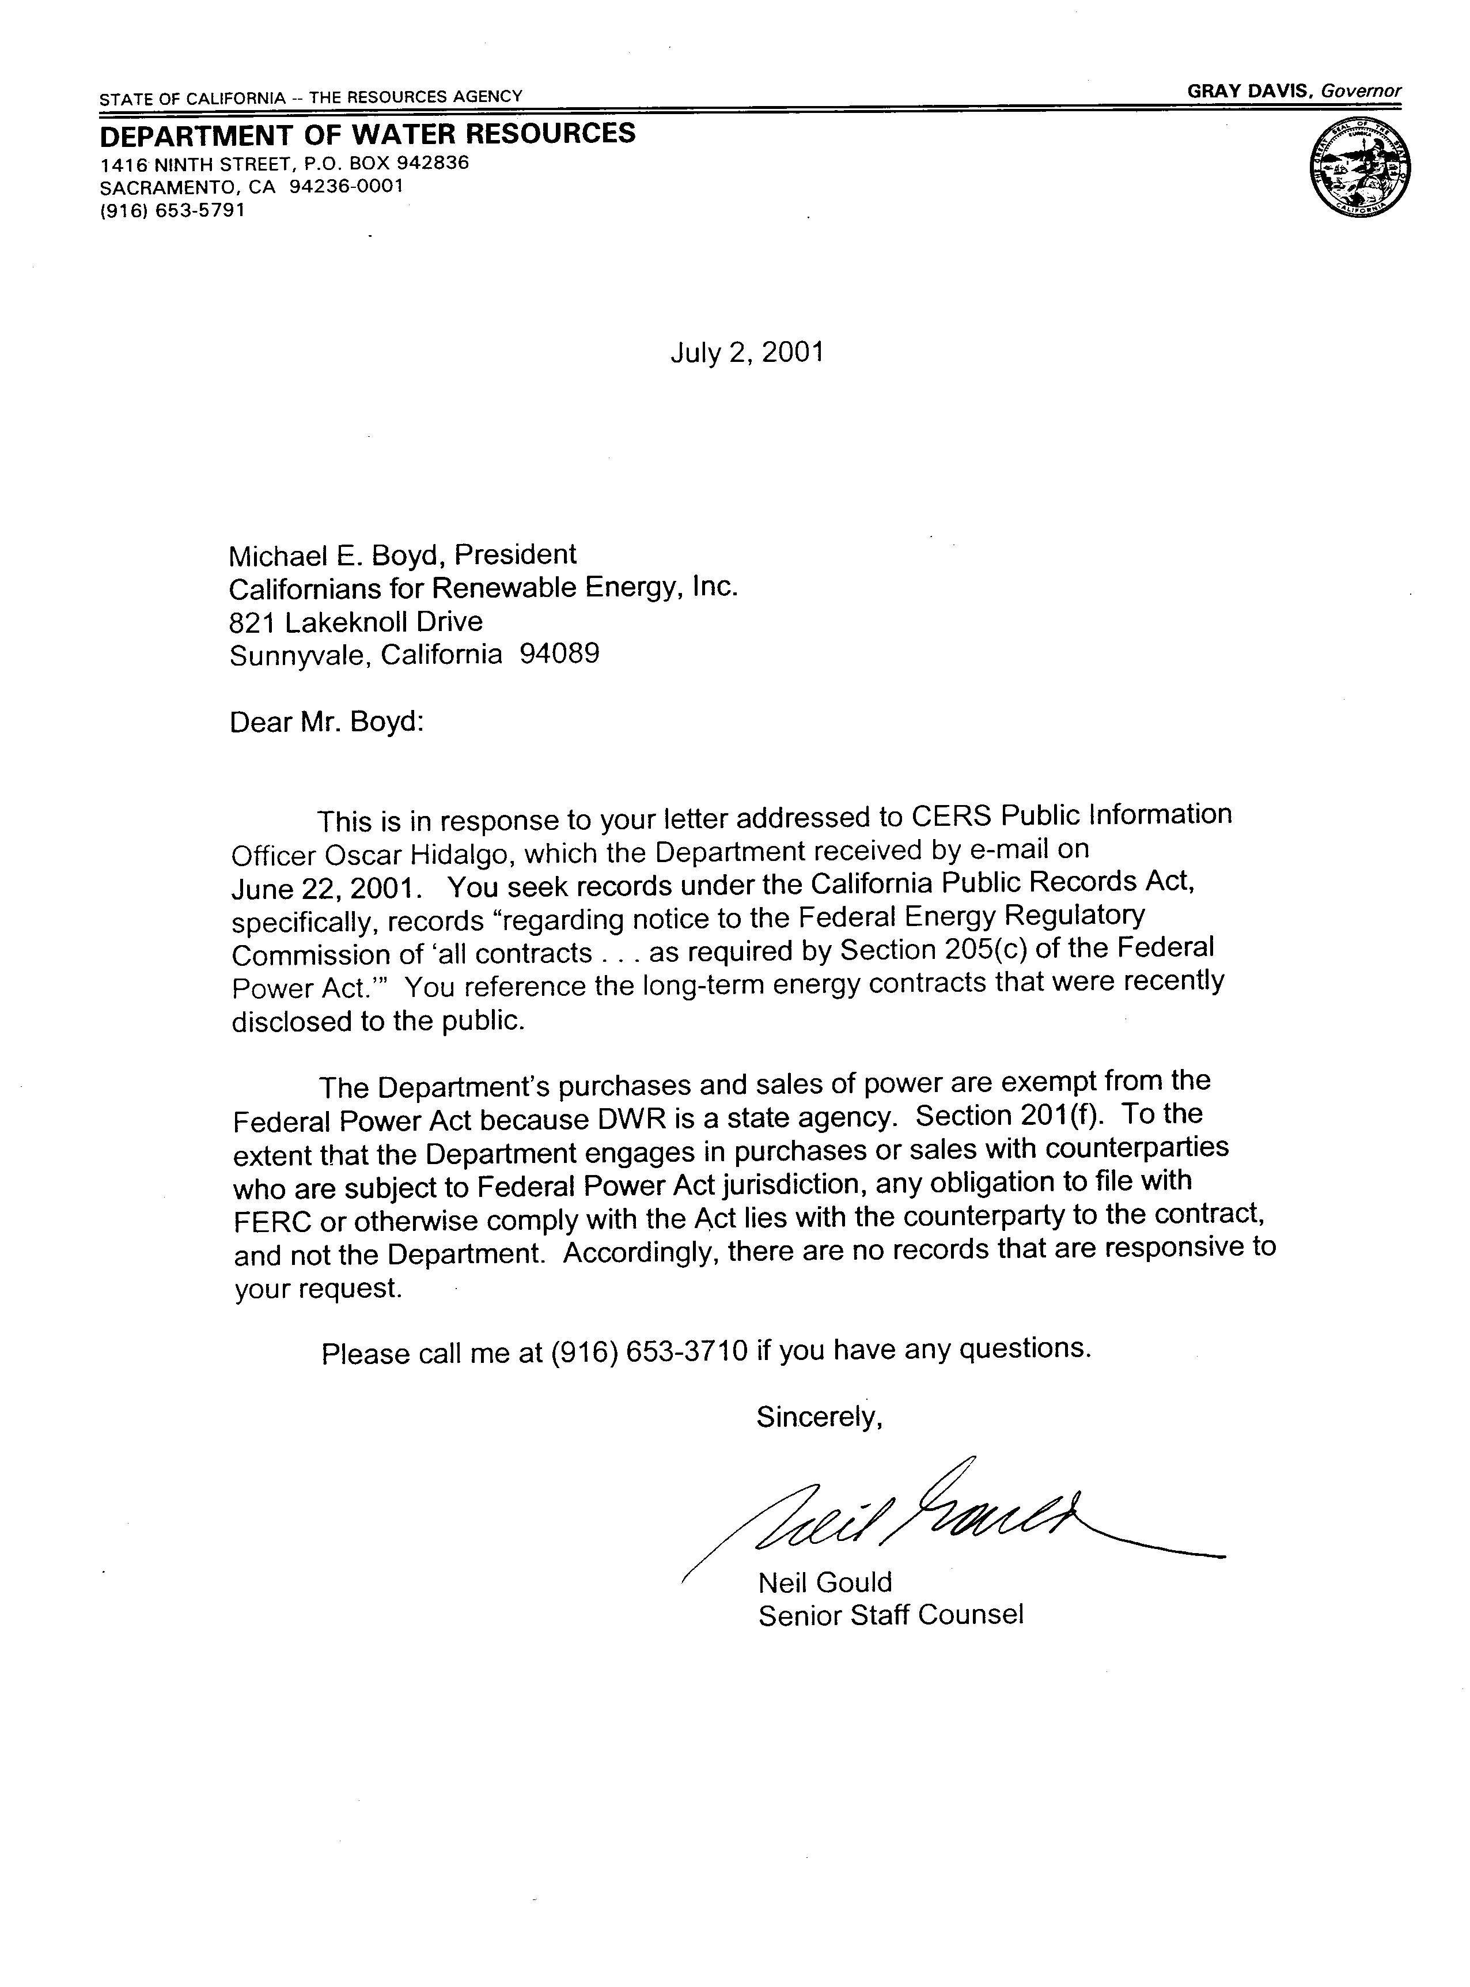
Exhibit B

Exhibit C

M e m o r a n d u m

Date: August 7, 2001

To: The Honorable Geoffrey Brown, Commissioner
California Public Utilities Commission

From: Thomas M. Hannigan
Department of Water Resources

Subject: Revised Revenue Requirement and Power Purchase Costs Pursuant to Water Code Section 80110 and Public Utilities Code Section 451

This letter is submitted by the California Department of Water Resources (DWR) and updates DWR’s July 23, 2001 Revenue Requirement submitted to the California Public Utilities Commission (PUC).

Background

On July 23, 2001, DWR submitted its Revenue Requirement to the PUC in accordance with Division 27 of the California Water Code. On July 24, 2001, the PUC issued a Ruling requesting clarifying comments, and DWR provided additional information to the PUC on July 26, 2001. DWR also participated in the PUC’s July 27 technical workshop to clarify the derivation of DWR’s Revenue Requirement.

During the comment period after the technical workshop, DWR received written questions and comments from the investor-owned utilities (IOUs) and other parties who participated in the PUC’s workshops. DWR addressed these questions and concerns in an August 1, 2001 letter to Paul Clanon of the PUC’s Energy Division.

Adjustments to the Revenue Requirement Based on Comments Received

On August 3, DWR received copies of additional comments from several parties. DWR’s Response to August 3 Party Comments is being forwarded to the PUC as a separate filing. In the course of reviewing comments received during the comment period, DWR has become aware of additional data that warrants some adjustments to the Revenue Requirement. Based on information and comments received to date, the following adjustments are incorporated in the modified projection, included as Exhibit A:

- Minor modifications to load assumptions;
- Modifications to quantities of bilateral contracts held by Pacific Gas & Electric Company (PG&E) and San Diego Gas and Electric Company (SDG&E) that will impact the amount of net short expected to be purchased by DWR (decrease net short for customers in the SDG&E service area and increase net short for customers in the PG&E service area);
- Modifications to the level of Qualifying Facility (QF) contract output for SDG&E;
- Modification of total estimated costs of QF output for Southern California Edison Company (SCE), which in turn will affect the allowance for costs of ancillary services (since ancillary services are estimated as a percentage of net short purchases and the costs of utility retained generation);
- Improved data on historical net short cost reconciliations; and
- Cash receipt reconciliations.

The cumulative result of these modifications has been to lower the share of the net short energy requirements for SDG&E customers and to an extent for SCE customers, and increase the net short energy requirements for the PG&E customers. With these net short energy cost projection changes, the Revenue Requirement for the customers of all three IOUs can be allocated on a uniform cost per kWh basis, and the proceeds of bonds can be allocated in proportion to the net short volumes for the customers of each IOU. This uniform allocation of costs and pro-rata allocation of bond proceeds results in revenue requirements for the customers of all three IOUs that can be accommodated within the three cents per kWh rate increase granted by the PUC for SCE and PG&E and the 2.99 cents per kWh increase for SDG&E presently pending before the Commission.

Exhibits

The following items are included as Exhibits to this filing:

- Exhibit A, the updated DWR Revenue Requirement which revises the July 23, 2001 Revenue Requirement submission. This exhibit provides the total DWR Revenue Requirement, as well as a proposed allocation of that revenue requirement, by utility as described in more detail in Exhibit A of the July 23 filing;
- Exhibit B, DWR’s conservation and load management revenue requirement summary; and
- Exhibit C, a description and breakdown of the DWR Revenue Requirement in accordance with the fourteen cost categories specified in the proposed Rate Agreement between the Department and the Commission, which will be filed with the Commission under separate cover;.

MSW/t93 8/15/2001 Exhibit D

BEFORE THE PUBLIC UTILITIES COMMISSION OF THE STATE OF CALIFORNIA

Application of San Diego Gas & Electric Company (U 902-E) for an Order Implementing Assembly Bill 265. | Application 00-10-045  (Filed October 24, 2000)
Application of San Diego Gas & Electric Company (U 902-E) for Authority to Implement an Electric Rate Surcharge to Manage the Balance in the Energy Rate Ceiling Revenue Shortfall Account. | Application 01-01-044  (Filed January 24, 2001)

ADMINISTRATIVE LAW JUDGE’S RULING ON THE AUGUST 7, 2001 REVENUE REQUIREMENT OF THE DEPARTMENT OF WATER RESOURCES

San Diego Gas & Electric Company (SDG&E) is hereby directed to produce updated estimates, including supporting analyses, of the system average electric rate increases required based on the revised revenue requirements determined by the Department of Water Resources’ (DWR), as set forth in the August 7, 2001 DWR communication to this Commission. SDG&E shall serve its estimates of the required increases by electronic means not later than August 16, 2001. In so doing, SDG&E shall observe the following:
- SDG&E shall use the relevant data that is set forth in Exhibit A, Table A-6, of DWR’s August 7, 2001 communication.

- SDG&E shall present alternative calculations of the required system average rate increases using (1) the format of Exhibit 14 (which is based on SDG&E’s position with respect to the allocation of utility-retained generation (URG) to “small” customers) and (2) the format of Exhibit 18 (which is based on the position of certain other parties with respect to the URG allocation).

- For both the Exhibit 14 format and the Exhibit 18 format, SDG&E shall present alternative calculations of the required system average rate increases that (1) collect the DWR-related rate increases over the remaining 5 quarters of the revenue requirement period set forth in Table A-6 (i.e., the fourth quarter of 2001 and the four quarters of 2002), (2) collect the DWR–related rate increases over the next 8 quarters (i.e., the fourth quarter of 2001, the four quarters of 2002, and the first three quarters of 2003), and (3) collect the DWR–related rate increases over the period from September 1, 2001 through December 31, 2002.

- SDG&E shall revise the assumed ISO charges set forth in Exhibits 14 and 18 to reflect the revised time period of the DWR revenue requirement (relative to the time period associated with the May 2, 2001 DWR revenue requirement calculation that is reflected in Exhibits 14 and 18) and to be consistent with the DWR calculations regarding ancillary services.

- SDG&E shall revise the assumed URG revenue requirements set forth in Exhibits 14 and 18 to reflect the revised time period of the DWR revenue requirement (relative to the time period associated with the May 2, 2001 DWR revenue requirement calculation that is reflected in Exhibits 14 and 18) and as may be necessary to be consistent with the URG testimony SDG&E has introduced in A.00-11-038, et al.

At a minimum, SDG&E shall produce calculations of required system average rate increases as set forth above. SDG&E shall also provide the analyses supporting its estimates, set forth in its comments dated August 14, 2001, that depending on certain assumptions, system average increases of 2.84 cents per kWh or 3.80 cents per kWh may be required. At its discretion, SDG&E may also produce any alternative rate increase calculation it believes to be necessary and appropriate for collection of the updated DWR revenue requirement. In the absence of objections, the August 7, 2001 memorandum from DWR to Commissioner Geoffrey Brown and SDG&E’s calculations provided in response to this ruling will be received in evidence. Any objections shall be raised by electronic or telephonic communication to Administrative Law Judge Wetzell not later than August 17, 2001.
IT IS SO RULED
Dated August 15, 2001, at San Francisco, California.

/s/MARK S. WETZELL
Mark S. Wetzell
Administrative Law Judge

CERTIFICATE OF SERVICE

I certify that I have by mail, and by electronic mail, to the parties to which an electronic mail address has been provided, this day served a true copy of the original attached Administrative Law Judge’s Ruling on the August 7, 2001 Revenue Requirement of the Department of Water Resources on all parties of record in this proceeding or their attorneys of record.
Dated August 15, 2001, at San Francisco, California.

/s/ MAUREEN S. LITTLE
Maureen S. Little

CARE contention was originally raised in a 6-22-01 letter to DWR requesting information under the California Public Records Act (“CPRA”) on “all contracts which in any manner affect or relate to such rates, charges, classifications, services, rules, regulations or practices, as required by section 205(c) of the Federal Power Act” (see Exhibit A).
DWR’s 7-2-01 response to CARE’s CPRA request (see Exhibit B).
DWR’s Revised Revenue Requirement and Power Purchase Costs Pursuant to Water Code Section 80110 and Public Utilities Code Section 451 issued August 7, 2001 (see Exhibit C)
ADMINISTRATIVE LAW JUDGE’S RULING ON THE AUGUST 7, 2001 REVENUE REQUIREMENT OF THE DEPARTMENT OF WATER RESOURCES (see Exhibit D).
See August 7, 2001 Memorandum from Thomas M. Hannigan, Department of Water Resources, to Commissioner Geoffrey Brown, including Exhibits A, B, and C thereto.
Since Table A-6 has only quarterly information, SDG&E should estimate September 2001 revenue requirements and sales and explain how it made that estimate.

