UNITED STATES OF AMERICA
FEDERAL ENERGY REGULATORY COMMISSION

San Diego Gas & Electric Company, Docket No. EL00-95-031
EL00-95-045

Complainant

v.

Sellers of Energy and Ancillary Service Into
Markets Operated by the California Independent
System Operator Corporation and the California
Power Exchange,
Respondents

Investigation of Practices of the California Docket Nos. EL00-98-030
Independent System Operator and the California EL00-98-033
Power Exchange EL00-98-042

California Independent System Operator Docket Nos. RT01-85-000
Corporation RT01-85-001

Investigation of Wholesale Rates of Public Utility Docket Nos. EL01-68-000
Sellers of Energy and Ancillary Services in the EL01-68-001
Western Systems Coordinating Council

CAlifornians for Renewable Energy, Inc. Docket No. EL01-2-000
(CARE)
Complainant

v.

Independent Energy Producers, Inc. and All Sellers
of Energy and Ancillary Services into the Energy
and Ancillary Services Markets Operated by the
California Independent System Operator Corporation
and the California Power Exchange; All Scheduling
Coordinators Acting on behalf of the Above Sellers;
California Independent System Operator Corporation;
and California Power Exchange Corporation

Respondents

Condolences and prayers in behalf of myself, CARE, and our membership go out to all the families and loved ones in New York, Washington DC, and around the world who have had to sacrifice so much for the liberty our great nation offers as a beacon to the rest of the world. It is unfortunate the terrorist forces of evil must take advantage of this very liberty, freedom, and very openness to worldwide commerce, to attack us. Here in Silicon Valley we too have lost loved ones, many who are among those heroes on United Flight 93, who sacrificed their lives to preserve our liberty. Many would agree they all deserve post-humus metals of honor for what they have done in our behalf.

My birthplace is in Washington DC and I spent most of my childhood in Brooklyn New York. In the spirit of a New Yorker I will continue on with my work even though the challenges we must face in our daily lives must seem insurmountable right now. We must all work to protect the liberty and freedom we all believe in and hold so precious. I am truly blessed as only in this great country of the world could a “citizen Mike” like me be allowed a voice on a issue of the magnitude of California’s “Energy Crises”.

In the spirit of extolling my first amendment rights, one of those freedoms we must continue to preserve, I provide the following comments in support of my motion to suspend the California Department of Water Resource’s long-term energy contracts, and my request that the FERC seek to restore financial confidence in the Western energy markets by assuming full control of this market on the wholesale and retail side.

I’ve tried to the best of my personal ability to keep you informed of the problems California has faced and continues to face in regards to the West’s dysfunctional energy markets, and I have warned you in the past of the resulting recession to follow. You have failed to head my warning of the devastating effects resulting to the worldwide economy of rolling blackouts in California’s Silicon Valley. I firmly believe that this unchecked manipulation by California power producers, a literal power Cartel, has resulted in the economic meltdown Silicon Valley, California, the nation, and the world now face.

The ineptitude of California’s state leadership is best illustrated in the $43 billion in long term power contracts negotiated by the DWR without the public’s statutory and constitutionally guaranteed right to notice, and the exercise of our first amendment rights to speak out. These contracts allow the very power cartel that contrived the crises to make their illegal exercise of market power permanent, and the resulting economic uncertainty long-term. These contracts are contrary to the very founding principal of our democracy, our right to make our voices heard on those issue that have such a significant effect on our jobs, our families, and our daily lives. Your decision to cancel or suspend these contracts sends a message to the nations energy markets that decisions on such a vital commodity must only take place with the consent of the people not in the absence of the public’s view.

I do not question the intent of the State to recover financial confidence in California’s and the West’s energy markets. My problem is, as FERC identified in it’s December 15, 2000 Order, California’s leadership, the Governor, Legislature, and Cal-ISO, do not have the technical sophistication to manage California’s energy markets. California needs a more experienced manager to restore the confidence necessary to create a return to market normalcy. In light of the horrific tragedy on Tuesday, we no longer have the luxury of squabbling over who is right or wrong in this, and which political party must gain the upper hand in the debate. The Western energy market and the continued prosperity of Silicon Valley is now a matter of national security. Rather than belaboring this point with hyperbola again I request that the FERC seek to restore financial confidence in the Western energy markets by assuming full control of this market on the wholesale and retail side. This is now is a matter in the nation’s interest.

Respectfully submitted,
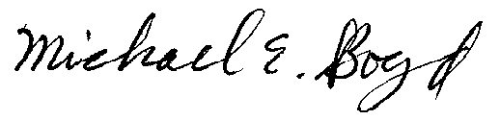
Michael E. Boyd 9-14-01

President, CARE
821 Lakeknoll Dr.
Sunnyvale, CA 94089
(408) 325-4690

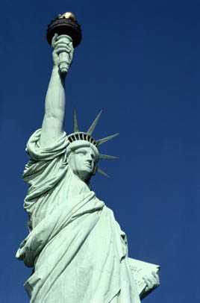
For those of you who might not be aware, Friday has been declared a
National Day of Prayer and Remembrance, and this is quickly spreading around the country to notify people of a national candlelight vigil.

Friday Night (9/14) at 7:00 p.m. step out your door, stop your car, or step out of your establishment and light a candle. We will show the world that Americans are strong and united together against terrorism. Please pass this to everyone on your e-mail list.

We need to reach everyone across the United States quickly.

The message:
WE STAND UNITED - WE WILL NOT TOLERATE TERRORISM.

