STATE OF CALIFORNIA
State Energy Resources
Conservation and Development Commission

In the Matter of )
) DOCKET NO.: 99-AFC-3 ERRATA TO 7-11-00
) STATUS REPORT, INTERVENOR’S PROPOSED

Metcalf Energy Center ) SCHEDULING ORDER ON THE STATUS OF
) PROCEEDINGS FOR CEC SITE LICENSING,
) AND MOTION TO CHANGE THE ORDER
___________________________________________) OF BUSINESS AT THE STATUS CONFERENCE

CARE provides the following errata to its Intervenor’s proposed scheduling order of 7-11-00 as follows:

The specific dates mast be determined by controlling agencies. The total minimum remaining duration is 9 months.

CARE’s Proposed scheduling order

30 days for BACT hearings by BAAQMD, new PDOC issued
30 days from submittal of new data by the applicant to the issuance of a second PSA.
30 days of workshops and PSA comments.
30 days to FSA
15 days to issuance of BAAQMD FDOC
15 days to evidentiary hearings
30 days to rebuttal testimony submission deadline
30 days to PMPD
30 day comment period
15 days to issue Errata
15 days Commission Considers PMPD and Errata.

DATED: July 11, 2000 respectfully submitted,

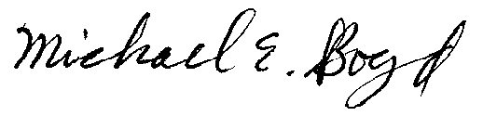
_____________________________ Michael E. Boyd
CAlifornians for Renewable Energy, Inc. (CARE)

