CAlifornians for Renewable Energy, Inc. (CARE)
821 Lakeknoll Dr.
Sunnyvale, CA 94089
(408) 325-4690
STATE OF CALIFORNIA
Energy Resources Conservation
and Development Commission

In the Matter of: ) Docket No. 99-AFC-3
)
Application for Certification for the ) Additional information for the
Metcalf Energy Center [Calpine ) administrative record regarding the
Corporation and Bechtel Enterprises, Inc.] ) Energy Crises

Dockets,
Please accept and place the attached materials [consisting of the following attachments: pdf 01-ep-09_assessment(1).pdf , 30901GreenTeammeetingminutes, and GovLetteronFiats.doc] in the Administrative Record (as defined by Public Resources Code section 21167.6(e)) for the MEC project captioned above. This is part of the large body of substantial evidence and objectively based information CARE has, is and will continue to submit regarding various aspects and developments of the current "energy crisis." This includes the Governor's declaration of an emergency, and related actions taken by the California Legislature, Congress and the President of these United States. It also includes, without limitation, the Governor's issuance of any Executive Order purporting to give any person or entity immunity of any kind from compliance with CEQA or other LORS concerned with environmental protection.

Respectfully submitted,

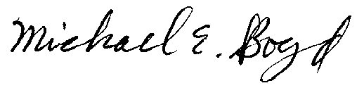
President-CARE 6-7-01

