CAlifornians for Renewable Energy, Inc. (CARE)
821 Lakeknoll Dr.
Sunnyvale, CA 94089
(408) 325-4690
STATE OF CALIFORNIA
Energy Resources Conservation
and Development Commission

In the Matter of: ) Docket No. 99-AFC-3
)
Application for Certification for the ) Motion to Deny the Application for
Metcalf Energy Center [Calpine ) Certification for the Metcalf Energy
Corporation and Bechtel Enterprises, Inc.] ) Center for Incontrovertible Evidence
) Of Prejudice by the Commission
) and its staff.
Dockets,
The following article titled Officials reject Calpine criticism Commission pushed for positive report, by Noam Levey of the San Jose Mercury News, provides incontrovertible evidence that the California Energy Commission, and its staff have demonstrated prejudice in their consideration of the Application for Certification for the Metcalf Energy Center. CARE hereby demands by its motion immediate denial of (99-AFC-3) the Metcalf Energy Center for actual Prejudice in the Commission’s consideration of this matter. To do other wise at this time will perpetrate criminal fraud against the public and the environment, and is a abuse of discretion on the part of this Commission
Your immediate response to this matter is demanded. If upon the Metcalf Committee’s deliberations it is decided to deny CARE’s motion in this matter, this hereby serves as immediate notice of an appeal of this matter to the full Commission. If upon deliberation of this matter by the full Commission it is decided to deny CARE’s motion, this hereby serves as notice of appeal to the California Resources Secretary and the Governor, and to serve as notice to request that Commissioners Laurie and Keese be disqualified from the office of Commissioner for conflict of interest and fraud.
How can CEC staff adequately represent the interests of the public and the public's right to well-informed and meaningful public participation when the CEC itself is an actual or potential adversary/party-litigant? If CEC staff were to carry out such a function, what are the measures necessary to eliminate or mitigate the conflict of interest problems based on the simple fact staff would be required to take action (e.g., conduct investigations, research, analysis, etc., and disclose evidence or information) contrary to the CEC's actual or potential litigation (administrative or judicial) interests? Does the CEC contend its staff is a representative of the public as to legal as well as factual issues arising in the administrative review process? These are such serious threshold matters they clearly should have been dealt with at the beginning, not near the end of the review process. The failure to do so has been and continues to be actually or potentially prejudicial to CARE and other members of the public, and a prejudicial abuse of the CEC's discretion calling for the termination of the present proceedings and the initiation of new ones in accordance with and not in violation of the law. CARE respectfully demands nothing less.

As a duly authorized officer of CARE, I declare under penalty of perjury under the laws of the State of California that the foregoing is true and correct to the best of my knowledge and belief, and this declaration was executed by me on the date given below at Sunnyvale, California.

Respectfully submitted,

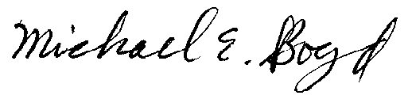
President-CARE 4-15-01

PS CARE hereby withdraws its formal apology of 1-4-01 to Commission staff for applying apparent illegal pressure and retribution against staff’s noise expert, Mr. Kisabuli. This also serves as further evidence of the Commission and its staff to perpetrate fraud on the public in it consideration of MEC. If not for the fact that these apparent illegal acts were perpetrated with Commissioner knowledge and concurrence CARE would expect nothing less than the immediate termination of those employees involved.

Posted at 8:59 p.m. PDT Saturday, April 14, 2001

Officials rejected Calpine criticism
Commission pushed for positive report
BY NOAM LEVEY
Mercury News

Under intense pressure to speed construction of power plants, top administrators at the California Energy Commission have taken extraordinary steps to win approval of Calpine's controversial plant proposed for San Jose's Coyote Valley.

Mercury News interviews with current and former staff members and a review of hundreds of pages of internal documents, reports and hearing transcripts show that senior energy commission officials undermined an initial negative environmental assessment that threatened the project.

And they sought to dismiss alternatives while recommending approval of Calpine Corp.'s Metcalf Energy Center in their final assessment.

The fate of the project -- which is opposed by the San Jose City Council -- is now in the hands of the five energy commissioners, who are expected to issue a decision this summer based in large part on the staff's work.

Commission deputy director Bob Therkelsen, a 25-year veteran who supervises the licensing of power plants, said the commission's work has been impartial, explaining that the staff needed to consider a range of legal, technical and policy issues in evaluating the project. Many state and local leaders, including the California Assembly and Silicon Valley Manufacturing Group, have endorsed Metcalf as a solution to the South Bay's energy shortfall.

``I would not deny that some of the staff have strong feelings,'' Therkelsen said in an interview last week. ``But I think the process allowed all perspectives to be heard.''
The commission will decide at a time when California and its governor are desperately seeking new sources of power to avoid rolling blackouts and skyrocketing electric bills. But the Mercury News review raises questions about the commission's stated commitment to conduct ``balanced, totally independent evaluations'' of new power plants.

In their efforts to ensure Metcalf's approval, commission management and attorneys:
Attacked the work of a respected analyst who believed that the review should point out sites better suited for the plant and directed him to downplay the advantages of other sites.
Silenced the analyst at a hearing when he tried to talk about the pressure he came under to alter his findings.

Pushed aside another analyst who refused to back off his recommendation that Calpine add more sound insulation to the plant.

Reversed the recommendation of a third analyst that Calpine have a contract for recycled water before construction be allowed to begin, a condition that could have delayed the plant.

Under the gun
Pressure to undo skeptical review
When the energy commission staff first analyzed Metcalf last year, the project drew a skeptical review.

The staff detailed a range of potential problems with Metcalf; from its impact on water quality to its incompatibility with long-established city plans to reserve North Coyote Valley for high-tech campuses.

In the most significant conclusion, the 574-page Preliminary Staff Assessment released in May identified several other sites that were ``environmentally preferable,'' chiefly two industrial sites in Fremont.

The staff assessment, which represented the commission's first evaluation of the project, was a serious setback for Calpine and its development partner, Bechtel Enterprises. Metcalf opponents -- many of them from the nearby Santa Teresa neighborhood -- seized on its conclusions to argue that Calpine should be denied permission to build.

Calpine played down the report as a draft. And Therkelsen said last week that he felt the report's conclusions were premature.

After the report's release, Calpine took steps to minimize some of the environmental impacts of the project.

But according to staff and internal documents obtained through a California Public Records Act request, energy commission analysts also began coming under pressure to change their conclusions before the commission issued its final assessment later in the year.

At several meetings in the summer, senior energy commission officials, including Therkelsen and the project manager, told staff analysts that the commission wanted to approve Metcalf, according to one analyst who worked on the project. Several analysts agreed to speak about the issue but only anonymously, fearing that talking about the review process could cost them their jobs.

Coming under particularly harsh criticism from the senior energy officials and attorneys was Gary Walker, a 21-year veteran who had concluded in his initial analysis that other sites were more suitable for a plant.

Walker, who would not talk to the Mercury News, is widely considered to be one of the most thorough and professional members of the commission staff, according to other analysts. But commission documents indicate Walker was told that his report was full of ``bias'' and ``inconsistencies.''

In one e-mail to the project manager, senior commission attorney Arlene Ichien warned that unless Walker's assessment was changed to cast Metcalf in a better light, it would be difficult for the energy commission to permit the plant. ``Staff is building a strong case for finding the alternative sites feasible,'' Ichien warned.

Direction to staffers
Employees were urged to accentuate positive
Ichien, Therkelsen and other senior staff members stressed in e-mails and memos that the staff review should focus on Metcalf's benefits, most especially its ability to come on line more quickly than alternatives. Calpine wants the plant to be running by the summer of 2002. And state energy officials have said that additional power generation is desperately needed in Silicon Valley, which imports most of the electricity it uses.

In numerous e-mails and memos, senior officials downplayed the advantages of other sites, identifying potential environmental problems that they said Walker was overlooking. They pointed out that sites in North San Jose, for instance, could be problematic because of their proximity to the largely minority Alviso neighborhood. And they pointed out that sites in Fremont would require changes to local land regulations that limit building height.
``I was concerned that the alternatives were being portrayed more optimistically than realistically,'' Therkelsen said last week.

But the officials added sweeping language to the final assessment that suggested more problems with the alternatives than the staff found.

In the executive summary, for example, Therkelsen wrote that the other sites would not comply with local land-use regulations, could have serious visual impact, and posed fairness issues because of their proximity to low-income neighborhoods.

Yet the commissions own land-use expert said the alternative sites would not pose as many problems as North Coyote Valley. ``All of the alternative sites would avoid, rather than reduce, some or all of the land-use impacts,'' Eric Knight said in one e-mail to his supervisors, advising them not to mischaracterize his findings.

The consultant hired by the commission to do a visual analysis of the project also said other sites would not have as great an impact as North Coyote Valley. And two of the sites in rural Alameda County are far from residential neighborhoods, limiting their potential impact on low-income communities.

Walker tried to defend his analysis in e-mails and memos, arguing that it was important to tell policy-makers if other sites were environmentally superior. ``Gary was under tremendous pressure to conform to the party line,'' said Kathryn Matthews, a 24-year veteran of the energy commission who worked on Metcalf until her retirement last year.

But when the commission released its final report last fall, in place of Walker's long discussion of the advantages of other sites was a new section warning that Silicon Valley risks more blackouts unless Metcalf is built.

The final report recommended approval.

When Walker tried to explain under questioning during a March hearing on the plant that he had come under pressure to downplay the advantages of other sites, he was cut off by a commission attorney.

Walker was not the only staff member coming under pressure. On at least two occasions, senior energy commission officials overruled analysts who wanted to put additional conditions on Calpine.

Kisabuli, a 12-year veteran of the energy commission (he uses only one name), said he was told to change his analysis of the potential noise impact of the power plant.

``During its operating life, the project will represent essentially a steady, continuous and broadband noise source day and night,'' Kisabuli wrote in his analysis, recommending that Calpine be required to further insulate Metcalf like other power plants.

But the additional insulation would be costly, and Calpine suggested that it insulate an isolated home closest to the project.

``I found myself defending my noise analysis like I have never had to do before,'' Kisabuli said in a letter to the energy commissioners last month. In the same letter, Kisabuli said that when he refused to change his recommendation, he was taken off the project and replaced by an outside consultant.

Therkelsen said he was surprised by Kisabuli's letter because Kisabuli had never expressed those concerns to him.

Change of heart
Noise conclusion switched in report
When the energy commission released its final assessment in October, the staff changed its conclusion about noise, concurring that the insulation was excessive given the few homes near the plant.

Power plant opponents tried to get Kisabuli to testify at project hearings, but they were told by the project manager that Kisabuli did not finish the noise analysis. In fact, Kisabuli wrote most of it, although his conclusion was changed.

``Staff know that if they stick to their guns, they will be vilified,'' said a former analyst.

``Many just decide it's not worth it.''

This spring, senior commission officials backed away from requiring Calpine to comply with another recommendation that could have complicated construction of the plant.

Lorraine White, a longtime commission analyst and former project manager, had recommended that before Calpine be allowed to begin construction, the company should be required to reach an agreement with San Jose to supply recycled water to the plant.

White had been the initial project manager on Metcalf, but she requested a demotion to analyst out of concern that senior energy commission officials were not committed to minimizing the environmental impact of new projects, according to a former commission analyst. Energy commission attorneys nonetheless initially agreed with her water recommendation, according to documents. Then, earlier this month, the commission changed its position, indicating that Calpine should be required only to start negotiations with the city.
The power plant will use 3 million to 6 million gallons of water each day for cooling, but it is unclear if San Jose will provide the water because the city opposes the project. City officials could drag out the water negotiations.

Therkelsen defended the change as part of the process of balancing priorities. ``We had to ask to what extent you let a local agency thwart the broader interests of the state,'' he said.

Contact Noam Levey at nlevey@sjmercury.com.

CAlifornians for Renewable Energy, Inc.(CARE)
821 Lakeknoll Dr.
Sunnyvale, CA 94089
(408) 325-4690
STATE OF CALIFORNIA
Energy Resources Conservation
and Development Commission

In the Matter of: ) Docket No. 99-AFC-3
)
Application for Certification for the ) CARE’s Formal Apology to MEC
Metcalf Energy Center [Calpine ) Project Manger, Paul Richins.
Corporation and Bechtel Enterprises, Inc.] )

CARE wishes to formally apologize to MEC project manager Paul Richins, in regards to CARE’s 12/29/00 Petition in support of Intervenor Ajlouny’s Motion to Allow Cross-Examination of Staff’s Witness Kisabuli on Noise, where it states,

“CARE is very concerned with the independence of the CEC staff manager in this project Paul Richins…. CARE object to and respectfully demands the CEC investigate the behavior of project manager, Paul Richins, for his apparent lack of independence in this cases consideration as a result of possible interference with staff member Kisabuli in the performance of his duties… CARE contends that staffs response in its December 22, 2000 opposition to Intervenor Ajlouny’s motion to cross-examination as evidence of manager Paul Richins bias in favor of the applicant were it states, “However, the assignment of staff witnesses in technical areas is solely within the discretion of staff management. Any testimony by another staff person would be immaterial and most likely irrelevant since it would not be based on the facts of this case. Moreover, Mr. Kisabuli will be out of the country for the entire month of January.” CARE contends that Mr. Kisabuli is not out of the country, and is also available for cross-examination, if Mr. Richins will allow him to do so. CARE further contends that Mr. Kisabuli is being subjected to illegal retribution from Paul Richins for performing his duty, “to represent the public to the fullest and best of (his) ability.”

Based on Dave Munstock's response to the California Public Records Request on this matter it appears CARE was misinformed on Mr. Kisabuli’s availability for cross-examination. The following vacation request provides evidence of Mr. Kisabuli’s absence during the evidentiary hearing in question. CARE wishes to formally apologize for targeting a specific member of CEC staff for what appears to us to be a public participation problem relating to the siting process. The CEC and its staff obviously do not recognize or operate under a duty to encourage and enhance public participation. On the contrary, the vast majority of the CEC and its staff act precisely like a party-litigant adversary under a duty to cause prejudicial harm to its actual or potential litigant-adversaries. In other words, the CEC and the vast majority of its

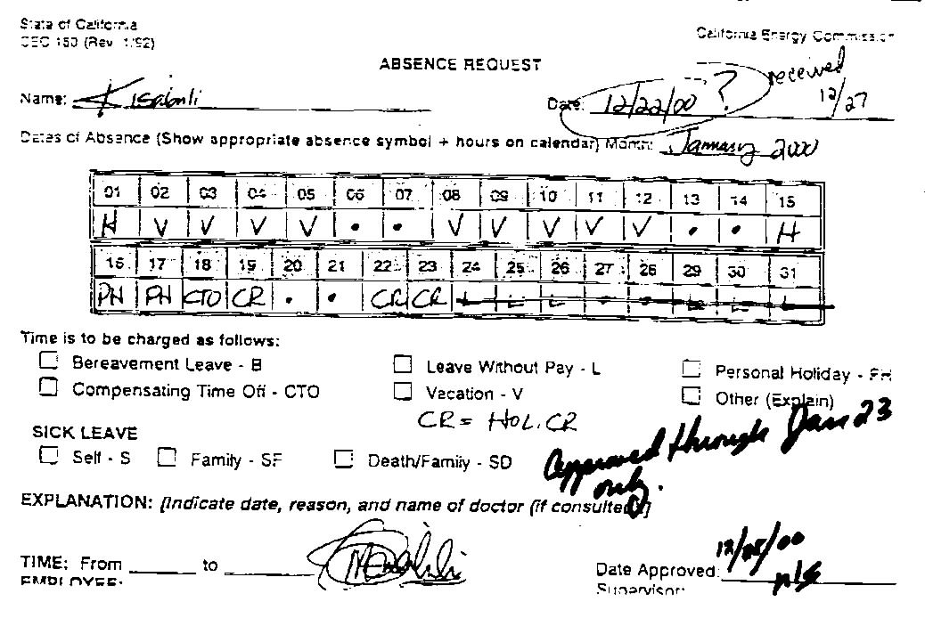
Staff are doing nothing to encourage or enhance, and with public funding are doing a great deal to discourage, harm and defeat the right of CARE, other intervenors and other members of the public to intelligently and meaningfully participate in the ongoing administrative review process. The resulting frustration of CARE in exercising its CEQA, Warren Alquist, and constitutional rights to public participation, wrongly targeted one member of the CEC staff, and we therefore apologize for doing so.
Figure 1 Vacation request form from Mr. Kisabuli
In regard to our objections and offers of proof regarding the CEC's refusal to allow CEC staff members (or CEC agent/representative of some other type) to testify and be cross-examined, some of the testimony from those witnesses would go directly to this very pertinent issue. More specifically, we believe the witnesses would testify that they were ordered not to provide information or take action that would have benefited well-informed and meaningful/effective participation by CARE, other intervenors or other members of the public.
We offer this reminder that, in addition to compensation or reimbursement for public participation costs, CARE respectfully demands the immediate termination of all administrative review procedures other than a final override determination that may be submitted to the courts for adjudication.

Respectfully submitted,
Michael E. Boyd, President 1-4-01

CARE formal apology letter of 1-4-01 follows the included news article.

