CAlifornians for Renewable Energy, Inc.(CARE)
821 Lakeknoll Dr.
Sunnyvale, CA 94089
(408) 325-4690
STATE OF CALIFORNIA
Energy Resources Conservation
and Development Commission

In the Matter of: ) Docket No. 99-AFC-3
)
Application for Certification for the ) San Francisco Chronicle Article
Metcalf Energy Center [Calpine ) March 5, 2001
Corporation and Bechtel Enterprises, Inc.] ) Calpine’s Quest For Power

Dockets,
Please incorporate the following March 5, 2001 San Francisco Chronicle article titled Calpine’s Quest For Power in the administrative records of the Metcalf Energy Center 99-AFC-3.

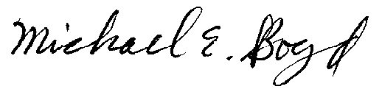
Michael E. Boyd President, CARE 3-5-01

Calpine's Quest for Power
American Indians split over Bay Area supplier's efforts to tap what some view as their own source of sacred, spiritual energy

Scott Winokur, Christian Berthelsen, Chronicle Staff Writers
Monday, March 5, 2001

--------------------------------------------------------------------------------

Critics accuse out-of-state power companies of profiting on the backs of Californians, but the Bay Area's own Calpine Corp. is one of the big winners in the high-stakes poker game that's the energy crisis.

Calpine's financial performance not only has astonished and delighted Wall Street, it has emboldened the San Jose company to try to reinvent itself as a high-profile power player on the national scene.

Although little noticed for years -- and still one of California's smaller energy producers -- Calpine has begun a mammoth construction program (24 plants in the works) that soon will make it the nation's largest independent wholesaler.

But the road to riches is not always a smooth one for this energy wholesaler with Trump-like ambitions, and nowhere are its troubles more evident than in Northern California's Siskiyou County.

Some American Indians and environmentalists there are fighting a Calpine plan to build a geothermal facility on federal land sacred to the Pit River Tribe and Shasta Nation.

Calpine, moreover, plans to sell most of the power that would be generated out of state, despite the fact that the California Energy Commission is subsidizing the project.

Conflicts with communities are nothing new to Calpine.

The company has been:

-- Ripped by residents, officials and the Cisco Corp. for proposing a plant in South San Jose;

-- Fined by regulators for construction errors in Pittsburg;

-- Savaged by Sonoma County residents for a sweetheart deal with Santa Rosa giving it free water for its geothermal facilities; and

-- Vilified by Coloradans for planning a Rocky Mountains plant destined, some believe, to produce energy for California.

There's no indication that these conflicts have slowed the Calpine steamroller, so far. Even the company's slogan has swagger today. "We're Repowering America," it boasts.

But Calpine's problems show how the energy crisis can pit an aggressive power wholesaler -- whose interests, deregulation proponents would argue, should mesh with the state's energy needs -- against individuals and entire communities.

"Projects such as these make news," said Calpine spokesman Kent Robertson, "but there are plenty that go flawlessly, where the mayor says, 'If you'd like to build another facility, let's talk.' "

OPPOSITION IN SISKIYOU
Groundbreaking on Calpine's federally approved plan to tap geothermal energy beneath the ancestral lands of the Pit River Tribe and the Shasta Nation could begin this year. There's a big obstacle, however: The opposition of American Indians and environmentalists who are trying hard to convince Washington that the project would be a crime against indigenous people and Mother Nature.

Both sides agree that there's energy in the ground, called Fourmile Hill, part of the Medicine Lake Highlands, below the Oregon border in Siskiyou County. But many American Indians say it is the spiritual energy of the natural world and shouldn't be tapped, unless the intrusion is part of a traditional vision quest or puberty rite.

"It's a sacred place, and we don't want anybody drilling on or near it. There's been proof of people going in the lake, bathing, praying and getting cured," said Vernon Johnson, head of the California Council of Tribal Governments in Redding and a member of the Pit River Tribe.

Project opponents have enlisted the support of a Stanford University Law School-backed environmental group, the Earthjustice Legal Defense Fund. They are now appealing federal decisions favorable to Calpine before the U.S. Department of the Interior's Board of Land Appeals in Washington, D.C. They threaten to go to court afterward, if necessary.

GEOTHERMAL'S CRITICS
Geothermal energy long has been considered a "clean," renewable alternative to fossil fuels and nuclear energy, because it uses naturally occurring subterranean steam heat to power electricity-generating plants above ground. But Fourmile Hill's opponents say that geothermal is not, in fact, without its downside.

"When you dig 9,000 or 10,000 feet into the ground," said Michelle Berditschevsky, executive secretary of the Native Coalition for Medicine Lake Highlands Defense in Mount Shasta, "you find a lot of hazardous, dissolved chemicals, like arsenic, chromium, boron and hydrogen sulfide.

"So, while the pollutants that go with fossil fuels are being avoided, they're being replaced by another set of pollutants."

Because output would be relatively small, questions have arisen as to Calpine's motive for building in a sensitive spot. There are two answers, project critics say.

If initial attempts to tap underground energy are successful, the site may prove to be one of the nation's best new sources of geothermally produced power and development could be expanded to more than 500 megawatts. One megawatt is enough energy to power 1,000 homes.

Equally important to Calpine is the fact that the California Energy Commission has conditionally granted a $21 million renewable energy subsidy to the company, which would begin when the juice flows, in 2004. The money would come from the state's half billion-dollar Renewable Resources Fund, accumulated from ratepayer contributions.

If these incentives weren't enough, Calpine also has locked in a purchaser of at least 60 percent of the energy that would be generated -- the Bonneville Power Administration, a federal Energy Department agency headquartered in Portland.

Bonneville and Calpine have inked a deal worth at least $14.5 million and probably much more in future revenues to the San Jose company. The Bonneville Power Administration supplies electricity to the Northwest and to small portions of California, Nevada, Utah and Wyoming.

Could Bonneville and Calpine's ratepayer-funded Fourmile Hill project help California solve its energy problem?

Not likely. Bonneville sells significant amounts of power in California and the Southwest, but only when it has surpluses, which are increasingly rare.

"It was not until Calpine saw the opportunity to fund a large portion of the project at the expense of California taxpayers . . . that it began seriously to pursue development," a Feb. 7 court record in the Earthjustice suit said.

Bonneville Power Administration "ratepayers and California taxpayers are being asked to finance a significant share of a private corporate undertaking .

. . that would exploit public resources, degrade the natural environment and destroy the age-old religious practices of a minority, " the suit said.

A NOTICEABLE NEIGHBOR
At 49.9 megawatts, the facility has been designed to be under the California Energy Commission's 50-megawatt threshold for oversight and fall, instead, under the lighter supervision of county authorities.

But if the project comes in under the radar of officials in Sacramento, it will be hard to miss in the Medicine Lake area. The plant would be almost 100 feet high and include more than 50 miles of pipelines, transmission lines and access road. It would make noise around the clock, and its 145-foot-tall drill rigs would be lit.

PAYOFFS TO AMERICAN INDIANS
Berditschevsky said there had been widespread opposition to Fourmile Hill not only among the Pit River Tribe's 2,500 members but among other American Indians in the region, including the 1,500-member Shasta Nation. But Calpine drove wedges between tribal members and entire tribes, she said, by paying for support.

"They just find people who want money more than they want their sacred sites," Berditschevsky charged. "They have approached different tribal members and gotten some to act against their own tribal government. They've made promises of individual economic advantages. The company has been irresponsible. "

Earthjustice attorney Deborah Sivas, who filed the legal challenge on behalf of the Pit River tribe, said: "Calpine spent a lot going around to members of the tribes to buy them off. For some tribe members, they have gone out to their houses in rural areas, shown up at their doors and tried to browbeat them into signing documents. It seems egregious to me.

"The deal with the Shasta Nation was to give them $25,000 in cash and to help them get federal recognition as a tribe. We met with people from the Shasta Nation who were very opposed, but then they stopped coming to our meetings."

The Shastas have been seeking official tribal status since the 1980s. Like any tribe, they can expect a windfall in public services and dollars if federal recognition is granted, according to Virgil Akin, superintendent of the the federal Bureau of Indian Affairs in Redding. Official recognition also would be necessary if a group of American Indians wanted to operate a casino on reservation land.

Still, many Shastas held out against the project. Howard Wynant of Macdoel, a disabled lumberjack, said the majority of tribe members -- backed by leading American Indian organizations -- remains against Fourmile Hill. However, a dissident group led by the Hall family in Quartz Valley broke away and set up their own tribal council, he said. Now the Shastas are two "tribes" and have two separate chairmen, Wynant said -- and each side detests the other, because of Calpine.

"They were looking for an endorsement from somebody. That's all they needed, " Wynant said.

But Betty Hall of Fort Jones, a Shasta Nation employee and mother of rival tribal Chairman Roy V. Hall Jr., disagreed strongly. She confirmed that some Shastas did, indeed, change their view of the Fourmile Hill project. But she said that happened after they'd learned from assessor's maps that Medicine Lake had become a magnet for vacation homes. The decision to cooperate with Calpine followed quickly.

"We met with Calpine a number of times," Betty Hall said. "They said they would help (with the petition for federal recognition). Our chairman made one trip with them back to Washington, and they also met with the Bureau of Indian Affairs.

"They put up money to help us get through the federal recognition process. I'm not saying how much, but not a great deal. Some people think the Shastas got millions -- I've heard the stories. No way. Personally, not one Shasta member has gotten a dime."

Betty Hall said Calpine also made a point of telling the Shastas that they would be encouraged to apply for future jobs at the proposed geothermal plant.

A WRITTEN UNDERSTANDING
Her son, Roy V. Hall Jr., said the arrangement his group of Shastas made with Calpine was spelled out in a written memorandum of understanding. He confirmed that the company helped with a petition for federal recognition, paying for his airfare back to Washington and at least one copying machine. But he denied Sivas' contention that $25,000 changed hands and that anything else of financial value was given to the Shastas.

"I understand that other people may be upset with us. Then again, we've been floundering in this federal recognition process for 20 years and most other tribes don't really care" about the Shastas' plight, he said.

Sean Haggerty of the federal Bureau of Land Management in Sacramento is the liaison with lessees of public land such as Calpine. Haggerty made a point of distancing the bureau from Calpine's efforts to buy Native Americans' cooperation.

"They did it on their own; it wasn't part of the BLM," he emphasized. "They initiated their own contracts, focusing on employment, scholarships, training, benefits, such as acquiring tribal museum pieces that may have been lost or be in private hands, and purchasing certain items, like vehicles and Xerox machines.

"As a federal agency, we had to distance ourselves from that. But we felt if Calpine could go forward and develop a working relationship, that was a good idea."

Haggerty estimated that the company spent at least half a million dollars in staff time lobbying the local American Indians -- plus more in property donated as gifts and long-term commitments such as college scholarships Calpine says are contingent on completion of the project.

Defending his agency's decision to approve Fourmile Hill, Haggerty said the Bureau of Land Management had done all it could to mitigate impacts, but they weren't enough for the Pit River tribal government.

"We balanced the need for energy development with the concerns of the few, and in this case, we felt it was justified to approve the project," he said.

Besides, the bureau feared that Calpine would take the agency to court if the project wasn't given a green light, according to Haggerty.

POWERING INTO THE PRESENT
Rosemary Nelson, a commercial property owner in Alturas, 90 minutes away in Modoc County, also belongs to the Pit River Tribe. She supports the project and has gone to Washington. D.C., as a paid Calpine consultant to argue for it.

In December, Nelson bought Calpine stock.

"I wonder how relevant these historic and spiritual sites are to your life, " said Nelson, "when Indians have the highest unemployment, alcoholism and suicide rates? Preserving cultural sites is important, but it hasn't solved the problems of Native Americans. We honor our ancestors by living successfully in the present."

Bill Highlander, another Calpine spokesman, said his company's methods -- spending over $500,000 to buy support -- were "standard practice."

"Whenever we go into any area, we have a community benefits program," he said. "The amount of money (spent by Calpine in Siskiyou) is very small for what we'd spend in a community relations effort."

For many of the local American Indians, however, it would be too much even if it were a fraction of that amount.

But because Siskiyou County's historically marginalized tribes do not speak with one voice, Calpine has been able to press ahead, making money by catering to the energy needs of a world that to this day covets lands belonging to the American Indians.

--------------------------------------------------------------------------------

Chronicle librarian Charles Malarkey contributed to this report.

Feedback
CALPINE'S EXISTING AND PROPOSED POWER PLANTS IN CALIFORNIA
.
GAS-FIRED PLANTS
Plant Baseload capacity in megawatts
Agnews, San Jose 27.0
Gilroy 112.0
Greenleaf 1, Yuba City 50.0
Greenleaf 2, Yuba City 50.0
King City 103.0
Pittsburg 64.0
Watsonville 29.0
.
GEOTHERMAL PLANTS
Plant Baseload capacity in megawatts
7 Middletown 340.0
12 Sonoma County 554.0
A 100-megawatt plant will provide enough electricity to power 100,000
households.
.
EXISTING:
Yuba City (2)
Middletown
Sonoma County
Pittsburg
San Jose
Gilroy
Watsonville
King City
.
PROPOSED:
Sutter Power Project
September 2001
500 megawatts
Fourmile Hill Project
49.9 megawatts
Los Medanos Energy Center
July 2001
500 megawatts
Delta Energy Center
June 2002
380 megawatts
Metcalf Energy Center
Calpine and Bechtel
600 megawatts
.
CALPINE CORP.
-- SIZE TODAY: Interests in 50 gas-fired and geothermal plants in 15 states,
including up-and-running and planned operations in 25 Northern and Central
California locations. Plus 24 gas-fired plants under construction.
Since May 2000, acquired energy companies in seven states and one Canadian
province.
Total current generation about 5,500 megawatts (including 1,300 in California,
about 4 percent of the state's daily energy load).
Workforce: about 2,000, including 900 hired last year.
-- SIZE TOMORROW: Year 2005 operating goal of 70,000 megawatts generated by
some 70 plants in 27 states and one Canadian province, almost 50 percent more
than any U.S. generator today and enough to power 70 million homes.
By 2006, the company says, nearly 10 percent of the power sold in California
will be Calpine's (an estimated 9,000 megawatts), increasing its market share
in the state more than twofold, accounting for projected growth in supply and
demand statewide.
-- FINANCIALS: Over $11 billion stock market capitalization. Year 2000 net
income, $324.7 million, up 238 percent. Year 2000 revenue, $2.3 billion, up
171 percent. Stock price increase in 1999 - 407 percent. Assets as of Dec. 31,
$9.7 billion, up 142.5 percent. Like other power wholesalers, it says it is
owed money by California utilities but won't say how much.
-- EXECUTIVE COMPENSATION: In 1999, board Chairman and Chief Executive
Officer Peter Cartwright received a total package worth $21.7 million,
according to company estimates as reported in a Securities and Exchange
Commission document.
A new media company that tracks SEC records of insider trading, InsiderScores.
com of Scottsdale, Ariz., and Hong Kong reported that in early November and
mid-December 2000, Cartwright exercised 227,000 stock options at a cost of $18,
655 while selling 102,000 shares for nearly $5.7 million.
Chief Financial Officer Ann B. Curtis exercised 35,000 shares on Dec. 11 at a
cost of $2,275 and on the same day sold an identical amount of stock for a
total of $1.46 million, according to InsiderScores.com. Three months earlier,
Curtis made similar transactions, netting more than $1.4 million, the research
organization said.
-- POLITICAL ACTIVITIES: Calpine donated $270,000 to candidates, incumbents
and political committees last year.
State Assembly Speaker Robert Hertzberg, D-Sherman Oaks, got $22,500; Gov.
Gray Davis, $19,000; and Senate President Pro Tem John Burton, D-San Francisco,
$16,000.
Politically influential organizations in Santa Clara and Sonoma counties,
where Calpine has controversial projects pending, received $14,500.
In Contra Costa County, the company gave $3,000 to Democratic Assembly
hopeful Joe Canciamilla of Pittsburg, who won. Canciamilla's 11th Assembly
district is home to several power plants; he was named to the Assembly's
Utilities and Commerce, and Energy Costs and Availability committees.
.
Sources: Calpine Corp., Securities and Exchange Commission, InsiderScores.
com, Federal Elections Commission, California Secretary of State, California
Fair Political Practices Commission
Chronicle Graphic

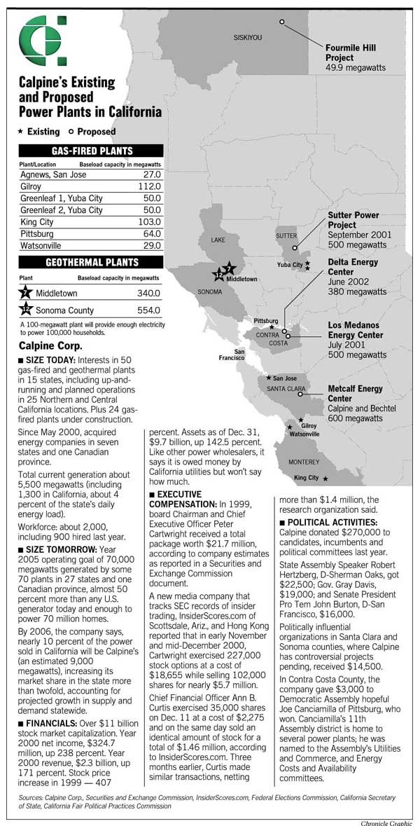
Calpine's Existing and Proposed Power Plants in California. Chronicle Graphic
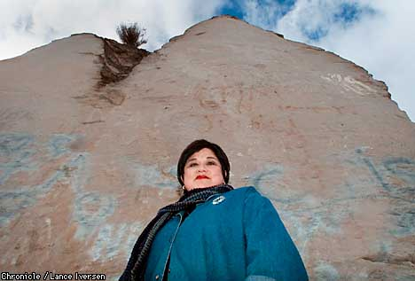

Pit River tribal member Rosemary Nelson, backing Calpine, wonders "how relevant these historic and spiritual sites are to your life." Chronicle photo by Lance Iversen
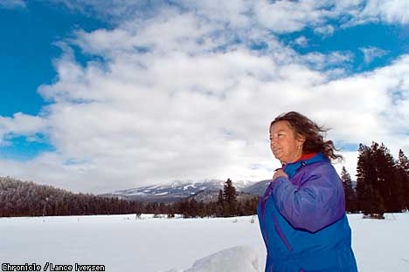

Michelle Berditschevsky, fighting the plant, says some Calpine supporters "want money more than they want their sacred sites." Chronicle photo by Lance Iversen
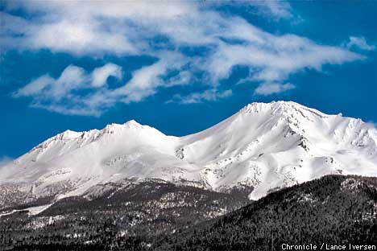

Calpine wants to build a power plant in the Medicine Lake Highlands volcanic area, which sits behind the western side of snowy Mount Shasta. Chronicle photo by Lance Iversen

