CAlifornians for Renewable Energy, Inc.(CARE)
821 Lakeknoll Dr.
Sunnyvale, CA 94089
(408) 325-4690
STATE OF CALIFORNIA
Energy Resources Conservation
and Development Commission

In the Matter of: ) Docket No. 99-AFC-3
)
Application for Certification for the ) CARE Provides Evidence of
Metcalf Energy Center [Calpine ) Violations of the Bagley-Keene
Corporation and Bechtel Enterprises, Inc.] ) Open Meeting Act

CARE Provides Evidence of Violations of the Bagley-Keene Open Meeting Act
On 3-7-01 CARE respectfully demanded that the California Energy Commission (C.E.C.) cure or correct actions alleged to have been taken in violation of Cal Government Code § 11125(a). CARE contended that the March 14, 16 and 23, 2001. Notice of Public Hearings Placed on line March 6, 2001 failed to meet the notice requirements of the Bagley-Keene Open Meeting Act. To be more specific, the Commission's web site states under the designation Metcalf Energy Center (99-AFC-3): "March 14, 16 and 23, 2001. Notice of Public Hearings Placed on line March 6, 2001." On its face, this is an express violation of the Act, § 11125(a) of which provides:

"The state body shall provide notice of its meeting to any person who requests that notice in writing. Notice shall be given and also made available on the Internet at least 10 days in advance of the meeting, and shall include the name, address, and telephone number of any person who can provide further information prior to the meeting, but need not include a list of witnesses expected to appear at the meeting. The written notice shall additionally include the address of the Internet site where notices required by this article are made available." (Emphasis added.)

Additionally, technically even the notice of the March 16 hearing is inadequate because, under a strict interpretation of the Act (which is perfectly appropriate given the key role public participation is supposed to play), as of its 3-7-01 Notice CARE had yet to receive written notice of the meeting as required by the Act. CARE has previously requested notice in writing. On 3-9-01 CARE received notice by US mail of the said hearings including the attached envelope (and notice) which was post marked utilizing the CEC’s bulk mailing stamp dated 3-7-01 (see attached.) Can there be any doubt that the notice which was post marked utilizing the CEC’s bulk mailing stamp dated 3-7-01 for a hearing commencing on March 14 and March 16 violates these statutory provisions?

In closing, let me again point out that our comments are not a matter of mere technicalities. These strong time constraints have caused and continue to cause CARE and other members of the public actual prejudice by interfering with their right to public participation as well as constitutional rights previously mentioned.
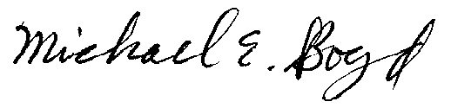
President-CARE 3-13-01

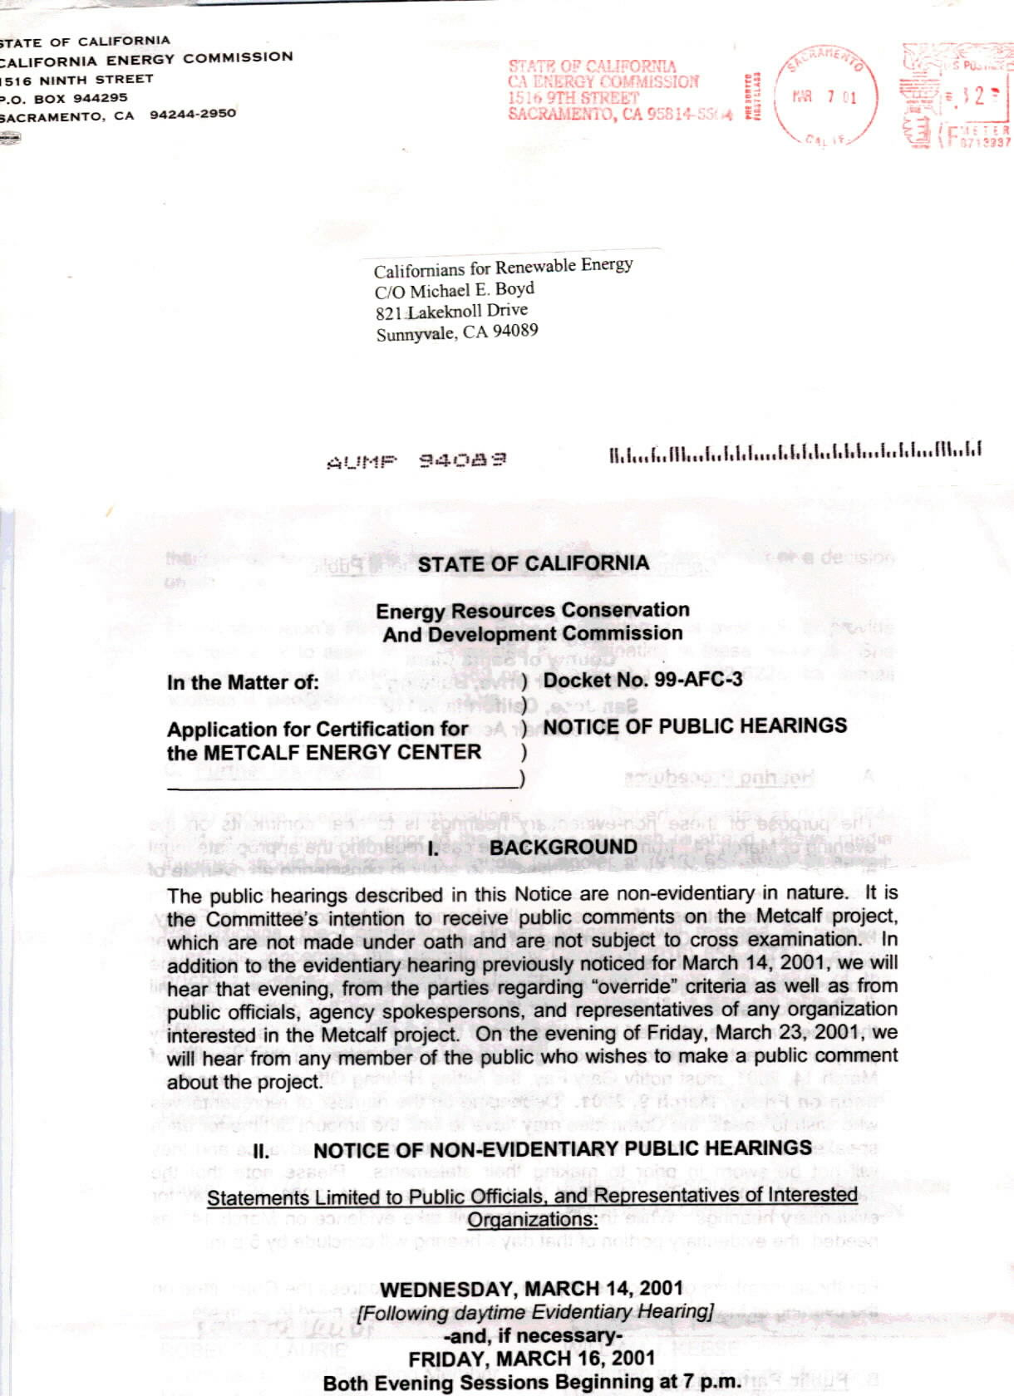
Notice of 3-14-01 and 3-16-01 hearing including CEC post marked envelope dated 3-7-01

