CAlifornians for Renewable Energy, Inc.(CARE)
821 Lakeknoll Dr.
Sunnyvale, CA 94089
(408) 325-4690
STATE OF CALIFORNIA
Energy Resources Conservation
and Development Commission

In the Matter of: ) Docket No. 99-AFC-3
)
Application for Certification for the ) CARE’s petition for full Commission Review
Metcalf Energy Center [Calpine ) of the CEC’s "override" authority, public
Corporation and Bechtel Enterprises, Inc.] ) participation, and Intervenor funding

PLEASE consider this CARE's petition for consideration by the entire Commission of our demand for the immediate suspension (stay) of all pending proceedings to focus on the override issues previously identified, and to also focus on providing CARE and others compensation or reimbursement for interim public participation costs. At least some of the reasons for our demands were previously spelled out and are fully incorporated by this reference. We also reserve the right to submit additional evidence and information prior to the matter being heard by the full Commission. Given our extremely limited, virtually nonexistent resources, which are continuing to be depleted by the CEC's insistence on not immediately addressing the override issues upon learning conclusively that an override is the only way the present project can ever go forward, we are still working on this matter.

Our work includes ongoing research on the override issues, which CEC staff should have already addressed thus making our job easier, less time consuming and less expensive. Therefore, if that work is not completed by the time the CEC is scheduled to hear the matter, we will be asking for (and in all fairness be entitled to) more time. This is not to say, however, that we won't continue to do everything reasonably possible to comply with your deadlines and other conditions, despite their lack of legal authority, their continuing (including actual) prejudice, and our continuing objections.

CARE continues to object to your apparent but unconfirmed claim, if true, that the CEC can determine the "evidence" upon which decisions are made-including decisions on the exercise of the override power, and that, although it will allow information and evidence submitted by the public to be placed in the project's "docket," the CEC has the discretion to reject and exclude such information and evidence from the "administrative record" even if the matter being rejected/excluded is relevant to the project under review. This claim is completely improper and contrary to law. The CEC has no such power or authority. The specific contents of the administrative record are specified and codified by CEQA. (Section 21167.6 of the Public Resources Code.) And the CEC may not adopt policies, rules, programs, procedural devices or other means of circumventing that definition. Please recall that the CEC's regulations and procedural devices must be equivalent to CEQA's. This is what the Legislature specified when it refused to give CEC review full exemption, choosing instead to give the CEC process a very limited exemption subject to the CEQA equivalency requirement.

In regard to the override issues, CARE hereby respectfully demands that the CEC and its staff take the following actions:

1. Conduct a full, good faith, independent and fair investigation (meaning one that doesn't give primary or even significant consideration to the CEC's role as a potential party-adversary in ongoing or ensuing administrative or judicial litigation) regarding the 6 alternative project sites the PSA and FSA found to be feasible and ecologically superior to the site presently proposed. Please also keep in mind that the MEC project may be approved only if the CEC overrides fundamental CEQA requirements that include, without limitation, the prohibition against the approval of projects where feasible alternatives or mitigation measures exist and have not been adopted. (See CEQA [Public Resources Code] sec. 21002 and its progeny.) The CEC investigation should be aimed at answering questions that includes and are reasonably related to the following:

- A more complete, more detailed history of the 6 alternative sites than provided in the PSA, FSA or other staff report to date, including details/explanations concerning reasonably related matters, such as applications for the siting of a power plant(s) on an alternative site(s). For example in the FSA on page 200 includes in its list of staff recommended alternative as, “Two sites are in rural eastern Alameda County, south of Interstate 580 and adjacent to PG&E’s Tesla Substation.” As an example that Calpine is already in the process of pursuing one of these sites is demonstrated by the San Jose Mercury News in an article published on 12/13/2000, titled, CALPINE LOOKS TO EAST BAY SITE POWER FACILITY NEAR LIVERMORE WOULD BE TWICE SIZE OF ONE REJECTED BY SAN JOSE A 1,100-MEGAWATT POWER PLANT IN ALAMEDA COUNTY WOULD SERVE 1 MILLION HOMES IN SAN JOAQUIN COUNTY AND THE EAST BAY, in which it states, “Calpine Corp. plans a Livermore area power plant nearly twice the size of a controversial electrical facility that the San Jose City Council rejected last month. The proposed East Altamont Energy Center would cost $550 million, generate 1,100 megawatts of electricity and serve 1 million homes in the East Bay and San Joaquin County.”
- An estimate of how long it would take for the applicant to obtain CEC approval for the siting of a powerplant(s) on each site, and the ramifications of a further delay in submitting such applications.
- If it's part of CEC staff's function to encourage and enhance well informed and meaningful/effective public participation (or is it?), why hasn't staff recommended that the alternative sites and their use for the siting of an alternative powerplant be considered? Isn't that information very relevant to the ongoing administrative review of the MEC project? Given the perceived energy crisis/emergency, haven't we wasted, and aren't we continuing to waste critical time in delaying consideration of an alternative site under the present circumstances where the only way the MEC site will ever be used in the reasonably foreseeable future is if the CEC overrides local laws and regulations, as well as the maximization of environmental protection and mitigation of environmental harm under CEQA; and where the CEC may not have the legal authority to override (e.g., there may be a statute purporting to give the CEC override power, but the statute, on its face or as applied to the present situation, doesn't pass constitutional muster in ways that may include violation of the separation of powers doctrine) or may be abusing its exercise of discretion by overriding? Doesn't this continuing waste of valuable time constitute and contribute to actual, irreparable harm that may support the granting of injunctive relief by a state court?

2. Please add to the administrative documentation for the present project (i.e., add to its administrative record, as defined by CEQA [Public Resources Code] section 21167.6), and please also consider this CARE's Public Records Act request for the inspection and copying of all documentation in the CEC's possession in any manner involving:

- Applications made by the MEC applicant, or any other person, for the siting of a power plant(s) on any of the 6 alternative sites identified by staff in the PSA and FSA.
- Applications made by PG&E, or any other person, for a CEQA review of any project, such as the construction or modification of transmission facilities, in any manner related to the 6 alternative sites identified by staff.

3. Although it will always continue to try as hard as possible to comply with all CEC regulations and requirements to the fullest extent it can reasonably do so, CARE respectfully reserves the right to supplement or modify these demands and comments as CARE sees fit as a member of the public throughout these ongoing CEC administrative proceedings.

In light of our limitations and problems in attempting to participate in these CEC administrative review proceedings, CARE acknowledges and sincerely appreciates your indulgence in having to address concerns, comments and demands, which are not always as clear and organized as they could or should be, and are usually never complete. Public participation always imposes such burdens on public agencies and applicants for public entitlements. But, alas, such is the price we pay for insisting on democratic self-government, as distinguished from autocratic rule which is not at all unrelated to giving state agencies the power to override the decisions--legislative, social and political included--of local agencies and their citizenry. And we know the applicant shares in paying homage to our constitutional safeguards. We know this because the applicant has not been shy, and some may say has been quite reckless, in asserting its constitutional rights in a situation where the superficial if not disingenuous nature of such claims is so readily apparent.

Respectfully submitted,
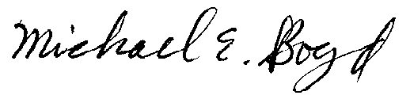
President-CARE 1-12-01

MEC Committee’s January 4, 2001 Ruling in Regards to CARE’s Original Petition


STATE OF CALIFORNIA
Energy Resources
Conservation and Development Commission

In the Matter of: ) Docket No. 99-AFC-3
)
Application for Certification for the ) RULING re: CARE's PETITION
Metcalf Energy Center [Calpine Corporation ) for HEARING and FUNDING
and Bechtel Enterprises, Inc.] )
____________________________________________)

I. BACKGROUND
On December 29, 2000, Intervenor Californians for Renewable Energy (CARE) filed a "Petition for a hearing on CEC 'override' of the City of San Jose, public participation, and Intervenor funding as part of the Evidentiary Hearings" (Petition). On January 2, 2001, CARE filed supplemental observations on this Petition.
The Petition essentially requests: 1) we suspend these proceedings and immediately focus upon the "override" issue, including court adjudication thereof; and 2) provide monetary compensation and reimbursement to CARE for its participation.

II. DISCUSSION
CARE's requests are simply spurious. The first would require us to reach a decision on a particular issue before considering all pertinent evidence of record, and the second seeks relief which we are not empowered to grant.

III. RULING
CARE's Petition is denied.
Date On Line: January 4, 2001
ENERGY CONSERVATION RESOURCES
AND DEVELOPMENT COMMISSION
ROBERT A. LAURIE, Commissioner WILLIAM J. KEESE, Chairman
and Presiding Member and Associate Member

CARE’s Original Petition of 12/29/00
CAlifornians for Renewable Energy, Inc. (CARE)
821 Lakeknoll Dr.
Sunnyvale, CA 94089
(408) 325-4690
STATE OF CALIFORNIA
Energy Resources Conservation
and Development Commission

In the Matter of: ) Docket No. 99-AFC-3
)
Application for Certification for the ) Petition for a hearing on CEC "override" of
Metcalf Energy Center [Calpine ) the City of San Jose, public participation,
Corporation and Bechtel Enterprises, Inc.] ) and Intervenor funding as part of the
) Evidentiary Hearings

CARE objects to CEC going forward with the presently scheduled evidentiary hearing process without first making a decision on whether to override--or attempt to override--the San Jose City Council's denial of the land use entitlements necessary for the construction of the MEC thermal powerplant. CARE respectfully demands that CEC immediately address the override issue, rather than allowing the parties, and the public, to go through an expensive, time consuming administrative review process that is rendered moot by the subsequent decision that the city's denial should not or may not be overridden. The most rational and logical approach is to deal with this override issue, including by allowing not only an administrative but also a judicial determination on the appropriateness of the override. There are specific provisions in the Warren Alquist Act, which provide for an "override" of local government under very specific circumstances. If you review substantive changes in the act over the last several years, you will find that the override provision has been substantially modified. You need to review these provisions very carefully and compare it to any information in the FSA. In particular any reference in the record to ISO testimony should be carefully considered since they have testified under oath in the Otay Mesa Power Plant project (99-AFC-5) that their " federally delegated jurisdiction" is currently not operative because they do not have a tariff approved in the area. In other words the burden of proof is on the Applicant. The CEC's decision to go forward with the administrative proceedings even though the City of San Jose has denied the land use entitlements necessary for implementation of the MEC project as presently proposed, and the 11-0 vote by the San Jose City Council, as well as the fact the MEC project would interfere with and possibly cause the demise of the heavily favored CVRP project, indicate beyond even a reasonable doubt that the city will not be changing its position and will not be approving the MEC project in the reasonably foreseeable future.

As a matter of law, as well as fact, the CEC is or certainly should be fully aware the City's land use denials may render the entire CEC proceedings moot. At best, it is highly questionable if the CEC has the power to override these particularly land use decisions, which include annexation and not merely general/specific plan or zoning amendments. The CEC has seldom if ever exercised its override power under even remotely similar circumstances.

And why should the CEC exercise its discretion to override the City of San Jose's decisions? In this regard, please note how CARE's ability to exert political influence on ecologically insensitive decision makers under the right to meaningful/effective public participation provided by CEQA comes into play (or is precluded from doing so).

At the very least the CEC should, and CARE respectfully demands that the
CEC hold the present administrative proceedings in abeyance while the legal issues concerning the agency’s override power are litigated by the appropriate court(s). The CEC's failure to take this course of action is not only wasteful of public funds and reckless in antagonizing local agencies, but is clearly prejudicial to, inter alia, the public's right to meaningful and effective public participation.

Given its extremely limited resources, CARE cannot afford to continue wasting them in this manner. Therefore, in the alternative, CARE respectfully demands the CEC compensate and reimburse CARE for the public participation costs already, being and to be expended or incurred. CARE respectfully demands that CEC immediately compensate or reimburse CARE for its public participation costs going back to at least the date of the City's land use denials. This is required to encourage and facilitate public participation because the CEC refuses to hold the present proceedings in abeyance while the issue of its legal override authority is conclusively resolved. This could have been and still can easily be accomplished by merely terminating the present proceedings and letting the applicant, if it so chooses in light of at least 2 ecologically superior project sites (especially in regard to public health & safety), take the matter to court. It is improper and a prejudicial abuse of discretion for the CEC to shift the burden to the public and the intervenors to go through what may become a totally meaningless administrative review process before being able to challenge the CEC's override authority.

There is urgency if not an emergency nature to CARE's demand for immediate compensation or reimbursement of public participation costs. Without the immediate receipt of such resources, CARE's ability to adequately and fully present relevant, objectively based information, and admissible or potentially admissible evidence, will be substantially impaired and substantially prejudiced. Our demand is supported by the Legislature's recognition, both in regard to the CEC as well as the PUC statutory schemes, that compensation or reimbursement of public participation costs is absolutely essential to assure adequate public participation. Under CEQA, to be adequate public participation must be both well informed and meaningful/effective.

This is an issue of importance in the siting process. The CEC Committee in the Contra Costa Power Project (00-AFC-1), has begun deliberations on the issues of public participation pursuant CEQA and Intervenor funding. CARE respectfully demands the record in the Metcalf Energy Center (99-AFC-3) remain open on this matter until these deliberations (in 00-AFC-1) are completed

Respectfully submitted,
Michael E. Boyd, President 12/29/00

CARE’s additional filing of 1/4/01 in regards to the Original 12/29/00 Petition
CAlifornians for Renewable Energy, Inc. (CARE)
821 Lakeknoll Dr.
Sunnyvale, CA 94089
(408) 325-4690
STATE OF CALIFORNIA
Energy Resources Conservation
and Development Commission

In the Matter of: ) Docket No. 99-AFC-3
)
Application for Certification for the ) More on staff’s role visa vi the public, the
Metcalf Energy Center [Calpine ) CEC’s "override" of the City of San Jose,
Corporation and Bechtel Enterprises, Inc.] ) Public participation, and Intervenor funding
) As part of the Evidentiary Hearings

As reflected by the testimony of one of the CEC commissioners in the previously submitted transcript of the public hearing held by the CEC on the Delta Energy Center project, there appears to be a good deal of question and confusion about the nature and appropriate scope of the right of public participation, including the proper role of CEC staff and other CEC members (agents or representatives subject to CEC control) in providing and enforcing the kind of well-informed and meaningful public participation that includes affording the public full and fair opportunity to exert political influence to compel CEQA compliance. These issues, as to which doubt and confusion is clearly shown, directly affect the requisite type of public participation allowed in these CEC administrative review proceedings. One such issue is whether CEC staff independently represents the interests of public (rather than the agency conducting the administrative review, which will become the respondent in any subsequent enforcement action).

The questions raised by Commissioner Moore are as perplexing as they are crucial to adequate public participation. They reflect a lack of a comprehensive, cohesive and firm understanding of the public participation requirement and its various elements under the CEQA as well as Warren-Alquist Act or other statutory authority.

As but one further example, how can CEC staff adequately represent the interests of the public and the public's right to well-informed and meaningful public participation when the CEC itself is an actual or potential adversary/party-litigant? If CEC staff is to carry out such a function, what are the measures necessary to eliminate or mitigate the conflict of interest problems based on the simple fact staff would be required to take action (e.g., conduct investigations, research, analysis, etc., and disclose evidence or information) contrary to the CEC's actual or potential litigation (administrative or judicial) interests? Does the CEC contend its staff is a representative of the public as to legal as well as factual issues arising in the administrative review process? These are such serious threshold matters they clearly should have been dealt with at the beginning, not near the end (or at least more than halfway into) the review process. The failure to do so has been and continues to be actually or potentially prejudicial to CARE and other members of the public, and a prejudicial abuse of the CEC's discretion calling for the termination of the present proceedings and the initiation of new ones in accordance with and not in violation of the law. CARE respectfully demands nothing less.

Of course, as CARE has previously pointed out, the present proceedings should have been (and certainly should be immediately) abated to deal with the existence, nature, scope, and appropriateness of the CEC's override authority. The CEC's refusal to abate the proceedings has obviously resulted in a waste of scarce, valuable and absolutely essential resources by CARE and other members of the public. It has also resulted in the CEC's squandering of public funds. After all, if it eventually turns out the CEC does not have or should not exercise override authority, it is the taxpaying public that will be stuck with bill for all the work done for naught by the CEC. CARE respectfully demands these matters be fully aired out as soon as possible, whether as part of the upcoming evidentiary hearing process or otherwise. At the very least, CARE and other members of the public have a right to be fully aware of the CEC's basic positions regarding such vital, threshold topics, as well as the many other issues raised by CARE.

PLEASE TAKE FURTHER NOTICE that, as previously indicated, the failure to address the override issues in a timely, direct, clear and effective manner has caused and is causing actual prejudice to CARE and other members of the public. Insisting that the administrative review proceedings continue unabated even though a resolution of the override issues may render those proceedings moot. One ideal example is if or when there is an administrative or judicial determination that CEC lacks legal authority to do anything other than defer to the city's proper exercise of legislative power in denying the MEC project. In addition, in denying the project the city made a policy (political, social, whatever it may be called) decision that the CVRP project should take precedence over the MEC. This is well within the city's legislative power. Indeed, one of the override issues that must be dealt with and could be conclusive in rendering the MEC administrative review moot is whether this is a violation of the separation of powers doctrine.

In closing, the actual prejudice CARE has suffered and continues to suffer stems from, at least in part, the fact that CARE and other members of the public have been forced to spread their already thin resources further than necessary, thus not only interfering with the right of well-informed and meaningful public participation in the CEC's administrative review process for the MEC project, but also violating the right of CARE and other members of the public to adequate public participation in the administrative review processes of the various other CEC projects currently pending, in many of which CARE are or may become involved.

Respectfully submitted,
Michael E. Boyd, President 1-4-01

CARE’s Response to the Curt, Demeaning and Summary Denial of CARE's Petition 1/5/01
CAlifornians for Renewable Energy, Inc. (CARE)
821 Lakeknoll Dr.
Sunnyvale, CA 94089
(408) 325-4690
STATE OF CALIFORNIA
Energy Resources Conservation
and Development Commission

In the Matter of: ) Docket No. 99-AFC-3
)
Application for Certification for the ) Response to the Curt, Demeaning and
Metcalf Energy Center [Calpine ) Summary Denial of CARE's Petition
Corporation and Bechtel Enterprises, Inc.] ) on the Override of the City of San Jose

A brief, preliminary response to the curt, demeaning and summary denial of CARE's petition on the override issues is warranted. First of all, the public has the statutory as well as constitutional right to make even "spurious" comments. This does not relieve the CEC from its duties to adequately address, investigate, etc., the comments, or any part thereof that isn't completely spurious. In addition, when coupled with the CEC's conduct toward CARE and other members of the public in this case, the denial helps make it quite clear it is futile for CARE to continue participating in the pending proceedings, since it is now more clearly apparent than ever that the CEC does not intend to afford CARE the kind of well-informed, meaningful public participation required by law. For this reason, CARE hereby notifies the CEC that CARE will no longer expend its funds towards the costs of providing its witnesses for cross examination at the upcoming evidentiary hearings, unless they choose to do so on a voluntary basis. CARE is no longer able to fund meaningful participation as such expenditures of funds has proven futile to date in the Commission’s so-called CEQA equivalent process. The summary denial of CARE's petition also establishes that, inter alia, the CEC has reviewed CARE's petition and extensive comments on the absolutely essential override issues, and in addition to refusing to do anything about them, the CEC does not specifically object or rebut any of the factual (if not legal) assertions we have been making. For example, the CEC does not deny there is only one way the MEC project will be approved, which is for the CEC to exercise the override authority it claims to have, while completely refusing to even discuss the nature, scope and appropriateness of the exercise of that authority.

It is the CEC that is being spurious by claiming that, at all costs, it has to go through the entire administrative review process in order to determine whether it has override authority, and whether that authority should be exercised in the present case. What good will further review do in regard to that particular issue? What additional factors will the CEC be looking for in making the override determinations? It is shocking and appalling that the CEC doesn't even recognize its duty to provide details in regard to something so unusual and so vital. We do not believe the courts will condone such an approach.

Respectfully submitted,
Michael E. Boyd, President 1-5-01

CARE’s 1/8/01 Response in Regards to CARE’s spurious requests on the CEC’s "override" of the City of San Jose, public participation, and Intervenor funding
CAlifornians for Renewable Energy, Inc. (CARE)
821 Lakeknoll Dr.
Sunnyvale, CA 94089
(408) 325-4690
STATE OF CALIFORNIA
Energy Resources Conservation
and Development Commission

In the Matter of: ) Docket No. 99-AFC-3
)
Application for Certification for the ) In Regards to CARE’s spurious requests
Metcalf Energy Center [Calpine ) on CEC "override" of the City of San Jose,
Corporation and Bechtel Enterprises, Inc.] ) Public participation, and Intervenor funding
) As part of the Evidentiary Hearings

CARE objects and reiterates its prior objections, and CARE respectfully demands that the CEC immediately take appropriate remedial steps regarding the now well-established practice of summarily dismissing CARE's input on the essentially false, unfair and misleading grounds that CARE's input is "spurious" (according to the CEC) or "puzzling" (according to the applicant in concert with the CEC), or otherwise improperly stated or presented in accordance with undisclosed arbitrary criteria for the administrative admissibility of such input. Even if the spurious and puzzling charges were generally true, and they certainly are not (as an unbiased tribunal would/will surely determine), this does not relieve the CEC of its duty to conduct a fair and adequate investigation, and provide fair and adequate responses to the concerns, demands and comments submitted by the public during the ongoing administrative review process.

It bears repeating that neither the CEC nor the applicant, have even the slightest authority to impose arbitrary, qualitative requirements on public input. Doing so is unlawful, period. Doing so causes ACTUAL PREJUDICE that includes the loss of political and financial support from those members of the public that are misinformed and misled. This actual prejudice contributes to the cumulative adverse effects being imposed on CARE and other members of the public, such as the failure and refusal to provide CARE with effective public participation assistance.

PLEASE TAKE FURTHER NOTICE that no matter how futile, to the extent its limited resources and the actual prejudice it is sustaining allow, CARE will not be dissuaded from attempting to participate in the ongoing administrative review process, as well as that of other CEC powerplant projects, and attempting to do so in a well-informed and meaningful manner.

As CARE has been telling the CEC all along, despite the clearly apparent ongoing futility of it, we have been doing the best we can given, inter alia, the complex and confusing nature of the subject matter, along with the severe time, money, personnel and other restrictions you are all fully aware of--not to mention the refusal to provide any effective assistance and the causing of actual or potential prejudice.

In acting exclusively in the public interest, CARE should be-and in many circles is--commended for such resilience. CARE deserves, in accordance with statutory and constitutional law, far better than to have its input summarily dismissed and ignored in the fashion being perpetrated by the CEC in concert with the developer.

As CARE recently asked, could this have anything to do with the fact that the CEC quite correctly perceives itself a potential party-litigant in litigation brought by CARE and other members of the public? For example, could it be that the CEC is avoiding setting out its detailed legal position, and the basis for that position, regarding such issues as the adequacy of public participation and whether the CEC has the authority to override local agencies such as the City of San Jose in these proceedings?

IN FURTHER RESPONSE to the CEC's summary denial of CARE's demands on the Mr. Kisabuli matter, it beggars belief that the CEC would claim a failure "to perceive any disadvantage to CARE by the witness substitution" in light of our offer of proof that, as fully known to the CEC, Mr. Kisabuli has information or evidence, including his personal observations and experiences, on the CEC's interpretation/application of the public participation procedures/requirements-including, more particularly, the withholding of evidence or information from the public. We believe Mr. Kisabuli's testimony will help show the CEC has consistently taken-and continues to take--steps to curtail public participation, particularly when it takes the form of strong opposition that challenges the CEC's fundamental authority or jurisdiction (e.g., the override issue).

This brings up the matter of the CEC's efforts (or lack thereof) to formulate and implement an effective public participation cost compensation or reimbursement program, as to which there has been legislative recognition that the adoption and implementation of such a program is essential; CARE has recently submitted a great deal of evidence or information; and the CEC has summarily denied CARE's requests in the manner previously discussed.

Attached is the letter dated 04-20-92 from state senator Rosenthal to CEC chairman Imbrecht (the letter). CARE respectfully demand(s), or reiterates its prior demand(s), that the CEC fully address all the matters discussed in the letter, and particularly the CEC's efforts to secure funding for and otherwise adopt/implement a viable Intervenor Funding Program, or similar program aimed at enhancing public participation in the CEC administrative review process. We believe the public is entitled to a full history and a full report on matters so absolutely vital to well-informed and meaningful public participation.

Respectfully submitted,
Michael E. Boyd, President 1-8-01

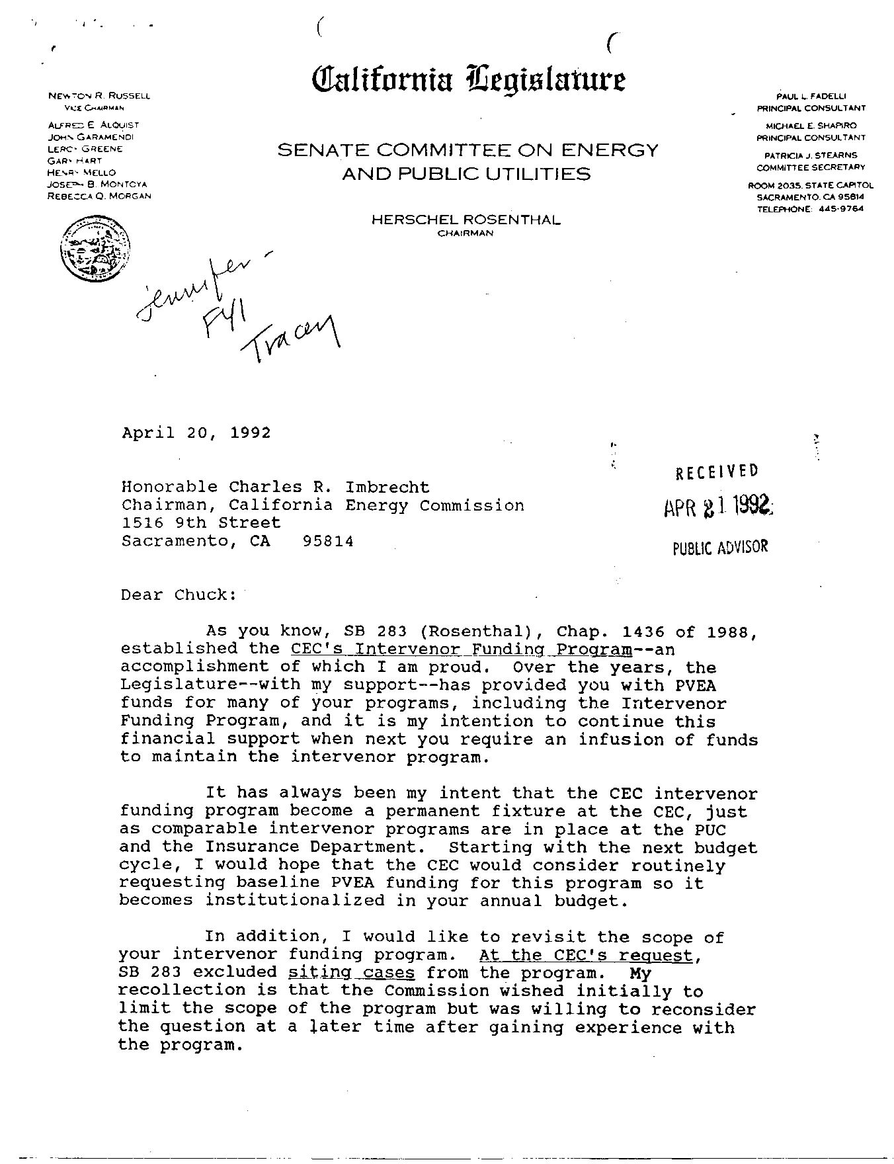
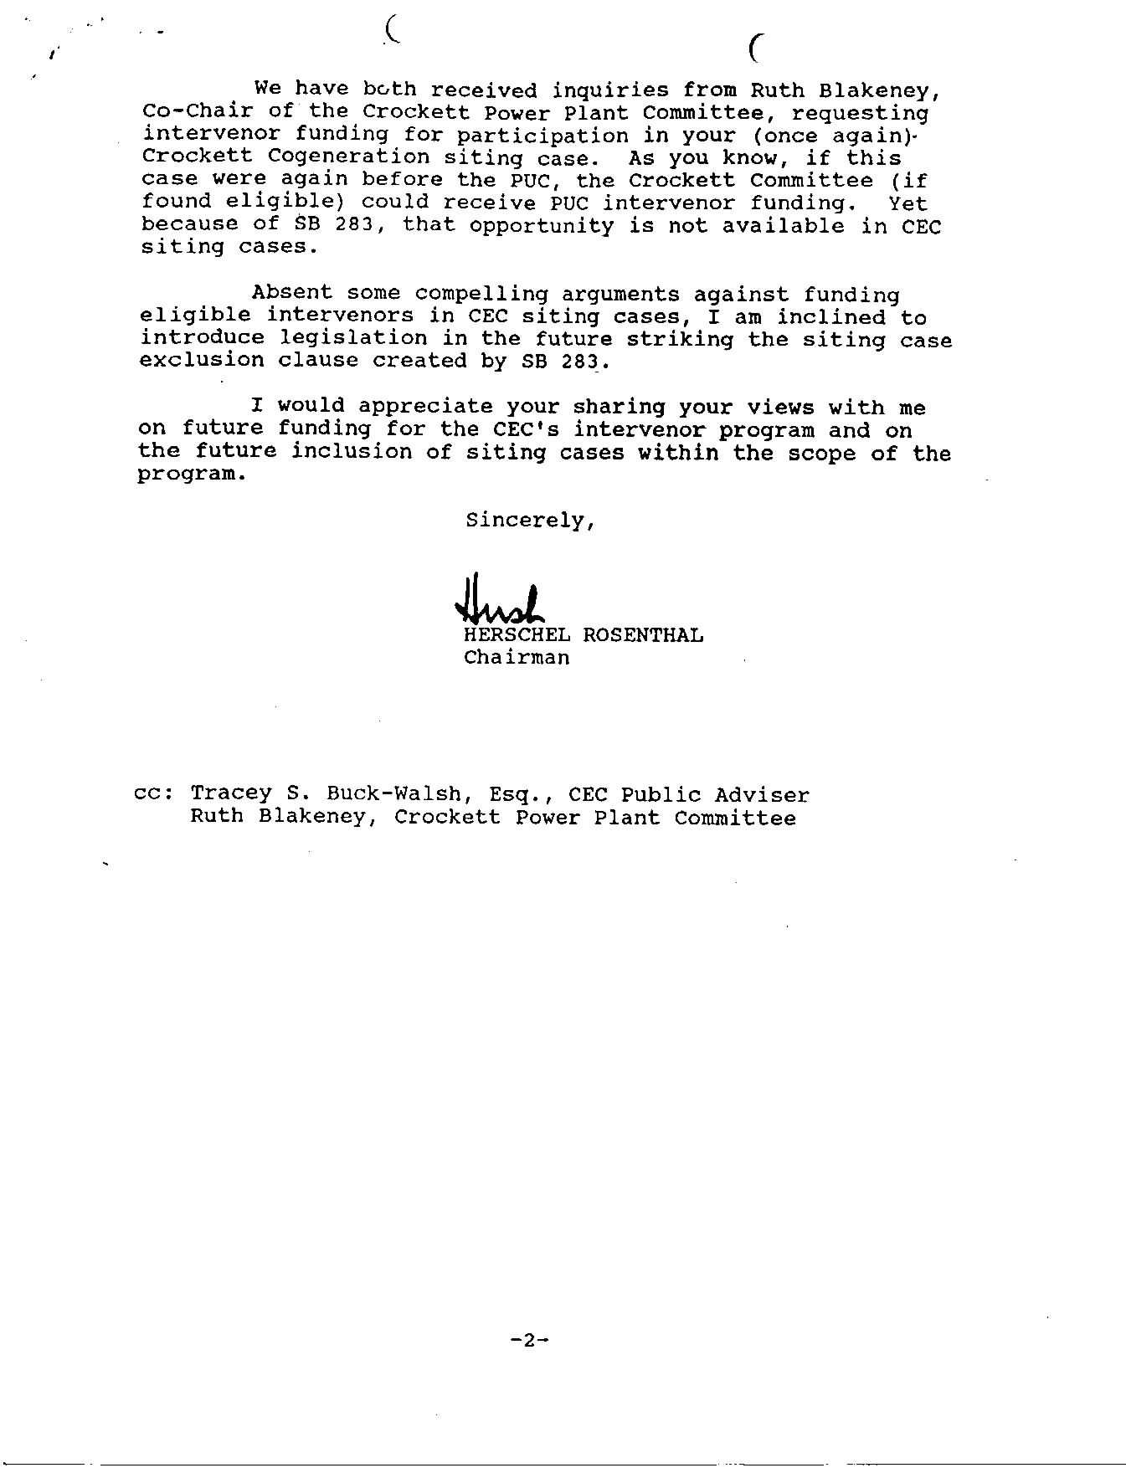
1/9/01 Regarding CARE’s spurious requests on the CEC’s "override" of the City of San Jose, public participation, and Intervenor funding as part of the Evidentiary Hearings (98-AFC-3)
CAlifornians for Renewable Energy, Inc. (CARE)
821 Lakeknoll Dr.
Sunnyvale, CA 94089
(408) 325-4690
STATE OF CALIFORNIA
Energy Resources Conservation
and Development Commission

In the Matter of: ) Docket No. 99-AFC-3
)
Application for Certification for the )More Regarding CARE’s spurious requests
Metcalf Energy Center [Calpine ) on CEC "override" of the City of San Jose,
Corporation and Bechtel Enterprises, Inc.] ) Public participation, and Intervenor funding
) As part of the Evidentiary Hearings
Among other objectionable acts, the CEC has officially reached the harsh and demeaning conclusion that CARE's input is "spurious" because we demand that the override issue be addressed immediately, and we contend it should've been addressed long ago and no later then the date the City of San Jose denied the project on a unanimous vote of the city council under circumstances making it perfectly clear the city isn't about to change its mind because doing so may jeopardize a far larger project the city adamantly wants to keep.
At the risk of being redundant and again being chastised as "spurious," or "puzzling" and thus capable of depriving the applicant of its constitutional due process rights, as the applicant would have us believe while acting in concert with the CEC to inflict actual prejudice upon and otherwise deprive CARE and other members of the public of their constitutional and statutory rights, CARE again respectfully demands that it be fully and fairly disclosed to the public precisely what additional information is needed by the CEC to determine whether it has the power to override LORS or CEQA (e.g., does the CEC have the power to override CEQA even in the face of feasible alternatives that the applicant refuses to adopt?) in this particular case, and whether it should exercise that right. CEC is now fully aware of the tremendous adverse impact on, and the substantial actual prejudice to, public participation its decision to defer making an override decision has had and continues to have, while refusing to even consider compensating or reimbursing CARE and other members of the public for such potentially unnecessary participation costs. Doesn't the CEC's duty to allow, assure, encourage and enhance public participation carry any weight whatsoever in making the deferral decision? Why? Under what authority? And does the CEC really believe it can avoid answering these questions posed by the public on the pretext they are spurious because the CEC is somehow required to complete the entire administrative review process before deciding even if it has the power to override (which is the only way the project can go forward)? And, since continuing the administrative review process under the present circumstances only helps the applicant, shouldn't the applicant, at the very least, pay for the cost of public participation?

Non-spuriously and clearly yours,
Michael E. Boyd, President 1-9-01

