CAlifornians for Renewable Energy, Inc.(CARE)
821 Lakeknoll Dr.
Sunnyvale, CA 94089
(408) 325-4690
STATE OF CALIFORNIA
Energy Resources Conservation
and Development Commission

In the Matter of: ) Docket No. 99-AFC-3
)
Application for Certification for the ) "Good Cause" Pursuant to CCR 1023(f)
Metcalf Energy Center [Calpine )
Corporation and Bechtel Enterprises, Inc.] )

Pursuant to CCR 1023(f), CARE respectfully submits it has shown, and upon request can and will show additional and ample "good cause" to be eligible for the lengthening of the time required for compliance by CEC regulations imposing harsh requirements on well informed and meaningful (including politically effective) public participation. That good cause includes, without limitation, the CEC's failure to apply for or otherwise follow up on securing funding and other resources to establish and carry out an effective, fair program to compensate for or reimburse public participation costs-particularly the cost of retaining and keeping on the job legal and scientific experts legislatively recognized as essential to adequate public participation in CEC administrative proceedings.

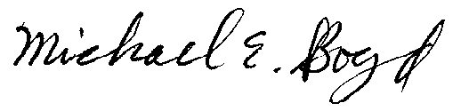
President-CARE 1-20-01

