DECLARATION OF

James B. MacDonald

I, Jim MacDonald, declare as follows:

- I am presently a member of the Board of Trustees of the Pittsburg Unified School District, in Pittsburg California.
- I provided expert oral testimony in regards to Environmental Justice on the Los Medanos Energy Center (98-AFC-1).
- I provided expert testimony and acted as an expert witness for CARE in regards to Environmental Justice during the evidentiary hearings on the Delta Energy Center (98-AFC-3).
- I provided the CEC a copy of Pittsburg Unified School District Resolution 99-32 (see figure 1), which calls on the US EPA to declare the community of Pittsburg an Environmental Justice community.
- I am a party to the complaint of discrimination in permitting filed with the US EPA Office of Civil Rights, against the California Energy Commission, Bay Area Air Quality Management District, California Air Resources Board, and the City of Pittsburg (Case#2R-00-R9).
5. It is my professional opinion that the applicant’s prepared testimony is invalid and inaccurate with respect to the issue(s) addressed herein.
6. I am personally familiar with the facts and conclusions related in the testimony and if called as a witness could testify competently thereto.

I declare under penalty of perjury that the foregoing is true and correct to the best of my knowledge and belief.

DATED: January 11, 2001 Signed: 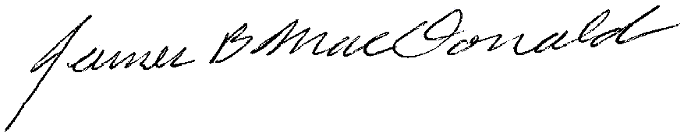
Location: Pittsburg, California

California Energy Commission Metcalf Energy Center siting Committee,

I have been asked to give testimony by CARE to the CEC in regards to Environmental Justice issues before the CEC. I am on record in the Los Medanos Energy Center case (98-AFC-1) and the Delta Energy Center Case (98-AFC-3) as to my views and concerns regarding the CEC's lack of understanding of EJ issues and demand that my testimony in these cases be incorporated by reference in this case. This testimony can be found in the administrative record for plant siting 98-AFC-1, and 98-AFC-3. I provided the CEC a copy of Pittsburg Unified School District Resolution 99-32 (see figure 1), which calls on the US EPA to declare the community of Pittsburg an Environmental Justice community, please incorporate this in this case by reference. I have thorough knowledge of the EPA Title VI guidelines and have given testimony at two National Environmental Justice Advisory Commission Conventions. I am a party to the complaint of discrimination in permitting filed with the US EPA Office of Civil Rights, against the California Energy Commission, Bay Area Air Quality Management District, California Air Resources Board, and the City of Pittsburg (Case#2R-00-R9). I respectfully demand that this complaint, and four amendments (as of this date), be incorporated by reference in the administrative record, in this case.

I will not be attending CEC hearings on socio-economics for the Metcalf Energy Center (99-AFC-3), because it is the opinion and the perception of many of the public participants, including myself, that the CEC has so weighted the scale against meaningful public input as to make it useless to participate.

Sincerely:
James B MacDonald 1-11-01

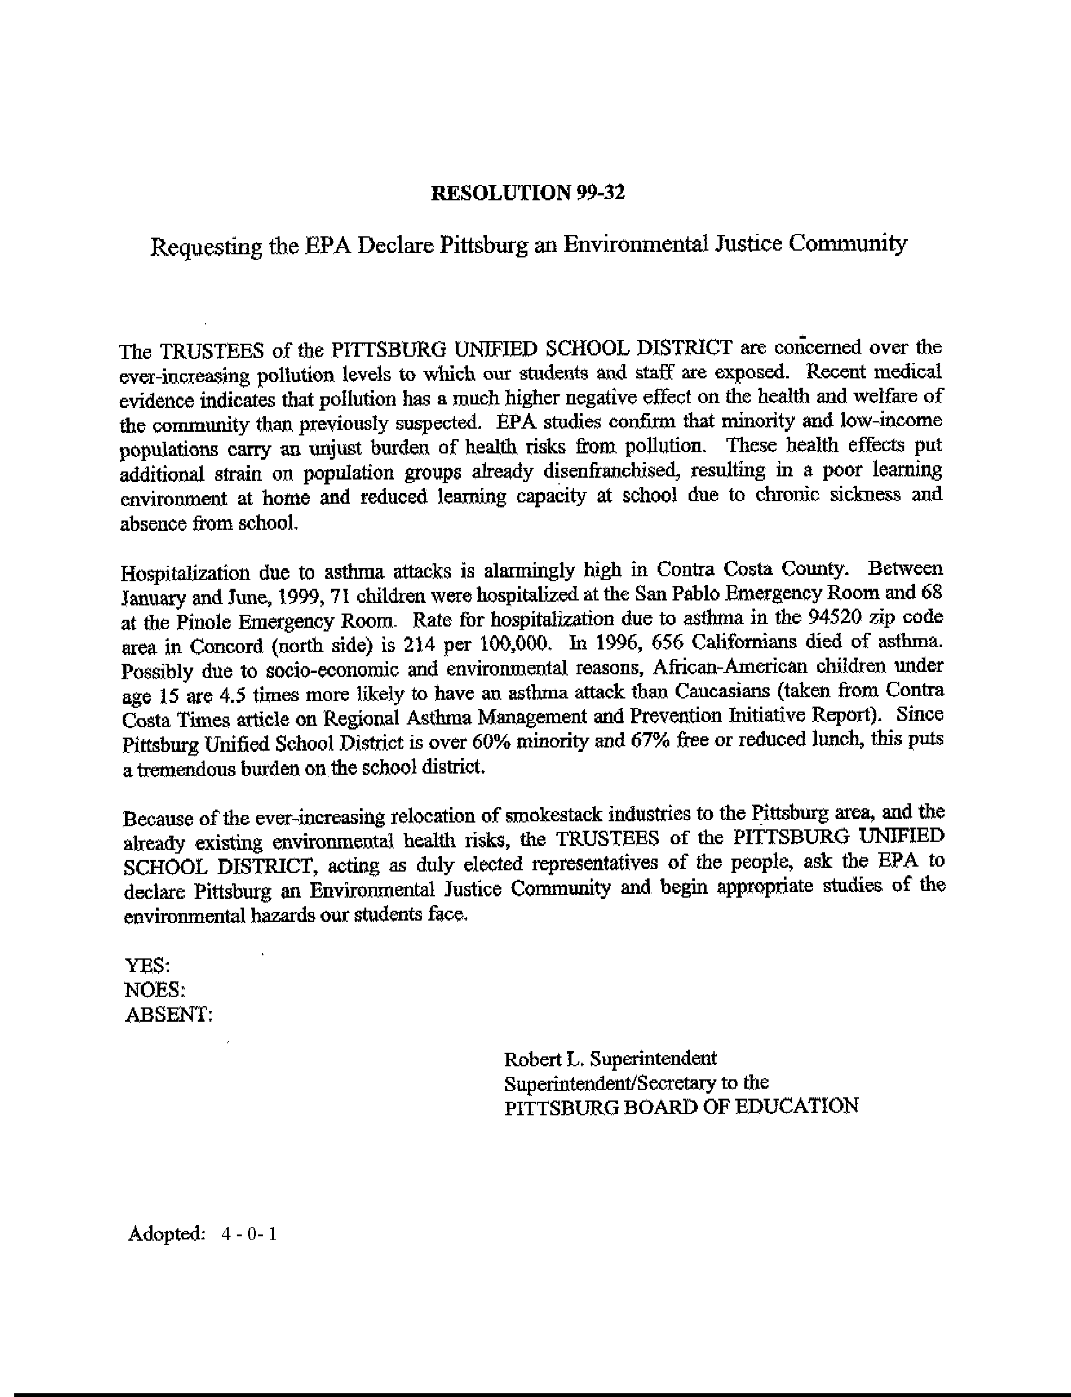
Figure 1 October 13, 1999 Resolution 99-32 of the Pittsburg Unified School District.

