CAlifornians for Renewable Energy, Inc.(CARE)
821 Lakeknoll Dr.
Sunnyvale, CA 94089
(408) 325-4690
STATE OF CALIFORNIA

Energy Resources Conservation
and Development Commission

In the Matter of: ) Docket No. 99-AFC-3
)
Application for Certification for the ) CARE’s Pre-hearing Brief 1
Metcalf Energy Center [Calpine )
Corporation and Bechtel Enterprises, Inc.] )

As you probably already know, CARE is a California private, not for profit Public-benefit Corporation relying exclusively on public funding. At the present time, CARE simply does not have the resources to obtain legal counsel and to fund expert consultants to fully, fairly, knowledgeably and meaningfully participate in your statutorily mandated administrative process. Therefore, CARE respectfully requests that your agency provide us with all available assistance to facilitate our public participation, including but not limited to an explanation of the administrative steps we must take in order to preserve and protect all our legal rights, particularly the right to have the issues we raise heard by a court of law in a legal proceeding to enforce our statutory and constitutional rights. We have already provided a great deal of sound, objectively based information and data (e.g., on biological resources and on the unavailability or serious shortages of natural gas), which you have completely ignored, trivialized, discouraged or otherwise failed to follow-up on. From where we sit, you have pretty much lost all credibility as an impartial fact-finding and decision-making agency. We see you primarily as strongly favoring the applicant in a process heavily weighed against project opponents and other members of the public. In other words, we believe in the most part you are implementing the basic goal of expediting the siting and construction of powerplants to deal with what is perceived as an energy crisis of urgent if not emergency proportions, rather than maximizing environmental protection to the fullest extent reasonably possible. This is why we say that the CEQA and Warrant-Alquist statutory schemes, as presently administered, are inherently in conflict.

In addition, and with all due respect, our understanding is that it is you as the administrative agency, and not CARE or other members of the public, who are required to conduct a full and fair investigation of matters as to which you have been put on notice by the submission of objectively-based, reasonably credible information, such as the information we have been providing you. It is our further understanding that the information we provide you with need not rise to the technical legal level of "substantial evidence" in order to trigger your duty to investigate. If our understanding is incorrect in any manner, please so advise us and explain in reasonable detail why. If our understanding is correct, please consider this our formal request for you to proceed in carrying out your duty to conduct an adequate investigation in accordance with the information CARE and other members of the public have provided or may provide in the future.

CARE will try to focus its brief on those subject matters identified for adjudication at the January 8, and January 9, 2001 evidentiary hearings.

Project Description
On November 29, 2000 the City of San Jose city council voted unanimously to deny the applicants proposed amendment to city’s general plan and land use designation changes. Additionally the city no longer guarantees the provision of sewer and water services to the proposed project. The applicant has failed to provide any project description changes subsequent to the City’s decision. CARE contends that for this project to go forward without the City’s concurrence will require a substantial to the project description. Please have the applicant provide intervenors and the public any proposed changes to the project description in its pre-hearing brief on this matter.

Compliance and General Conditions
The applicant's ability or willingness to comply with conditions to project approval, mitigation measures and similar obligations depending in large part on the good faith of the applicant to carry out even if left unsupervised. The applicants pre-hearing brief should include beefed up or additional monitoring measures to assure compliance given the applicant's prior legal difficulties and other conduct indicating the applicant may not fully discharge its duties in a good-faith manner. CARE provides evidence of the applicant’s poor track record of complying with the Conditions of Certification of the Los Medanos Energy Center (98-AFC-1) and the Sutter Power Project (97-AFC-2).

CARE has received information on Calpine/Bechtel’s compliance issues via a request pursuant to the California Public Records Act from the Commission. In a 11/16/00 correspondence from Chuck Najarian to Bob Therkelsen in regards to the “Los Medanos Stop Work Order” it states, “Several days ago we were notified that Calpine has constructed 99% of a short segment (about 900 feet) of the Los Medanos transmission line differently than what was described in the Decision and which may conflict with the existing conditions of certification. In doing so, they encroached on the City of Pittsburg property near designated future residential development because they went outside the 40-foot easement they obtained from the City. The designated CBO has placed a stop order on the transmission line segment in question.”

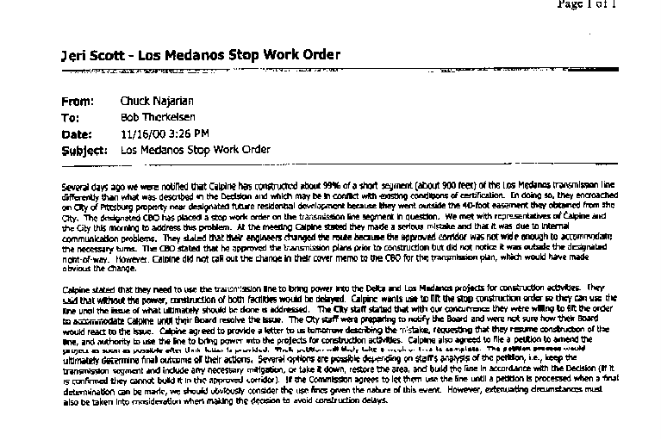
Figure 1 11/16/00 correspondence from Chuck Najarian to Bob Therkelsen in regards to the “Los Medanos Stop Work Order”
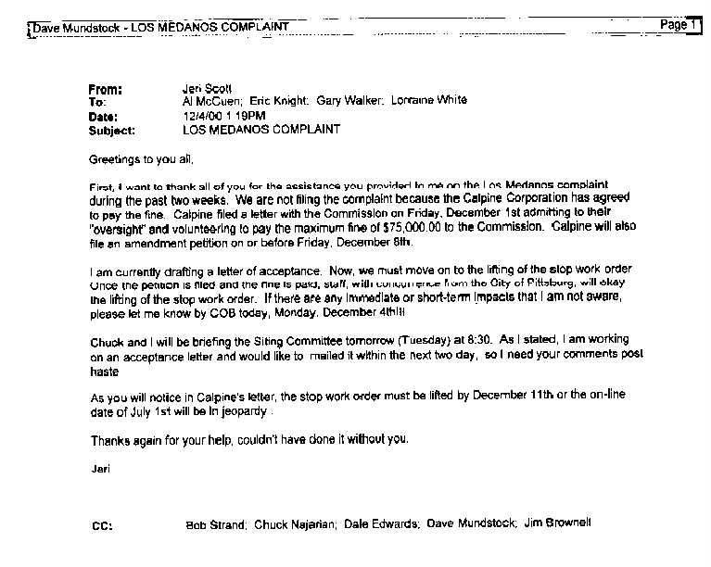
On 12/4/00 Compliance project manager Jeri Scott sent e-mail to Commission staff Al McCuen, Eric Knight, Gary Walker, and Lorraine White titled “Los Medanos Complaint”, where it states, “We are not filing the complaint because the Calpine Corporation has agreed to pay the fine. Calpine filed a letter with the Commission on Friday, December 1st admitting to their “oversight” and volunteering to pay the maximum fine (sic) of $75,000.00 to the Commission.” CARE contends this demonstrates the applicants and Commission staff’s propensity to look the other way on the environmental and socioeconomic impacts of this project’s failure to comply with Conditions of Certification. CARE requests adequate time and the presence of Jeri Scott, and Bob Therkelsen at the January 8th, 2001 hearing to more clearly identify staff’s role in this matter, and what compliance conditions will be placed on the applicant in regards to the Metcalf Energy Center as a result of past violations.
Figure 2 Compliance project manager Jeri Scott's e-mail to Commission staff titled “Los Medanos Complaint”

In regards to the rights of the public to participate, by this reference, we incorporate the attached December 19, 2000 letter to Commission chairman, William Keese, from Glenn May a reporter at the Contra Costa Times complaining about the inability of the press as well as the publics to obtain information required to meaningfully participate in the Commission’s proceedings, as well as all comments submitted by CARE on the subjects of public participation and the procedural/substantive unfairness, in the MEC proceedings. Please let us know immediately if you reject this attempt to incorporate these materials by reference without having to resubmit them. In this letter Mr. May states,

“Dear Mr. Keese,
I am writing to express my deep dissatisfaction with the performance of California Energy Commission staff and my resulting loss of confidence in the commission’s stated goal of providing California residents with full and complete information about power projects affecting them.

I am a reporter for the Contra Costa Times (Knight-Ridder) chain who covers the city of Pittsburg, which is, as I’m sure you’re aware, ground zero in efforts to site generation assets to ease the current power shortage.

As a reporter whose duty it is to relay information to a community particularly at risk to excesses of that zeal, I entrust the Energy Commission with providing me with full and thorough information on projects under its jurisdiction. After recent developments regarding the Calpine Los Medanos Energy Center, I fear that trust is misplaced.

To me, the residents of a community in which not one but two power plants are being built deserve at least a base level of disclosure. An admission by the constructor of those plants that it violated terms of its license, I believe, meets that threshold.

If you disagree, I would welcome hearing your rationale.

Ms. Scott is not, I am aware, a public information officer and I appreciate her willingness to discuss with me aspects of projects in which she is involved. As such, I understand her not taking the step of advertising what Calpine has done by issuing a press release.

But it is my strong belief that when presented direct questions about a matter in which she knew certification violations were involved, it was her duty to fully disclose the matter.

But she was not alone in playing possum.
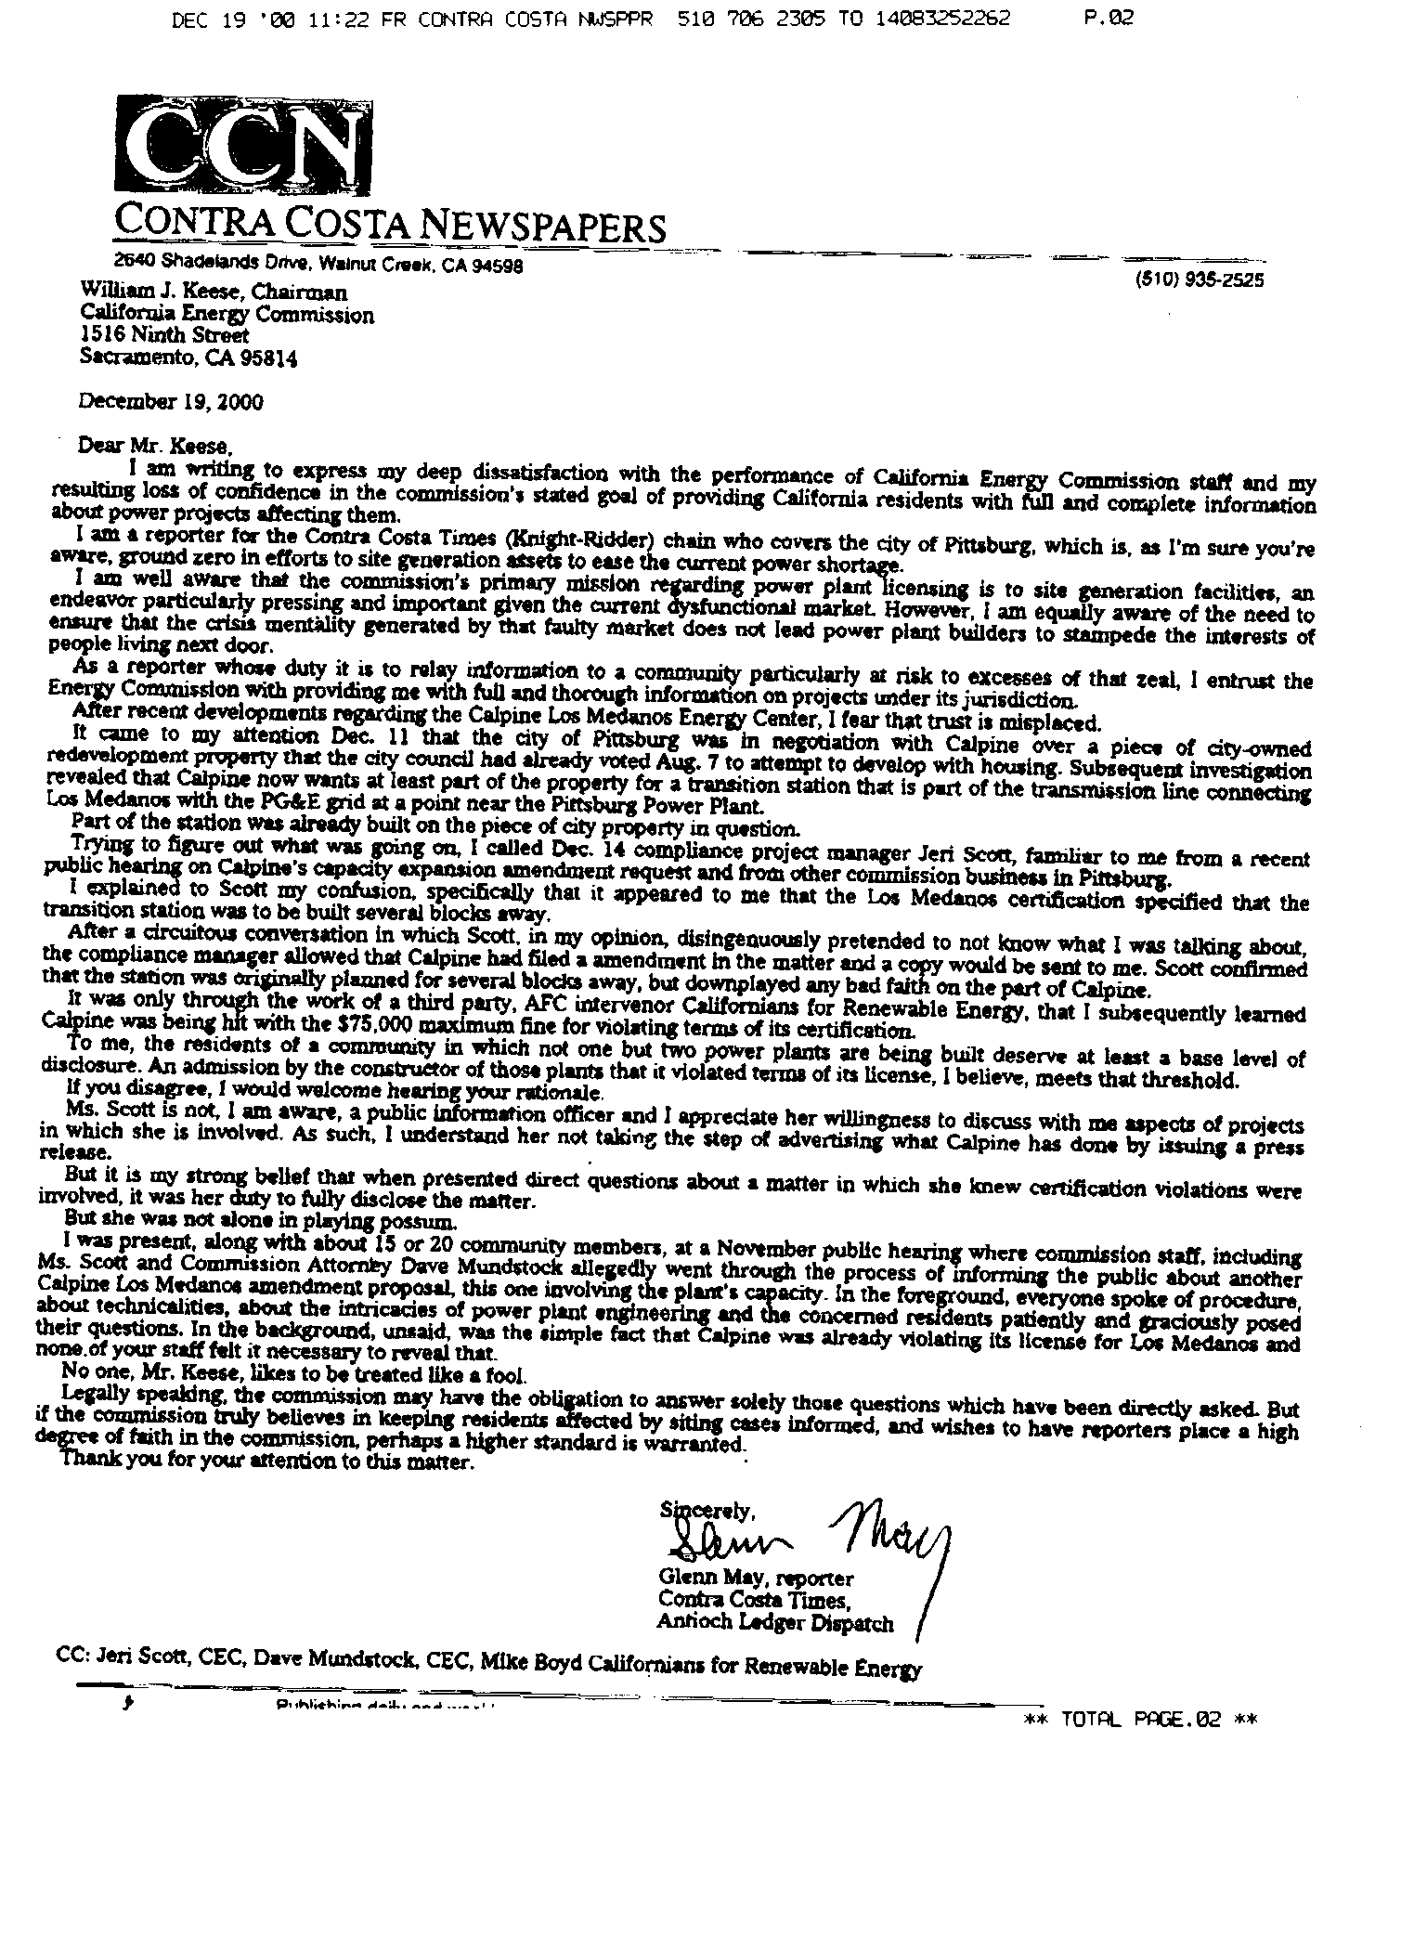
Figure 3 Letter Glenn May CC Times to Commissioner Keese on Compliance Staff

I was present, along with about 15 or 20 community members, at a November public hearing where commission staff, including Ms. Scott and Commission Attorney Dave Mundstock allegedly went through the process of informing the public about another Calpine Los Medanos amendment proposal, this one involving the plant’s capacity. In the foreground, everyone spoke of procedure, about technicalities, about the intricacies of power plant engineering and the concerned residents patiently and graciously posed their questions. In the background, unsaid, was the simple fact that Calpine was already violating its license for Los Medanos and none of your staff felt it necessary to reveal that.

No one, Mr. Keese, likes to be treated like a fool.”

One matter for consideration is Bechtel's treatment of its employees, as shown by a recent state Supreme Court case, Guz v. Bechtel National, Inc. (2000) 24 Cal.4th 317, 332. Among other things, in this litigation it is alleged, and there is evidence establishing at least a question of fact that Bechtel--or one of its corporate offspring--engaged in deceptive practices, that include the failure to follow its own policies, in order to cut costs. Of course, the tendency to disregard its own ameliorative policies in order to cut costs is a very relevant attribute of corporate character that needs full and fair investigation, and it is up to the CEC, not the public, to conduct this investigation. In this regard CARE cites the 10/6/00 e-mail from Bob Therkelsen to Compliance Officer Jeri Scott where it states, “On Wednesday, October 4th, Andrew Berna-Hicks of the Department of Toxic Substance Control telephone Mike Ringer to inform him of two alleged arsenic poisoning at LMEC. Apparently, two workers at the LMEC where exposed to arsenic contaminated soil on the site. One backhoe operator tested for exposure on October 9, 2000 (Sample C6896) listed an exposure level of 0.0053mg/m³ with a California OSHA action level of 0.0050mg/m³. CARE contends that Calpine/Bechtel is “engaged in deceptive practices, that include the failure to follow its own policies, in order to cut costs.”

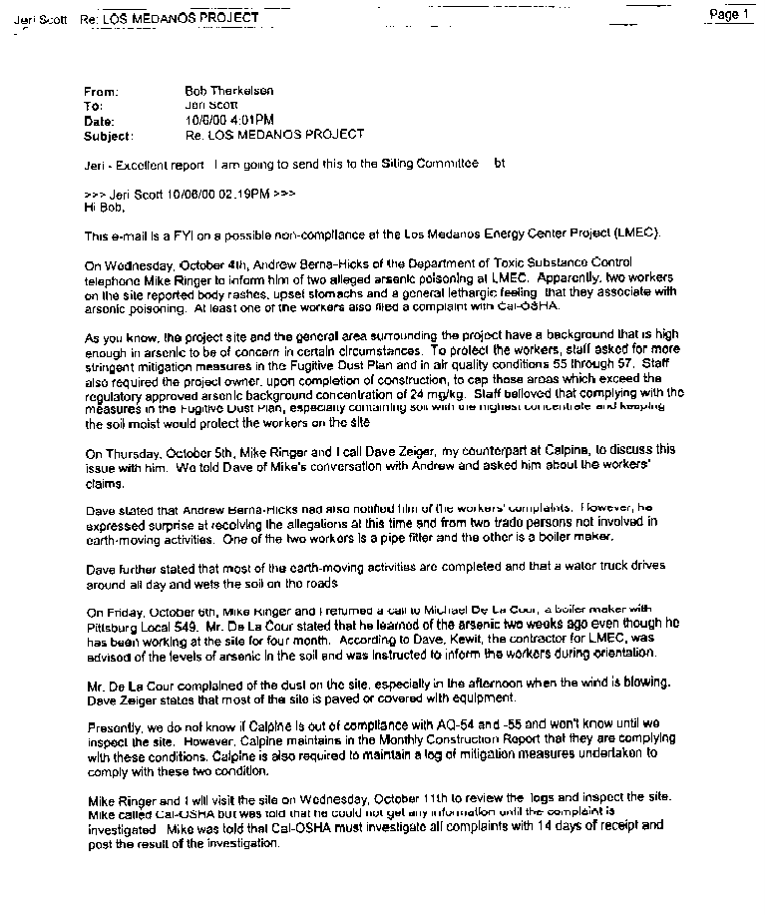
Figure 4 E-mail from Bob Therkelsen to Jeri Scott on Arsenic exposure of workers at LMEC
Finally, in regards to Calpine/Bechtels compliance problems CARE also cites for the record, Calpine’s compliance problems in Sutter where truckers hired by the company failed to confine traffic to the prescribed routes. Clearly there is a pattern of failure on the part of the applicant to comply the Conditions of Certification of projects you have already approved.
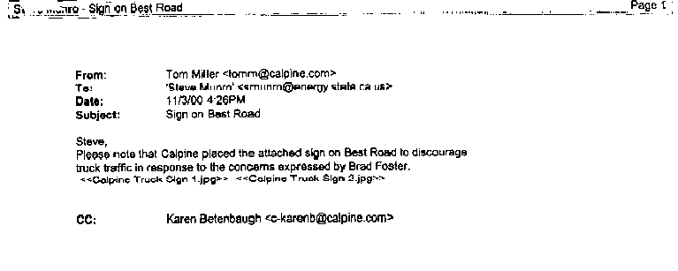
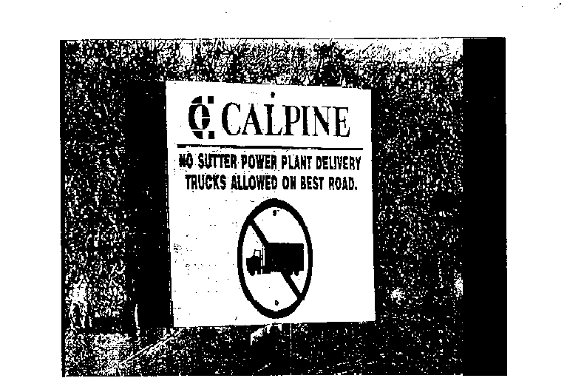
Figure 5 E-mail from Tom Miller to Steve Munro on Sutter truck routes to the project and sign.

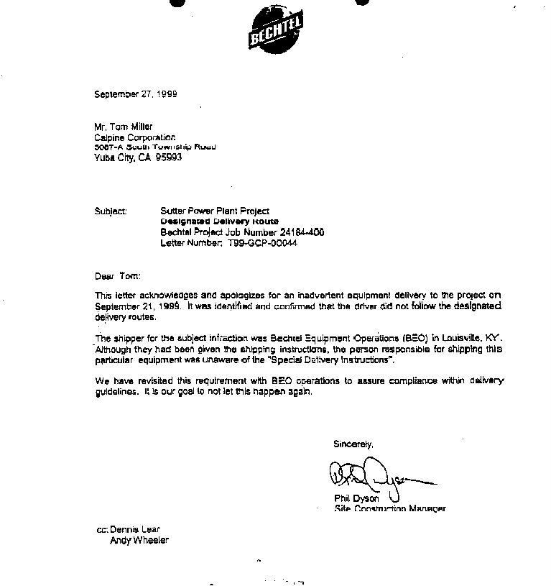
Figure 6 Letter from Bechtel on truckers using route not per the Conditions of Certification.
Geology
CARE notes that the FSA failed to identify two faults nearby the proposed site. CARE requests to make part the evidence the (included file PRINCIPAL FAULTS BnW.jpg) the original CH2MHILL geological fault map titled Source: Map showing recency of faulting, San Francisco- San Jose Quadrangle, California, Bortugno et al, 1991. CARE noted the presence of two nearby faults labeled the Piercy Fault, and the Bernal Fault. It appears on the subject map that these two faults may intersect at or near the Metcalf site. Please be prepared to discuss the presence of a possible subduction zone or thrust fault near the site during the evidentiary hearing. It should be noted that the Northridge earthquake occurred on an unknown thrust fault in a subduction zone in Northridge, which obscured it from detection prior to the earthquake.

Efficiency, Reliability, and Facility Design
CARE is concerned with the inadequacy of staff’s analysis of the effects of possible natural gas curtailments on the efficiency and reliability of the proposed facility’s design, with it sole fuel source being natural gas. In this regard CARE submitted a, “Motion to call a workshop on MEC alternative fuel sources to natural gas”, on 9/22/00. Again on 10/27/00 CARE issued a, “Motion for Reconsideration of a workshop on MEC alternative fuel sources to natural gas”, along with the expert testimony of two experts William Kucewicz and Dr. Bernard Weinstein. By this reference, we incorporate the foregoing filings by reference. Please let us know immediately if you reject this attempt to incorporate these materials by reference without having to resubmit them.

Cultural Resources
CARE has filed substantial evidence in regards to the presence of cultural resources. These include technical publications of local ethnographic history, and reports from two independent archaeologists Dr. Alan Leventhal and Katherine Davidson. CARE will resubmit these filings as requested at the pre-hearing conference. CARE has already raised some concern for the adequacy of the applicant’s analysis. CARE is highly disturbed that the Commission would abrogate its responsibility to the public and descendants of native people by allowing the applicant’s archaeological firm, Basin Research, to carry out trenching activities on the site without the owner’s concurrence and without a Native American representative from the Muwekma-Ohlone tribe present. CARE would like to call former site property owner Oliver Kramer as a witness to testify that he was not informed prior to trenching, and to substantiate reports of the owner’s discovery of native resources on the property.

CARE’s was concerned about the track record of the archaeological firm Basin Research because their apparently unethical (if not illegal) practice of trenching without a native monitor. To CARE’s amazement we have disclosed that the archaeological firm Basin Research has a poor track record in regards to cultural resources in general, and the cultural resources of the Muwekma Ohlone tribe in particular. On April 27, 1987 Ms. Rosemary Cambra (CARE’s witness) wrote to James Bard of Basin Research about, “possession of twenty seven burials recovered from site CA-SCI-519 for purposes of proper treatment and reburial.” On April 30, 1988 Ms. Cambra again wrote asking Native American Heritage Commission for their the return of tribal resources.

“I am formally requesting, as the designated native American and most likely descendent and on behalf of Citation Builders, that a written directive be issued by the Native American Heritage Commission, in compliance with SB-297, immediately ordering Basin Research…to relinquish any and all burial artifacts and related materials relevant to the site to Ohlone Families Consulting Services for proper preparation and re-interment.”

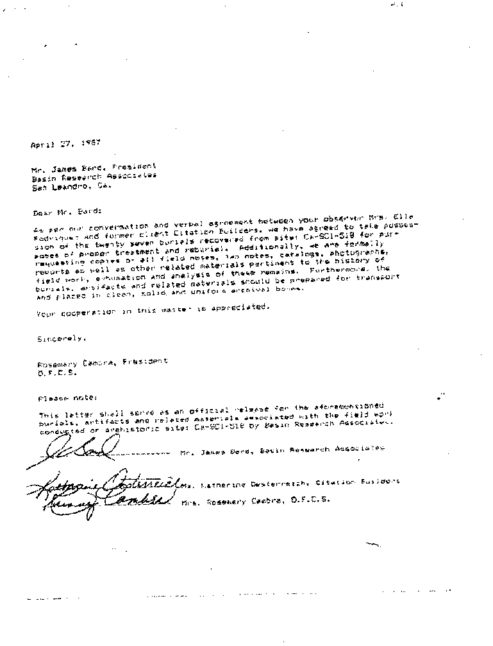
Figure 7 to James Bard of Basin Research about, “possession of twenty seven burials recovered from site CA-SCI-519 for purposes of proper treatment and reburial.”

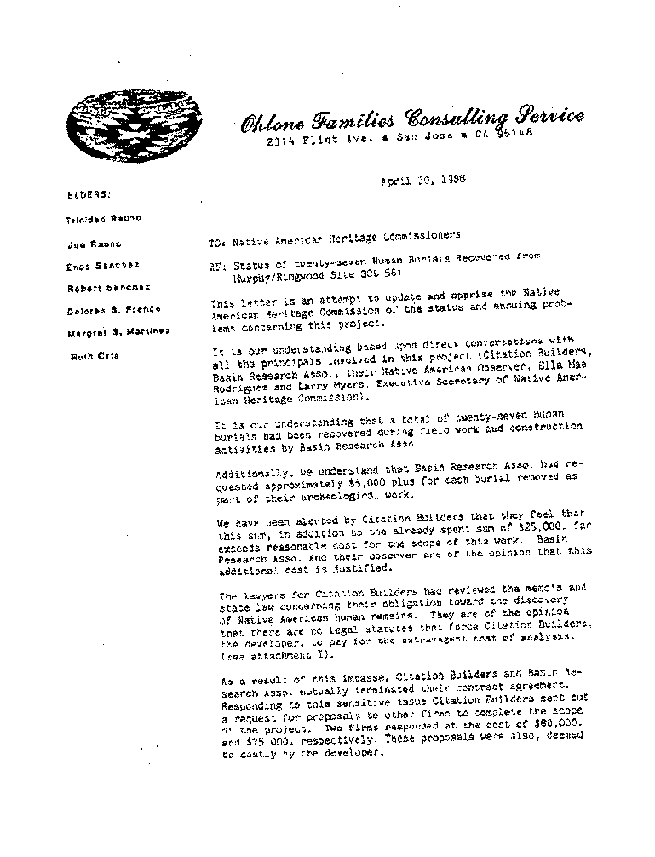
Figure 8 Page 1 Letter to Native American Heritage Commission

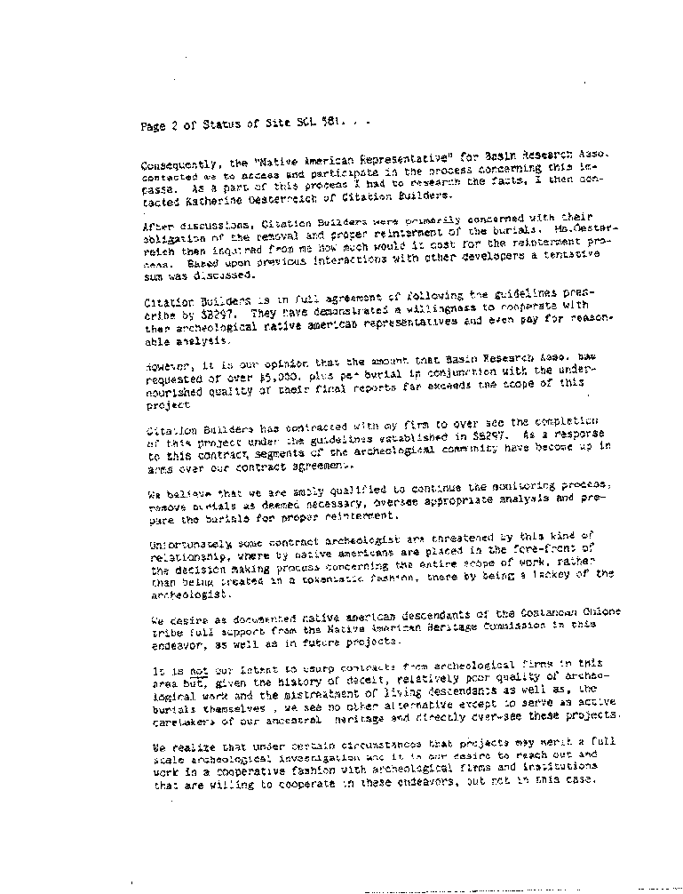
Figure 9 Page 2 Letter to Native American Heritage Commission

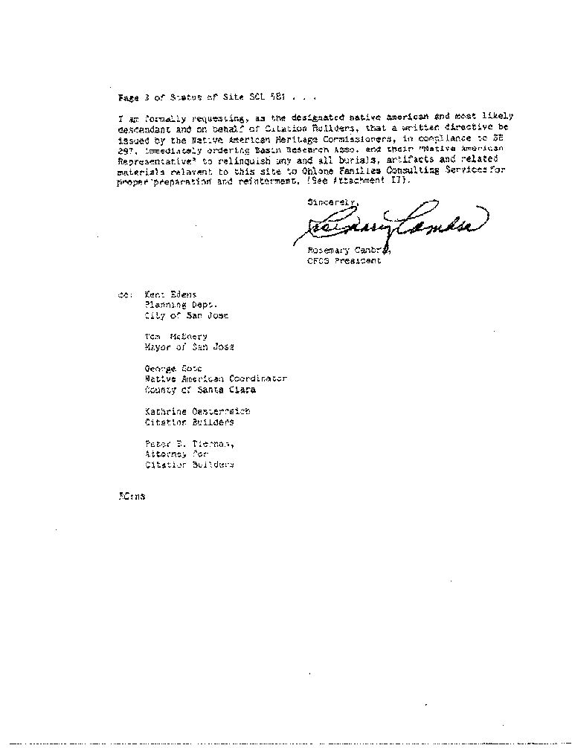
Figure 10 Page 3 Letter to Native American Heritage Commission
Basin Research refused to return the tribal resources until May 3, 1988 when the California Attorney General’s office issued an order, which states “under these circumstances, it would appear to me that you are required by law to return the human remains to the landowner for re-interment…I am aware of no provision of law which authorizes your continued possession of these remains…. I would appreciate hearing from you …whether you intend to persist in your refusal to release the remains to the landowner.” CARE hereby incorporates these documents by reference, and calls on the Commission to uphold all applicants to conditions of analysis that protect the cultural resources as well as the civil rights of the Muwekma Ohlone tribe. Your failure to properly protect these rights and property may surely be the subject of future judicial review.

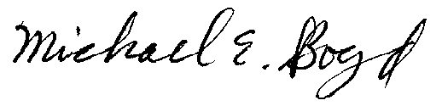
Michael E. Boyd – President, CARE 12-20-00

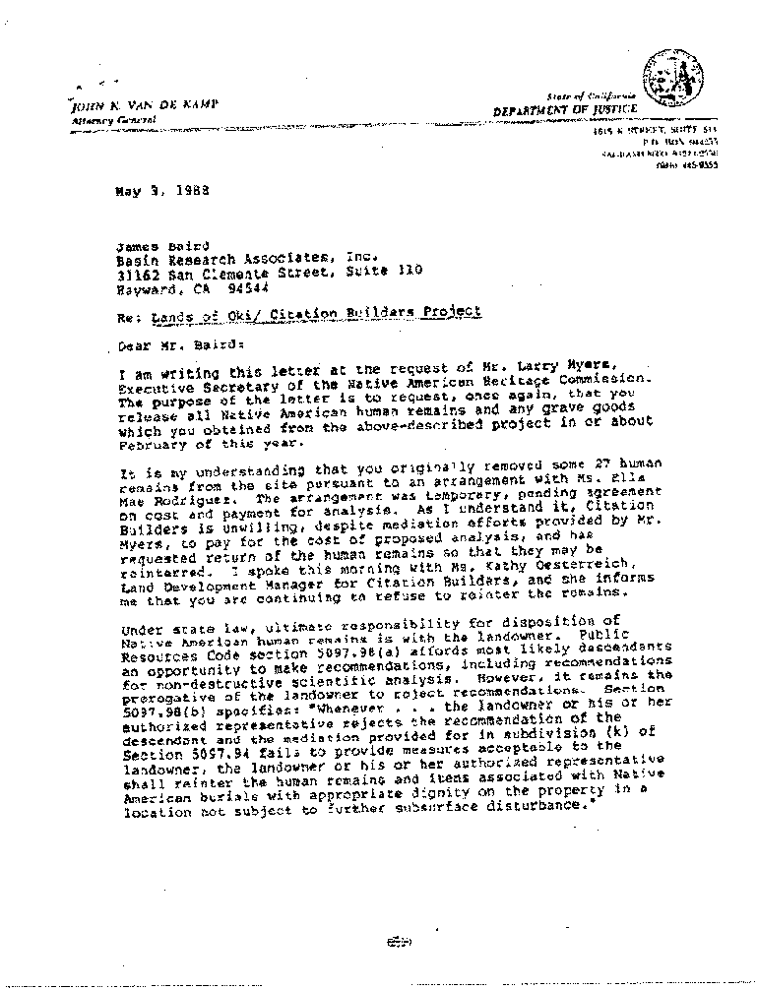
Figure 11 Page 1 of the Letter from Cal. Attorney General to Basin Research on the release of tribal remains.

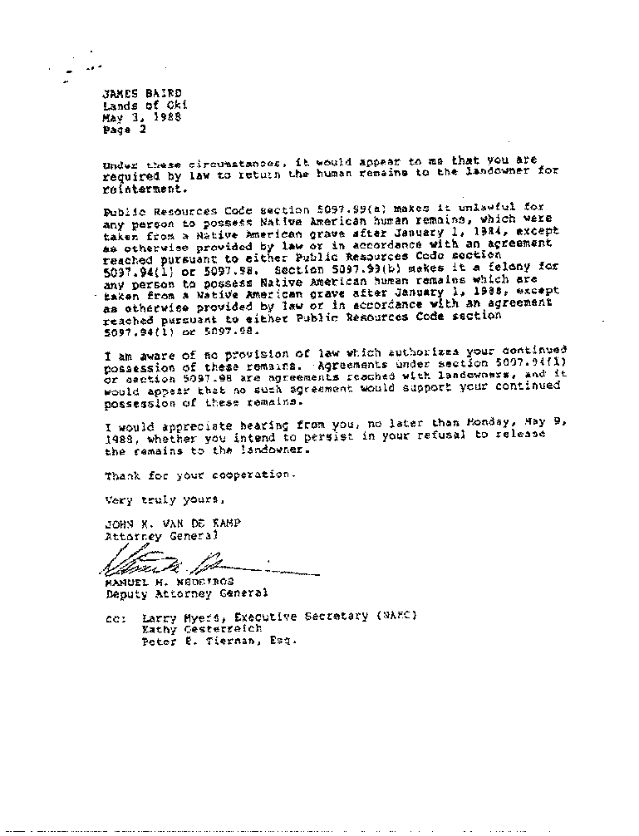

Figure 12 Page 2 of the Letter from Cal. Attorney General to Basin Research on the release of tribal remains

