CAlifornians for Renewable Energy, Inc.(CARE)
821 Lakeknoll Dr.
Sunnyvale, CA 94089
(408) 325-4690
STATE OF CALIFORNIA
Energy Resources Conservation
and Development Commission

In the Matter of: ) Docket No. 99-AFC-3
)
Application for Certification for the ) Section 1702(a) of 20 CCR 1701 et seq
Metcalf Energy Center [Calpine ) and PRC 21167.6(a) the CEQA "record of
Corporation and Bechtel Enterprises, Inc.] ) proceedings”

Section 1702(a) of the CEC site certification regulations (20 CCR 1701 et seq) provides that the "administrative record" (AR) for the MEC project contain "all materials that have been entered into the docket on the proceeding … include[ing] but … not limited to the hearing record." To the extent, if any, these or similar CEC provisions on the contents of the AR have been or are ever construed more narrowly than CEQA provisions on the same subject, and particularly PRC 21167.6(a) specifying the contents of the CEQA "record of proceedings," CARE objects and respectfully demands relief that includes immediate termination of all administrative proceedings (with the possible exception of activities relevant to the override issues), and restarting as well as conducting the administrative proceedings in compliance with the applicable law.

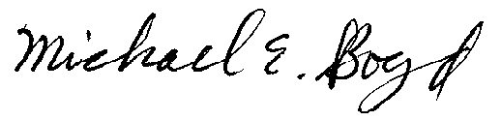
President-CARE 1-20-01

