CAlifornians for Renewable Energy, Inc.(CARE)
821 Lakeknoll Dr.
Sunnyvale, CA 94089
(408) 325-4690
STATE OF CALIFORNIA
Energy Resources Conservation
and Development Commission

In the Matter of: ) Docket No. 99-AFC-3
) CARE respectfully alleges and demands an
Application for Certification for the ) investigation of ongoing violations of law
Metcalf Energy Center [Calpine ) spelled out in the materials submitted by
Corporation and Bechtel Enterprises, Inc.] ) CARE in this administrative review process

This is all pursuant to 20 CCR 1231. CARE respectfully alleges and demands an investigation of ongoing violations of law spelled out in the materials submitted by CARE in these administrative review proceedings. The investigation should focus on matters regarding or reasonably related to whether, and precisely in what nature and to what extent, the CEC has override power/authority under PRC 25525, and whether as well as to what extent CARE and others have been and are being deprived of their right of public participation in regard to that dispositive subject. Assuming the CEC does not require all materials submitted to the CEC by CARE so far in these proceedings to be actually resubmitted to CEC's general counsel, CARE requests these allegations and requests be deemed duly filed with CEC's general counsel, along with CARE's further request for a jurisdictional determination of the presently proposed MEC site. All other regulatory requirements for this relief are already in the administrative record (or the CEQA record of proceedings) for the MEC project. The declaration required by CCR 1023(f), which has previously been made in regard to these proceedings generally, immediately follows.

As a duly authorized officer of CARE, I declare under penalty of perjury under the laws of the State of California that the foregoing is true and correct to the best of my knowledge and belief, and this declaration was executed by me on the date given below at Sunnyvale, California.

Respectfully submitted,

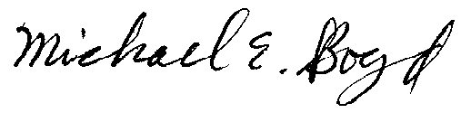
President-CARE 1-19-01

