To: Ellen Garvey

Bay Area Air Quality Management District
939 Ellis Street
San Francisco, CA 94109

From: CAlifornians for Renewable Energy, Inc. (CARE)
821 Lakeknoll Drive
Sunnyvale, CA 94089
(408) 325-4690

Request for Hearing on the NDOC for the MEC PSD
Dear Ellen,
I’ve attached CARE’s appeal submitted to the U.S.E.P.A. environmental appeals board. Please accept this as our formal request for hearing on the NDOC for the MEC PSD permit, and consideration of our appeal to the EAB

We thank you kindly for this opportunity to be heard.

Very truly yours,
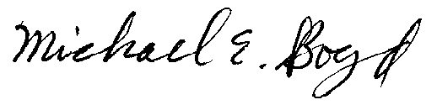
President-CARE (408) 325-4690
DATED: June 14 , 2001

