UNITED STATES OF AMERICA

FEDERAL ENERGY REGULATORY COMMISSION

Before Commissioners: Pat Wood, III, Chairman;
William L. Massey, Linda Breathitt,
and Nora Mead Brownell.

San Diego Gas & Electric Company,
Complainant,

v.
Docket Nos. EL00-95-045

Sellers of Energy and Ancillary Service Into
Markets Operated by the California
Independent System Operator Corporation
and the California Power Exchange Corporation,
Respondents

Order Directing Staff Investigation Docket No. PA02-2-000

State of California, ex.rel. Bill Lockyer,

Complainant,
v. Docket No. EL02-71-000

British Columbia Power Exchange Corp.,
Coral Power, LLC, Dynegy Power Marketing, Inc.,
Enron Power Marketing, Inc., Mirant Americas
Energy Marketing, L.P., Reliant Energy Services, Inc.,
Williams Energy Marketing & Trading Co.,

All Other Public Utility Sellers of Energy and
Ancillary Services of the California Energy Resources
Scheduling Division of the California Department of
Water Resources, and

All Other Public Utility Sellers of Energy and
Ancillary Services into Markets Operated by the
California Power Exchange and California
Independent System Operator,

Respondents

Investigation of Practices of the California Docket No. EL00-98-042 and
Independent System Operator and the EL00-98-047
California Power Exchange

Public Meeting in San Diego, California Docket No. EL00-107-008

Reliant Energy Power Generation, Inc., Docket No. EL00-97-002
Dynegy Power Marketing, Inc., and
Southern Energy California, L.L.C.,
Complainants,
v.
California Independent System Operator
Corporation,
Respondent

California Electricity Oversight Board Docket No. EL00-104-007
Complainant,
v.
All Sellers of Energy and Ancillary Services
Into the Energy and Ancillary Services Markets
Operated by the California Independent System
Operator and the California Power Exchange,

Respondents
California Municipal Utilities Association, Docket No. EL01-1-008
Complainant,
v.
All Jurisdictional Sellers of Energy and Ancillary
Services Into Markets Operated by the
California Independent System Operator and
the California Power Exchange,
Respondents

CAlifornians for Renewable Energy, Inc. (CARE), Docket No. EL01-2-002
Complainant,
v.
Independent Energy Producers, Inc., and All
Sellers of Energy and Ancillary Services Into
Markets Operated by the California Independent
System Operator and the California Power
Exchange; All Scheduling Coordinators Acting
on Behalf of the Above Sellers; California
Independent System Operator Corporation; and
California Power Exchange Corporation,
Respondents

Puget Sound Energy, Inc., Docket No. EL01-10-003
Complainant,
v.
All Jurisdictional Sellers of Energy and/or Capacity
at Wholesale Into Electric Energy and /or Capacity
Markets in the Pacific Northwest, Including
Parties to the Western Systems Power Pool
Agreement,
Respondents

California Independent System Operator Docket No. ER01-607-002
Corporation

California Independent System Operator Docket No. RT01-85-007
Corporation

Investigation of Wholesale Rates of Public Docket No. EL01-68-009
Utility Sellers of Energy and Ancillary
Services in the Western Systems Coordinating
Council

California Power Exchange Corporation Docket No. ER00-3461-003

California Independent System Operator Docket No. ER00-3673-002
Corporation

California Independent System Operator Docket No. ER01-1579-003
Corporation

Southern California Edison Company and Docket No. EL01-34-002
Pacific Gas and Electric Company

Arizona Public Service Company Docket No. ER01-1444-003

Automated Power Exchange, Inc. Docket No. ER01-1445-003

Avista Energy, Inc. Docket No. ER01-1446-005

California Power Exchange Corporation Docket No. ER01-1447-003

Duke Energy Trading and Marketing, LLC Docket No. ER01-1448-005

Dynegy Power Marketing, Inc. Docket No. ER01-1449-006

Nevada Power Company Docket No. ER01-1450-003

Portland General Electric Company Docket No. ER01-1451-006

Public Service Company of Colorado Docket No. ER01-1452-003

Reliant Energy Services, Inc. Docket No. ER01-1453-007

Sempra Energy Trading Corporation Docket No. ER01-1454-003

Mirant California, LLC, Mirant Delta, LLC, Docket No. ER01-1455-009
and Mirant Potrero, LLC

Williams Energy Services Corporation Docket No. ER01-1456-010

Procedural Matters

With sincere apology for our failure to understand your process for participation in the proceeding EL00-95-045, and in behalf of CARE, I am curious to know why CARE is not currently listed on the restricted service list for this proceeding? I spoke with a representative of the utility PG&E on July 17, 2002 who informed me that CARE should also be on the List Server for access to Cal-PX filings and electronic service by the other parties to this proceeding. I did request electronic service in CARE's FERC RIMS Submittal 20010904-0024 filed on 08/28/2001. This is where CAlifornians for Renewable Energy, Inc (CARE) submitted our Non-Disclosure Certificate pursuant to the Protective Order adopted August 7, 2001 by the Chief Judge re San Diego Gas & Electric Company et al under EL00-95. I will also made follow-up calls to your staff to confirm receipt of the original e-mail I sent you on this subject.

Without access to the information posted on the list server, and served on the Restricted Service list CARE, and the members of the lay public we exclusively represent cannot meaningfully participate in this proceeding. CARE does not have a password access to download transaction specific data posted on the FERC FERRIS system in PA02-2, and EL02-71.We need specific information and data, that is currently being denied to us, in order to formulate our position, on the three issues subject to the public hearing before you in San Francisco in August. If the failure to be included on the Restricted Service list is due to an oversight on our part in the process, please consider this our formal motion requesting we be added to the Restricted Service List in docket EL00-95 at this time.

August 2002 Hearings on EL00-95 in San Francisco

Also, in regards to the August hearings, it is not clear to us what the role of the public is in this process?

Will there be any opportunity for the public to comment on the matters under hearing?

When is time scheduled for public input on such?

How much time is allowed for the public’s participation?

Can you set aside one specific day for public input on the three issues under hearing?

Can the FERC do Public Service Announcements (PSAs) on California television and radio stations in advance of the hearing to encouraging the public’s participation?

CARE has submitted several technical reports in these proceedings, as a “Production of Document” under docket EL00-95-045, which are relevant to the Mitigated Market Clearing Price and what is owed to whom. We would like the opportunity to call the authors of these documents as witnesses on issues one through three during the August hearings. In regards to CARE’s participation as a formal party in the issues under hearing, is it possible for CARE to produce witnesses for cross-examination at the August hearings in San Francisco? CARE is willing to file Declarations and written witness testimony in advance of the hearings.

Consolidation of EL01-2, EL01-65, PA02-2, and EL02-71 under EL00-95-045

FERC has not yet formally responded to our requests to consolidate our complaints in EL01-2, and EL01-65, along with the Commission’s investigation in docket PA02-2, under the docket EL00-95. The Commission denied CARE’s motion to consolidate the California Attorney General’s complaint in docket EL02-71 in its May 31, 2002 Order (FERC Issuance 20020604-0039). On June 25, 2002 CARE timely petitioned for rehearing on this matter (Submittal 20020625-5002). CARE formally requested rehearing on these matters and requests that FERC provides CARE the statutory basis for its findings in terms that lay-members of the public can comprehend, those issues that are distinct and also identify those issues raised that are the same or similar between the California Attorney General’s complaint and the other dockets CARE has cited in our consolidation motion.

CARE is confused regarding this finding as the May 31, 2002 Order, also stated

These arguments were advanced and addressed in prior Commission orders, and thus the Complaint constitutes an impermissible collateral attack on those earlier Commission rulings. Compare Complaint at 5 (summarizing contentions) with San Diego Gas & Electric Co., et al., 96 FERC 61,120 at 61,505-06 (2001) (July 25 Order) In addition, the Commission agrees with those parties who have pointed to other similarities between the complaint and arguments addressed in prior Commission orders. See supra nn.14-18 and accompanying text. Accordingly, we dismiss this portion of the Complaint as an impermissible collateral attack on those orders.

More specifically, in details that lay-members of the public can understand, please explain in detail what our failure is, to properly identify the similarities between dockets EL00-95 and EL02-71, necessary to compel your action to consolidate these two matters? Please explain, in details the lay-members of the public can understand, what specific conditions precedent, are required for such approval of our consolidation motions. CARE is also confused on whether or not FERC has yet even heard our motion to consolidate dockets EL02-71, PA02-2, EL01-2, and EL01-65, under docket EL00-95-045, which is the subject of refund hearings in San Francisco California, in August 2002? Is this Order the final decision in this matter, or does it just cover docket EL02-71?

Are Day-ahead market transactions through the California PX subject to refund?

In issuing its March 27, 2001 Opinion in regards to the California Power Exchange’s Petitions for Writs of Mandamus to the Federal Energy Regulatory Commission Orders in docket EL00-95 (California Power Exchange Corp., 245 F.3d 1110), the 9th Circuit in regards to the Day-ahead market (herein referred to as the “near-term markets”) stated:

FERC specifically found that its near-term markets were not functioning properly, but were instead vulnerable to the exercise of market power and, indeed, producing unjust and unreasonable short-term rates under certain conditions.

Are Day-ahead market transactions through the California PX subject to refund? We have a copy of a 41-page document from PG&E covering 01/01/00 to 12/31/01 for their market price based sales in California. One justification for requesting you Consolidate EL02-71 into docket EL00-95-045 is in order to make transaction specific information filed under docket EL02-71 part of the evidentiary record in docket EL00-95-045. This data is highly relevant to the three issues under the public hearing to be held in San Francisco in August 2002.
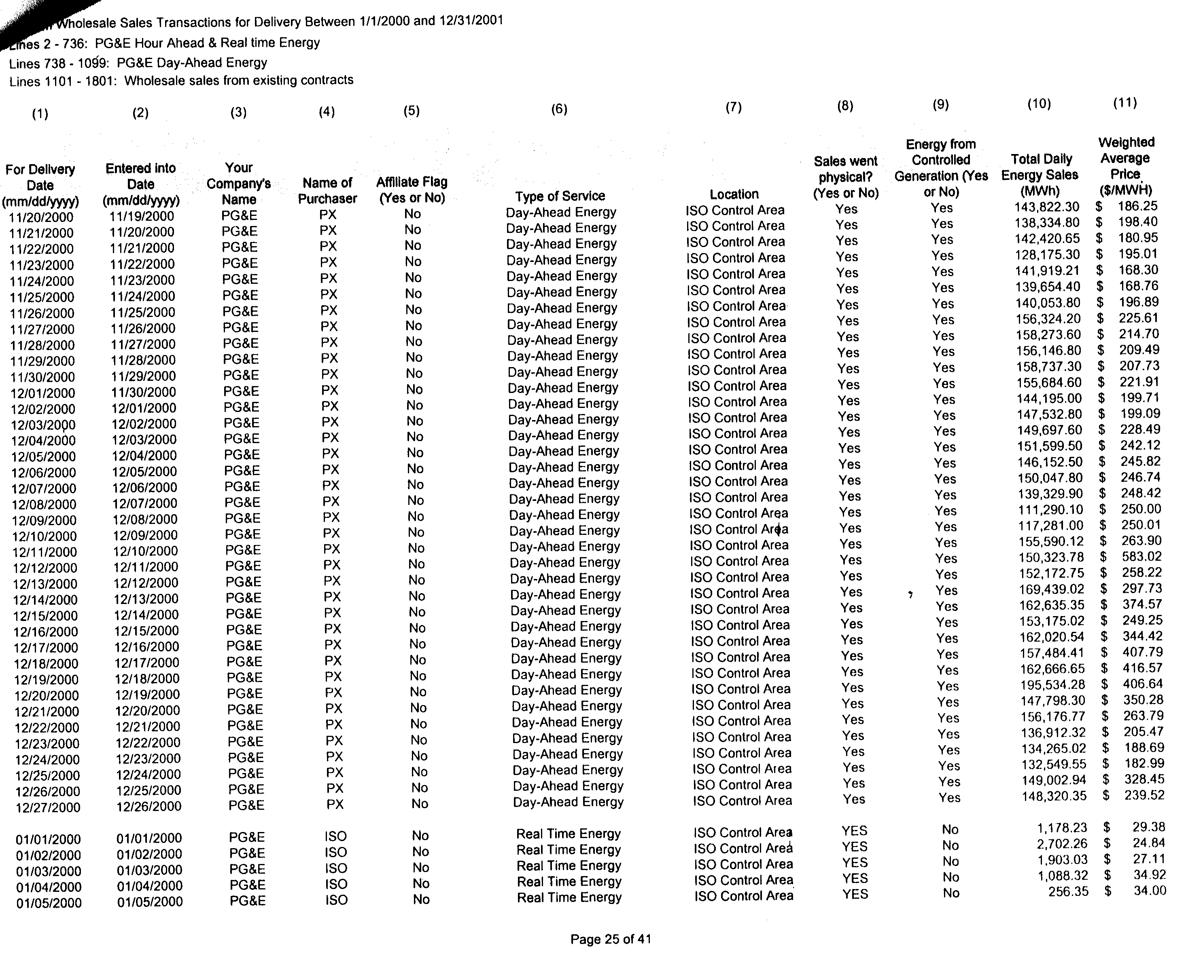
It looks at first glance like IOU PG&E overcharged California consumers over seven billion dollars for power in the California PX Day-Ahead market alone. I’m including a copy of one page for the Day-Ahead market covering the period when the Enron Memos where produced in December 2000.

In the month of January 2000 PG&E was charging roughly an average of $30/MWh for the power it produced. As you can see from the figure on 12/12/00 alone PG&E Corp charged $583/MWh or $87,641,770 for power or approximately eighty three million dollars in one day’s profit, in excess of their January 2000 average sale price of $30/MWh.

I’ve separated out PG&E’s sales for December 1st through December 27th 2000 in a table to demonstrate that the month of December 2000 produced windfall profits for PG&E in excess of a billion dollars.
PG&E, with both a utility and marketing arm, should have understood most the cost of their manipulation to the energy markets. They literally had their finger on the switch on June 14, 2000. The Revelation of my petition to you today is that apparently PG&E defrauded Californians of seven to ten billion dollars in overcharges for electricity.

PG&E’s actions where in concert with other traders, like Enron. In a CBS MarketWatch report titled PG&E, Calpine admit 'wash' trades Reliant discloses one round trip deal, on June 1, 2002 it reported that in response to the FERC’s probe, PG&E Corp., Reliant and Calpine admitted instances in which they engaged in so-called "wash" or "round trip" trades, the same so-called “round trip” trades cited in California State Senator Dunn’s testimony before the US Senate Commerce, Science & Transportation Committee on May 15, 2002 on RICO.

PG&E Corp told FERC late Friday that it found 12 occasions where its National Energy Group subsidiary was a party to these kinds of transactions -- basically described as the sale and purchase of electricity at the same price whereby companies can artificially puff up their revenue and trading numbers.

PG&E Corp. said the deals had no material effect on its reported financial results.

PG&E Corp is strongly implicated in Enron’s fraudulent market practices because
PG&E Corp and Enron are both listed in the FERC’s approval of PG&E’s and Enron’s Market-based rate filing in ER00-2395, on May 31, 2000, in PG&E’s acquisition of Portland General from Enron.

On April 12, 2000, Quantum Ventures (“Quantum”), the non-utility parent holding company of PGES, and Enron Energy Services Operations, Inc. (“EESO”) entered into a Stock Purchase Agreement whereby, subject to certain condition precedent, including issuance of all regulatory approval, EESO will acquire 100% of the capital stock of PGES from Quantum (the “Acquisition”). EESO is a wholly owned subsidiary of Enron Energy Services, LLC, in which Enron Corp. (“Enron”) is a majority owner, Portland General is a wholly-owned subsidiary of Enron and the only Enron affiliate that is an electric utility with a franchise service territory.

CARE contends that any market practices by any market participant (including PG&E and Enron) to participate in so-called “round trip” trades are based on fraud. Therefore any market transaction reports must be false, and therefore these parties failed to comply properly with the FERC’s reporting requirements under FPA Section 205(c). Additionally, any subsequent transactions following the date of such fraud’s perpetration becomes contaminated and therefore creates a fraud, upon a fraud. CARE further contends that any subsequent transaction, are subject to FERC’s statutory requirement to issue refunds for overcharges. Such refunds are required to be based on the difference between the price charged and the cost of production, not the FERC’s “so-called” Mitigated Market Clearing Price (MMCP), because FERC’s issuance of market-based rate authority to all market participation are conditioned on market participants’ agreements not to exercise market power.

In order to assist in recovering overcharges by all market participants including IOU PG&E, Enron, and other market participants, I request that Office of Market Oversight and Investigations (OMOI) staff be available to act as expert witnesses (subject to cross examination) on the MMCP and the amount of overcharges for power by each market participant at the August 2002 hearings in San Francisco. On October 29, 2001 I submitted CARE'S Case Against Independent Energy Producers Association (“IEPA”), and California Parties including evidence of violations of law and requests for appropriate relief to the FERC in Docket EL00-95. We have a need to put the numbers behind this report, in order to be able to raise this in the hearings in August. Additionally, we need the FERC or OMOI to provide us access to the reporting data submitted to FERC by PG&E and the other market participants as a result of Orders issued in regards to docket PA02-2, and the complaint in docket EL02-71. We request this information in MS Excel or CSV data format in order to have enough time to address issue one the MMCP in the public hearing. The second issue under hearing is how much money is owed in refunds to California. We are asking that FERC and /or OMOI make this data available on the Internet, so no other Party is unduly prejudiced.

Conclusions

Your current process for public participation in these proceedings as presently carried out is tainted with gross unfairness, inequity and inherently fraudulent goals. When the process gets near the end, strict time lines are imposed which create additional burdens on CARE, and other members of the public, further hindering if not completely preventing their full and meaningful participation in a process heavily weighed in favor of power wholesalers, retailers, and California politicians and public officials, with virtually unlimited resources whose only excuse for piecemealing the required information is to use it as a tactic to avoid or minimize opposition. This is accompanied by FERC’s and these party’s well-publicized emphasis on the policy of expediting the siting and approval of powerplant projects.

This is a recipe for ecological disaster being carried out without adequate state and federal legislative knowledge or approval. In other words, if the goal is to fully exempt the powerplant siting process from NEPA --meaning that crisis conditions are so bad we should blindly sacrifice irreplaceable environmental resources for the unproven benefits of creating new, unregulated energy markets--this policy decision should be made by the Congress.

Providing a full NEPA exemption through the legislative process, rather than in the underhanded manner presently being allowed by the current process, would enable the citizens of this great nation to have a voice in the matter. It would also allow a full investigation and discussion of such relevant factors as the actual existence, nature and extent of the so called energy crisis which purportedly compels the blind destruction of irreplaceable ecological resources, as well as other related topics such as revisiting the decision to completely deregulate the electric power production market and leave vital policy decisions in the hands of politically insulated state and federal agencies and the multi-national corporations seeking to profit from the situation.

In addition to greatly increasing the cost of public participation, the existing process, which, among other things (without limitation), includes piecemealing the public disclosure of information vital to an adequate public review, also makes it extremely difficult if not virtually impossible to intelligently determine if and when to retain additional experts to continue participating in the ongoing review process in a knowing and meaningful manner. As it stands, this is a clear violation of the strong Constitutional rights of public participation, which will undoubtedly continue, and most probably get worse, unless immediate steps are taken to rectify it--assuming, of course, that such steps are feasible.

CARE, the other opposing parties, and the public, wish to participate to carry out this activity, which is protected by the first amendment of the federal constitution. These rights may not be impinged upon by procedural requirements that are not reasonable in light of all pertinent circumstances, not least of which is our lack of resources to properly participate, and your refusal to provide those resources, in whole or in part. Irrespective of the barriers (technical as well as procedural) to meaningful and informed public participation a “good faith effort” has herein been made to raise these issues to compel you to comply with the procedural due process protections of sections 1085 and 1094.5 of the Code of Civil Procedure, Article I, section 7 of the California Constitution and the Fourteenth Amendment of the United States Constitution, the Supremacy Clause of Article VI of the United States Constitution, and the Public Trust Doctrine in order to assure that (1) the adverse impacts and basis of FERC’s forthcoming findings in these matters are fully disclosed, evaluated and, where feasible, appropriate mitigation is provided, (2) the need (or lack thereof) for these measures are fairly presented and assessed, (3) reasonable alternatives to proposed market mitigation measures are given full and fair consideration, and (4) CARE, and the public are afforded their constitutionally-protected right to a fair hearing untainted by prejudice, bias and the exclusion of evidence substantiating our claimed urgent need for refunds to be order for all markets contaminated by fraudulent market practices.

CARE fails to understand why refunds are required to be based on the FERC’s “so-called” Mitigated Market Clearing Price (MMCP), and not the difference between the price charged and the cost of production for all charges made subsequent to fraudulent market transactions? We object on the basis that you are making the FERC party to civil rights and anti-trust matters involving the violation and enforcement of fundamental constitutional rights of due process and equal protection.

Respectfully submitted,
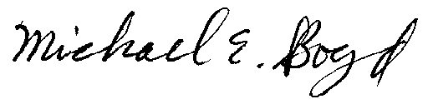
President, CARE Dated this 19th day of July 2002.
(831) 465-9809
5439 Soquel Drive
Soquel, CA 95073
E-mail: michaelboyd@sbcglobal.net

Certificate of Services

I hereby certify that I have this day served the foregoing document upon each person designated on the official restricted service list, via electronic mail, compiled by the Secretary in this proceeding in Docket EL00-95 et.al. Rule 2010(f)(3) provides that you may serve pleadings by email. I further certify that those parties without electronic mail have been served this day via US mail.

Verification
I am an officer of the complaining corporation herein, and am authorized to make this verification on its behalf. The statements in the foregoing document are true of my own knowledge, except matters, which are therein stated on information and belief, and as to those matters I believe them to be true.

I declare under penalty of perjury that the foregoing is true and correct.

Dated this 19th day of July 2002.

Respectfully submitted,
President, CARE
(831) 465-9809
5439 Soquel Drive
Soquel, CA 95073
E-mail: michaelboyd@sbcglobal.net

Response of Judge Birchman

UNITED STATES OF AMERICA
FEDERAL ENERGY REGULATORY COMMISSION

San Diego Gas & Electric Company,
Complainant Docket No. EL00-95-045

v.

Sellers of Energy and Ancillary Service Into
Markets Operated by the California
Independent System Operator Corporation
and the California Power Exchange,
Respondents.

Investigation of Practices of the California Docket No.
EL00-98-042
Independent System Operator and the
California Power Exchange

ORDER CONCERNING CARE S MOTION FOR PLACEMENT ON THE RESTRICTIVE
SERVICE AND OTHER MATTERS BEFORE ME

(Issued July 23, 2002)

1. On July 19, 2002, CARE filed a motion in the lead
docket and in several other California proceedings which are
not before me which, inter alia, seeks to be placed on the
restrictive service list for this proceeding and
specifically requests that it be added to the Restricted
Service list in the lead docket at this time. CARE s motion
at page 3 asks why it has not been placed on the restrictive
service list in the lead docket. The answer is
simple it has not taken the time to understand my rulings and
orders governing inclusion on the restrictive service list that
I adopted by an Order on August 21, 2001. Earlier this week
CARE was repeatedly advised by my staff that it needed to file a
motion that requested placement on the restrictive service list.
As the current motion accomplishes this, as soon as possible
CARE will be placed on the restrictive service list. Please
refer to http:www.ferc.fed.us/alj/procedsched/EL00-95-045.htm.

2. CARE S motion at page 3 asks for access to Listserv
which is not administrated by
the Commission or me and was established by the participants to
facilitate the exchange of information relative to the issues and
resolution of matters relating to compliance with the
procedural schedule. CARE should further consult with the active
parties or contact Commission trial Staff to understand what it
needs to do to access ListServ.

Docket Nos. EL00-95-045 and EL00-98-042
2

3. CARE s motion at pages 4 and 5 asks several questions with
regard to participation in the August hearings on issues 2 and 3,
the issues which essentially concern who owes what to whom .
CARE should review the official transcript of the proceedings and
my rulings and orders for this purpose. The hearing is a formal
evidentiary hearing convened under the Federal Power Act,
Commission regulations, and the Administrative Procedure Act of
1946, and hearings to date on the stipulated mmcp issues and
issues concerning section 202(c) of the Federal Power Act have
involved the participation of Commission trial Staff and more
than 100 other active participants, almost all of whom have
sponsored expert witness testimony that has been subject to
cross-examination relevant to these stipulated issues.

4. CARE s motion at page 10 asks the Commission to provide it
data on how much money is owed in refunds to California. With
regard to the August hearing on issues 2 and 3, the participants,
including the ISO and PX, have filed expert testimony and
evidence addressing this matter and additional testimony and
evidence is to be filed under the governing trial schedule. That
testimony and evidence is publicly available.

5. As concerns CARE s requests for input in the August
hearings before me with regard to mmcp issues and issues 2 and 3,
CARE should understand that, in general, input is in the form
of relevant timely filed testimony which addresses the issues set
for hearing in the context of the several narrative joint
stipulation of issues that I have adopted. Hearings on the
record have been held on the mmcp issues and section 202(c)
issues, the participants have filed briefs with proposed findings
on those issues, and the record as to those adjudicated issues is
closed. Insofar as CARE s motion seeks leave at the August
hearing to sponsor expert testimony and evidence on the mmcp
issues already adjudicated, that request is inappropriate and
untimely. As good cause has not been established, CARE s motion
at pages 5 and 10 which requests the opportunity to sponsor
testimony and evidence on the mmcp issues that have been
adjudicated is denied.

6. The August hearing on issues 3 and 3, like the hearings
convened and concluded on other issues, is a formal evidentiary
hearing convened under Commission regulations and the
Administrative Procedure Act of 1946. The August hearings will
adjudicate issues 2 and 3 and are governed by the current trial
schedule which is applicable to those issues. The ISO and PX
have filed direct testimony on those issues, a wealth of
responsive testimony by numerous participants was filed on July
3, 2002, and further rounds of testimony on issues stipulated by
the participants will be filed per the deadlines in the trial
schedule. CARE may elect to actively participate in these

Docket Nos. EL00-95-045 and EL00-98-042
3
proceedings as concerns issues 2 and 3. If it chooses to do so,
CARE should review the trial schedule and my rulings.

7. CARE avers that the Commission s process for public
participation in these proceedings are grossly
unfair and inequitable. My comments are
addressed solely to the adjudicatory process and matters before
me. As concerns the issues that have been adjudicated and issues
2 and 3 that are to be adjudicated at the August hearing and the
applicable evidentiary procedures, there has been a level playing
field for all and CARE s unspecific assertions are baseless. I
note that CARE has not participated in any
prehearing conference, oral argument, or formal hearing reflected
in the 3,610 pages of the transcript of official proceedings.

8. CARE s motion at pages 5 to 10 raises several matters,
including assertions concerning inappropriate or fraudulent
practices, which are not among the issues set for hearing, are
not before me, are not within my area of responsibility, will not
be adjudicated at the August hearing, and are before the
Commission. Those facets of CARE s motion are matters for
resolution by the Commission and are not addressed by this Order.

Bruce L. Birchman
Presiding Administrative Law Judge

No. 01-70031, Argued February 7, 2001 Pasadena, California Nos. 00-71701* and 01-70031, Submitted March 27, 2001.
In its papers filed in these proceedings, CalPX at times suggests that FERC’s finding of unjust and unreasonable rates in the California short-term wholesale markets was limited to the Cal-ISO’s real time imbalance energy market. As we summarized in Part I, this is not correct. Although FERC noted that the Cal-ISO real time market was especially volatile, FERC specifically found that structural flaws affecting the CalPX spot markets had caused, and continued to have the potential to cause, unjust and unreasonable short-term rates under certain conditions. December 15 Order, 93 FERC ¶ 61,294, at 61,998.
This is the subject of CARE’s October 6, 2000 complaint in docket EL01-2.
We note here that based on PG&E’s data showing price spikes in its energy sales as early as April 2000, it is reasonably foreseeable that the market based sales by PG&E after these transactions occurred may be void and unenforceable and/or subject to refund due to evidence establishing at least a question of fact that PG&E engaged in deceptive practices, that included fraud.
We note here that this is relevant to the first issue under public hearing i.e., what is the “so-called” Mitigated Market Clearing Price (MMCP) during all hours during the refund effective period.
This position is evinced by findings in the Docket No. ER02-1656-000 that “this Commission urges California officials to act aggressively to improve its energy infrastructure, including the construction of new power plants, transmission lines and gas pipelines and to improve the ability of retail customers to see and respond to wholesale price signals” (FERC July 17, 2002 Order).

