UNITED STATES OF AMERICA
FEDERAL ENERGY REGULATORY COMMISSION

Mirant Delta, LLC and
Mirant Potrero, LLC,
Complainants,

v. Docket No. EL01-35-001

California Independent System
Operator Corporation,
Respondent.

San Diego Gas & Electric Company,
Complainant,

v. Docket No. EL00-95-067

Sellers of Energy and Ancillary Services
Into Markets Operated by the California
Independent System Operator and the
California Power Exchange,
Respondents, et al.

California Independent System Docket No. ER01-1877-001
Operator Corporation
Docket No. EL00-98-056

Operational Audit of the
California Independent System Operator Docket No. PA02-1-001

California Independent System
Operator Corporation Docket No. RT01-85-010

Pacific Gas and Electric Company Docket No. RT01-83-003

San Diego Gas & Electric Company Docket No. RT01-82-003

Southern California Edison Company Docket No. RT01-92-003

PETITION FOR REHEARING ON STAY AND MOTION OF CALIFORNIANS FOR RENEWABLE ENERGY, INC. (CARE) FOR A STAKEHOLDER’S ELECTION OF THE GOVERNING BOARD OF THE CALIFORNIA INDEPENDENT SYSTEM OPERATOR CORPORATION

(Submitted September 26, 2002)

- In it’s September 16, 2002 Order the Commission denied CARE’s request for rehearing and request for stay of an order issued on July 17, 2002 involving the California Independent System Operator's (CAISO) Governing Board (Board) and its governance structure. Purportedly this order benefits California energy market participants and their customers as well as energy participants in other parts of the West, because it serves to ensure the independent operation of the CAISO, which, in turn, will allow the Commission to maintain just and reasonable rates in the West and help solve California's long-term electricity supply deficiency.

Petition for Rehearing on Stay
- Our pursuit of this request for rehearing on CARE’s request for stay of an order issued on July 17, 2002 involving the CAISO Governing Board and its governance structure is based on your failure to examine the impacts of the Commission's proposed Standard Market Design raising significant socioeconomic and environmental issues that require “a corporate election", that CARE submitted as comments on such under docket RM01-12-000. This is evinced by the Commission’s finding in the September 16 Order that:

CAlifornians for Renewable Energy (CARE) contends that "the Commission's proposed Standard Market Design, has raised significant socioeconomic and environmental issues that make it necessary for CARE to seek a Stay of [the Commission’s] actions regarding [CA]ISO's governance at this time" until a new Board is elected using CARE's proposal for a "corporate election" process. []

We find that even if the EOB, the CAISO, or CARE could demonstrate that it would likely suffer irreparable harm absent a stay, the other factors do not justify granting a stay. A significant public interest exists in establishing an independent Board that will allow the Commission to ensure just and reasonable prices in California as well as other areas of the West and that will help restore the confidence in the Board that is necessary to attract infrastructure investment to help solve California's electricity supply deficiency. In addition, because a stay will only delay the ability of the Commission to accomplish these goals, we find that a stay will be detrimental to customers. []

We find that CARE's request that a stay is necessary, because the Commission's proposed Standard Market Design raises significant socioeconomic and environmental issues that require “a corporate election" to address them, to be without merit. Although CARE alludes to a public interest in a stay because of socioeconomic and environmental issues, we find that this argument is insufficient to grant a stay because it is unexplained and unsupported. CARE has neither identified the socioeconomic and environmental issues that the Commission's proposed Standard Market Design allegedly raises nor has it shown the relevance of these issues to the July 17 Order. []

It is precisely because the Commission failed to review CARE’s submissions under docket RM01-12-000, the Commission’s proposed Standard Market Design, that you misunderstood the relevance of these socioeconomic and environmental issues in our prior request for rehearing and the motion for stay we are seeking rehearing on here. We generally concur with the September 16 Order’s finding that “a significant public interest exists in establishing an independent Board that will allow the Commission to ensure just and reasonable prices in California as well as other areas of the West and that will help restore the confidence in the Board that is necessary to attract infrastructure investment to help solve California's electricity supply deficiency.” Where we disagree is whether the FERC’s imposed Board of Governors or a stakeholder elected Board of Governors serves the “public interest”? We contend the later to be the case, and we further contend that our proposal if adopted insures an independent Board.

- CARE did not submit comments and related technical reports as part of our motion for stay which we submitted in response to the Commission’s solicitation for comments on the proposed NEPA compliant Environmental Impact Statement (EIS) for the Commission’s proposed Standard Market Design, under docket RM01-12; because we believed this would further confuse your deliberations over the environmental and socioeconomic issues that make it necessary for CARE to seek a Stay on CAISO governance as such. Specific examples of some of the environmental issues that make it necessary for CARE to seek a Stay are summarized in CARE’s Submittal 20020812-5089 in docket RM01-12-000 at page 8:

CARE requests the FEIS examine these three Market Design scenarios to compare the environmental effects of each on the environment including but not limited to an examination of the following areas of concern:

1. The effect of each Market Design scenario in a comparative basis on emissions of criteria pollutants and Toxic Air Contaminants, regulated under the Clean Air Act, on compliance with regional and local ambient air quality standards for each pollutant.

2. The effect of each Market Design scenario in a comparative basis on water usage in areas dependent on ground water resources, and associated socioeconomic and environmental effects.

3. The effect of each Market Design scenario on public health and environmental quality.

4. The effect of each Market Design scenario on biological resources, listed, and endangered species under the Endangered Species Act.

5. The effect of each Market Design scenario on global warming.

Another example comes from Dr. Eugene P. Coyle, in his presentation on April 6, 2001 titled Aids In Africa And The Electric Crisis In California: What Is The Connection? CARE submitted this report in its entirety on 9/3/02 as Exhibit 5 (Submission 200209035149 on 09/03/2002 in docket RM01-12).
What we, as environmentalists and consumers want is the right amount of capacity, no more and no less. We are not going to get that without public control of the planning.

Besides the amount of capacity, we also want a mix of types of capacity, baseload and peaking capacity. We are not going to get that without public control of the planning.

And besides the mix of baseload and peaking, we also want a diversified fuel mix, and in particular we want benign types of capacity, renewable energy, to use an umbrella term. We are not going to get that without public control of the planning. So competition or de-regulation will never deliver on what was promised, in any dimension.

This report points to the flaws in assuming that the Commission’s proposed Standard Market Design, and your proposed CAISO governance scheme, will deliver to consumers and ratepayers any benefits from competition, when both proposals precludes “public control of planning”. CARE concurs with Dr. Coyle’s expert findings that therefore “competition or de-regulation will never deliver on what was promised, in any dimension.” CARE’s proposal for CAISO governance is the only proposal to date that provides the mechanism for this “public control of planning”, and therefore it necessary for CARE to seek a Stay until such time as such is achieved in practice.

- In this regard CARE provided comment on specific environmental and socioeconomic analysis necessary to demonstrate the benefits of “competition and de-regulation.”
CARE requests the ”Scope” of the FEIS perform a NEPA analysis on the proposed rule as it regards the presumption that the environmental benefits of market-based competition is realizable in comparison to such economic benefits to consumers from a cost-based regulatory regime, or some hybrid of the two. We request you examine the following Standard Market Design market scenarios.
- Perform a NEPA environmental analysis on the market-based competition scenario proposed in RM01-12 the current Rulemaking under review.
- Perform a NEPA socioeconomic analysis of an alternative scenario based on a cost based regulatory regime.
- Perform a NEPA analysis of an alternative scenario based on a hybrid approach, which provides incentives for investments in energy efficiency, load shifting, distributed generation, and examine whether or not the environmental benefits of load reduction through consumer self generation utilizing renewable energy has greater value than those realized under the current incentives programs provided by the existing and proposed market designs, for new fossil-fuel based generation capacity.

- In regards to the incentives for investments in energy efficiency, load shifting, distributed generation, and examining whether or not the environmental benefits of load reduction through consumer self generation utilizing renewable energy has greater value than those realized under the current incentives programs provided by the existing and proposed market designs, for new generation capacity, the testimony of Chairman Pat Wood, III before the Committee on Energy and Natural Resources of United States Senate on July 24, 2002 (at pp 9-10) evinces the benefits CARE contends need to be analyzed in an EIS, prior to the Commission’s implementation of the July 17 Order on CAISO governance.
Demand response is a crucial element for efficient grid use, as well as an effective deterrent to the exercise of supplier market power. Demand response moves a step beyond energy efficiency, to empower customers to change their energy consumption in response to energy prices over time. Most retail customers see flat, “after-the- fact” electric prices that give little hint of the underlying cost of energy production; they don’t reflect scarcity, as when total demand outstrips supply and purchasers compete for the limited power available, or the higher production costs that occur when more inefficient (and costly) power plants are brought on- line. Most customers have a sense of when a product or service costs too much, and many would be willing to use less electricity when it costs more. Demand response programs give customers this opportunity, using technologies ranging from real-time pricing with “smart meters”, to time of use rates with interval meters, or classic interruptible and curtailable programs which reward customers for sudden power reductions. Such programs allow grid managers to leverage existing grid assets by reducing peak loads and thus improve the ability of a constrained grid to serve more customers reliably. Demand response, energy efficiency and distributed generation programs can be targeted within constrained load pockets to relieve strains on the grid and delay asset exhaustion – this is being done in New York City, Southwest Connecticut, Chicago, and elsewhere.

Distributed generation (small generators using renewable or fossil fuels) can be used close to load centers to improve grid reliability while reducing the need for new transmission and reducing transmission line losses (the need for additional generation to replace energy lost due to resistance along the lines). Distributed generation includes solar photovoltaics (as on home rooftops), small wind generators (as at farms and oilfields), combined heat and power (once called cogeneration, used at office buildings and industrial sites), diesel- or natural gas- fired reciprocating engines (as for hospital and industrial emergency generators), and newer technologies such as fuel cells, microturbines, and flywheels (technically a form of energy storage). These are often installed by customers who wish to improve site reliability, reduce or stabilize energy costs, reduce environmental impact, or gain greater independence from the grid.

Used in urban areas and at transmission substations, distributed generation can improve local voltage stability, reduce the need for imports into the urban area, expand the capability of local substations, and reduce net emissions from power generation. [emphasis added]

CARE concurs with the Chairman’s findings in this regards and provides CARE’s President of the board of directors, Michael Boyd’s home as an example of a case study of actual experience in the implementation of the current market design, and current CAISO governance, as it relates to the provision of Distributed generation such as solar photovoltaics (as on home rooftops). We contend that neither the Commission’s proposed rulemaking in docket RM01-12, the ISO proposed market design in docket ER02-1656, nor the Commission’s proposed CAISO governance, nor the existing CAISO governance provides any mechanism for meaningful participation by consumers and ratepayers which provides incentives for investments in energy efficiency, load shifting, distributed generation, and an examination of whether or not the environmental benefits of load reduction through consumer self generation utilizing renewable energy has greater value than those realized under the current incentives programs provided by the existing and proposed market designs, for new fossil-fuel based generation capacity. Only by enfranchising all market participants through a fair and free corporate election can the establishment of such a mechanism be guaranteed.

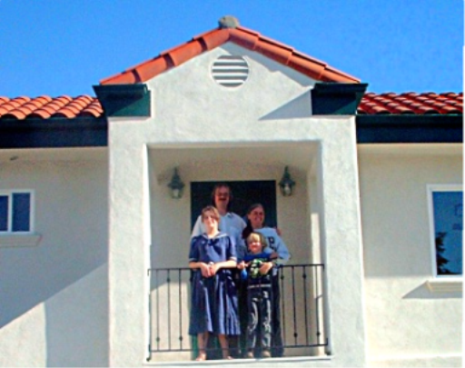
- The following example is a 2500 square foot home that includes energy efficient lighting controls, energy saving insulation, and fluorescent lighting throughout, with 5300 Watts of installed solar photovoltaic capacity. The purpose of this case is demonstrate the current market design as well as CAISO governance erects major barriers to entry by consumers utilizing installed solar photovoltaic self generation
Figure 1 above shows the Boyd family at the entry to their solar photovoltaic powered home.
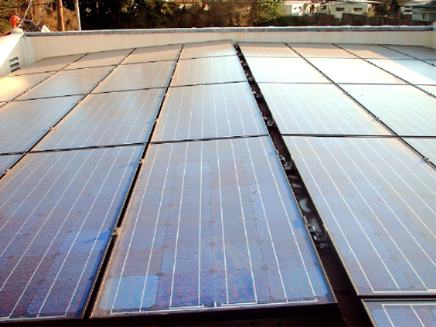
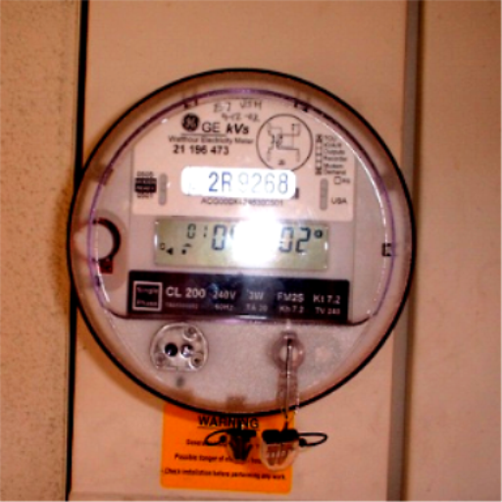
Figure 3 Time-of-use Meter
Figure 2 half of the fifty-three 100-Watt solar panels on the roof of the Boyd family’s home

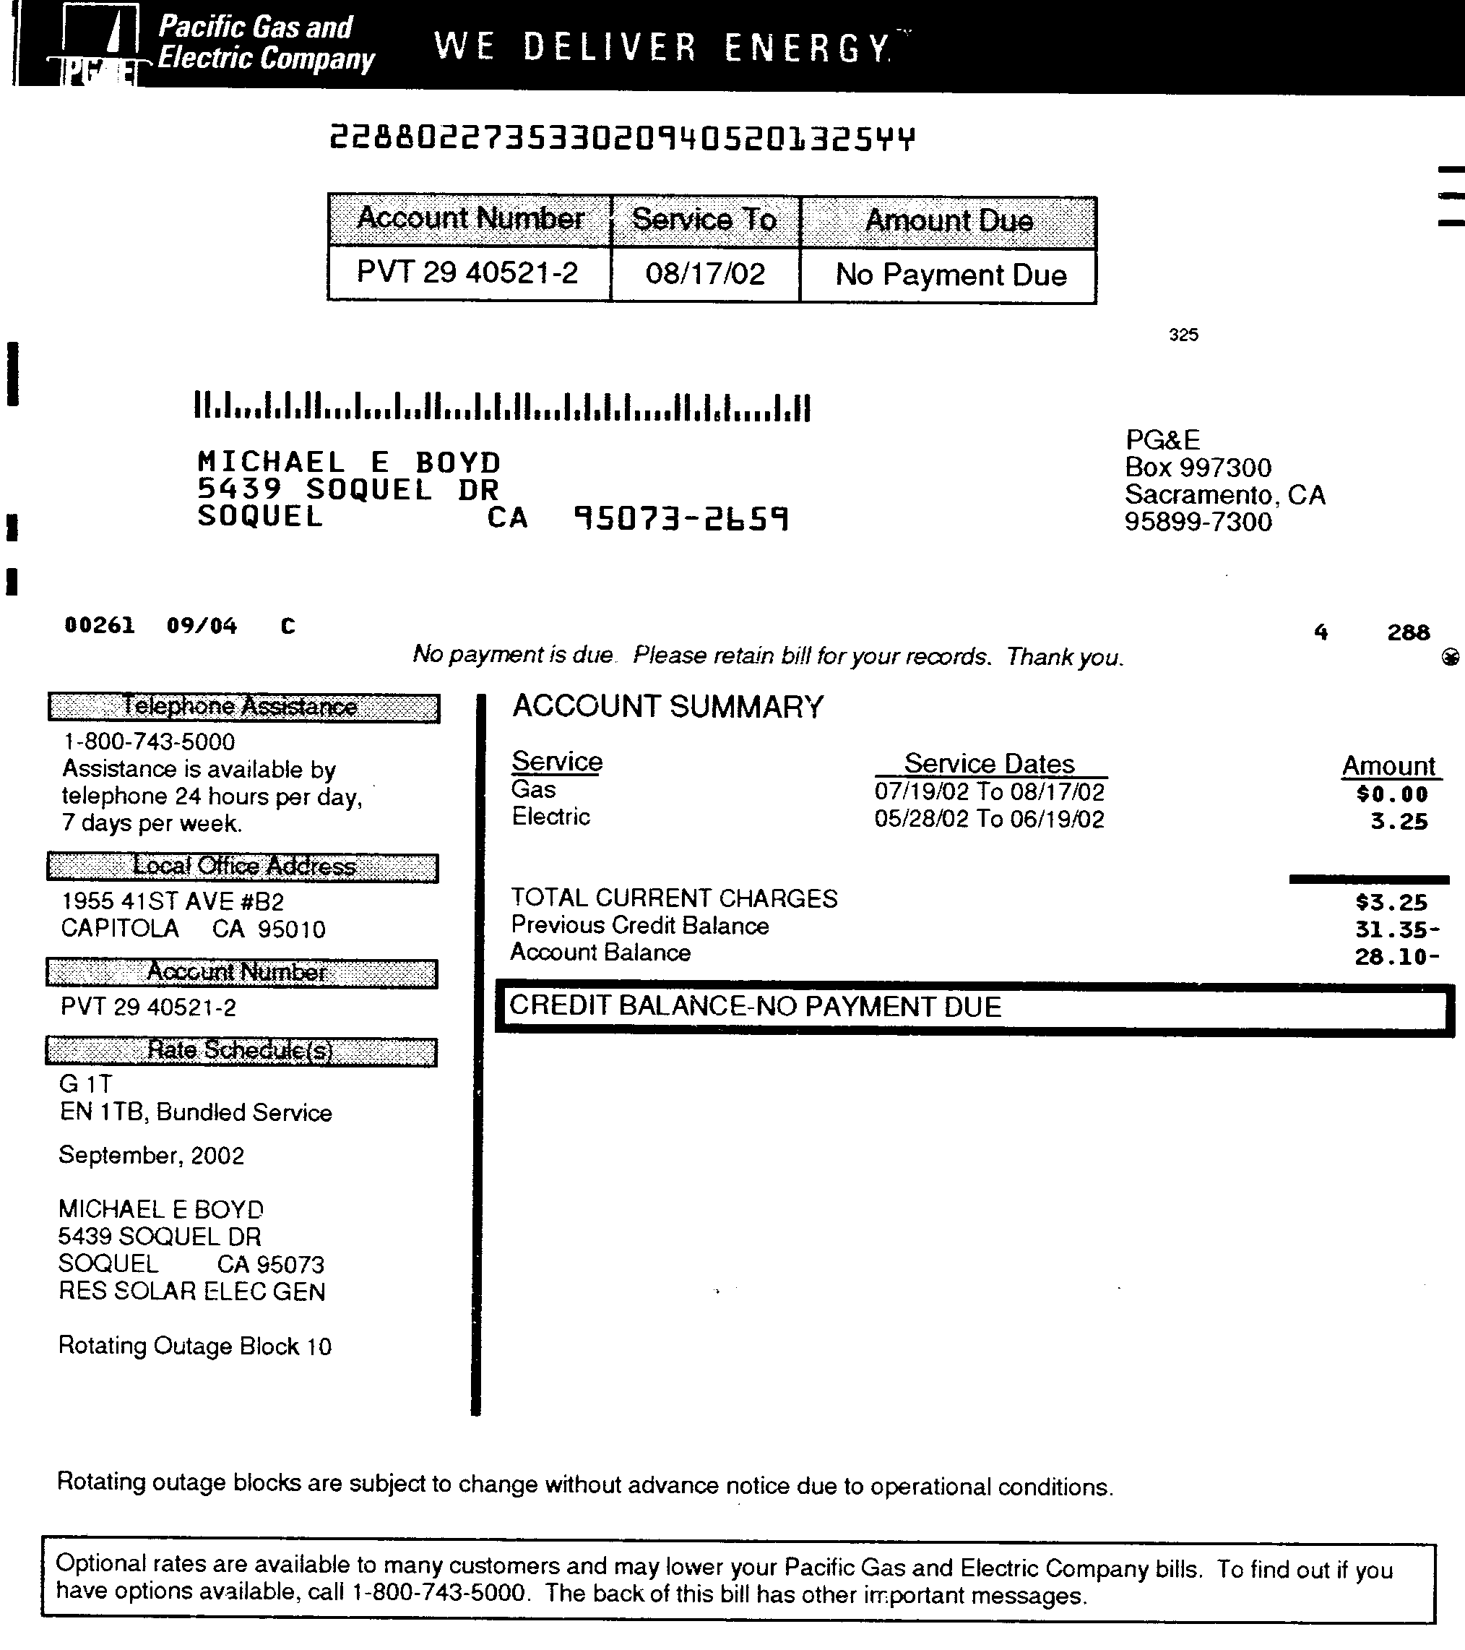
capacity. This 5300 Watts of installed solar photovoltaic capacity includes 4400 Watts of capacity tied to the PG&E owned transmission system. The system includes 900 Watts of backup power with a 48 Volts DC battery bank wired to critical circuits with 2 days reserve power capacity. The entire system cost $58,000 including installation with a refund of $20,000 received under the state’s CEC rebate program. For an addition cost of $277 this home includes a time-of-use meter as shown in figure 3. By limiting the time of household use of major appliances to non-peak hours the Boyd family has been able to maximize their solar photovoltaic production capacity to the level that this household is a net producer of energy. The excess production capacity is therefore returned the grid during a period of both maximum production capacity as well as maximum consumer demand (see figure 4).
Figure 4 this bill demonstrates that not including the $3.25 distribution charge the Boyd's donated $31.35 to PG&E for their excess electricity capacity.

- The current market mechanisms fail to provide self-generating consumers and ratepayers’ incentives for investments in energy efficiency, load shifting, and distributed generation, because all excess production capacity is given as gift of free electricity to the utility, in this case PG&E. There currently exists no provision in the current market design or under the current CAISO governance to pay self-generating consumers and ratepayers for their excess production capacity. What incentive does the current mechanisms provide for self-generation in excess of native demand? What incentive does the current mechanisms provide for installation of time-of-use metering? Only by enfranchising all market participants through a fair and free corporate election can the establishment of such mechanisms be guaranteed.

- NOx emissions in any given year depend primarily on one key uncertainty that has not been addressed in the proposed rule making under RM01-12, the relative price of natural gas and coal. Lower prices for natural gas, relative to coal, lead to lower levels of NOx emissions. Two factors having a direct bearing on the need for CARE to seek a Stay until such time as mitigation is achieved.
  - In light of the FERC’s Chief Administrative Law Judge’s recently issued Initial Decision in Public Utilities Commission of California v. El Paso (RP00-241-006) it is clear that there exists a relationship between market power abuses in California’s energy markets and market power abuses in the natural gas markets, some mechanism needs to be established as part of the proposed ISO governance to mitigate market power abuse in both markets.
  - Recently Matthew R. Simmons President -Simmons & Company International has predicted the likely depletions in existing domestic supplies, and the development of new domestic sources of natural gas. CARE submitted Dr. Simmons’ report titled Depletion & U.S. Energy Policy, presented to the International Workshop on Oil Depletion, in Uppsala, Sweden, on May 23, 2002 (Submission 20020903-5147), and his June 21, 2002 presentation titled Is There A Gas Crisis Ahead to the Energen Corporation Board Retreat in Greenbrier, West Virginia June 21, 2002 (Submission 20020903-5148), as Exhibit 3 and 4 respectively in our 9/3/02 comments on the Commission proposed Standard Market Design rulemaking under docket RM01-12. CARE is concerned that because higher natural gas prices, resulting from the predicted depletion of domestic supplies, will result in higher levels of NOx emissions. Only by enfranchising all market participants through a fair and free corporate election can there be the establishment of market mechanisms that are not preferential to natural gas based generation over renewable electricity generation and only then can such be guaranteed.

- It is CARE’s contention that the Commission’s proposed Standard Market Design, the current market design, the Commission’s proposed CAISO governance, and the current CAISO governance, allows for, if it is not already encouraging, the perpetration of discriminatory effects on California’s peoples-of-color in the siting, construction, and operation of powerplants in the state of California. President Clinton's Executive Order 12898, ‘Federal Actions to Address Environmental Justice in Minority Populations and Low-Income Populations’ was signed on February 11, 1994. The order required the US Environmental Protection Agency (USEPA) and all other federal agencies to develop environmental justice strategies. The USEPA subsequently issued Guidelines that require all federal agencies and state agencies receiving federal funds to develop strategies to address this problem. The agencies are required to identify and address disparately high and adverse human health or environmental effects of their programs, policies and activities on minority populations and low-income populations. We respectfully request a stay in implementing the July 17, 2002 Order on CAISO governance until such time as the FERC identifies and addresses disparately high and adverse human health or environmental effects of their programs.

- We respectfully request a stay in implementing the July 17, 2002 Order on CAISO governance until such time as all administrative review activities concerning the Standard Market Design (RM01-12) before the Commission in any manner requiring NEPA compliance as part of the administrative review is completed, or at least the substantial stabilization of prices, supplies and other market conditions in regard to, the ongoing California energy crisis. The energy crisis has made it impossible to conduct the type of stable, finite and accurate review of conditions, as they actually exist required by NEPA. The energy crisis has destroyed and continues to destroy the database essential to the identification, evaluation and mitigation of potentially significant environmental impacts that may occur as a result of powerplant or transmission projects. The compilation of that fundamental database is the backbone of the process required by NEPA to afford, assure and maximize environmental protection and avoidance of harm to the environment caused by activities carried out or allowed by public agencies. Moreover, we respectfully demand that the NEPA environmental review carried out in previous Rulemaking be immediately reopened to determine if and precisely how the environmental documentation for each such previously approved Rulemaking must be modified to take into account the ongoing energy crisis and its potentially significant effects on powerplant and transmission projects themselves, as well as on the environment generally.

Motion for a Stakeholder’s Election of the Governing Board of the California Independent System Operator Corporation
- Our pursuit of this motion before the FERC does not seek rehearing on CARE’s prior motion for a CAISO Governing board elected by California’s consumers and ratepayers. CARE concurs with the Commission findings in the regard in its September 16 Order that there is “no merit to this proposal for the reasons described above in which we identified the problems with a Board that represents the interests of one stakeholder group”. We where wrong here, and we stand corrected. It is for this reason alone we seek this as a new motion to enfranchise the CAISO’s Governance through a mail ballot election involving all the stakeholders: power suppliers, IOU’s, public utilities, state agencies, consumers and ratepayers alike. CAISO governance must come from all the stakeholders up – not from the Federal or State government down this is a basic principal upon which our democracy was founded.

- CARE proposes the ISO board be composed of five directors elected at large by its general membership, whom are market participants in California’s electricity markets, including, but not limited to, power suppliers, Investor Owned Utilities, public utilities, state agencies, consumers and ratepayers. Market participants are entitled to one vote per stakeholder, irrespective of their stakeholder class. The individual receiving the highest number of votes in the annual corporate election is recommended be designated by the title of Independent System Operator, who shall act as the corporation’s, President of the Board, Chief Executive Officer, and shall act as the official representative of its California membership, in the FERC’s proposed western Regional Transmission Organization.

- CARE proposes that any stakeholder member receiving fifty qualified member signatures on a nomination petition not less than ninety days prior to the corporate election be qualified as a nominee for election to the ISO board of directors. Such candidate shall be entitled to a statement of not more than 500 words, free of charge, which shall be delivered along with the official mail ballot. CARE proposes that such election take place by mail ballot delivered to each market participant with a thirty-day polling period for return of ballots in a self-addressed postage-paid envelope. Such ballots are recommended be addressed to the California Secretary of State, who is statutorily entrusted to insure the fairness and impartiality of the corporate election process. The tallying of the ballots must be open to the members and their corporate candidates to insure such impartiality.

- CARE proposes that all candidates for the CAISO Governance board be required to provide a “Statement of Economic Interest” as a stakeholder that is part of, but separate from, the Candidate’s statement delivered along with election ballot materials. Such disclosure must include clear identification of the candidates stakeholder class, with some examples being: large electricity supplier or generator of 50 KWh or greater, small electricity supplier or generator of 50 KWh or less, distributed generators includes solar photovoltaics (as on home rooftops and small business), small wind generators (as at farms and oilfields), IOU, public utility, state agency, provider of ancillary services, or consumer and ratepayer classes. By maintaining a corporate funded election with equal access to all market participants irrespective of class and each participant irrespective of class having the one vote this guarantees that the more financially influential participants (like the large generators and IOUs who manipulated California’s energy and natural gas markets) will not control the CAISO Board of Governors. Perhaps, the consumer and ratepayer class will have the largest voice over CAISO governance in this process. But isn’t this what we want, a CAISO Governing Board the represents the will of the governed, not the will of the Distant Federal government, as you are proposing? What you propose stands all the basic principals behind our democracy on its head. We the governed must grant authority to the government, any other governance structure must therefore be illegitimate.

Conclusions
- For the foregoing reasons CARE requests rehearing of CARE’s request for stay of an order issued on July 17, 2002 involving the CAISO Governing Board and its governance structure based on your failure to examine the impacts of the Commission's proposed Standard Market Design raising significant socioeconomic and environmental issues that require “a corporate election" to resolve, and our new motion to enfranchise the CAISO’s Governance through a mail ballot election involving all the stakeholders: power suppliers, IOU’s, public utilities, state agencies, consumers and ratepayers alike. CAISO governance must come from all the stakeholders up – not from the Federal or State government down this is a basic principal upon which our democracy was founded.

- In regards to the September 16 Order finding that “because we find no merit to CARE's arguments, we will deny CARE's request for rehearing” we ask your consideration of the fact that despite the fact that you may disagree with the “merit” of our arguments we offer them up in the spirit of a democratic debate on the issue before you. We ask you reconsider your decision to stifle or end the debate before the issue of CAISO governance is equitably resolved. Until then, all parties to this proceeding have the right to participate in the debate. This is what it means for us to be Americans. Please accept our motions with this perspective in mind we seek here to broaden not narrow the “public’s interest” in this matter.

Respectfully submitted
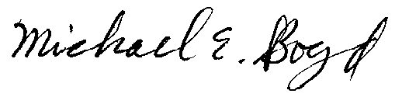
President, CARE
5439 Soquel Drive
Soquel, CA 95073
(831) 465-9809

E-mail: michaelboyd@sbcglobal.net

Verification

I am an officer of the movant corporation herein, and am authorized to make this verification on its behalf. The statements in the foregoing document are true of my own knowledge, except matters, which are therein stated on information and belief, and as to those matters I believe them to be true.

I declare under penalty of perjury that the foregoing is true and correct.

Executed on September 26th, 2002, at Soquel, California
Michael E. Boyd – President, CARE
CAlifornians for Renewable Energy, Inc. (CARE)
5439 Soquel Dr.
Soquel, CA 95073-2659
Tel: (408) 891-9677
Fax: (831) 465-8491
michaelboyd@sbcglobal.net

Certificate of Services

I hereby certify that I have this day served the foregoing document upon each person designated on the official restricted service list, via electronic mail, and the ListServ, compiled by the Secretary in this proceeding in Docket EL00-95 et.al. until such time as the restricted service list is established for the above captioned matter. Rule 2010(f)(3) provides that you may serve pleadings by email. I further certify that those parties without electronic mail have been served this day via US mail or the ListServ.

Dated at this 26th day of September 2002.

Respectfully submitted,
President, CARE
5439 Soquel Drive
Soquel, CA 95073
(831) 465-9809
E-mail: michaelboyd@sbcglobal.net

See 100 FERC ¶ 61,059 (2002) (July 17 Order).
CARE's Request for Rehearing at 7.
Id.
100 FERC ¶ 61,271 (EL00-95 9-16-02 Order at 3)
100 FERC ¶ 61,271 (EL00-95 9-16-02 Order at 13) [emphasis added]
See Electricity Market Design Structure, 67 Fed. Reg. 55,452 (2002) (Standard Market Design).
? 100 FERC ¶ 61,271 (EL00-95 9-16-02 Order at 14) [emphasis added]
See the reference 9/3/02 Submission 200209035145 (9/3/02 CARE’s RM01-12 comments Exhibit 1) a report by William B Marcus, of JBS Energy, Inc titled Cost Curve Analysis of the California Power Markets, and See 9/3/02 Submission 200209035146 (9/3/02 CARE’s RM01-12 comments Exhibit 2) a power point presentation by William B Marcus, of JBS Energy, Inc titled Valuing Load Reduction in Restructured Markets.
See Figure 3 for Mike Boyd’s time-of-use meter.
See Figure 2 for Mike Boyd’s 5300-Watt Solar Photovoltaics System.
Docket Nos. RM95-8-000 and RM94-7-001 at page 63 In reviewing applications to sell at market-based rates, whether from new (unbuilt) capacity or existing capacity, we require that the seller (and each of its affiliates) must not have, or must have mitigated, market power transmission and not control other barriers to entry. In order to demonstrate the requisite absence or mitigation of transmission market power, a transmission-owning public utility seeking to sell at market-based rates must have on file with the Commission an open access transmission tariff for the provision of comparable service.
See CARE’s 12/8/01 Submission 20011210-5052 a production of the document authored by the Latino’s Issues Forum titled Power Against the People? This document provides corroborative evidence of discrimination.

