UNITED STATES OF AMERICA

BEFORE THE

FEDERAL ENERGY REGULATORY COMMISSION

Southern California Edison Company ) Docket Nos. EL03-19-000

v. )

Enron Generating Facilities: )

)

Victory Garden Phase IV Partnership ) QF90-43-005

Sky River Partnership ) QF91-59-006

Cabazon Power Partners LLC ) QF95-186-005

Zond Wind System Partners, Ltd. ) QF85-687-002

Series 85A )

Zond Wind System Partners, Ltd. ) QF85-686-002

Series 85B )

)

Investigation of Certain Enron-Affiliated QFs ) Docket Nos. EL03-17-000

)

Zond Windsystems Holding Company ) QF87-365-005

Victory Garden Phase IV Partnership ) QF90-43-004

Sky River Partnership ) QF91-59-005

(Consolidated)

CARE’S COMMENTS TO THE SETTLEMENT AND CONSENT AGREEMENTS

To: The Honorable H. Peter Young
Presiding Administrative Law Judge

- Although the settlement offer and proposed Consent Agreement is uncontested among the Settlement Parties, it was negotiated without participation by CARE, and we therefore contend it fails to serve the “public interest”. It does not address the factual issue whether the projects violated the ownership rules under PURPA and Commission implementing rules for Qualifying Facilities. In EL03-17-000, the Commission set for hearing, by order dated October 24, 2002, the question whether the Enron Corporation and three small power producers met the ownership requirements for QF status at and following the asserted 1997 transfer of ownership interests in the facilities to an entity named RADR. The Commission expanded the scope of this proceeding in EL03-19-000 both by adding additional projects for investigation of ownership status and by expanding the scope to cover the time period from 2000 to the present. This time period covers the re-purchase of the projects by Enron from RADR. Most importantly both Agreements fail to incorporate the March 26, 2003 FERC Trial Staff’s Final Report on Price Manipulation in Western Markets in docket PA02-2-000 which includes that the Settlement Parties Enron and Southern California Edison have been named by Commission Staff as Parties who where involved in trading strategies that were based on false information. Therefore CARE believes at this time the Settlement Agreement at best should only be considered a partial settlement of the case. Twelve parties have filed motions to intervene in Dockets Nos. EL03-17, et al. and EL03-19, et al including CARE.
- The Settlement Agreement fails to address CARE’s fundamental concern for effects of Enron and Southern California Edison’s and the other Parties’ participation as a counter party to bilateral transactions (contracts) like those addressed in the above captioned matters and their alleged participation in “trading strategies that were based on false information and that had an adverse effect on the markets encompassed within the MMIP protocol of the Cal ISO and Cal PX tariffs” as identified in the March 26, 2003 FERC Trial Staff’s Final Report on Price Manipulation in Western Markets in docket PA02-2-000.
- CARE is unwilling to sign a Consent Agreement in this case that does not provide for a direct pass through mechanism for consumers and ratepayers in Southern California Edison’s (SCE’s) service territory. CARE contends SCE must pass through refunds directly to its ratepayers in the form of a refund check and provide its customers reduced retail rates in order to protect the public interest; this is required in the absence of the Commission’s certification of Enron’s, and SCE’s market based rate authority, at this time.
- CARE does not agree that the June 19, 2001, settlement of a lawsuit, in which Edison signed releases, which they maintain estop Edison from collecting refunds for sales prior to that point. In this case of market-based rates, the just and reasonable standard of FPA 205(e) is usually satisfied by the Commission's determination, prior to the effectiveness of those rates, that the utility (and its affiliates) lacks market power or has taken sufficient steps to mitigate market power (E.g., Grand Council of the Crees, 198 F.3d at 953.) Because the Settlement Parties Enron and SCE have been individually named as participants in manipulative trading strategies by FERC staff we respectfully request the FERC staff seek refunds from respondents of all profits made in excess of the cost of service provided and execute changes to all bilateral agreements to return them to a cost basis, as CARE contends these Parties have voluntarily waived their market based rate authority by participating in these trading strategies. The temporal scope of refunds accrue from the time the first incident of providing false information to the Commission took place, because Enron and SCE waived their market based rate authority by providing such information to the Commission.
- CARE contends that upon completion of its investigation to determine the appropriate cost based rates in this matter, FERC Trial Staff will determine in excess of three hundred million dollars in refunds is due and owing to ratepayers and consumers in Southern California Edison’s service area for charges by Enron for their QF projects that are in excess of their cost of service.
- CAlifornians for Renewable Energy, Inc. (CARE) is a non-profit public benefit corporation organized under the laws of California in 1999 recognized as a tax-exempt under §501 (c)(3) of the US Tax Code for the purpose of educating the public about, and encouraging public agencies to consider, alternative forms of renewable energy as a means of avoiding (1) dependence on declining supplies of fossil fuels and (2) the harmful air emissions their use occasions.
- The insolvency and decommissioning of these Enron Wind generating facilities and Enron Wind generating affiliates does not serve these purposes; therefore CARE stipulates that in return for signing a Consent Agreement with the Parties Enron and SCE allowing them to continue production of wind energy from these facilities they must:
- Agree to cost-based ratemaking going forward to be passed directly to SCE ratepayers in the form of reduced retail rates.
- Agree to pass through the $51-$58 million in refunds, as estimated by Edison, directly to its ratepayers in the form of a direct refund check.
- Agree to Amortize repayment to SCE consumers and ratepayers of additional refunds and/or penalties as determined under the Commission’s statutory authority over a time period sufficient to protect the solvency and continued production of these wind-generating facilities going forward.

- The Commission issued a “show cause” order against Enron on March 26, 2003, and CARE anticipates the Commission will issue a “show cause” order against Southern California Edison following its forthcoming review of the Trial Staff’s Final Report on Price Manipulation in Western Markets in docket PA02-2-000.
- The Final Staff Report on Price Manipulation in the Western Markets Chapter VI at VI-35 to VI-36 demonstrates that the Settlement Parties have been named by Commission Staff as Parties who where involved with Enron in trading strategies that were based on false information and that had an adverse effect on the markets.

Recommended Commission Responses
The Enron trading strategies that were based on false information and that had an adverse effect on the markets are encompassed within the MMIP protocol of the Cal ISO and Cal PX tariffs. Therefore, Staff recommends that the Commission initiate show cause proceedings for the companies listed in this chapter, with disgorgement of unjust profits associated with the various transmission congestion strategies (e.g., non-firm exports, death star, and wheel-out), load shift, ancillary service sales without the necessary resources, megawatt laundering, and selling non-firm energy as firm energy. These proceedings should involve both public and nonpublic utilities that engaged in these strategies under the Cal ISO and Cal PX tariffs.

We emphasize that the trading strategies—while bearing Enron’s name—were not limited to Enron but appear to have been widely engaged in by numerous parties. Indeed, it would appear to Staff that the majority of public utility entities, and some nonpublic utilities, engaged in at least some of the trading strategies some time during the 2-year review period. The cumulative effect of this prevalent alleged misconduct is that customers did not pay just and reasonable rates for wholesale electricity. This is because the trading strategies as a whole adversely affected the operations of Cal ISO or Cal PX markets and the calculation of the market-clearing price, which is dependent on participants engaging in bidding practices consistent with the Cal ISO and Cal PX tariffs and market rules, and not gaming the system or otherwise taking undue advantage of market rules.

All of the market participants identified in the Cal ISO study by its initial screen should be required to show cause why their behaviors did not constitute gaming in violation of the Cal ISO and Cal PX tariffs, with disgorgement of unjust profits associated with the violations or other appropriate remedies. Those market participants are as follows:
♦ Sempra
♦ San Diego Gas & Electric
♦ Morgan Stanley Capital Group
♦ Coral Power, LLC
♦ Powerex or British Columbia
♦ Enron Power Marketing Inc. and its affiliate, Enron Energy Services Inc.
♦ Avista Energy Inc.
♦ Pacific Gas and Electric Company
♦ American Electric Power Services Corporation
♦ Duke Energy Trading & Marketing
♦ Mirant (previously known as Southern Company Energy
Marketing, L.P.)
♦ Cargill-Alliant, LLC
♦ Idaho Power Company
♦ Puget Sound Energy
♦ Dynegy
♦ PGE Energy Services
♦ Calpine Corporation
♦ Modesto Irrigation District
♦ City of Glendale, California
♦ City of Azusa, California
♦ City of Riverside, California
♦ City of Pasadena, California
♦ City of Vernon, California
♦ Salt River Project
♦ Reliant
♦ Arizona Public Service Company
♦ Williams Energy Services Corporation
♦ PacifiCorp
♦ Automated Power Exchange
♦ Bonneville Power Administration (BPA)
♦ Portland General Electric
♦ Los Angeles Department of Water and Power (LADWP)
♦ Aquila
♦ Southern California Edison
♦ Citizens Electric
♦ Constellation Power Service
♦ Sierra Pacific Power Company

- CARE notes here that SCE was identified specifically as a participant in violations of market rules (i.e. the MMIP protocol) that “prohibit submission of false information”
While Enron’s load shift trading strategy by and large did not move the price paid to relieve congestion, Enron nevertheless attempted to raise the price of congestion by artificially scheduling load in the hopes that it could collect higher revenues. This trading strategy was defeated, not by market rules or oversight, but rather by the actions of other companies (primarily PG&E in the north and SoCal Edison in the south) that were underscheduling load, contrary to the market design rules. Both of these behaviors would be prohibited by Staff’s recommendation to prohibit submission of false information. Market rules should also be designed to economically discourage infeasible schedules.

CARE’s Comments on Trial Staff’s findings
- CARE, as a Party has tended to support Trial Staff’s positions in these proceedings. We apologize for not providing support to the Trial Staff sooner, Staff who we contend have attempted to protect the public interest, but have been, thwarted by SCE and Enron through the mechanism of these proposed Settlement and Consent Agreements. CARE has reviewed the draft Consent Agreement Among Commission Trial Staff, Respondents, Enron Wind LLC, ESI VG Limited Partnership, and ESI Sky River Limited Partnership (“Consent Agreement”), which we provide excerpts of Trail Staff findings and CARE’s response to such. We note here our concurrence and differences of opinion with Trial Staff in response to their specific findings in the proposed Consent Agreement.

- CARE concurs with Trial Staff that an inference might be drawn that the sale of the Sky River, Victory Garden and ZWHC projects was not arm's-length and, thus, not a legitimate sale to an independent entry by Enron.
Trial Staff believes that if the sale price was well below fair market value, and the amount of the loan from EREC to RADR, the interest rate, and/or the repayment terms, were not at market value, an inference might be drawn that the sale was not arm's-length and, thus, not a legitimate sale to an independent entry. There is evidence in this case that Enron Wind assessed the fair market value of the Sky River, Victory Garden and ZWHC projects at the time of their purchase by RADR to be about $30 million. They were sold for only $17 million, however, approximately 50 percent of their value. The Commission might conclude that this could require additional analysis of whether the sale was legitimate. (Consent Agreement at page 10)

- CARE concurs that “Enron Corp. may have derived benefits as a result of the full avoided cost rates that Edison continued to pay to ZWHC during the RADR period”.

Trial Staff has researched the issue of whether wrongful acts of an officer of a corporation can be imputed to the corporation. The legal analysis on this issue described in this paragraph H is Trial Staff's analysis and the other Signatories and their affiliates do not subscribe to this particular interpretation of the law or Trial Staff's application of the law to the facts as also set forth in this paragraph H.

H Trial Staff's research indicates that normally, knowledge of fraud by a corporate officer is imputed to the corporation when the officer's conduct was committed in the course of his employment and where the officer was acting for the benefit of that corporation. Askanase v. Fatjo, 130 F.3d 657 (5th Cir. 1997) (Texas state law). However, there is a well-established exception providing that knowledge of an agent in a transaction in which the agent secretly is acting adversely to the corporation and entirely for his own or another's purposes is not imputed to the corporation. Kaplan v. Utilicorp United, Inc., 9 F.3d 405 (5th Cir. 1993) (Texas state law). But if the corporation benefits as well, even if the agent’s action are somewhat inimical to the corporation’s, the corporation can be held liable. Beck v. Deloitte, Haskins, et al., 144 F.3d 732, reh’g denied, 189 F.3d 487 (11th Cir. 1998) (officer’s actions must neither be intended to benefit corporation, nor actually cause short or long-term benefit to corporation).

If it could be established that either the sale of the three QFs to RADR was not legitimate or that RADR was a sham entity, not truly independent of Enron Corp. and its officers, and if the Commission adopted Trial Staff's interpretation of corporate law discussed in this paragraph, then the Commission might hold that Enron Corp. improperly benefited from the RADR transaction. Under Staff's analysis, even if RADR was secretly controlled by Mr. Fastow, and the secret payments to Mr. Fastow and other Enron Corp. officers and employees did not accrue to Enron Corp.’s balance sheets, the Commission might legally impute the fraudulent acts of its officers to Enron Corp. since their acts might be construed as having conferred a benefit on the corporation. According to Staff's analysis, in the case of ZWHC, due to the indirect ownership interest it retained in ZWHC, Enron Corp. may have derived benefits as a result of the full avoided cost rates that Edison continued to pay to ZWHC during the RADR period. Thus, under Trial Staff's analysis of the law and facts, the Commission might find that ZWHC was not entitled to QF benefits during the RADR period and that Enron Corp. impermissibly gained from that RADR sale due to the profits allocated to it as a 50% owner of ZWHC. (Consent Agreement at pages 12-15)

- CARE disagrees with the other Parties contentions that “Mr. Fastow was acting primarily for his own benefit” and agrees with the contention that “Staff claims that Mr. Fastow’s actions can be imputed to Enron because Enron benefited through the ZWHC facility retaining its QF status.
The other parties to this Consent Agreement disagree with Trial Staff’s summary of corporate law and with Staff’s application of that law to the facts in this case. Trial Staff states that, even if Mr. Fastow was acting primarily for his own benefit, his actions as Enron’s Chief Financial Officer might be attributed to Enron Corp. if Enron improperly benefited from those actions. Trial Staff’s example of an improper benefit stems from Enron’s attempt to make a legitimate transfer of 50% of its interest in ZWHC to a third party before it acquired Portland General. Mr. Fastow may have undermined that legitimacy by “secretly” gaining control over the purchasers, i.e. the RADR principals. Staff claims that Mr. Fastow’s actions can be imputed to Enron because Enron benefited through the ZWHC facility retaining its QF status. The other parties to this Consent Agreement, on the other hand, believe that, had Mr. Fastow not become involved, the transfer of the 50% interest would have been legitimate and the project’s QF status would not have been challenged. Thus, Mr. Fastow’s alleged improper actions did nothing to increase Enron’s benefits, but instead were either neutral or harmful to Enron’s enjoyment of QF status for the project. (Consent Agreement at pages 15-16)

Perhaps, taken by themselves, Mr. Fastow’s involvements might not provide the Commission sufficient evidence for Mr. Fastow’s actions to be imputed to Enron here, but by including the evidence provided by Timothy Belden, Director of Enron’s California energy trading desk, and later Vice President and Managing Director in charge of Enron’s West Power Trading Division (West Power) in Portland, Oregon, in his Plea Agreement before the US Department of Justice the Commission had sufficient evidence necessary to issue its March 26, 2003 “show of cause” order on Enron in docket PA02-2-000.
(Timothy Belden’s Plea Agreement at 2) Beginning in approximately 1998, and ending in approximately 2001, I and other individuals at Enron agreed to devise and implement a series of fraudulent schemes through these markets. We designed the schemes to obtain increased revenue for Enron from wholesale electricity customers and other market participants in the State of California. The scheme’s required us to submit false information to the PX and ISO in the electricity and ancillary services markets described above. Among other things, we knowingly and intentionally filed energy schedules that misrepresented the nature of electricity we proposed to supply, as well as the load we intended to serve. We intentionally filed schedules designed to artificially increase congestion on California transmission lines. We were paid to “relieve” congestion when, in fact, we did not relieve it. We exported and then imported amounts of electricity generated within California in order to receive higher, out-of-state prices from the ISO when it purchased “out-of-market.” We scheduled energy that we did not have, or did not intend to supply.

As a result of these false schedules, we were able to manipulate prices in certain markets, arbitrage price differences between the markets, obtain “congestion management” payments in excess of what we would have received with accurate schedules, and receive prices for electricity above price caps set by the ISO and the Federal Energy Regulatory Commission. We received the revenues from the above-described schemes through the ISO, which on a monthly basis billed all customers for wholesale electricity in California, and paid all suppliers, like Enron. I acknowledge that the ISO made these payments to Enron by interstate wire transmission through the Bank of America in San Francisco, California. For the purpose of carrying out the conspiracy, I and others involved in the schemes caused the ISO to transmit these payments to Enron monthly during the course of the conspiracy, from 1998 through 2001.

CARE concurs with Trial Staff’s position that the Commission has concurrent jurisdiction over the “good faith” question with the SEC.

Trial Staff, though not other signatories or their affiliates, believes that the FERC has concurrent jurisdiction. Therefore, if it agreed with the Trial Staff's interpretation of the law, the Commission might decide that it has discretion to reach the good faith issue in the absence of an SEC ruling. If FERC made such a determination, and upon examination of the facts, the Commission might find that the Enron application to the SEC was not filed in good faith, and the Commission might expand the scope of the period of potential non-compliance with the ownership requirements under PURPA for the QFs. That decision might broaden the scope of a possible refund remedy, with interest, beyond the date Enron filed its Section 3(a)(3) and Section 3(a)(5) application, April 14, 2000, by expanding it to 2003. There is, however, no need to reach the good faith question, as Trial Staff submits that the Settlement is in the public interest and achieves as much benefit for Edison’s ratepayers as would a refund remedy for the entire period at issue in this proceeding. Thus, all the signatories to the Consent Agreement agree that if the Commission approves the Settlement, it need not reach the good faith question.

Normally, the essential remedy for non-compliance with QF status is to order refunds plus interest to cover the period of non-compliance. The just and reasonable rate for sales during a period of non-compliance “should be no higher than the price the buyer would have paid for energy had it not been required to purchase from the QF under PURPA’s mandatory purchase requirements and instead had made an economic decision to purchase power from the QF." (Consent Agreement at page 16)

The initial decision does not address the issue of whether the application was filed in good faith. However, Edison raised the issue before the full SEC. It is possible that the SEC will not address the issue of good faith, as the issue was deemed premature in a prior order and no other evidence concerning this issue was introduced at the hearing. Trial Staff believes that if the SEC does not act on this issue, it raises the question of whether the FERC has concurrent jurisdiction to decide on the good faith filing. The other parties to this Consent Agreement believe that case law does not support any such grant of concurrent jurisdiction to FERC.

However, acceptance of the Settlement obviates the need for this Commission to address the question of its jurisdiction to decide the good faith issue. Even if the Commission were to find that the SEC application was not made in good faith, and revoked QF status for the SEC period (for ZWHC, VGIV and Sky River, beginning July 1, 2000 - the effective date of the repurchase of RADR's interest in ZWHC, VGIV and Sky River and for Cabazon, December 29, 2000, the date of the repurchase of the VIFW1 interest in Cabazon), such a finding would likely not result in additional refunds for Edison’s ratepayers beyond those in the Edison Agreement. Trial Staff’s analysis suggests that the Edison Agreement is likely to produce benefits for consumers at least as great as those which would be produced by revocation of QF status since the RADR period began (e.g., July 1, 1997-2003). Thus, the Signatories recommend adoption of the Settlement as the sole remedy for possible violations of QF status during the SEC period. (Consent Agreement at page 33 to 34)

- CARE disagrees with Trial Staff’s contention that “There is, however, no need to reach the good faith question, as Trial Staff submits that the Settlement is in the public interest and achieves as much benefit for Edison’s ratepayers as would a refund remedy for the entire period at issue in this proceeding” to the degree that the Settlement fails to return these wind facilities to a cost basis going forward and to the degree that SCE fails to demonstrate that it will pass through refunds directly to ratepayers. What evidence is there to demonstrate that refunds will not be passed through to executive compensation as Enron has done with no remedy that serves the public interest?
- Enron in its trading unit rewarded traders based upon profits produced and it regularly “repositioned ” ((i.e. fired) the lowest ten percent of the traders based upon performances. Many of its trading strategies involved derivative products that had no market, and therefore had to be valued based on estimates. The derivative products were marked to market on a real time basis, and optimistic valuations had the effect of increasing revenues and profits. Enron ’s business became extremely complicated, and its corporate structure included large numbers of subsidiary corporations and other entities, including partnerships.
- The company pursued an accounting strategy of creating “special purpose entities ” ((SPEs), whose purpose was to finance Enron ’s activities, but also to shift debt from Enron ’s books and to hide credit risk. Enron ’s strategy was to use the SPEs in order to reduce pressures on its balance sheet. The higher the levels of debt, the greater difficulty Enron would have in obtaining additional loans. Additionally, traditional loan transactions needed to be avoided because cash flow might not be sufficient to meet debt service requirements. High debt levels or problems with debt service would tend to decrease Enron ’s investment grade credit rating, a credit level necessary for it to engage in its energy trading business and rapid expansion plans.
- In addition to facilitating off balance sheet borrowing, the special purpose entities had other advantages. Many of Enron ’s investments were in illiquid enterprises, some of which involved high risk. Enron was able to transfer these investments to SPEs either to produce an apparent immediate profit or to eliminate risky investments from its balance sheet. As a means of improving the effectiveness of these off balance sheet its chief financial officer, Andrew Fastow, despite conflict of interest problems, managed transactions for Enron’s special purpose entities like Zond Windsystems Holding Company (QF87-365-005). Fastow- managed entities could more easily enter into complicated transactions, and could do so in less time because Fastow was on both sides on the transactions.
- Enron ’s common stock prices were in the range of $5 to $9 per share in 1985 to 1990 and rose to $20 to $30 per share range during the first seven years of the 1990 ’s. In January of 1998 the stock began a dramatic rise, reaching of high of $90 in mid 2000 and traded in the $80 to $90 range during the remainder of the year 2000.
- The general stock market decline at the end of the decade of the 1990s affected Enron stock prices. As the general market began to decline in the year 2001 Enron ’s stock began to decline from its $80 to $90 range and reached the $30 to $40 range in the summer and early fall of 2001.
- In the early fall of 2001,Arthur Andersen, LLP (Andersen), Enron ’s auditor, reviewed one of the special purpose entities and decided that the accounting had been incorrect. On October 16,2001, Enron announced it was taking a $544 million after-tax charge against earnings relating to transactions with LJMZ Co. Investment, L.P., a partnership managed by Fastow. Enron also recognized that in prior transactions it had issued its shares in exchange for notes receivable and had improperly recorded these transactions as an increase to notes receivable of $1 billion and an increase in shareholder equity of $1 billion. Proper accounting would have been to show the notes receivable as a reduction to shareholder equity. As a result, shareholder equity was reduced by $1.2 billion, including an additional $200 million from 2001 transactions.
- Andersen also determined that a SPE, called Chewco, had been organized without sufficient outside equity and required a retroactive consolidation of Chewco into Enron. On November 8,2001 Enron announced a restatement of earnings and an increase in debt for the years 1997 to 2000.
1997 earnings of $105 million were reduced by $28 million,
1998 earnings of $703 million were reduced by $133 million,
1999 earnings of $893 million were reduced by $153 million,
2000 earnings of $979 million were reduced by $91 million.
- Reported debt was increased by over $500 million for each of the years 1997 through 2000, as follows:
1997 -$711 million
1998 -$561 million
1999 -$685 million
2000 -$628 million
- The announced restatements of earnings, increased debt, and reduction of shareholder equity caused third parties in the trading community to lose confidence in Enron and to cease trading with the company. By the fall of 2001 the State of California had locked up most of the state’s merchant power in long term contracts, thereby locking Enron out of California’s market. The result was a collapse of Enron ’s ability to trade in the energy markets. Some have described this loss of confidence as the equivalent of a run on the bank. Others have described Enron ’s collapse as due to market reaction to the disclosures regarding Enron ’s earnings and balance sheet. CARE contends the major cause of Enron’s collapse was their loss of market power in California.
- In any event, Enron ’s stock collapsed and the company filed for bankruptcy in mid-December of 2001. Whatever the final causes of Enron ’s collapse, it appears that the Enron management created a failed business plan. Many of its energy investments lost money and some of its trading strategies produced questionable profits. As some of its investments began to fail, management apparently decided to use sales of investments to SPEs as a means of showing continued progress in earnings. In the special purpose entities, management seems to have treated accounting standards as rules to be evaded rather than as a means of assuring accurate disclosure. Its deliberate efforts to prevent disclosure of credit risk and indebtedness through the special purpose entities at worst may have violated SEC disclosure and fraud rules and at best amounted to a use of accounting principles to hide the truth.
- Placing Enron officers in charge of the SPEs created intolerable conflict problems. Following the Enron collapse a special committee on the Enron Board of Directors under the leadership of a new director, William C. Powers, Jr. the Dean of the University of Texas Law School, investigated transactions between Enron and the investment partnerships created and managed by Andrew Fastow, Enron ’s former Executive Vice-President and Chief Financial officer.
- The Powers Report concluded that:
“Enron Employees involved in the partnerships were enriched, in the aggregate, by tens of millions of dollars they should never have received …”
“Many of the most significant transactions were designed to accomplish favorable financial statement results, not to achieve bona fide economic objectives.
“Other transactions … allowed Enron to conceal from the market very large losses … by creating an appearance that those investments were hedged (by a third party) when in fact that third party was simply an entity in which only Enron had a substantial economic risk.”
“Enron ’s publicly-filed …disclosures were obtuse, did not communicate the essence of the transactions completely or clearly, and failed to convey the substance of what was going on between Enron and the partnerships.”
- Management ’s apparent lack of respect for the accounting systems that underlie financial reporting including those required for FERC may have contributed to Enron ’s downfall. Management seems to have been so intent on pursuing its chosen strategies and hiding negative results that it failed to recognize that lack of adequate disclosure would eventually have ruinous consequences. Taken in this perspective Enron’s special purpose entity Zond Windsystems Holding Company (QF87-365-005), while insignificant in its own right, is significant when considered as part of corporate management chosen strategy.
- Unfortunately, Enron ’s management behaved in ways typical of failing companies. It apparently believed that disclosure of its troubles would have a negative effect on its ability to do business. Managers of failing companies are not likely to sound warnings of their death throes, and in that sense, Enron ’s managers were not different from other managers.
- Another, theory may explain Enron managements conduct. According to the consolidated class action complaint filed in the Enron Corporation Securities Litigation, during a three year period prior to Enron ’s collapse, twenty eight officers and directors of Enron sold almost 21 million shares of Enron ’s common stock for more than $1.1 billion.
- Kenneth L. Lay, Chairman of the Board and Chief Executive Officer (CEO) sold over 4 million shares for approximately $185 million, Jeffrey K. Skilling, the President and Chief Operating Officer and later CEO sold 1.3 million shares for more than $70 million, and Andrew S. Fastow, the Chief Financial Officer, sold 687 thousand shares for more than $33 million.
- These officers apparently had ample motivation to try to keep Enron stock prices high so that they could sell stock received through the Company ’s stock options program at enormous profits. The Enron officers were not alone in seeking to gain enormous profits by selling their shares of their corporation at very high prices. Similar sales took place at WorldCom, Aldelphi, Tyco and other companies whose high profile failures have been reported in the press. There reports of huge stock profits are very disturbing because they accrued at troubled companies.
- They should also cause us to wonder how many corporate managers are pursuing short term stock options profit goals rather than long term goals that will benefit the corporation and its shareholders as well as ratepayers and consumers which therefore serves the public interest?
- CARE agrees with Trial Staff’s conclusions of fact in the case.
Trial Staff believes that there are various grounds upon which the Commission might find the three projects in which RADR had an interest did not maintain their QF status during the RADR Period. First, if upon further investigation adequate evidence came to light, the Commission might find that the sale to RADR was never a legitimate arm’s length transaction. Second, it might find that Enron Corp. indirectly controlled, or at least had the ability to control, RADR from 1997 to 2000 through the influence of Mr. Fastow upon the RADR investors. Third, after further investigation, the Commission might, uncover evidence that Enron Corp. received benefits from each project in which Enron Corp. had an interest which would have caused the total “stream of benefits” to utilities, as defined under PURPA, to exceed 50%. Fourth, if it were to adopt an interpretation of corporate law similar to Trial Staff's, it might find that Fastow's actions could be imputed to Enron Corp. Finally, the Commission might also find that the mere facts that Enron Corp. accounted for all the RADR transactions as financings rather than as sales, and accounted for its interest in the VGIV and Sky River projects as equity investments, rather than as debt, are sufficient to merit revocation of QF status. (Consent Agreement at page 27 to 28)

CARE disagrees with Trial Staff’s conclusion that the remedies established in the Settlement would be in the public interest because the Settlement Parties Enron and SCE have been individually named as participants in Enron trading strategies by FERC staff we respectfully request the FERC staff seek refunds from respondents of all profits made in excess of the cost of service provided and execute changes to all bilateral agreements to return them to a cost basis, as CARE contends these Parties have voluntarily waived their market based rate authority by participating in these trading strategies.
Purely for the purposes of evaluating the just and reasonableness of this settlement, Trial Staff has determined that, even if all facts which tend to disprove QF status are true, and the Commission after a hearing were to find that the projects were not QF’s during the periods set for investigation, the remedies established in the Settlement would be in the public interest. Set forth below are certain facts and information relevant to this investigation and Settlement. Neither this document, nor Exhibit A, constitutes an admission by any Respondent or affiliate of any charge or allegation made against them. (Consent Agreement at page 19-20)

- CARE in the interest of its members wishes to reach a full settlement of this case by addressing the fairness and reasonableness of the settlement rate and terms of the Agreement in the context of a stipulation of facts and Consent Agreement with Enron, and by negotiating further with all the parties to this case to achieve an uncontested global settlement that protects the equitable interests of all Parties including CARE. That goal, however, may take additional time and effort, unless Trial Staff and the Signature Parties agree. If successful, it will allow the parties to convert the partial settlement into a full settlement of the case and CARE will agree to recommendation six of the proposed Consent Agreement which states; “If adopted, the Settlement would be binding upon the parties to this case”.
- The Commission will likely view more favorably the presentation before it of a full settlement as compared to the partial offer of settlement currently on file that fails to incorporate the March 26, 2003 FERC Trial Staff’s Final Report on Price Manipulation in Western Markets in docket PA02-2-000 which includes that the Settlement Parties Enron and Southern California Edison have been named by Commission Staff as Parties who where involved in trading strategies that were based on false information. While this is no doubt true in any case, it is particular true here given the Commission's heightened scrutiny of Enron-related matters and the concomitant need for the Commission to demonstrate vigorous enforcement of QF certification requirements.
- Enron prior to its bankruptcy transferred 1.3 billion dollars to its executives. This move accomplished two purposes for the morally bankrupt executives in charge of the company’s operations. First the enormous and unprecedented transfer allowed Enron to avoid all corporate tax liability for the year. Secondly and most importantly the money Enron extorted from the California ratepayers was removed from the company and shielded from future creditors in any bankruptcy proceedings such as is present in the Settlement and Consent Agreement before us. Enron utilized the classic corporate veil to avoid corporate income tax and also shield extorted assets from creditors and even their own shareholders. In order for Enron to demonstrate its Agreements serve the public interest, any settlement derived from these proceedings should pierce the corporate veil and be levied against executives of Enron who received this exorbitant compensation for manipulating energy prices in California and extorting all the utilities and ratepayers in the State of California. It is unconscionable that Enron’s bankruptcy would be used in such a manner to limit the settlement from blatant manipulation in these proceedings and this settlement offer's acceptance is acquiescence to criminal activity by Edison, and Enron. You accept and approve of this settlement offer at your own risk. CARE denounces this offer as further extortion of the ratepayers and demands moneys transferred out of the Enron due to excessive officer compensation be returned to the ratepayers.
- Because the Settlement Parties Enron and SCE have been individually named as participants in trading strategies based on “false information” by FERC staff we respectfully request the FERC seek refunds from respondents of all profits made in excess of the cost of service provided and execute changes to all bilateral agreements to return them to a cost basis, as CARE contends these Parties have voluntarily waived their market based rate authority by participating in these trading strategies. Going forward, the Commission should determine a maximum profit margin allowed in addition to these costs of service, which should be based on the Party’s performance to the degree the Parties (the Signature Parties here) provide voluntary admissions in regards to those trading strategies identified by the Commission’s staff. CARE contends the Commission’s grant of market based rate authority is a privilege, not a right, which can be waived at any time by a market participant exercise of “market power”.
- Wherefore, for good cause shown, CARE stipulates that in return for signing the Consent Agreement with the Parties Enron and SCE allowing them to continue production of wind energy from the above captioned QF facilities, they must:
1. Agree to cost-based ratemaking going forward to be passed directly to SCE ratepayers in the form of reduced retail rates.
2. Agree to pass through the $51-$58 million in refunds, as estimated by Edison, directly to its ratepayers in the form of direct refund checks.
3. Agree to Amortize repayment to SCE consumers and ratepayers of additional refunds and/or penalties as determined under the Commission’s statutory authority in the PA02-2-000 or related proceedings over a time period sufficient to protect the solvency and continued production of these wind-generating facilities going forward.
Respectfully submitted,
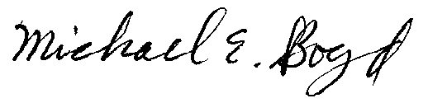
Filed Electronically 4-9-03
Michael E. Boyd – President, CARE
5439 Soquel Drive
Soquel, California 95073
(831) 465-9809
E-mail: michaelboyd@sbcglobal.net

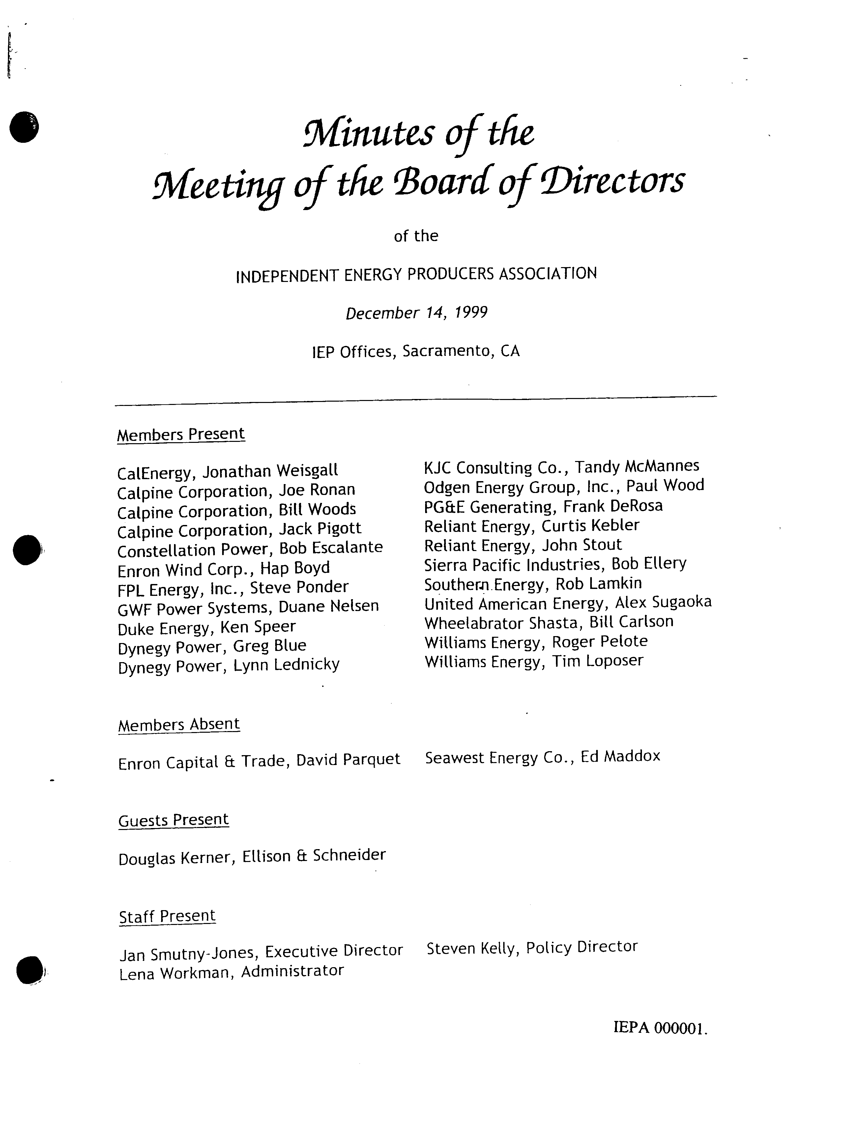
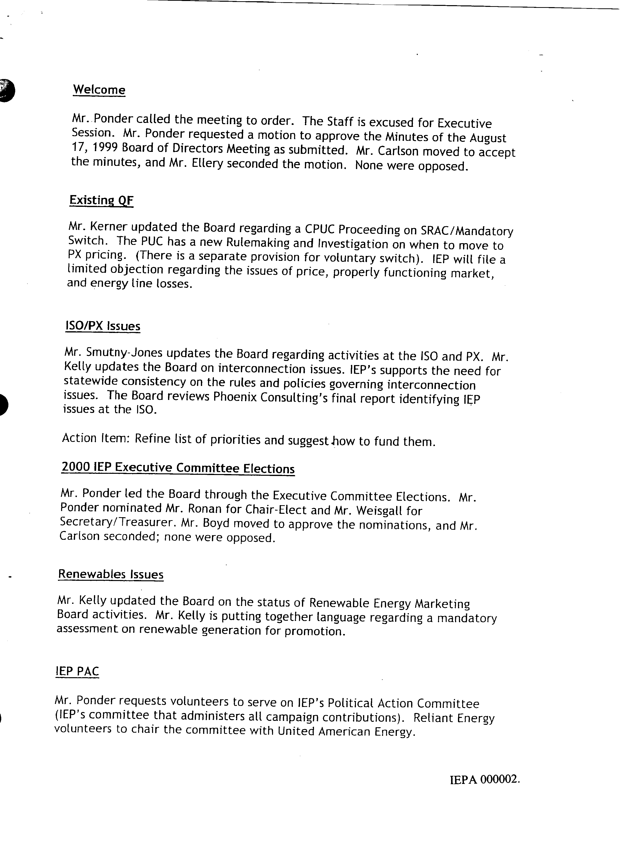
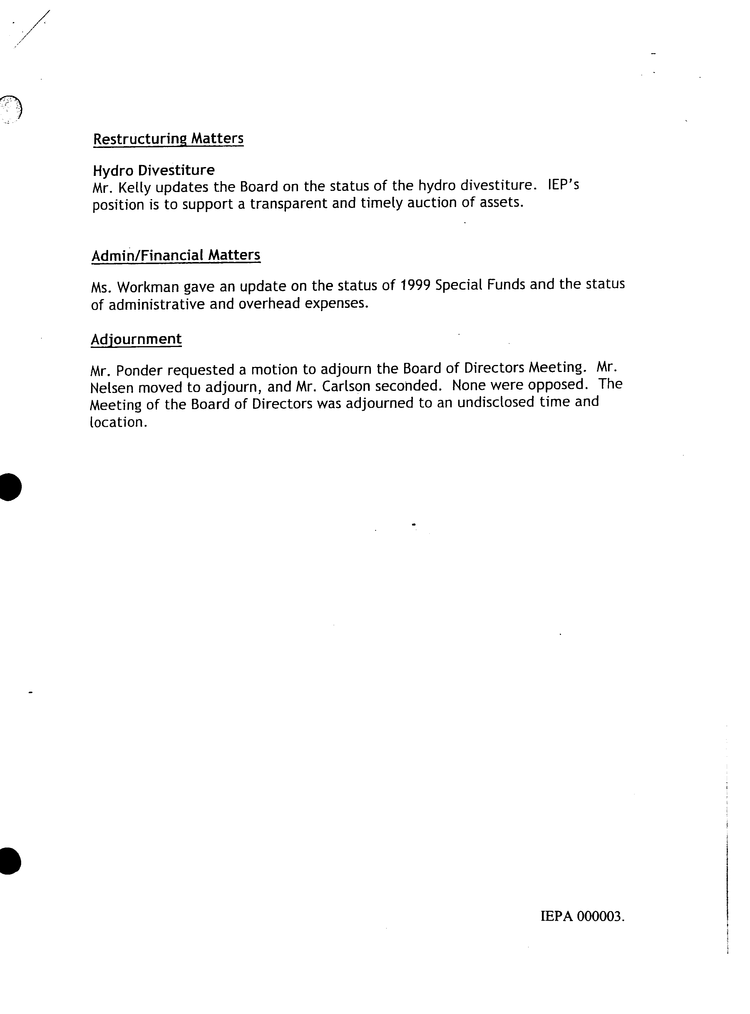

Certificate of Services

I hereby certify that I have this day served the foregoing document upon each person designated on the official service list, via electronic mail, until such time as the restricted service list is established for the above captioned matter. Rule 2010(f)(3) provides that you may serve pleadings by email. I further certify that those parties without electronic mail have been served this day via US mail or the ListServ.

Dated at this 9th day of April 2003.

Respectfully submitted,
President, CARE
(831) 465-9809
5439 Soquel Drive
Soquel, CA 95073

Verification

I am an officer of the intervening corporation herein, and am authorized to make this verification on its behalf. The statements in the foregoing document are true of my own knowledge, except matters, which are therein stated on information and belief, and as to those matters I believe them to be true.

I declare under penalty of perjury that the foregoing is true and correct.

Executed on April 9th, 2003, at Soquel, California
Michael E. Boyd – President, CARE
CAlifornians for Renewable Energy, Inc. (CARE)
5439 Soquel Dr.
Soquel, CA 95073-2659
Tel: (408) 891-9677

Fax: (831) 465-8491
michaelboyd@sbcglobal.net

These parties are Pacific Gas and Electric Company; the Cogeneration Association of California; the California Electricity Oversight Board; Eurus Toyowest Management LLC, which owns and manages the 46-mile transmission line which serves certain of the Respondent Projects; CAlifornians for Renewable Energy, Inc. ("CARE"); ESI Sky River and ESI VG, which are indirect, wholly-owned subsidiaries of the FPL Group (“FPL”), an electric utility holding company as defined under PURPA; Wind Energy Prototypes, LLC (“WEP”), which owns certain of the turbines involved in the Respondents' Projects; Enron Wind; Sithe/Independence Power Partners, L.P., in which an Enron Corp. subsidiary owns 40%, but which has no ownership interest in any Respondents' Projects; the California Energy Commission[CEC], which is the State of California’s primary energy policy and planning agency; and H&S filed a Motion for Late Intervention in Dockets Nos. EL03-17, et al. and EL03-19, et al. H&S is a California Limited Partnership that owns 47 wind turbines, which comprise some of the QFs at issue in this proceeding.
These are the same Parties listed in footnote 1 (including CEC) except for CARE.
These releases are discussed in detail in Exhibit A of the proposed Consent Agreement.
("In reviewing such applications, the Commission demands that the power marketer establish that it, and its affiliates, either do not have, or have adequately mitigated, market power in both generation and transmission. The applicant must also establish that it cannot erect barriers to entry, and that there is no evidence of other behavior perceived as anti-competitive, such as affiliate abuse or reciprocal dealing.")
CARE contends that Enron can assume a portion of the $13.6 billion in long-term bonded indebtedness taken on by the State of California Department of Water Resources to purchase power for all of California during the 2001 time period, to cover these Amortize repayments.
During the time period January 1, 2000 through June 20, 2001, Independent Energy Producers Association, Inc. (IEPA) acted as a "trust" composed of electricity generators and traders exercising market power to unlawfully manipulate the California wholesale electricity market, resulting in grossly inflated wholesale electricity prices throughout the state and much of the western United States. This result was accomplished by, inter alia, improperly using confidential real time generator capacity, use, and maintenance data, along with transmission system flow data to “game” the wholesale electricity market by withholding electrical generating capacity from the California Power Exchange’s forward markets, by improperly parking power with affiliates in other states which was later resold in California at inflated rates, by scheduling previously unplanned plant outages to coincide with other plants’ planned maintenance shutdowns, and by scheduling transmission flows to cause or exacerbate congestion. IEPA members include those members of identified in the Minutes of the December 14, 1999 meeting of IEPA, which list Enron Wind as a member.
A sale at less than the fair market price would not necessarily have been inconsistent with the Commission's ownership regulations because such a price would have resulted in a lower loan amount and therefore less likelihood that the benefits Enron Corp. received in the form of interest was excessive. A reduced loan amount might suggest that the negotiations were not at arm’s-length, and the 3% investors would reap a windfall in receiving profits sooner than if they invested on a higher sale principal amount.
Trial Staff's research also indicates that state law governs this question of imputing even the fraudulent acts of a corporate officer to the corporation. According to Trial Staff's analysis, since Enron Corp. is incorporated in Oregon, was headquartered in Texas, and did business with the QF projects in California, each state’s law may be applied. Because Trial Staff believes there is no appreciable variation in state law on this question, it concludes that it is not necessary to address choice of law principles.
(102 FERC ¶ 61,316) This order directs Enron Power Marketing, Inc. and Enron Energy Services, Inc. (collectively, Enron Power Marketers) to show cause to the Commission in a paper hearing why their authority to sell power at market-based rates should not be revoked by the Commission in light of their apparent engagement in gaming, in violation of Section 205(a) of the Federal Power Act's (FPA) requirement that rates be just and reasonable, as well as their apparent failure to disclose changes in their market shares to the Commission in violation of their market-based rate authority.
See, US West Financial Services, Inc., 55 FERC ¶ 61,377 at 62,148 (1991) (in absence of SEC ruling, FERC reviewed whether lease agreement satisfied PUHCA, as relevant to PURPA); Lyonsdale Energy Ltd. Partnership, 51 FERC ¶ 61,303 (1990) (FERC found, for purposes of PURPA, that applicant qualified for PUHCA 3 (a)(5) exemption. See also, “Financial Oversight of Enron: The SEC and Private-Sector Watchdogs,” Report of the Staff Senate Committee on Governmental Affairs, at 56, n. 202 (www.senate.gov) (it is the job of the FERC to decide good faith). The legal analysis on this issue described in this paragraph is Trial Staff’s analysis and the other Signatories and their affiliates do not subscribe to this particular interpretation of the law or Trial Staff’s application of the law to the facts as also set forth on this paragraph M.
Megan-Racine Associates, Inc., 76 FERC ¶ 61,354 at 62,669 (1996). Other remedies can include the termination of other QF regulatory exemptions. Id. Although the Commission did not set for hearing the question of an appropriate remedy in this case, it is useful to analyze what the scope of remedies might be as a means to evaluate the fairness of the Edison Agreement rate.
Id. at 62,669. The methodology for making that determination retroactively is ordinarily to require the public utility that has been buying power from the QF to provide data from its dispatch logs showing the highest cost option it actually selected in each hour, i.e. the most expensive energy purchase or unit running cost. Id. at 62,670. Reconstituting such data is a time-consuming process.
Report of Investigation by the Special Investigative Committee of the Board of Directors of Enron Corp., February 1,2002. Hereafter “Powers Report ”.
Powers Report
Id at 3
Id
Id at 4
Id at 17
In re Enron Corporation Securities Litigation Civil Action No.H-01-3624 (S.D.Tex.April 8,2001)
Id. at para 401.The number of shares are adjusted for an Enron two for one stock split in 1999.

