STATE OF CALIFORNIA
Energy Resources
Conservation and Development Commission
 | )
APPLICATION FOR CERTIFICATION OF | ) | DOCKET NO. 01-AFC-12
THE LOS ESTEROS CRITICAL ENERGY | )
FACILITY (LOS ESTEROS) | )
_______________________________________ | )

CARE’S COMMENTS ON THE
PRESIDING MEMBER'S PROPOSED DECISION (PMPD)

On May 30, 2002, the Committee designated to conduct proceedings in the above-captioned matter issued its Presiding Member's Proposed Decision (PMPD) recommending that the full Commission approve the Application for Certification for the Los Esteros Critical Energy Facility as proposed by Calpine C* Power. The 30-day comment period will end on June 29, 2002. If the comments and edits proposed by the parties do not substantively change the Committee's findings and conclusions, no Revised PMPD will be issued. CARE herein provides comments on the Presiding Members Proposed Decision for the Los Esteros Critical Energy Facility
Procedural Matters
On Monday, June 24, 2002, the Committee held a public Committee Conference to discuss comments on the PMPD. Mr. Bill Garbett, who is an agent for T.H.E.P.U.B.L.I.C., is also a member in good standing of CAlifornians for Renewable Energy, Inc. (CARE). Mr. Garbett attempted to participate in the Monday, June 24, 2002 Committee Conference, and had pre-arranged phone conferencing several weeks in advance of the meeting. Mr. Garbett attempted to participate in the meeting, but was unable to participate, because apparently the phone number listed on the Internet was not properly scheduled or working.
CARE respectfully demands that the California Energy Commission (C.E.C.) cure or correct action alleged to have been taken in violation of Cal Government Code § 11125(a). CARE contends that the June 4, 2002 Notice of Availability of Presiding Member’s Revised Proposed Decision and Notice of Commission Hearing fails to meet the notice requirements of the Bagley-Keene Open Meeting Act. The cure CARE seeks is the notice of said public hearing in accordance with the Act, to provide the public an opportunity for meaningful and informed public participation in accordance with the First Amendment constitutional rights enjoyed by citizens of the United States.
Failing to properly list the correct phone number or schedule teleconferencing services means that the CEC, in essence, altered the agenda. The Committee cannot do so without complying with the Bagley-Keene Act, which requires Notice shall be given at least 10 days in advance of the meeting, and shall include the name, address, and telephone number of any person who can provide further information prior to the meeting (§11125(a)) and with notice in writing and listed on the web site, which the CEC did not comply with.
The fundamental question remains this: did the CEC provide notice of the teleconferencing phone number in a way that complied with the Act and permitted meaningful public participation? CARE contends that the notice did not meet the requirements of the Act.
CARE objects to continued attempts by this Commission too preclude meaningful and informed participation to the public. Failing to properly list the correct phone number or schedule teleconferencing services makes it difficult for the public by making it impossible for the Intervenor and other members of the public to participate at the distant Sacramento location of this meeting. Most Intervenors and other members of the public must arrange travel, vacation requests from work, and childcare in order to participate.

Introduction
The CEC process is a long way from providing CEQA equivalency in any sense of that requirement, particularly in regard to public participation, and there appears to be “an irreconcilable conflict” between CEQA and the Warren-Alquist Act on this and other points, including absolutely vital elements of an adequate CEQA review. (See Mt. Lion, 16 Cal.4th 105, 114 (claim of “irreconcilable conflict” between CEQA and California Endangered Species Act).)
The CEC process as presently carried out is tainted with gross unfairness, inequity and inherently fraudulent goals. When the process gets near the end, strict time lines are imposed which create additional burdens on Intervenors and other members of the public, further hindering if not completely preventing their full and meaningful participation in a process heavily weighed in favor of an applicant with virtually unlimited resources whose only excuse for piecemealing the required information is to use it as a tactic to avoid or minimize opposition. This is accompanied by the CEC’s well-publicized emphasis on the policy of expediting the siting and approval of powerplant projects.
This is a recipe for ecological disaster being carried out without adequate legislative knowledge or approval. In other words, if the goal is to fully exempt the powerplant siting process from CEQA--meaning that crisis conditions are so bad we should blindly sacrifice irreplaceable environmental resources for the unproven benefits of creating new, unregulated energy markets--this policy decision should be made by the Legislature.
The Legislature can make the policy decision by simply making powerplant siting and licensing projects exempt from CEQA review, as the Legislature has the power to do (Napa Valley Wine Train, Inc. v. Public Utilities Commission (1990) 50 Cal.3d 370, 376; Sagas v. McCarthy (1986) 176 Cal.App.3d 288, 299), and as the Legislature has done for a multitude of specific types of project. (See, generally, CEQA §§ 21080(b), 21080.01 - 21080.08, 21080.7 - 21080.33.)
Indeed, to accomplish the goal of fully exempting the powerplant siting process from CEQA review, all the Legislature needs to do is amend and expand an existing, partial statutory exemption specifically granted to public agencies (e.g., the CEC) for specified actions on projects “relating to any thermal powerplant site or facility...” (CEQA § 21080(b)(6).)
Providing a full CEQA exemption through the legislative process, rather than in the underhanded manner presently being allowed by the CEC process, would enable the citizens of this state to have a voice in the matter. It would also allow a full investigation and discussion of such relevant factors as the actual existence, nature and extent of the so called energy crisis which purportedly compels the blind destruction of irreplaceable ecological resources, as well as other related topics such as revisiting the decision to completely deregulate the electric power production market and leave vital policy decisions in the hands of politically insulated state agencies and the multi-national corporations seeking to profit from the situation.
In addition to greatly increasing the cost of public participation, the existing CEC process, which, among other things (without limitation), includes piecemealing the public disclosure of information vital to an adequate CEQA review, also makes it extremely difficult if not virtually impossible to intelligently determine if and when to retain additional experts to continue participating in the ongoing review process in a knowing and meaningful manner. As it stands, this is a clear violation of the strong CEQA right of public participation which will undoubtedly continue, and most probably get worse, unless immediate steps are taken to rectify it--assuming, of course, that such steps are feasible.
The Intervenor, and the public, wish to participate to carry out this activity, which is protected by the first amendment of the federal constitution. These rights may not be impinged upon by procedural requirements that are not reasonable in light of all pertinent circumstances, not least of which is the Intervenor's lack of resources to properly participate, and your refusal to provide those resources, in whole or in part. Irrespective of the barriers (technical as well as procedural) to the Intervenor’s meaningful and informed participation a “good faith effort” will herein be made to provide comments in behalf of Intervenor Garbett, in behalf of myself, and on behalf of the public, raise these issues to compel the CEC to comply with the procedural due process protections of sections 1085 and 1094.5 of the Code of Civil Procedure, Article I, section 7 of the California Constitution and the Fourteenth Amendment of the United States Constitution, the Supremacy Clause of Article VI of the United States Constitution, and the Public Trust Doctrine in order to assure that (1) this Project's adverse impacts are fully disclosed, evaluated and, where feasible, mitigated, (2) the need (or lack thereof) for this Project is fairly presented and assessed, (3) reasonable alternatives to this Project are given full and fair consideration, and (4) Intervenor Garbett and the public are afforded their constitutionally-protected right to a fair hearing untainted by prejudice, bias and the exclusion of evidence refuting the claimed urgent need for this Project
CARE’s comments on the PMPD

California Department of Water Resources (DWR) Energy Contract

In the PMPD the Commission fails in its statutory duties under CEQA and the Warren – Alquist Act to insulate California’s consumers from unjust and unreasonable pricing imposed on California’s ratepayers through manipulation and fraud by Calpine in concert with Enron. The PMPD’s failure to address the unjust and unreasonable pricing in the energy contract with DWR allows Calpine to further exercise market power through YOUR approval of this project. We assume this means you assume full liability for the unjust rates and charges imposed by the DWR while the California energy markets where subject to fraud and manipulative market practices by Calpine in concert with Enron. Your position on this matter is made clear in the PMPD where it states at page 9-10.
In reviewing Applicant’s various motions to expedite our process, the Committee was mindful of Applicant’s energy contract with the state Department of Water Resources (DWR) for LECEF to supply energy to the grid in 2002. Upon Applicant’s request, however, the Committee ruled that the DWR contract as an emergency measure was outside the scope of our proceedings and would not be addressed further. The Committee later applied that ruling at our March 11, Hearing when the Coalition sought, over Applicant’s objection, to introduce matters related to energy costs in the DWR contract. (Cf. 3/11/02 RT 584:18-586:12 & 638:6-641:11; 645:3-651:4.)
During the March 11, 2002 Hearing, Applicant advocated an expedited schedule, which would call for two, 10-hour shifts--essentially construction around the clock. (3/11/02 RT 572:18-574:5.) In reviewing Applicant’s plans to expedite the construction schedule, we concluded that the AFC was ambiguous on the question of 24-hour construction, and that Staff had not evaluated those impacts. In addition, we concluded that Applicant had not carried its burden under section 25552 to demonstrate that LECEF could be in service by December 31, 2002. Therefore, we decided that the AFC should fall be removed from the four-month process and converted to a 12-month AFC as set forth in Public Resources Code section 25540.6. (Appendix E.) In concurrent orders dated April 25, 2002, the
Committee, inter alia, removed the AFC from the four-month process and ordered an Evidentiary Hearing on May 20, 2002 On May 20, 2002, the committee conducted a supplemental evidentiary hearing to consider additional evidence on the expedited construction schedule and the visual resources issues contested by Milpitas. Staff and Applicant presented evidence on 24-hour construction impacts and the likelihood that the project could be in service by December 31. Thereafter, in an order dated May 21, 2002, the Committee found that the record, as augmented, supported a finding that Applicant had met its burden under section 25552. Accordingly, we granted Applicant’s request to reinstate the AFC to the expedited process set forth in section 25552.

These positions on the DWR energy contract demonstrate your records conclusion that you have pre-committed your approval for this project to the California Department of Water Resources, who negotiated said energy contract in Secret, without the benefit of legislative or public participation in any form but through executive edict. PLEASE TAKE NOTICE that we respectfully demand that all administrative review activities concerning applications for the siting, construction or operation of natural gas powerplants in the state of California presently before the CEC in any manner requiring CEQA or CEQA-equivalent compliance as part of the administrative review be immediately terminated or substantially modified, and no additional public funds be expended to review such applications pending the resolution of, or at least the substantial stabilization of prices, supplies and other market conditions in regard to, the ongoing California energy crisis declared to constitute an emergency by the Governor through the issuance of executive orders commencing in January 2001. The energy crisis has made it impossible to conduct the type of stable, finite and accurate review of conditions, as they actually exist required by CEQA. The energy crisis has destroyed and continues to destroy the database essential to the identification, evaluation and mitigation of potentially significant environmental impacts that may occur as a result of a powerplant project. The compilation of that fundamental database is the backbone of the process required by CEQA to afford, assure and maximize environmental protection and avoidance of harm to the environment caused by activities carried out or allowed by public agencies. Moreover, we respectfully demand that the CEQA environmental review carried out in previously approving all natural gas powerplant projects be immediately reopened to determine if and precisely how the environmental documentation for each such previously approved powerplant project must be modified to take into account the ongoing energy crisis and its potentially significant effects on the powerplant project themselves, as well as on the environment generally. We strongly urge you to provide us with an immediate and final response to these demands, consisting of or accompanied by a fair explanation of the CEC's position. Should we fail to receive an adequate, good faith and fair response from you within a reasonable period (reasonable in regard to our resources and fund raising as well as time elapsed), we will assume and rely upon your silence as a full and final denial and we will proceed accordingly without further futile efforts to correct and salvage the validity of your administrative process for the siting, construction and operation of thermal powerplants in California.
PLEASE TAKE FURTHER NOTICE that your failure to immediately cease and desist from the further waste of public funds by processing applications subject to a CEQA equivalent review that may not be performed because of existing, ongoing conditions--i.e, the energy crisis--may become the subject of a taxpayers suit under section 526a of the Code of Civil Procedure, and relief may be sought against the decision-makers personally, as well as against other parties.

Environmental Justice
CARE is highly disturbed by the pattern of discrimination being exhibited by the Commission in the siting of, so-called, peaking power plants in areas predominately of color. You fail to understand your responsibilities under the Federal Civil Rights Act of 1964 (Title VI). The Staff Assessment (p4.8-14) identifies the community of Alviso as 70% Hispanic (Chicano), and 69% of the population within a six-mile radius as people-of-color.
As presented in SOCIOECONOMICS Table 2, minorities comprise 48.5 percent of San Jose’s and 46.2 percent of Santa Clara County’s population. Minorities also comprise 69 percent of the population with a six-mile radius of the LECEF site. SOCIOECONOMIC Figure 1 shows the distribution of minorities within the six-mile radius. This population resides primarily in Alviso, Santa Clara County, City of Milpitas, Alameda County, and an established mobile home park located approximately one-mile southwest of the site. Approximately 70 percent of Alviso’s population is Hispanic. The majority of Milpitas’ 54 percent and San Jose’s 29 percent minorities are Asian (U.S. Census 2000). The 45 percent minority residents of the mobile home park are Hispanic. According to the 1990 Census, 9.2 percent of San Jose’s population and six percent of residents within six miles of the LECEF were below the poverty level. Although Census 2000 low-income data is not yet available, the area’s low-income population is not expected to exceed 50 percent. Alviso, located approximately two miles to the west, is separated from the proposed LECEF site by the San Jose/Santa Clara Water pollution Control Plant. The mobile home park lies south of Highway 237 and west of Zanker Road. The residential areas of Milpitas are located one to six miles to the east across Interstate 880. Because of the distances, development and highway structures that separate these residential areas from the LECEF site, its construction is not expected to adversely affect the social or economic character of these communities in any significant way. Therefore, the proposed LECEF will not result in significant adverse socioeconomic effects on the surrounding minority and low-income populations.
How then can the Commission return to expedited schedule authorized under the Governor’s Executive Orders (Edicts) allowing the development of four simple-cycle gas turbines in an area, which already experiences a disparate environmental burden in comparison to surrounding communities?

Cancer Risk and Sources of Criteria Air Pollutants
 | | | Key to Map Symbols
  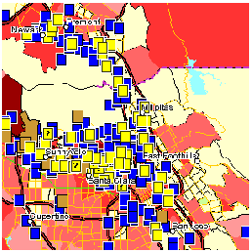
  Added Cancer Risk from Hazardous Air Pollutants: 1996 rank among all census tracts
  Lowest / Cleanest (0-20%)
  Second lowest (20-40%)
  Middle (40-60%)
  Third highest (60-80%)
  Second highest (80-95%)
  Highest / Dirtiest (95-100%)
  Sources of Criteria Air Pollutant Emissions (National Emissions Trends database)
  Facility
  Facility (approx. location)
  Superfund Sites
  -
  TRI Manufacturing Facility
  TRI Facility
  TRI Facility (approx. location)

CARE contends that the presence of such disparately impacted peoples-of-color within the project’s zone of deposition requires you to carry out your duty to properly identify impacts from the proposed project that are disparate in comparison to other projects the Commission has approved. For example the PMPD could have recommended the project be moved to the twelve month review process, as was done with the Tracy Peaker Project. Additionally there is no rational justification for not requiring the applicant to construct a combined cycle plant, as opposed to the simple cycle plant now proposed, with its additional environmental burden in the form of increased emissions of Criteria Pollutants and Toxic Air Contaminants. Intervenor Garbett also identified the reasonably foreseeable impact of emission of pathogens from the project’s reclaimed water-cooling system, which may be mitigated through the use of potable water or dry cooling technology by the applicant. CARE interprets the PMPD findings regarding section 25552 as an act of discrimination by the CEC against the surrounding community-of-color because of an existing disparate environmental burden and your failure to properly perform your duties pursuant to Title VI to identify alternatives and additional mitigation to address this environmental burden. The fact that you are allowing the applicant to develop this inadequate project on an expedited basis demonstrates illegal pre-commitment to the project for the purposes of fulfilling the terms of the DWR contract which is clearly only to the economic benefit of the applicant and not California’s rate payers or the surrounding community-of-color. The PMPD’s failure to properly address Environmental Justice and the unjust and unreasonable pricing in the energy contract with DWR allows Calpine to further exercise market power through YOUR approval of this project, which is based on prejudice, and which is an abuse of discretion. Without limitation, we object on the basis that you are making the CEC party to civil rights and anti-trust matters involving the violation and enforcement of fundamental constitutional rights of due process and equal protection.
Alternatives
The PMPD points to an inadequate alternatives analysis, which fails to comply with your duties under Title VI, CEQA, and the Warren-Alquist Act to identify alternatives and additional mitigation to address the environmental burden on the surrounding community.
FINDINGS AND CONCLUSIONS
Based upon the totality of the evidence of record, including that relating to each subject area contained in other portions of this Decision, we find and conclude as follows:
1. The evidence of record contains an acceptable analysis of a reasonable range of alternatives to the project as proposed.
2. The evidentiary record contains a review of alternative technologies, fuels, linear routings, and the “no project” alternative.
3. No alternative to the project considered by the Commission, including but not limited to the 'no project' alternative would avoid or lessen any direct, indirect, or cumulative significant adverse environmental impact.
4. No alternative to the project considered by the Commission, including but not limited to the 'no project' alternative is feasible, because none are capable of meeting the project objectives as specified in the Staff Analysis.
We therefore conclude that the evidence of record contains an analysis of possible alternatives to the LECEF project, including its appurtenant facilities, which satisfies the requirements of both the Warren-Alquist Act and CEQA and its implementing regulations.

How can such false assertions be made in light of the fact that your alternatives analysis failed to properly examine disparate impacts on peoples-of-color, and failed to offer-up any additional mitigation measures to address the existing disproportionate environmental burden on the surrounding community? CARE’s position is that the PMPD fails to identify any evidence in the record that you considered all the technically feasible options to mitigate disparate impacts on the surrounding community. These include, without limitation, the requirements to construct a combined-cycle power plant, the use of enhanced SCR and enhanced Oxidation catalyst technology, or the use of SCONOx emission controls to meet new federal BACT requirements, and the use of alternative cooling technology including, but not limited to, potable water and dry cooling. None of these technically feasible mitigation measures, all approved in practice, where even considered. Instead the PMPD recommends a plant design, which is experimental at best. Please be forewarned, your approval of this project as currently proposed, and the matters CARE has raised, may be the subject of future judicial or administrative review of your decision.

Compliance and General Conditions

The applicant's ability or willingness to comply with conditions to project approval, mitigation measures and similar obligations depending in large part on the good faith of the applicant to carry out even if left unsupervised. In the case applicant Calpine recent disclosure of insider trading, round-trip energy transactions, and other manipulative and fraudulent market practices, in proceedings before the Federal Energy Regulatory Commission, have raised questions over the ability of the applicant to meat the compliance and general conditions required for the approval of this project. We continue to misunderstand why the CEC is providing cover to Calpine when their fraudulent transactions with Enron are so transparent?

This is a securities fraud class action on behalf of purchasers of the public traded securities of Calpine Corporation (“Calpine” or the “Company”) between January 5, 2001 and December 31, 2001, inclusive (the “Class Period”), seeking to pursue remedies under the Securities Exchange Act of 1934 (the “Exchange Act”). The essence of the action is that in order to overstate its earnings in 2001, Calpine manipulated its results in violation of Generally Accepted Accounting Principles and SEC rules by recording revenue from reciprocal transactions with Enron in which Enron and Calpine sold energy to one another at inflated amounts. In manipulating these transactions, defendants had actual knowledge that certain public documents and statements issued or disseminated in the name of the Company to the investing public during the Class Period were materially false and misleading. Further, substantial insider sales by the officer defendants during the Class Period are probative of the defendants’ scienter in this case.

In order to overstate its earnings in 2001, Calpine manipulated its results in violation of GAAP and SEC rules by recording revenue from reciprocal transactions with Enron in which Enron and Calpine sold energy to one another at inflated amounts. It has subsequently been disclosed that Calpine had sold 6.5 million megawatt hours of electricity to Enron at a price 58% higher than other Calpine customers paid. The reason for this is that Calpine had purchased natural gas from Enron at similarly inflated prices.

Apparently Calpine was also involved in manipulation in the natural gas markets, because fraud in one market taints both the energy and natural gas markets.

CBS MarketWatch report titled PG&E, Calpine admit 'wash' trades
Reliant discloses one round trip deal, on June 1, 2002 reported,
In its review of over 72,000 transactions, Calpine said it found 31 of these trades. It said the transactions were made for risk management reason, not for "the purpose of increasing volumes or revenue, impacting market prices, or for any other improper business purpose."

Here we have Calpine admitting to fraud, once again, along with denial of culpability for their actions. CARE contends these are the same so-called “round trip” trades cited in California State Senator Dunn’s testimony before the US Senate Commerce, Science & Transportation Committee on May 15, 2002 on RICO.
The PMPD failed to include beefed up or additional monitoring measures to assure compliance given the applicant's prior (and current) legal difficulties and other conduct indicating the applicant may not fully discharge its duties in a good-faith manner. CARE provides evidence of the applicant’s poor track record of complying with the Conditions of Certification of the Los Medanos Energy Center (98-AFC-1) and the Sutter Power Project (97-AFC-2).

CARE has received information on Calpine’s compliance issues via a request pursuant to the California Public Records Act from the Commission. In a 11/16/00 correspondence from Chuck Najarian to Bob Therkelsen in regards to the “Los Medanos Stop Work Order” it states, “Several days ago we were notified that Calpine has constructed 99% of a short segment (about 900 feet) of the Los Medanos transmission line differently than what was described in the Decision and which may conflict with the existing conditions of certification. In doing so, they encroached on the City of Pittsburg property near designated future residential development because they went outside the 40-foot easement they obtained from the City. The designated CBO has placed a stop order on the transmission line segment in question.”
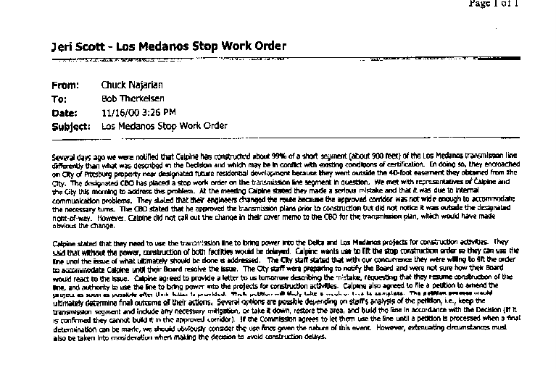
Figure 1 11/16/00 correspondence from Chuck Najarian to Bob Therkelsen in regards to the “Los Medanos Stop Work Order”
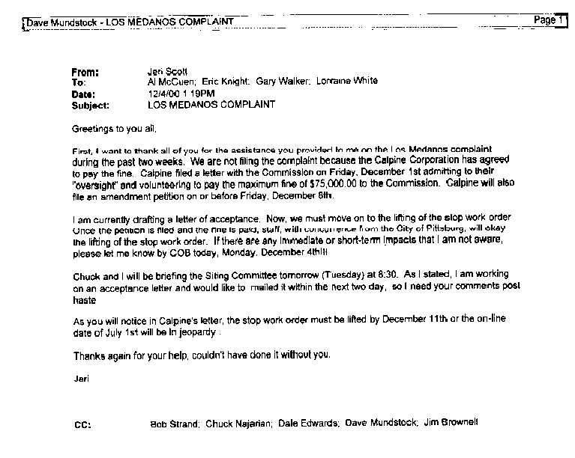
On 12/4/00 Compliance project manager Jeri Scott sent e-mail to Commission staff Al McCuen, Eric Knight, Gary Walker, and Lorraine White titled “Los Medanos Complaint”, where it states, “We are not filing the complaint because the Calpine Corporation has agreed to pay the fine. Calpine filed a letter with the Commission on Friday, December 1st admitting to their “oversight” and volunteering to pay the maximum fine (sic) of $75,000.00 to the Commission.” CARE contends this demonstrates the applicants and Commission staff’s propensity to look the other way on the environmental and socioeconomic impacts of this project’s failure to comply with Conditions of Certification.
Figure 2 Compliance project manager Jeri Scott's e-mail to Commission staff titled “Los Medanos Complaint”

In regards to the rights of the public to participate, by this reference, we incorporate the attached December 19, 2000 letter to Commission chairman, William Keese, from Glenn May a reporter at the Contra Costa Times complaining about the inability of the press as well as the publics to obtain information required to meaningfully participate in the Commission’s proceedings, as well as all comments submitted by CARE on the subjects of public participation and the procedural/substantive unfairness, in the MEC proceedings. Please let us know immediately if you reject this attempt to incorporate these materials by reference without having to resubmit them. In this letter Mr. May states,

“Dear Mr. Keese,
I am writing to express my deep dissatisfaction with the performance of California Energy Commission staff and my resulting loss of confidence in the commission’s stated goal of providing California residents with full and complete information about power projects affecting them.

I am a reporter for the Contra Costa Times (Knight-Ridder) chain who covers the city of Pittsburg, which is, as I’m sure you’re aware, ground zero in efforts to site generation assets to ease the current power shortage.

As a reporter whose duty it is to relay information to a community particularly at risk to excesses of that zeal, I entrust the Energy Commission with providing me with full and thorough information on projects under its jurisdiction. After recent developments regarding the Calpine Los Medanos Energy Center, I fear that trust is misplaced.

To me, the residents of a community in which not one but two power plants are being built deserve at least a base level of disclosure. An admission by the constructor of those plants that it violated terms of its license, I believe, meets that threshold.

If you disagree, I would welcome hearing your rationale.

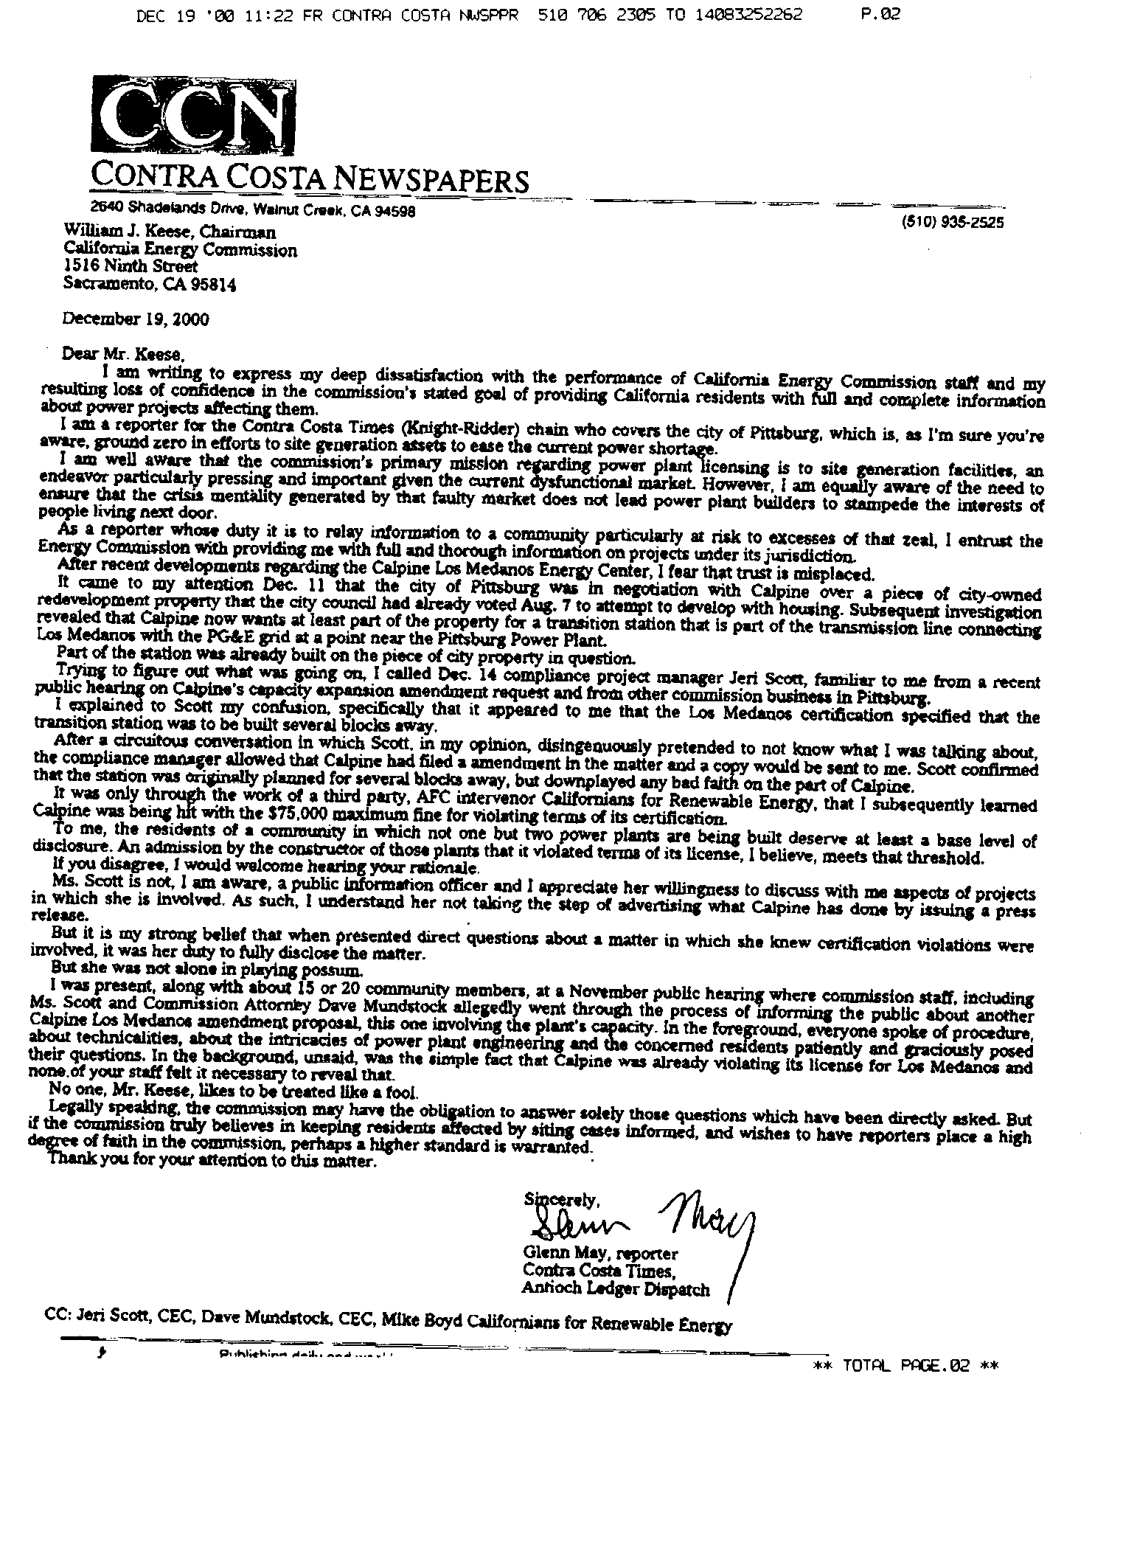
Ms. Scott is not, I am aware, a public information officer and I appreciate her willingness to discuss with me aspects of projects in which she is involved. As such, I understand her not taking the step of advertising what Calpine has done by issuing a press release.
Figure 3 Letter Glenn May CC Times to Commissioner Keese on Compliance Staff

But it is my strong belief that when presented direct questions about a matter in which she knew certification violations were involved, it was her duty to fully disclose the matter.

But she was not alone in playing possum.

I was present, along with about 15 or 20 community members, at a November public hearing where commission staff, including Ms. Scott and Commission Attorney Dave Mundstock allegedly went through the process of informing the public about another Calpine Los Medanos amendment proposal, this one involving the plant’s capacity. In the foreground, everyone spoke of procedure, about technicalities, about the intricacies of power plant engineering and the concerned residents patiently and graciously posed their questions. In the background, unsaid, was the simple fact that Calpine was already violating its license for Los Medanos and none of your staff felt it necessary to reveal that.

No one, Mr. Keese, likes to be treated like a fool.”

One matter for consideration is Calpine's treatment of its employees and there is evidence establishing at least a question of fact that Calpine engaged in deceptive practices, that include the failure to follow its own policies, in order to cut costs or inflate its stock value. Of course, the tendency to disregard its own ameliorative policies in order to cut costs is a very relevant attribute of corporate character that needs full and fair investigation, and it is up to the CEC, not the public, to conduct this investigation. In this regard CARE cites the 10/6/00 e-mail from Bob Therkelsen to Compliance Officer Jeri Scott where it states, “On Wednesday, October 4th, Andrew Berna-Hicks of the Department of Toxic Substance Control telephone Mike Ringer to inform him of two alleged arsenic poisoning at LMEC. Apparently, two workers at the LMEC where exposed to arsenic contaminated soil on the site. One backhoe operator tested for exposure on October 9, 2000 (Sample C6896) listed an exposure level of 0.0053mg/m3 with a California OSHA action level of 0.0050mg/m3.” CARE contends that Calpine is “engaged in deceptive practices, that include the failure to follow its own policies, in order to cut costs or inflate its stock value.

Figure 4 E-mail from Bob Therkelsen to Jeri Scott on Arsenic exposure of workers at LMEC

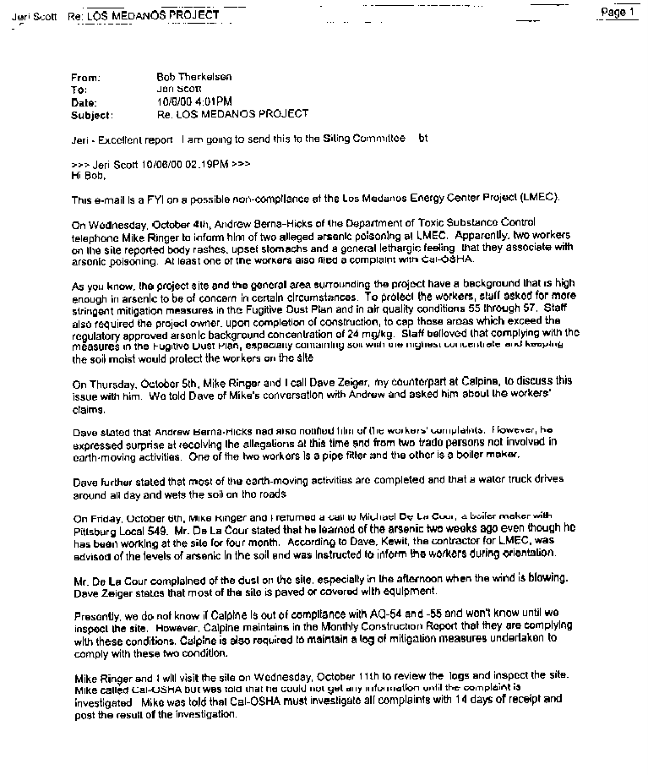
In regards to Calpine’s compliance problems CARE also cites for the record, Calpine’s compliance problems in Sutter where truckers hired by the company failed to confine traffic to the prescribed routes. Clearly there is a pattern of failure on the part of the applicant to comply the Conditions of Certification of projects you have already approved.
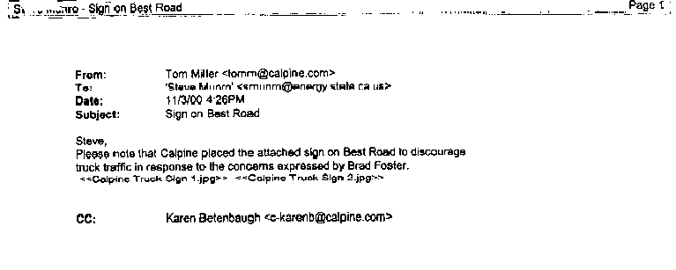
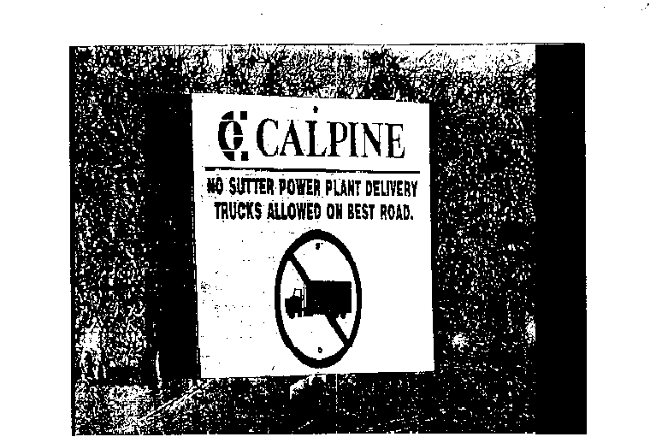
Figure 5 E-mail from Tom Miller to Steve Munro on Sutter truck routes to the project and sign.
Cultural Resources
CARE notes that the recent site preparation of the Metcalf Energy Center project disturbed the human remains of several individuals. CARE provided extensive expert testimony from fully qualified archeologists that both concluded the presence of human remains was highly likely for the MEC project’s site. The Commission ignored this choosing to accept on good faith the applicant’s claim that such remains where unlikely. In reviewing the events surrounding the discovery and removal of the remains CARE discovered that the CEC has not yet adopted a protocol to protect the civil and constitutional rights of the Most Likely Descendents (MLD). In this case the CEC allowed the removal of the remains prior to notifying the MLD, then when the MLD was contacted, the CEC and applicant failed to carry out the MLD’s recommendation for the remains which included, leaving the remains in place until the MLD could examine the remains for removal to another MLD selected location for re-internment. The MLD also recommended that the remains not be removed by the applicants archaeologist Basin Research for research purposes, because of the MLD’s prior problems with the applicant’s archaeologist’s over their previous handling of native remains. The CEC in fact allowed the applicant to remove the remains and keep them in storage on the project site where they where than presumably subject to research by Basin Research. The CEC has failed to develop the appropriate protocols to protect the civil, constitutional, and statutory rights of the MLD, and we expect nothing less than a guarantee that such actions will not re-occur in the development of this project.

Efficiency, Reliability, and Facility Design
CARE is concerned with the inadequacy of staff’s analysis of the effects of possible natural gas supply curtailments or manipulations on the efficiency and reliability of the proposed facility’s design as well as natural gas quality. CARE is also concerned that the PMPD provides the false conclusion that this project is the most efficient and reliable design for the project. The record for the case demonstrated that you failed to compare the efficiency of the proposed design in comparison with a combined cycle design, which is clearly more efficient because that design is based on the cogeneration of electricity.

Air Pollution Impacts
The PMPD failed to properly identify the Best Available Control Technology for the project. The applicant has proposed to use selective catalyst reduction (SCR) and oxidation catalysts to minimize the emissions of oxides of nitrogen (NOx) to 5 parts per million (ppm), carbon monoxide (CO) to 6 ppm, and Volatile Organic Compounds (VOCs) at 2 parts per million, while maintaining the slip of ammonia (NH3) emissions to 10 ppm. However, the Federal Environmental Protection Agency (EPA), recently determined that the BACT for a combustion turbine combined cycle operation should be set at 2 ppm for NOx, 2 ppm for CO and 5 ppm for ammonia. CARE objects to the PMPD’s failure to recommending that the project mitigate to the above-mentioned EPA-recommended BACT levels.
· Staff has found that the project’s emissions of NOx and VOC have the potential to cause significant impacts relative to the state 1-hour and the federal 8-hour ozone air quality standards. The area experiences violations of the state 1-hour and federal 8-hour ozone standards each year (since 1992) and there is no clear indication of improvement. Thus, it is crucial that any NOx and VOC emission increases be fully offset and limited to EPA recommended BACT levels to avoid worsening violations of the ozone ambient air quality standard.
The project is a major source whose emissions trigger PSD requirements for NOx, PM10, and CO. Any major modification subject to PSD must conduct an analysis to ensure that best available control technology ("BACT") is used. This requirement is set forth in section 165(a)(4) of the federal Clean Air Act, in federal PSD regulations at 40 C.F.R. § 52.21(j), and in federal regulations providing the requirements for State implementation plan (SIP) approval of a State PSD program, at 40 C.F.R. § 51.166(j). For PSD purposes, BACT is “an emissions limitation… based on the maximum degree of reduction for each pollutant subject to regulation under [the] Act which would be emitted from any proposed major stationary source….” (40 CFR § 52.21(b)(12).)

SCONOx
The Staff’s Analysis and PMPD failed to identify any evidentiary record that the CEC even considered SCONOx emission control technology for the project. A proper top-down analysis would almost certainly have concluded that SCONOx is BACT for this project, even if it achieved exactly the same emission limit as SCR, because it offers a number of important advantages over SCR alone, with no offsetting disadvantages. First, SCONOx uses a single catalyst to simultaneously remove NOx, CO, VOCs, and toxics. Second, it uses no ammonia or other hazardous materials and thus requires no ammonia slip, eliminating the many significant impacts associated with ammonia use (e.g., transportation accidents, unloading accidents, site releases, PM10 generation). Third, the SCONOx system operates effectively at temperatures ranging from 300ºF to 700ºF, making it well suited for merchant operation and providing better control during startups and shutdowns than achieved with other competing catalytic technology (e.g., SCR, CO oxidation catalyst). Fourth, unlike other catalytic systems, the SCONOx catalyst is continuously regenerated, assuring continuous maximum catalyst effectiveness. Finally, notwithstanding the forgoing benefits, SCONOx has achieved much lower NOx and CO levels than other competing technologies and, therefore, is de facto BACT for this project. The SCONOx system has been demonstrated to achieve 2 ppmvd averaged over 3 hrs or 2.5 ppmvd averaged over 1 hr on the 32 MW combined cycle (25 MW LM2500 gas turbine plus 7 MW steam turbine) Federal Cogeneration facility in Vernon, California (“Federal Facility”). (South Coast AQMD Staff Report, p. 3-4.) The South Coast AQMD has concluded that SCONOx/water injection is “achieved-in-practice” technology for natural gas-fired turbines with rated capacities of 3 MW or greater. EPA Region 9 has also concluded that the Federal Facility “has, based on data submitted to EPA for the six-month period from June 28, 1997 to December 28, 1997, ‘demonstrated in practice’ NOx emissions rates that are consistently at or below 2.0 ppmvd based on a 3-hour rolling average.” (Haber 3/23/98. ) EPA has recently acknowledged that this same facility is currently meeting 1 ppm NOx. In addition, SCONOx has been operating on a 5-MW Solar Taurus 60 gas turbine at the Genetics Institute facility in Andover, Massachusetts since August 1999, likewise meeting 1 ppm. SCONOx simultaneously removes NOx, CO, and VOCs. The nine months of recent CEMs data indicate that the Federal Facility routinely achieves a CO limit of 1.0 ppm averaged over 1 hour, and 0.7 ppm averaged over 3 hours.

Enhanced SCR and Oxidation Catalyst
The Staff Assessment identified and summarized the emission control technology for the project as follows:
NOx Controls
The combustion turbines will be equipped with water injection to minimize Nox generation and the CTG exhaust will also be treated by a selective catalytic reduction (SCR) system before release to the atmosphere. Selective catalytic reduction refers to a process that chemically reduces NOx to elemental nitrogen and water vapor by injecting ammonia into the flue gas stream in the presence of a catalyst and excess oxygen. The process is termed selective because the ammonia preferentially reacts with NOx rather than oxygen. The catalyst material most commonly used is titanium dioxide, but materials such as vanadium pentoxide, zeolite, or noble metals are also used. Newer catalysts (versus the older alumina-based catalysts) are more resistant to fuel sulfur fouling at temperatures below 770° F (EPRI 1990). Regardless of the type of catalyst used, efficient conversion of NOx to nitrogen and water vapor requires uniform mixing of ammonia into the exhaust gas stream and a catalyst surface large enough to ensure sufficient time for the reaction to take place.
POC and CO Controls
Precursor organic compounds (POC) and carbon monoxide (CO) will be controlled at the CTG combustor and by an oxidation catalyst. An oxidation catalyst system chemically reacts organic compounds and CO with excess oxygen to form nontoxic carbon dioxide and water. Unlike the SCR system for reducing NOx, an oxidation catalyst does not require any additional chemicals.

Ammonia Emissions

To control NOx emissions, aqueous ammonia will be injected into the flue gas stream as part of the Selective Catalytic Reduction (SCR) system. Not all of this ammonia mixes in the flue gases to reduce NOx; a portion of the ammonia passes through the SCR and is emitted unaltered from the stacks. These ammonia emissions are known as ammonia slip. The LECEF has proposed (and the BAAQMD has agreed) to an ammonia slip no greater than 10 ppm. On a daily basis, ammonia slip of 10 ppmv from all four turbines combined will yield approximately 600 lbs total emitted to the atmosphere. It should be noted that ammonia slip of 10 ppm usually only occurs after significant degradation of the SCR catalyst, usually five years or more after commencing operations. At that point, the SCR catalysts are removed and replaced with new catalysts. During most of the operational life of the SCR system ammonia slip emissions would be significantly less, in the 1 to 5 ppm range.

The basic principals behind enhanced SCR and Oxidation Catalyst is that the larger the reactive area (or volume of ammonia in SCR) the more efficient the reaction occurs. Increasing the reaction efficiency may be accomplished by simple doubling or tripling the area of catalyst and volume of ammonia used in SCR system which enables NOx levels of 1 part per million to be achieved. One collateral benefit of this method is a reduction in ammonia slip due to increased efficiency in the reaction. The same is true with the use of Oxidation catalyst, increasing the reaction efficiency may be accomplished by simple doubling or tripling the area of catalyst. Also considered a VOC, ammonia is further reduced by the use of enhanced Oxidation catalyst. Enhanced SCR and Oxidation catalyst can readily achieve emission levels of 1 ppm Nox, 1 ppm VOC, 1 ppm CO, and 1-ppm ammonia slip, utilizing existing technology. CARE objects to the PMPD’s failure to identify this, and SCONOx, as technology capable of achieving EPA’s new requirements for BACT.

Public Health
Partial load emissions (for air quality and public health) in the CEC Staff's calculations, summarized in the amended SA, suggest that the total cancer risk is less than the significance threshold of one in one million. These calculations assume that both turbines are operating simultaneously at full load. However, emissions of some toxic compounds are substantially higher during reduced loads, such as occur during startup, shutdown, and partial load operation, than during routine operation. The LOCEF operating scenario based on an annual equivalent availability factor ranging from 92 to 98 percent or 250 start and shutdowns annually.
Applicant proposes to operate the LECEF throughout its intended life as a simple-cycle peaking power plant, selling peaking power through a contract with the California Department of Water and Power (CDWR) and providing load following and/or baseload power on the competitive market. As a peaking power plant, the LECEF must be able to operate reliably in the summer for only a few hours per day without shutting down for maintenance or repairs. Maintenance and repairs will occur when the facility is shut down (at night, on weekends, and in the fall, winter and spring). The LECEF is expected to operate at an annual equivalent availability factor ranging from 92 to 98 percent. (Ex. 1, p. 5.4-2.)
The Gas Research Institute ("GRI") investigated the effect of load on criteria and toxic pollutant emissions from nine gas turbines including a large Frame 7 GE turbine. This study found that emissions of benzene, toluene, formaldehyde, methane, and total non-methane hydrocarbons decrease with load. Emissions of formaldehyde, a carcinogen, increased dramatically, by up to a factor of 343 when the load was reduced from 100% to 20%. For the 750 MW GE Frame 7, the formaldehyde emission factor increased by a factor of 503, and the formaldehyde emissions increased from 0.11 to 16.08 tons/yr or by factor of 146, when the load was reduced from 100% to 30%. (GRI 8/96, Table S-5.) This substantial increase in formaldehyde emissions during reduced load operation was not taken into account in the Applicant's risk calculations. CARE contends that the CEC has failed to carry out your duty to properly identify impacts from the effects of partial load emissions (on peoples-of-color) from the proposed project that are disparate in comparison to other projects the Commission has approved. Besides the clear economic benefit to the applicant, and not electricity ratepayers, the PMPD provides no justification or evidence for not requiring this project be a combined cycle plant subject to the twelve-month review process.

Biological Resources
CARE objects to the PMPD’s failure to identify the local and regional cumulative impacts of emissions and water usage from the project on biological resources. These include, without limitation, the effects of emissions of criteria pollutants, and Toxic Air Contaminants as identified by Dr. Shawn Smallwood’s expert testimony in the Metcalf Energy Center, which we hereby incorporate here in its entirety, as if fully set forth by CARE. The PMPD also failed to properly identify reasonably foreseeable impacts of air-born pathogens (prions) emitted from the plants stacks from the reclaimed water supply utilized for cooling.
The PMPD failed to address these issues, instead making the following findings, which CARE contends are erroneous.
Based upon the uncontroverted evidence of record, we find and conclude as follows:
1. Sensitive plants and animals exist in the project area, as the serpentine soils in Santa Clara County support many state and/or federally listed species as well as species of concern.
2. There are no wetlands or sensitive plant species on LECEF’s proposed site.
3. The LECEF site footprint has been cleared of structures and vegetation that could provide wildlife shelter.
4. LECEF’s construction will result in the permanent loss of 18 acres of disturbed land suitable for foraging habitat.
5. Construction and operation of the LECEF project, if not adequately mitigated, could create adverse impacts to the sensitive biological resources in the project area.
6. The combined impact of constructing PG&E’s Los Esteros Substation, and the USD project at the same time as LECEF would create a significant impact to foraging and nesting habitat for sensitive species.
7. Applicant’s compliance with the mitigation measures set forth in the environmental documents for the USD and Los Esteros Substation projects, along with our Conditions will ensure that cumulative impacts are mitigated to less than significant levels.
8. Construction of the stormwater drain to the high flow channel of Coyote Creek does not require permit authorizations from the CDFG or the U.S. Army Corps of Engineers. Applicant has completed the design process for permitting by the Santa Clara Valley Water District.
9. Applicant has submitted an amendment for its the Section 1600 Streambed Alteration Agreement permit determination by the California Department of Fish and Game (CDFG) based upon the high flow channel proposal for the stormwater drain. Applicant will obtain a Streambed Alteration Agreement if required by the CDFG.
10. The mitigation measures contained in the Conditions of Certification set forth below were developed in cooperation and consultation with the United States Fish & Wildlife Service and with the California Department of Fish and Game.
11. The Conditions of Certification assure that the LECEF Project will cause no significant unmitigated adverse impacts to biological resources in the project area.
12. The Conditions of Certification, if properly implemented, ensure that the LECEF Project will comply with applicable LORS, which are set forth in the pertinent portion of Appendix A of this Decision. We therefore conclude that construction and operation of the LECEF Project will not create any significant direct, indirect, or cumulative adverse impacts to biological resources.
How can such claims be made in light of your failure, without limitation, to properly identify all potential and reasonably foreseeable impacts on biological resources as well as the cumulative impacts on such? Once again the CEC and applicant are only recommending mitigation for the specific biological resource impacts on the project site. The mitigation recommended fails to address the regional cumulative impacts on biological resources within the zone of pollution deposition for the project, and once again as in the MEC project, locating the proposed mitigation within that zone of deposition, thereby eliminating any benefits from the mitigation proposed.

Reclaimed Water Resources
At your March 11, 2002 evidentiary hearing on Water Resources, Intervenor Garbett, raised the issue of the reasonably foreseeable threat of airborne pathogens such as prions to the public health, which is a threat as well to biological resources.
1 There are some organisms, such as
2 anthrax, which is very difficult to kill, even if
3 you run it through the turbine engine, even at
4 5000 degrees you don't kill the anthrax spores.
5 Anthrax has been found in Santa Clara County, in
6 the foothills. It is a disease here, as is
7 Scrapie from sheep is found in humans as
8 Creutzfeldt-Jakob disease, commonly known as mad
9 cow disease. It is a prion and there is no known
10 way of killing these off, including water
11 treatment processes.
12 With this, other viruses are not
13 necessarily killed off or attenuated greatly by
14 the treatment process, including the AIDS virus.
15 With the use of this recycled water, you
16 are having a public health hazard in San Jose; and
17 the newspaper of general circulation, they've
18 talked about the flu epidemic that started when
19 they started using recycled water in the San Jose
20 State power plant cooling towers. All the
21 hospitals were filled, and eventually they backed
22 off on the water for awhile.
23 On the athletic fields of San Jose State
24 University there's two athletes that had major
25 infections. One of them had an amputation from

Prion diseases are often called spongiform encephalopathies because of the post mortem appearance of the brain with large vacuoles in the cortex and cerebellum. Probably most mammalian species develop these diseases.
It seems that a protein alone is the infectious agent. The infectious agent has been called a prion. A prion has been defined as "small proteinaceous infectious particles, which resist inactivation, by procedures that modify nucleic acids". The discovery that proteins alone can transmit an infectious disease has come as a considerable surprise to the scientific community.
Hypothesized in 1982 by Dr. Stanley B. Prusiner of UCSF, prions are a class of infectious agents composed of nothing but protein. Dr. Prusiner was awarded the Nobel Prize in physiology or medicine in 1997 for the discovery. Though their exact mechanisms of action and reproduction are still unknown, it is now commonly accepted that they are responsible for a number of previously known but little-understood diseases including scrapie? (a disease of sheep), Kuru (a disease common among a New Guinean tribe who practiced funerary cannibalism), Creutzfeldt-Jakob Disease (a neurological disorder), and Bovine Spongiform Encephalopathy ("Mad Cow Disease").
The word is derived from a combination of the words "proteinaceous infectious particle". It refers to the hypothesis (widely discounted when first proposed) that infectious agents causing such diseases consisted only of protein, with no nucleic acids. All pathogens known prior to that time (bacteria, viruses, etc.) contain nucleic acids, which enable reproduction. The prion hypothesis was developed to explain why the mysterious infectious agent causing Creutzfeldt-Jakob disease which resisted ultraviolet radiation (breaks down nucleic acids) but responded to agents that disrupt proteins. Ultraviolet radiation is used in many wastewater treatment facilities as a disinfectant.
A breakthrough occurred when researchers discovered that the infectious agent consisted mainly of a protein called PRP. This protein is found in the membranes of normal cells (its precise function is not known), but an altered shape distinguished the infectious agent. It is hypothesized that the distorted protein binds to normal proteins of the same type and somehow induces them to change their shape as well, producing a chain reaction that both propagates the disease and generates new infectious material. Since the original hypothesis was proposed, a gene for the PRP protein has been isolated, the mutation that causes the variant shape has been identified and successfully cloned, and studies using genetically altered mice have bolstered the prion hypothesis. The evidence in support of the hypothesis is quite strong now, but not incontrovertible.
While CARE’s research on prions has failed to discover any direct evidence in the literature on the effects of airborne prion exposure, such inference may be drawn from reports linking prions to sludge.
EPA looks away from possible health threat
USA Today, Oct 7, 1999
Early in the morning of Nov. 24, 1995, Joanne Marshall woke to find her 26-year-old son, Shayne Conner, gasping for breath. Though an ambulance rushed him to the hospital, he later died from respiratory distress. Conner's death was just one of several medical problems that neighbors in Greenland, N.H., had experienced in the month after trucks started dumping sewage sludge - residue left over from wastewater treatment plants - on a nearby field.
Did sludge contribute to Conner's death? Did it cause the death of 11-year-old Tony Behun? He died in 1994 shortly after riding his motorcycle through a Pennsylvania field recently coated with sewage sludge. And has it killed farm animals, as some farmers allege? So far, no clear link has been established between the deaths and sludge. There are only troubling questions about the possible health effects of exposure to sewage sludge.

Further Corroborative evidence of the effects of airborne pathogens comes form the June 24, 2002 addition of Time Magazine titled What's in Your Pipes?
Fern Leitman, 56, a longtime Florida resident, thought her repeated bouts of pneumonia were just bad luck. Doctors told Suzan King-Carr, 58, of Hobe Sound, Fla., that the spots on her lungs were probably cancer. Ida Mae Williams, 76, of Bogalusa, La., was informed that she had tuberculosis. Three women, three different diagnoses — all of them wrong. After years of ineffectual treatment, each woman learned that she, like thousands of other Americans, had developed a mysterious lung infection that mimics TB, seems to strike thin, white women in particular and can be permanently debilitating. Most unsettling of all, they could have developed the ailment simply by stepping into a shower.
What is unclear is whether the increase in reported cases is the result of better diagnoses or of some as yet undiscovered change in the bug or the environment it grows in. "That's what keeps me awake at night," says Dr. Gwen Huitt, a pulmonologist at the National Jewish Medical and Research Center in Denver. "These mycobacteria are everywhere." They thrive in what scientists call biofilms — pond scum and the slime inside faucets and showerheads.
Shower stalls are particularly suspect. Some doctors believe that mycobacteria from the pipes are becoming aerosolized in water spray.

Wastewater treatment involves three steps referred to as primary, secondary, and tertiary treatment. Primary treatment involves the removal of solids from the wastewater in settling ponds, followed by second treatment, which removes the majority of pathogens through a large tank filled with bacteria filled water called a digester. Secondary treated effluent is then disinfected using chlorine or ultraviolet light. Tertiary treatment is basically a large activated charcoal filter that removes the remaining dissolved solids present. The bi-product of the tertiary treated wastewater is sludge.

The evidence of prion exposure from sludge infers that the presence of such pathogens in the remaining wastewater is reasonably foreseeable, and your failure to properly analyze such impacts, implies your and the applicant’s acceptance of full liability for such. The evidence of mycobacteria from the pipes becoming aerosolized in water spray also infers that exposure to airborne prions is reasonably foreseeable and there is no evidence in your records that this was properly analyzed.
Respectfully submitted,
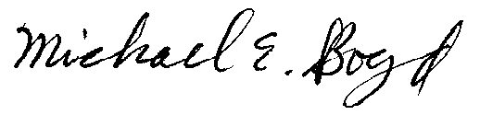
President, CARE Dated this 28th day of June 2002.
(831) 465-9809
5439 Soquel Drive
Soquel, CA 95073
E-mail: michaelboyd@sbcglobal.net

Verification
I am an officer of the commenting corporation herein, and am authorized to make this verification on its behalf. The statements in the foregoing document are true of my own knowledge, except matters, which are therein stated on information and belief, and as to those matters I believe them to be true.

I declare under penalty of perjury that the foregoing is true and correct.

Dated this 28th day of June 2002.

Respectfully submitted,
President, CARE
(831) 465-9809
5439 Soquel Drive
Soquel, CA 95073
E-mail: michaelboyd@sbcglobal.net

This is the subject of CARE January 1, 2002 Complaint to the Federal Energy Regulatory Commission (FERC) alleging CEC discrimination in the siting, construction, and operation, of power plants in the state, as the necessary and only cure to the so-called energy crises. http://www.calfree.com/1-1-02CARERequest4Rehearing.doc
For figure 1 see http://www.scorecard.org/community/ej-summary.tcl?fips_county_code=06085 by Environmental Defense.
On April 1, 2002 Calpine’s shareholder filed an SEC lawsuit that specifically identifies fraudulent transaction between Calpine and Enron.
These and the following references to CARE’s expert testimony and briefs before the CEC on the MEC project’s impacts on Cultural Resources are incorporated by this reference as if fully set forth here.
The PMPD identifies these as Precursor organic compounds (POC’s).
The Warren-Alquist Act now allows a simple-cycle plant such as the LECEF to be operated within a period of three years and thereafter, it will be recertified modified, removed or replaced, with a cogeneration or combined-cycle powerplant. (Pub Res. Code, § 25552 (e) (5).)

