UNITED STATES OF AMERICA
FEDERAL ENERGY REGULATORY COMMISSION
Before Commissioners:
Pat Wood, III, Chairman,
William L. Massey, and Nora Mead Brownell.

Fact-Finding Investigation into Possible ) Docket No. PA02-2-000
Manipulation of Electric and Natural Gas Prices )
)
San Diego Gas & Electric Company, ) Docket No. EL00-95-000
Complainant, )
)
v. )
)
Sellers of Energy and Ancillary Services )
Into Markets Operated by the California )
Independent System Operator and the )
California Power Exchange, )
)
Investigation of Practices of the California ) Docket No. EL00-98-000
Independent System Operator and the )
California Power Exchange )

CARE’S ANSWER TO PROTEST OF DUKE ENERGY NORTH AMERICA, LLC AND DUKE ENERGY TRADING AND MARKETING, L.L.C. TO CARE’S FORM 95 CLAIM FOR DAMAGES

CARE sincerely thanks the FERC for its patience in dealing with lay members of the general public, and any error or inconvenience caused by CARE in continuing to raise these important issues, or in otherwise failing to adequately follow your procedures and regulations are not only regrettable but serve to further point out CARE's desperate need for expert, professional and technical assistance. Without the resources for the benefits of this assistance CARE has no way of knowing if Duke’s assertions in its “Protest” are based on the law or their particular opinion in this matter.

The issue in question being the validity of CARE’s April 28, 2003 Form 95 Claim for $71 billion dollars against the FERC for damage, injury, or death resulting from failure of the FERC to exercise proper oversight over California’s energy and natural gas markets. We contend this $71 billion dollars is the amount of refunds due to ratepayers and consumers in the California energy and natural gas markets, for damages resulting from illegal actions by Sellers, Investor Owned Utilities, Municipal Utilities, and the State Of California as participants in these dysfunctional markets between May 2000 and June 2001.

In CARE’s FERC submittal 20020426-5002 (submitted 4/26/2002) in a production of document titled “Hoax How Deregulation Let The Power Industry Steal $71 Billion From California” under docket EL00-95 we specifically identified $71 billion as the cost to California ratepayers and consumers as a result of the energy crises and this is the bases for our Claim against FERC for $71 billion in refunds to California’s ratepayers and consumers. Since no Party to these proceedings, nor the Commission itself, disputed the $71 billion dollar damage claim, at the time, including Duke, we had no choice but to assume the amount of the claim was not in dispute. In filing the Form 95 which we had recently discovered this form during research on the DOE web site and we wished to make a “good faith” effort to comply with procedural requirements to file a “Torte Claim” on FERC.

To state our position and answer Duke’s protest, CARE was making a “good faith” attempt to notify and make clear that CARE is filing a “Torte Claim” against the FERC for the failure of the FERC to exercise proper oversight over California’s dysfunctional energy and natural gas markets between May 2000 and June 2001. We liken this to a waste conveyance district whose sewer main bursts contaminating private property with untreated sewage, or a utility district whose downed power lines causes a fire, or a police officer who accidentally discharges his handgun killing an innocent bystander. If FERC needs a specific incident to site for such an accident in these proceedings we contend the June 14, 2000 blackouts in the San Francisco bay area is just one of many examples corroborative of CARE’s claim.
Recognizing, as a result of the Commission’s March 26, 2003 Order on Proposed Findings on Refund Liability that it expects an increase in the amount of refunds in connection with California's energy crisis of 2000 and 2001, we are apparently unclear on who else besides the FERC is responsible for the balance of our $71 billion dollar claim?

Respectfully submitted,
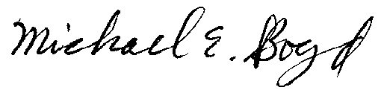
Filed Electronically 5-13-03
Michael E. Boyd – President, CARE
5439 Soquel Drive
Soquel, California 95073
(831) 465-9809
E-mail: michaelboyd@sbcglobal.net
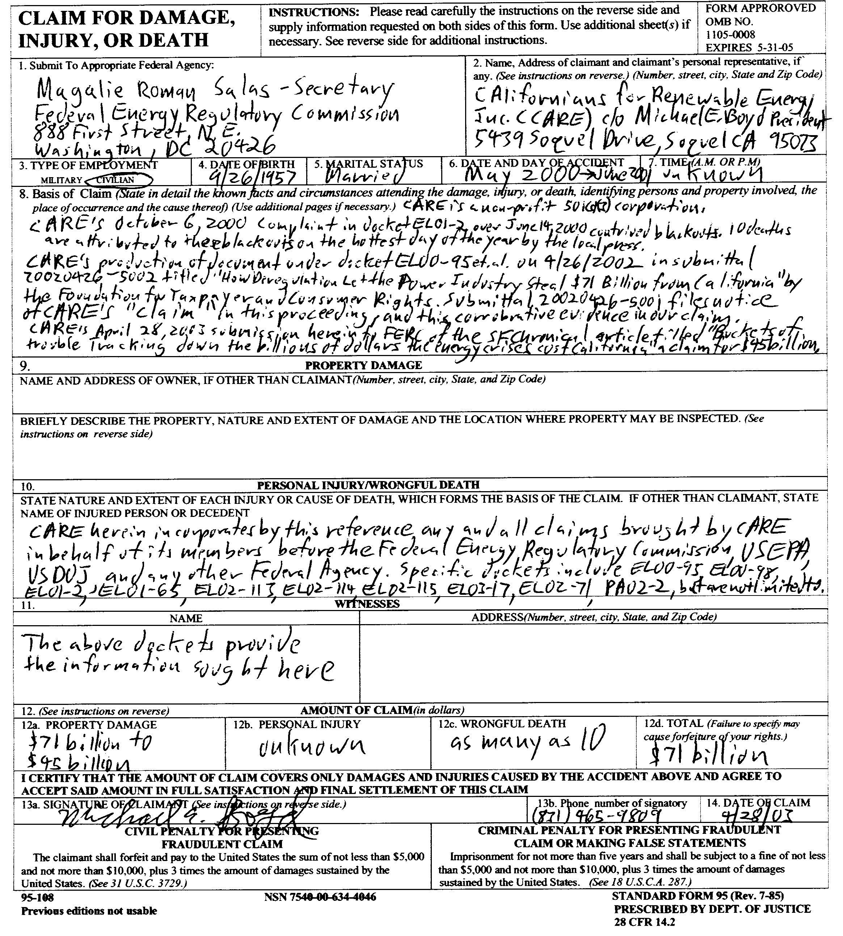

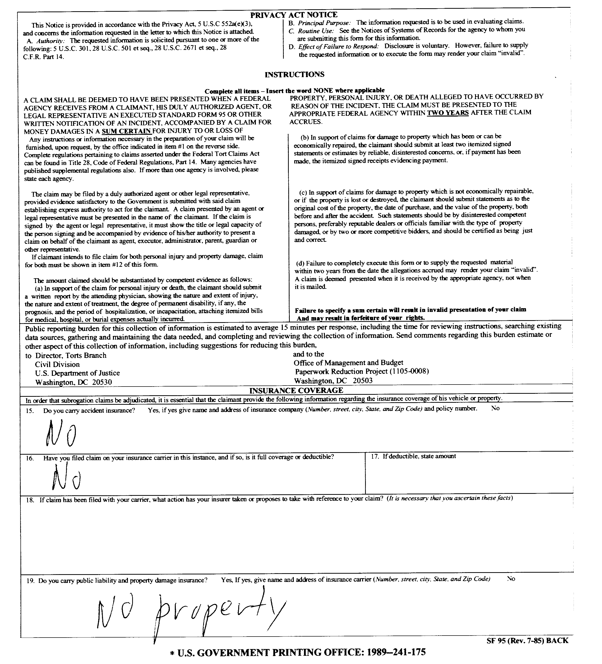
Verification

I am an officer of the movant corporation herein, and am authorized to make this verification on its behalf. The statements in the foregoing document are true of my own knowledge, except matters, which are therein stated on information and belief, and as to those matters I believe them to be true.
I declare under penalty of perjury that the foregoing is true and correct.
Executed on this 13 th day of May 2003, at Soquel, California
Michael E. Boyd – President, CARE
CAlifornians for Renewable Energy, Inc. (CARE)
5439 Soquel Dr.
Soquel, CA 95073-2659
Tel: (408) 891-9677
Fax: (831) 465-8491
michaelboyd@sbcglobal.net

Certificate of Services

I hereby certify that I have this day served the foregoing document upon each person designated on the official service list, via electronic mail, compiled by the Secretary in this proceeding until such time as the service list is established for the above captioned matter, and the ListServe for docket EL00-95-045. Rule 2010(f)(3) provides that you may serve pleadings by email. I further certify that those parties without electronic mail have been served this day via US mail.

Dated at this 13th day of May 2003.

Respectfully submitted,
President, CARE
(831) 465-9809
5439 Soquel Drive
Soquel, CA 95073
(831) 465-9809
E-mail: michaelboyd@sbcglobal.net

