UNITED STATES OF AMERICA
FEDERAL ENERGY REGULATORY COMMISSION
Before Commissioners:
Pat Wood, III, Chairman,
William L. Massey, and Nora Mead Brownell.

Fact-Finding Investigation into Possible ) Docket No. PA02-2-005
Manipulation of Electric and Natural Gas Prices )

CARE herein provides its brief comments on Commission Staff's interpretation, contained in Chapter VI of its Final Report on Price Manipulation in Western Markets (Docket No. PA02-2-000 March 26, 2003)(Final Report), of the California Independent System Operator's (ISO) and California Power Exchange's (PX) Market Monitoring and Information Protocol (MMIP). The Final Staff Report on Price Manipulation in the Western Markets Chapter VI at VI-35 to VI-36 demonstrates that members of Independent Energy Producers Association where directly involved with Enron in trading strategies based on providing “false information” to the FERC.
CARE, as a Party has tended to support Trial Staff’s positions in these proceedings. We apologize for not being more obvious in our support to the Trial Staff sooner, Staff who we contend have attempted to protect the public interest, but have been, thwarted by the other Parties including the Sellers, Utilities, and California’s Governor.

Recommended Commission Responses
The Enron trading strategies that were based on false information and that had an adverse effect on the markets are encompassed within the MMIP protocol of the Cal ISO and Cal PX tariffs. Therefore, Staff recommends that the Commission initiate show cause proceedings for the companies listed in this chapter, with disgorgement of unjust profits associated with the various transmission congestion strategies (e.g., non-firm exports, death star, and wheel-out), load shift, ancillary service sales without the necessary resources, megawatt laundering, and selling non-firm energy as firm energy. These proceedings should involve both public and nonpublic utilities that engaged in these strategies under the Cal ISO and Cal PX tariffs.

We emphasize that the trading strategies—while bearing Enron’s name—were not limited to Enron but appear to have been widely engaged in by numerous parties. Indeed, it would appear to Staff that the majority of public utility entities, and some nonpublic utilities, engaged in at least some of the trading strategies some time during the 2-year review period. The cumulative effect of this prevalent alleged misconduct is that customers did not pay just and reasonable rates for wholesale electricity. This is because the trading strategies as a whole adversely affected the operations of Cal ISO or Cal PX markets and the calculation of the market-clearing price, which is dependent on participants engaging in bidding practices consistent with the Cal ISO and Cal PX tariffs and market rules, and not gaming the system or otherwise taking undue advantage of market rules.

All of the market participants identified in the Cal ISO study by its initial screen should be required to show cause why their behaviors did not constitute gaming in violation of the Cal ISO and Cal PX tariffs, with disgorgement of unjust profits associated with the violations or other appropriate remedies. Those market participants are as follows:
♦ Sempra
♦ San Diego Gas & Electric
♦ Morgan Stanley Capital Group
♦ Coral Power, LLC
♦ Powerex or British Columbia
♦ Enron Power Marketing Inc. and its affiliate, Enron Energy
Services Inc.
♦ Avista Energy Inc.
♦ Pacific Gas and Electric Company
♦ American Electric Power Services Corporation
♦ Duke Energy Trading & Marketing
♦ Mirant (previously known as Southern Company Energy
Marketing, L.P.)
♦ Cargill-Alliant, LLC
♦ Idaho Power Company
♦ Puget Sound Energy
♦ Dynegy
♦ PGE Energy Services
♦ Calpine Corporation
♦ Modesto Irrigation District
♦ City of Glendale, California
♦ City of Azusa, California
♦ City of Riverside, California
♦ City of Pasadena, California
♦ City of Vernon, California
♦ Salt River Project
♦ Reliant
♦ Arizona Public Service Company
♦ Williams Energy Services Corporation
♦ PacifiCorp
♦ Automated Power Exchange
♦ Bonneville Power Administration (BPA)
♦ Portland General Electric
♦ Los Angeles Department of Water and Power (LADWP)
♦ Aquila
♦ Southern California Edison
♦ Citizens Electric
♦ Constellation Power Service
♦ Sierra Pacific Power Company

CARE alleged substantially the same Parties where involved in trading strategies that were based on false information that had an adverse effect on the markets encompassed within the MMIP protocol of the Cal ISO and Cal PX tariffs in our October 24, 2001 submission titled CARE's Case Against Independent Energy Producers Association (“IEPA”), And California Parties Including Evidence Of Violations Of Law And Requests For Appropriate Relief (FERC submission 20011024-5001)
Part of the CAISO Tariff is the ISO Market Monitoring & Information Protocol (MMIP). The MMIP's purported objective is to set forth the work-plan and rules under which markets can be monitored to identify abuses of market power. The MMIP applies to IEPA as a CAISO market participant. Under the MMIP, IEPA engaged in

"[a]nomalous market behavior, which is defined as behavior that departs significantly from the normal behavior in competitive markets that do not require continuing regulation or as behavior leading to unusual or unexplained market outcomes. Evidence of such behavior may be derived from a number of circumstances, including:

"MMIP 2.1.1.1 withholding of generation capacity under circumstances in which it would normally be offered in a competitive market;

"MMIP 2.1.1.2 unexplained or unusual redeclarations of availability by Generators;

"MMIP 2.1.1.3 unusual trades or transactions;

"MMIP 2.1.1.4 pricing and bidding patterns that are inconsistent with prevailing supply and demand conditions, e.g., prices and bids that appear consistently excessive for or otherwise inconsistent with such conditions; and

"MMIP 2.1.1.5 unusual activity or circumstances relating to imports from or exports to other markets or exchanges.

"The Market Surveillance Unit shall evaluate, on an ongoing basis, whether the continued or persistent presence of such circumstances indicates the presence of behavior that is designed to or has the potential to distort the operation and efficient functioning of a competitive market, e.g., the strategic withholding and redeclaring of capacity, and whether it indicates the presence and exercise of market power or of other unacceptable practices." (MMIP § 2.1.1.)

“Gaming', or taking unfair advantage of the rules and procedures set forth in the PX or ISO Tariffs, Protocols or Activity Rules, or of transmission constraints in periods in which exist substantial Congestion, to the detriment of the efficiency of, and of consumers in, the ISO Markets. `Gaming' may also include taking undue advantage of other conditions that may affect the availability of transmission and generation capacity, such as loop flow, facility outages, level of hydropower output or seasonal limits on energy imports from out-of-state, or actions or behaviors that may otherwise render the system and the ISO markets vulnerable to price manipulation to the detriment of their efficiency." (MMIP § 2.1.3.)

While the FERC Trial Staff has done a excellent job in identifying the different participants in the markets manipulation they have failed to identify the leadership and/or architects of the markets manipulation, IEPA and California Davis Governor Davis. CARE has provided you corroborative evidence of its claims against IEPA and Governor Davis in our March 3, 2003 filing of CARE’s Additional Evidence And Proposed New And/Or Modified Findings Of Fact With Specific Citations To The Record To Support Any Proposed Substantive Recommendations. For just one example of this evidence CARE provides its Exhibit CARE 2.18 a 12-13-00 internal e-mail among IEPA’s various members providing what amounts to a “dispatch order” from IEPA two days before the FERC issued its 12-15-00 Order which sent the market haywire, and forced PG&E’s bankruptcy. This e-mail states “IEP requests all its members to deliver as much generation as possible to California ASAP in order to avert potential shortages.”
We ask that the Trial Staff’s recommendations to the Commission be adopted and incorporated into “Show Cause Orders” on the Parties so-listed, and further CARE recommends that to the degree these Parties cannot demonstrate “cause” that you revoke their FERC granted privilege to sell at market based rates going forward. In this case of market-based rates, the just and reasonable standard of FPA 205(e) is usually satisfied by the Commission's determination, prior to the effectiveness of those rates, that the utility (and its affiliates) lacks market power or has taken sufficient steps to mitigate market power (E.g., Grand Council of the Crees, 198 F.3d at 953.) Because the Parties listed have been individually named as participants in manipulative trading strategies by FERC staff we respectfully request the FERC staff seek refunds from respondents of all profits made in excess of the cost of service provided and execute changes to all bilateral agreements to return them to a cost basis, as CARE contends these Parties have voluntarily waived their market based rate authority by participating in these trading strategies. The temporal scope of refunds should accrue from the time of the first incident of providing false information to the Commission took place, because these Parties waived their market based rate authority by providing such information to the Commission.
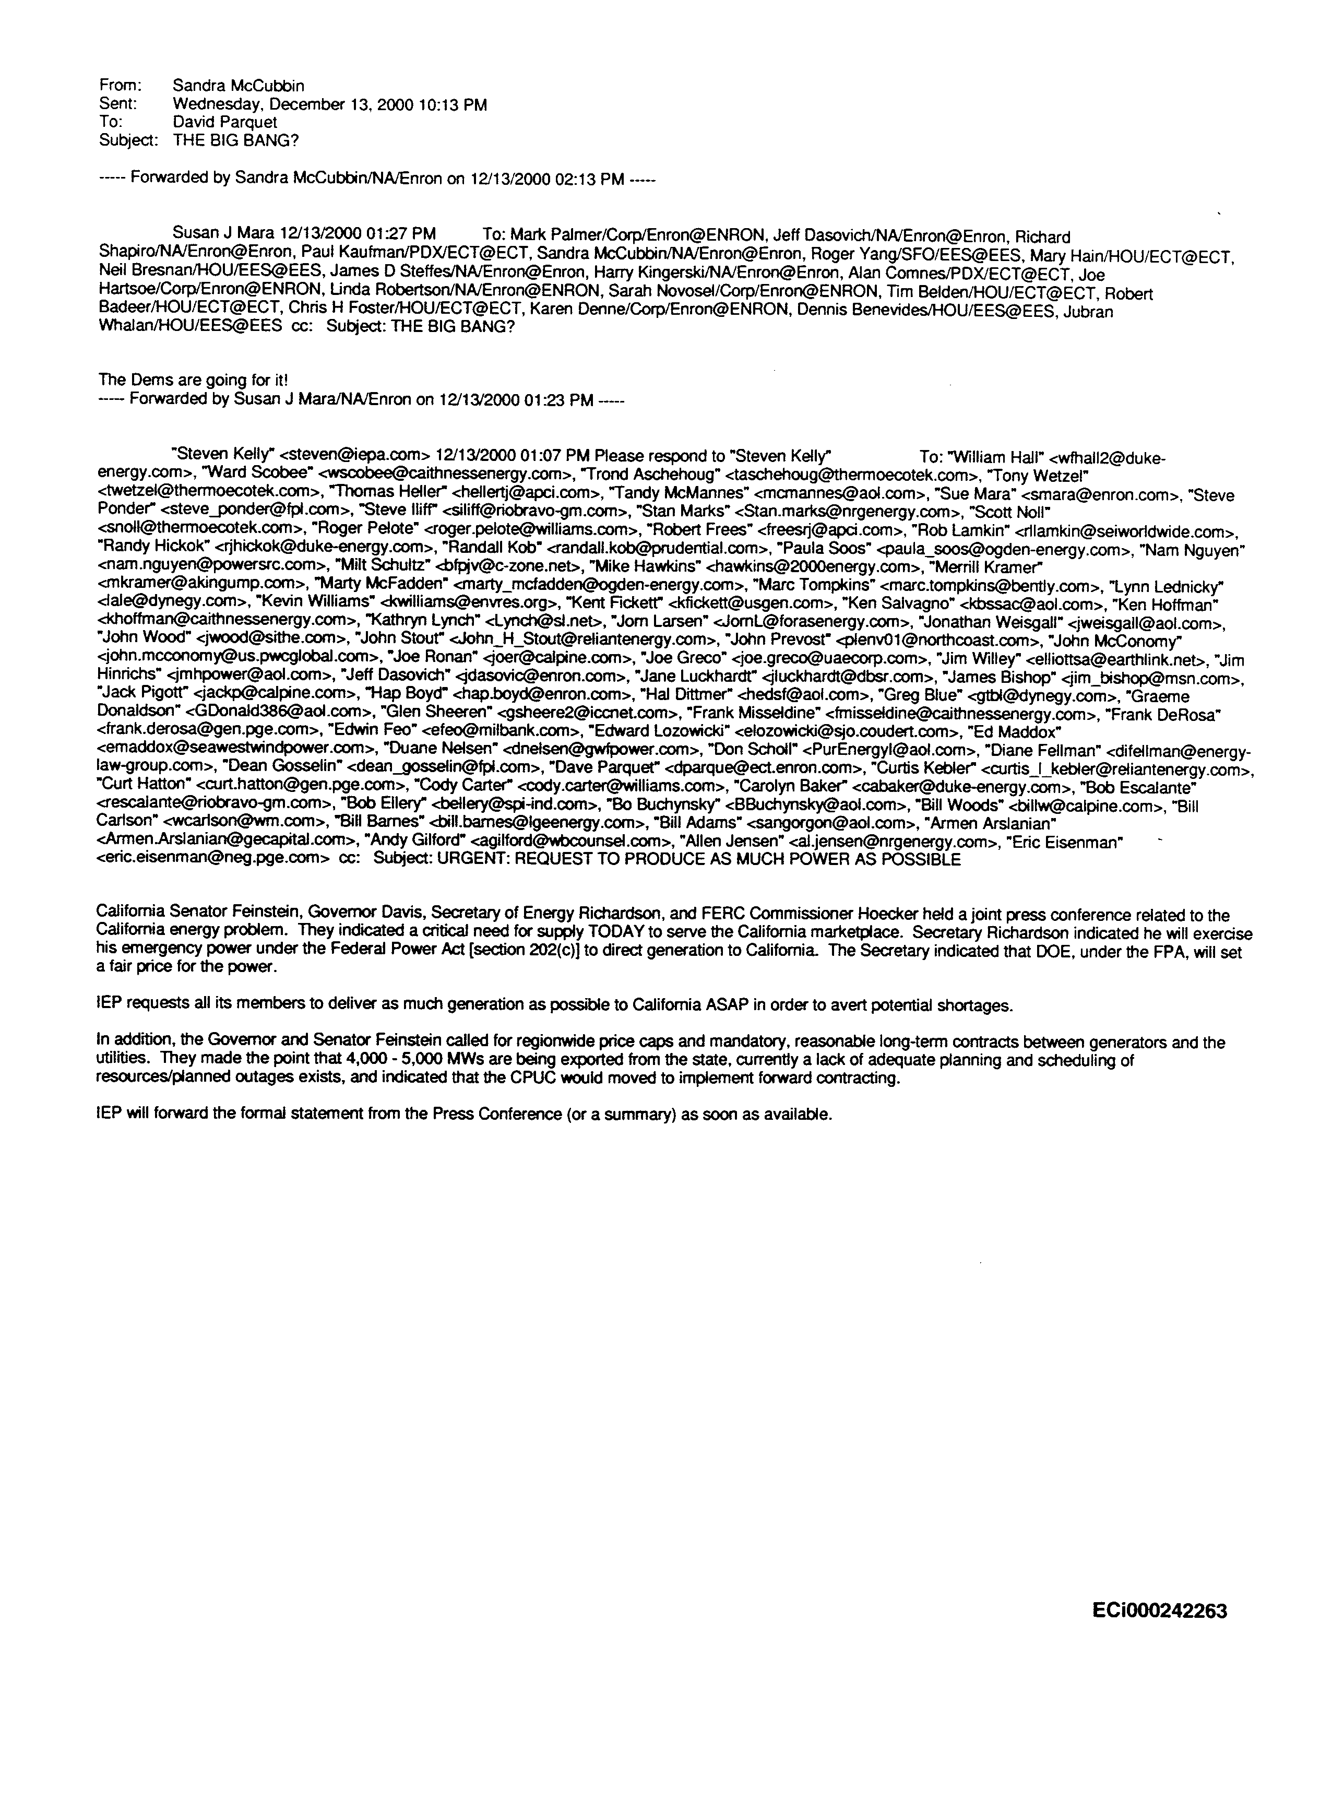

Respectfully submitted,
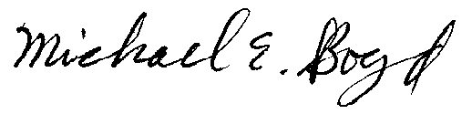
Filed Electronically 4-11-03
Michael E. Boyd – President, CARE
5439 Soquel Drive
Soquel, California 95073
(831) 465-9809
E-mail: michaelboyd@sbcglobal.net

Certificate of Services

I hereby certify that I have this day served the foregoing document upon each person designated on the official service list, via electronic mail, compiled by the Secretary in this proceeding until such time as the service list is established for the above captioned matter, and the ListServe for docket EL00-95-045. Rule 2010(f)(3) provides that you may serve pleadings by email. I further certify that those parties without electronic mail have been served this day via US mail.

Dated at this 11th day of April 2003.

Respectfully submitted,
President, CARE
(831) 465-9809
5439 Soquel Drive
Soquel, CA 95073
(831) 465-9809
E-mail: michaelboyd@sbcglobal.net

CAlifornians for Renewable Energy, a non-profit public benefit corporation, which is the only citizen group intervener in these FERC proceedings acting for the exclusive benefit and on behalf of the general public.
Independent Energy Producers Association.
The California Parties are the Governor and Attorney General of the State of California, California Electricity Oversight Board, California Public Utilities Commission, California Department of Water Resources (intervener CARE’s alleged IOU “designated representative” in the purchase of power), and Investor Owned Utilities San Diego Gas and Electric Company and Southern California Edison. Pacific Gas and Electric.
We note that during this time period IEPA’s Executive Director Jan Smutney-Jones, was also the President of the Board of Directors of the California Independent System Operator Corporation.

