UNITED STATES OF AMERICA
FEDERAL ENERGY REGULATORY COMMISSION
Before Commissioners:
Pat Wood, III, Chairman,
William L. Massey, and Nora Mead Brownell.

Fact-Finding Investigation into Possible ) Docket No. PA02-2-000
Manipulation of Electric and Natural Gas Prices )
)
San Diego Gas & Electric Company, ) Docket No. EL00-95-000
Complainant, )
)
v. )
)
Sellers of Energy and Ancillary Services )
Into Markets Operated by the California )
Independent System Operator and the )
California Power Exchange, )
)
Investigation of Practices of the California ) Docket No. EL00-98-000
Independent System Operator and the )
California Power Exchange )

CARE’S FORM 95 CLAIM FOR $71 BILLION DAMAGE, INJURY, OR DEATH
AND CARE COMMENTS ON THE AMOUNT OF ACTUAL
REFUND LIABILITY OF SELLERS, INVESTOR OWNED UTILITIES, MUNICIPAL UTILITIES, AND THE STATE OF CALIFORNIA
TO CALIFORNIA RATEPAYERS AND CONSUMERS

CARE in order to serve the “public interest” wishes to enlighten the Commission of our perspective on the cost of the “energy crises” to California ratepayers and consumers. In yesterday’s San Francisco Chronicle’s staff writer, Carolyn Said, posed this very question?
Who's paying for the California energy crisis?

Flip on your light switch and take a look in the mirror.

If you are a California electricity ratepayer, you -- and your fellow customers -- will be picking up the tab for the next two decades.

CARE provides an unedited version in the SF Chronicle report below with footnotes providing commentary from CARE.
CARE will follow this with our perspective, and a notice of our standard form 95 Claim against the FERC for refunds due to ratepayers and consumers in the California energy and natural gas markets, for damages resulting from illegal actions by Sellers, Investor Owned Utilities, Municipal Utilities, and the State Of California as participants in these dysfunctional markets between May 2000 and June 2001.

Buckets of trouble
tracking down the billions of dollars the energy crisis cost California
SF Chronicle April 27, 2003
Carolyn Said, Chronicle Staff Writer

Three years ago, in May 2000, Californians got their first practical lesson in energy deregulation as electricity costs began to soar in San Diego, the first city where deregulation's impact was felt by ratepayers. In the next 18 months, costs skyrocketed throughout California, bankrupting PG&E and forcing the state to borrow billions of dollars to pay energy generators. Ultimately, this grand experiment in free-market economics will cost utility customers more than the price tag to date for the war in Iraq.

Who's paying for the California energy crisis?

Flip on your light switch and take a look in the mirror.

If you are a California electricity ratepayer, you -- and your fellow customers -- will be picking up the tab for the next two decades.

What did it cost?

Experts, who like to have round numbers to throw around, have centered on a nice, rotund one: $45 billion.

That's the figure Gov. Gray Davis' office cites when asked the cost of the energy crisis.

It's a sum many energy analysts think is roughly accurate, with the emphasis on roughly, because it bristles with assumptions, if/then scenarios, hunches and value calls.

Some consumer advocates think the total is as high as $70 billion, particularly if one adds in the $20 billion California spent to get ready for deregulation.

There are also secondary costs to consider, such as the higher price of goods and services that use power, the economic impact of the rolling blackouts and the possibility that some businesses fled California as a result of its power crisis.

Sooner or later, almost anyone discussing the cost of the energy crisis ends up quoting former Senate leader Everett McKinley Dirksen: "A billion here and a billion there, and soon you're talking about real money."

Every home, office, farm and factory in the state has already paid a portion of the cost through higher monthly utility bills the past two years. They will continue to shoulder the rest for years to come through higher rates.

Ratepayers may get some fractional relief if federal regulators order electricity generators to refund some of their ill-gotten gains.

"Ratepayers took it big time in this crisis," said Christopher Weare, a research fellow at the Public Policy Institute of California and author of a report on the crisis. "They're footing most of these bills. We're essentially paying about 50 percent more (for electricity) than we were before the crisis. And we were already paying significantly more than the rest of the country before the crisis."

To give a sense of the precrisis prices, according to Weare, California's average 1995 rate of about 9.9 cents per kilowatt hour was more than double the rates in Oregon and Washington, 60 percent more than in Nevada and 30 percent more than in Arizona.

One quick and dirty way of figuring the energy crisis cost per ratepayer is this: Pacific Gas and Electric Co., San Diego Gas and Electric Co. and Southern California Edison, Co. -- the three investor-owned utilities that took the brunt of the cost of the energy crisis -- have about 10 million customers.

That means the $45 billion crisis averages out to $4,500 per customer. The good news -- don't break out the champagne yet -- is that the hit will be spread out over many years.

This gross oversimplification overlooks the fact that industrial and business users pay higher rates, ignores the 3 million customers of municipal utilities (who were partially shielded from the crisis anyway) and turns a blind eye to numerous other considerations.

Tallying all the guesstimates that go into the cost accounting is as difficult as counting the stars in the sky (and considerably less poetic).

But most experts agree -- more or less -- on several key points.

MONEY OUT
Wholesale power. In 1999, California paid $7.4 billion on the wholesale market for electricity, according to the California Independent System Operator, which is responsible for the state's grid. In 2000, it paid $27.1 billion -- $19.7 billion more. In 2001, the tab was $26.8 billion, a $19.4 billion increase. (The ISO figures are for the three investor-owned utilities, which sell 72 percent of the megawatt hours in California. Municipal utilities sell 24 percent and federal agencies 3 percent.)

There was little year-to-year growth in the state's electricity consumption, so the $39.1 billion extra over the two years is largely attributable to the spikes in the price of energy that started early in the summer of 2000, supposedly as generators figured out ways to game the market by withholding supply until they drove up prices.

Some of the extra cost, though, was due to "natural causes," such as a drought in the Pacific Northwest, which reduced the available amount of hydroelectric power. The spiraling cost of natural gas, the main fuel source for electricity, also contributed to the cost overruns. But many experts think the natural gas spikes were also caused by market manipulation by such entities as El Paso.

It's hard to assess what the costs would have been minus the market gaming - - perhaps $10 billion a year because of the hydroelectric shortage, some experts say. That would mean California paid an extra $17 billion for power in both 2000 and 2001. (In 2002, overall wholesale market costs fell to $10.1 billion, according to the ISO.)

Costs for 2000 were borne by the investor-owned utilities (also known by the all-too-apropros acronym of IOUs).

PG&E's under-collections -- the difference between what it paid for wholesale electricity and what customers paid it -- were $9.2 billion by the time it filed for bankruptcy in April 2001. About $6.7 billion of that debt was racked up in 2000.

Edison ended up with about $3.9 billion in debt.

SDG&E had about $750 million in debt.

By early 2001, the utilities had been financially devastated. PG&E and Edison were on the verge of bankruptcy. Banks treated them like a chronic drunk asking for credit at the corner liquor store.
To keep the lights on, the state was forced to start buying wholesale electricity. On Jan. 17, 2001, the Department of Water Resources took over buying the final (and most expensive) third of juice needed for the state. The rest came from the utilities' own generation and their existing contracts. DWR spent $11.7 billion on power in 2001, financed by a $4.3 billion bridge loan and a $6.1 billion loan from the general fund.

Long-term contracts. In spring 2001, Gov. Gray Davis signed $43 billion of long-term contracts for electricity at an average price of about $69 a megawatt hour -- which critics said was double what the rate should have been. Davis has subsequently renegotiated some of the contracts at a lower rate and is trying to renegotiate more. Critics say the contracts still lock California into paying about $10 billion too much for power for the next 12 years.

Bonds. When it started buying power, the state used a short-term loan from financial institutions and a loan from the general fund. To pay off those loans, in October and November 2002, the state issued $11.25 billion in bonds, essentially spreading the debt load over years through a variety of bonds with varying maturation rates. Ratepayers will be picking up the tab for the interest on those bonds, which averages 4.8 percent, according to DWR. Over 20 years, the interest cost will amount to about $6.4 billion, according to the state treasurer's office. The bill starts at about half a billion dollars in the first few years, tapering down to $17.8 million in 2022. Principal plus interest will be $517 million this year, $706 million next year and then about $900 million a year every year from 2005 to 2022.

MONEY IN
The costs are difficult to calculate because while billions of dollars were flowing out to buy wholesale electricity from generators, billions were also flowing in to the utilities and the state from ratepayers, and to the utilities from their own power plants. But the money came in a myriad differing amounts, depending on the type and amount of electricity usage, as well as on the various rate increases implemented at different times.

Think of a bucket with water pouring out through a huge hole in the bottom and numerous other leaks; now picture dozens and dozens of spigots, some trickling, some spurting different amounts of water into that bucket at different rates.

Self-generation. Money was also flowing in from the utilities' sales to themselves of the electricity they generated. They are not required to disclose their actual expenses. Assuming they paid themselves market rates, the sky-high wholesale prices may have helped the utilities as well as hurting them.

"PG&E's profits were $2 billion to $3 billion selling their own electricity, " said Christopher Danforth, a program and project supervisor at the Office of Ratepayer Advocates at the California Public Utilities Commission. (That number is still in dispute in bankruptcy court.)

Rates. Customers' monthly electricity bills didn't keep pace with the spiraling wholesale costs because they had been frozen as part of California's deregulation plan.

However, in San Diego, SDG&E initially charged its 1.2 million customers rates consistent with the huge wholesale costs. That's because in 1999, the utility had met conditions to have the retail price freeze lifted. Outraged to find their electricity bills doubling or tripling, San Diegans demanded relief -- and the Legislature responded by capping their rate increase to 30 percent, retroactive to June 1, 2000.

For PG&E and Edison customers, the Public Utility Commission implemented two rate increases totaling about 40 percent that are still in force. For residential customers, they average an extra $14 a month. Because of a tiered system, both increases were disproportionately more for industrial users.

Much of the rate hike money went to DWR to reimburse it for part of its power purchases. In 2001, it received $3.4 billion from ratepayers; in 2002, it received $4.8 billion.

However, Edison and PG&E also both receive money from the rate increases. This so-called "head room" in part goes to paying off their huge energy crisis debts.

"The amount from the surcharges is now being booked in a balancing account and tracked separately (from PG&E's regular earnings)," said PG&E spokesman John Nelson.
He said the company had reduced its $9.2 billion in debts to $3.8 billion "through a combination of head room and other things."

PG&E took in $2.7 billion in head room and reversal of charges during the final three quarters of 2001. In 2002, it booked $2.4 billion in head room and charge reversal, according to Nelson.

Bailouts. In fall 2001, the state agreed to a $3.3 billion deal to bail out Edison. As part of that, Edison was to maintain higher rates for two years -- a period that is almost up -- while its shareholders gave up $1.2 billion worth of dividends over three years.

PG&E's situation is considerably more complicated.

Under PG&E's $13 billion bankruptcy plan (the amount is higher than the energy crisis debts because it had other outstanding debts), the utility wants to spin off an unregulated generation company that will sell electricity to the regulated utility for the next decade "at a price double the actual cost of service," said Danforth from the PUC.

"The markup over the cost of service over the 10 years is probably in a similar order of magnitude (as PG&E's 2000 under-collections) -- $6 billion is a rough guess," he said. "That's a contract for 10 years. After that contract expires, the PG&E affiliate could potentially charge anything it wants to the utility."

Those power costs would eventually get passed on to ratepayers, he said. Under the PUC's competing plan, Danforth said, ratepayers would more directly pay for PG&E's energy crisis cost.
Both plans are up in the air for now; a bankruptcy judge is expected to rule on them sometime in May.

Federally ordered refunds. Contending that it was ripped off by greedy power generators, California has asked federal regulators to force generators to refund $9 billion of its costs. In March, the Federal Energy Regulatory Commission said energy firms had manipulated the market, and indicated it would order the firms to refund at least $3.3 billion. The exact amount will be set through future hearings. How any refunds would be apportioned is still to be determined.

But what about the wider economic impact of the blackouts and the energy crisis' dampening effect on business growth? Even experts who propound the $45 billion figure for the energy crisis, such as the Public Policy Institute's Weare, hasten to add that it is a conservative estimate when considering the bigger picture.

Even so, Weare said, $45 billion amounts to about 3.5 percent of California's annual economic output. By comparison, the savings and loan debacle, at a total cost of $100 billion, represented 0.5 percent of the total U.S. economy, he wrote in a research report, "The California Electricity Crisis: Causes and Policy Options."

The higher cost for ratepayers will be felt most acutely over the next eight years. That's when we'll be paying the bulk of the interest for the $11.25 billion in bonds. That's also the period during which the long-term contracts lock us in to higher power rates. But the bond principal and interest payments continue until 2022.

James L. Sweeney, a Stanford professor and author of the Hoover Press book "The California Energy Crisis," sums up the long-term outlook in a chapter appropriately titled "From Crisis to Blight."

"Although the electricity crisis itself was a short-term event, the policy actions -- or inactions during the challenge period and the crisis have left a continuing harmful legacy that threatens to remain for years or even decades to come," he writes.

Nettie Hoge, executive director of The Utility Reform Network, puts it bluntly.

Federal regulators are likely to order generators to give a refund "so there may be a small contribution from the gougers," she said. "But mostly the experiment is being laid at the feet of ratepayers."

MONEY IN
Funds that trickled into the state's energy market during the power crisis couldn't keep up with the amount of money spurting out. .

Ratepayers, whose bills were frozen as part of deregulation, paid rates in 2000 that covered only about a third of the wholesale costs.

Rate hikes passed in early 2001 and implemented midyear added 40 percent to customer costs.

Self-generation by the utilities brought them some profits, although the amounts are in contention. For example, PG&E may have made $2 billion to $3 billion in profits, the state utilities commission estimates.

Generator refunds may be ordered this year by federal regulators but are likely to be around $3 billion, a third of what the state requested.

Total cost: The ultimate price tag is difficult to tally because so many variables go into it. But many experts have reached consensus around one guesstimate:

$45 BILLION ($4,500 per customer) .

MONEY OUT
Funds gushed out to keep the lights on during the energy crisis.

Wholesale costs soared to $27 billion in 2000 and 2001 -- $20 billion more than in 1999, and $17 billion more than in 2002. PG&E, Edison and SDG&E paid all the costs in 2000; in 2001, the state stepped in and assumed $11.7 billion of the burden.

Long-term contracts, signed at the height of the energy crisis and later partially renegotiated, account for about $10 billion in extra costs.

Energy bonds sold by the state brought in $11.25 billion that will have to be paid back, along with $6.4 billion in interest.

E-mail Carolyn Said at csaid@sfchronicle.com.

In CARE’s FERC submittal 20020426-5002 (submitted 4/26/2002) in a production of document titled “Hoax How Deregulation Let The Power Industry Steal $71 Billion From California” under docket EL00-95 we specifically identified $71 billion as the cost to California ratepayers and consumers as a result of the energy crises. CARE provided this production of document as corroborative evidence in CARE’s various complaints, claims, and motions before the Commission. CARE had sought and received authorization to file a copy in the dockets so listed as an independent expert analysis by the following e-mail correspondence from Doug Heller of the Foundation for Taxpayer and Consumer Rights.
-----Original Message-----
From: Doug Heller [mailto:doug@consumerwatchdog.org]
Sent: Tuesday, April 23, 2002 11:47 AM
To: mboyd
Subject: FTCR report
Mike: Please feel free to use the report. It is available on the website for download.
Doug
---------
Douglas Heller
Foundation for Taxpayer and Consumer Rights
http: //www.consumerwatchdog.org
doug@consumerwatchdog.org
ph. 310/392-0522 ext. 309

CARE had no control or direct interest in the production of this document. We incorporated this in the foregoing dockets as if fully set forth by CARE and this is the bases for our Claim against FERC for $71 billion in refunds to California’s ratepayers and consumers. Wherefore CARE herein provides Notice and a copy of Standard Form 95 a Claim for $71 billion in refunds.
Respectfully submitted,
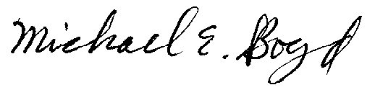
Filed Electronically 4-28-03
Michael E. Boyd – President, CARE
5439 Soquel Drive
Soquel, California 95073
(831) 465-9809
E-mail: michaelboyd@sbcglobal.net
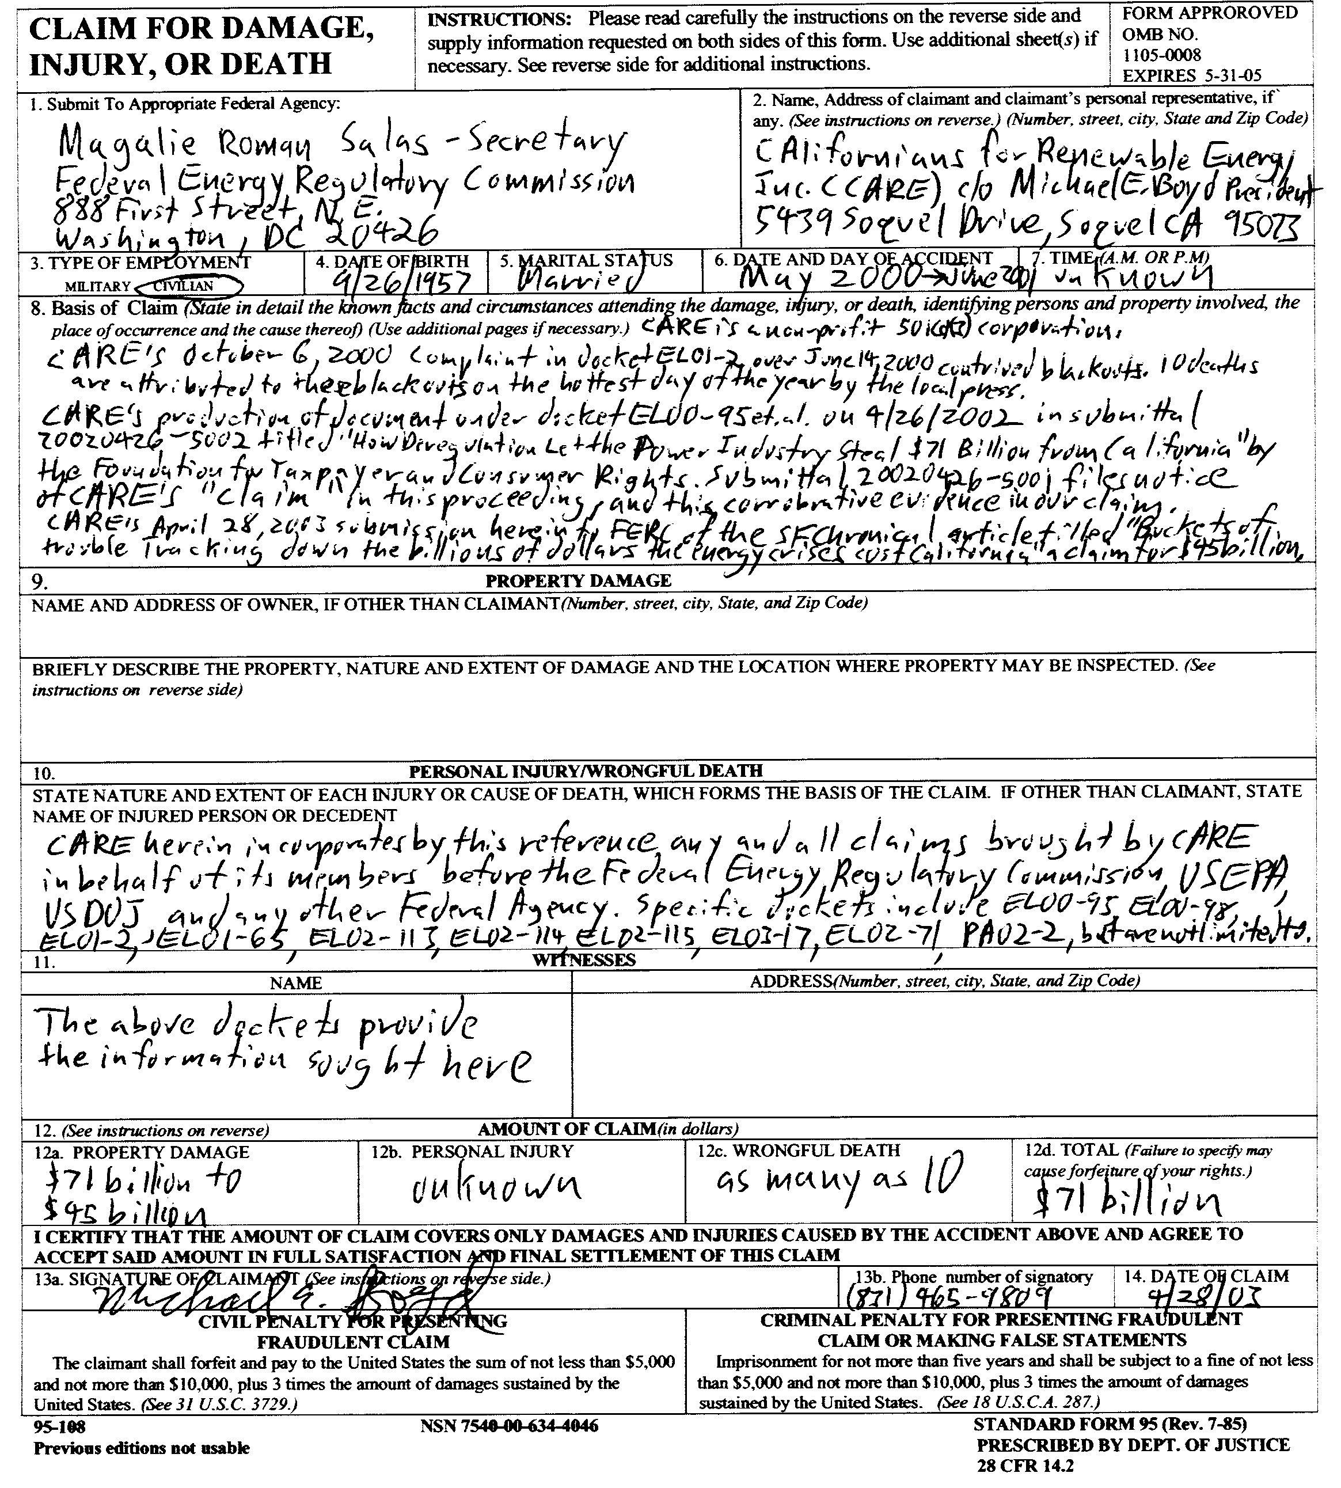

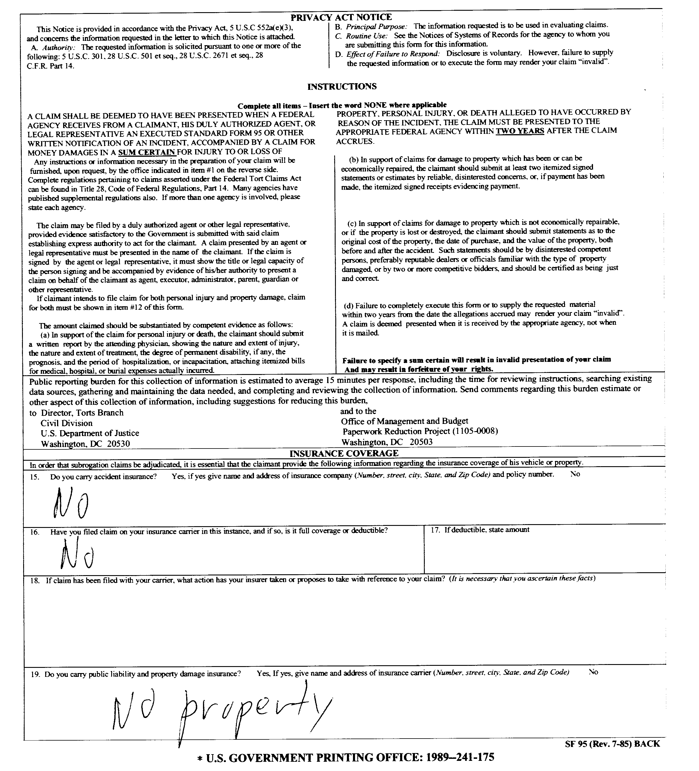
Verification

I am an officer of the movant corporation herein, and am authorized to make this verification on its behalf. The statements in the foregoing document are true of my own knowledge, except matters, which are therein stated on information and belief, and as to those matters I believe them to be true.
I declare under penalty of perjury that the foregoing is true and correct.
Executed on this 28 th day of April 2003, at Soquel, California
Michael E. Boyd – President, CARE
CAlifornians for Renewable Energy, Inc. (CARE)
5439 Soquel Dr.
Soquel, CA 95073-2659
Tel: (408) 891-9677
Fax: (831) 465-8491
michaelboyd@sbcglobal.net

Certificate of Services

I hereby certify that I have this day served the foregoing document upon each person designated on the official service list, via electronic mail, compiled by the Secretary in this proceeding until such time as the service list is established for the above captioned matter, and the ListServe for docket EL00-95-045. Rule 2010(f)(3) provides that you may serve pleadings by email. I further certify that those parties without electronic mail have been served this day via US mail.

Dated at this 28th day of April 2003.

Respectfully submitted,
President, CARE
(831) 465-9809
5439 Soquel Drive
Soquel, CA 95073
(831) 465-9809
E-mail: michaelboyd@sbcglobal.net

CARE wishes to use this $45 billion as the minimum of what California ratepayers and consumers are owed.
FERC submittal 20020426-5002 (4/26/2002) in production of document “Hoax How Deregulation Let The Power Industry Steal $71 Billion From California” under docket EL00-95 identifies $71 billion as the cost to California ratepayers and consumers, which is one of the bases for our claim here.
This is corroborative of CARE’s claims under dockets EL01-2, EL00-95, and PA02-2.
This is corroborative of CARE’s claims under dockets EL00-95, EL01-65, EL02-113, EL02-114, EL02-115, and PA02-2.
This is corroborative of CARE’s claims under dockets EL00-95, and EL00-98 specifically as they relate to CARE’s contention that DWR was acting as PG&E’s, and SCE’s “designated representative” under the Federal Power Act in their procurement of power, without proper notice under the Act.
This is corroborative of CARE’s claims under dockets EL00-95, and EL00-98 specifically as they relate to CARE’s contention that the Governor through the DWR was establishing new rates and charges on ratepayers and consumers, without proper notice under the Federal Power Act.
Enron prior to its bankruptcy transferred 1.3 billion dollars to its executives. This move accomplished two purposes for the morally bankrupt executives in charge of the company’s operations. First the enormous and unprecedented transfer allowed Enron to avoid all corporate tax liability for the year. Secondly and most importantly the money Enron extorted from the California and Western ratepayers was removed from the company and shielded from future creditors in any bankruptcy proceedings. Enron utilized the classic corporate veil to avoid corporate income tax and also shield extorted assets from creditors and even their own shareholders. In order for FERC to demonstrate its Actions serve the public interest, any settlement derived from these proceedings should pierce the corporate veil and be levied against all corporate executives (including PG&E) who received this exorbitant compensation for their role in manipulating energy prices in California and extorting all the consumers and ratepayers in the State of California. It is unconscionable that any company’s bankruptcy would be used in such a manner to limit the settlement from blatant manipulation in these proceedings and your acceptance is acquiescence to criminal activity by PG&E, Enron, and others. You accept and approve of this at your own risk.
(Final Report on Price Manipulation in Western Markets in docket PA02-2 March 26, 2003) All of the market participants identified in the Cal ISO study by its initial screen should be required to show cause why their behaviors did not constitute gaming in violation of the Cal ISO and Cal PX tariffs, with disgorgement of unjust profits associated with the violations or other appropriate remedies. Those market participants are as follows: ♦ Sempra ♦ San Diego Gas & Electric ♦ Morgan Stanley Capital Group ♦ Coral Power, LLC ♦ Powerex or British Columbia ♦ Enron Power Marketing Inc. and its affiliate, Enron Energy Services Inc. ♦ Avista Energy Inc. ♦ Pacific Gas and Electric Company ♦ American Electric Power Services Corporation ♦ Duke Energy Trading & Marketing ♦ Mirant (previously known as Southern Company Energy Marketing, L.P.) ♦ Cargill-Alliant, LLC ♦ Idaho Power Company ♦ Puget Sound Energy ♦ Dynegy ♦ PGE Energy Services ♦ Calpine Corporation ♦ Modesto Irrigation District ♦ City of Glendale, California ♦ City of Azusa, California ♦ City of Riverside, California ♦ City of Pasadena, California ♦ City of Vernon, California ♦ Salt River Project ♦ Reliant ♦ Arizona Public Service Company ♦ Williams Energy Services Corporation ♦ PacifiCorp ♦ Automated Power Exchange ♦ Bonneville Power Administration (BPA) ♦ Portland General Electric ♦ Los Angeles Department of Water and Power (LADWP) ♦ Aquila ♦ Southern California Edison ♦ Citizens Electric ♦ Constellation Power Service ♦ Sierra Pacific Power Company
Here is a case of the “pot calling the kettle black” The Utility Reform Network (TURN) has been appointed by Governor Davis to a seat on the ISO board (conflict-of-interest), purportedly in return for TURN’s support of the siting and development of Calpine’s Metcalf Energy Center in San Jose California. This project is subject to litigation in the “public interest” by CARE in both the Federal and State courts.
CARE’s Exhibit 2.29 included in our April 3, 2003 filing of Additional Evidence under Docket EL00-95 provides empirical evidence that around $5 billion is owed ratepayers and consumers by PG&E for its sales.

