UNITED STATES OF AMERICA
FEDERAL ENERGY REGULATORY COMMISSION
Before Commissioners:
Pat Wood, III, Chairman,
William L. Massey, and Nora Mead Brownell.

Fact-Finding Investigation into Possible ) Docket No. PA02-2-000
Manipulation of Electric and Natural Gas Prices )
)
San Diego Gas & Electric Company, ) Docket No. EL00-95-000
Complainant, )
)
v. )
)
Sellers of Energy and Ancillary Services )
Into Markets Operated by the California )
Independent System Operator and the )
California Power Exchange, )
)
Investigation of Practices of the California ) Docket No. EL00-98-000
Independent System Operator and the )
California Power Exchange )

CARE’S MOTION TO DENY CALPINE’S
MOTION FOR PARTIAL DISMISSAL

CARE is opposed to a limited dismissal of Calpine’s refund liability and seeks to clarify that CARE and its members’ interests will be adversely affected by this dismissal. On March 25, 2003, Calpine Corporation and its wholly owned subsidiaries, including Calpine Energy Services L.P. (together “Calpine”) filed a motion for partial dismissal from the California refund proceeding “to the extent that those proceedings direct refunds for electric power sold by Calpine to CDWR or any other agency of the State” Motion at 7 (emphasis added). In addition, the language in the Settlement Agreement provides a release by the CPUC, CEOB, and State Attorney General of a much broader range of claims.
CARE is not an agency of the State and we contend that your release from Claims against Calpine for ours and other’s outstanding claims, due to our prior protests over the DWR contracts in dispute, our March 3, 2003 filing of Additional Evidence And Proposed New And/Or Modified Findings Of Fact With Specific Citations To The Record To Support Any Proposed Substantive Recommendations, under FERC docket EL00-95 specifically related to Calpine, and the new information CARE is providing here, demonstrates that such a release will cause irreparable harm to California’s ratepayers and consumers, and these obvious due process violations insure that CARE and the public it represents have not been afforded equal protection of the law.

CARE’s EL02-71 Protest
The AG 206 Complaint cited in CARE’s footnote 1 refers to FERC docket EL02-71 of which CARE is an Intervenor. On May 8, 2002 CARE filed its Answer And Protest To Notice Of Partial Withdrawal With Prejudice Of Complaint As To Calpine Energy Services LP, And Notice Of Partial Withdrawal Of Complaint As To Constellation Power Source, Inc. (submission 20020508-5043).
The May 8th Protest states CARE’s concerns regarding the renegotiated DWR contracts.
In addition to this unlawful act CARE contends that section 205(c) of the FPA is also being violated by the California Parties in the form of allowing extortion by Calpine of a “capacity payment” of $15,102,807.86 for the period from December 1, 2001 through April 30, 2002 in return for final release by Calpine, its parents, subsidiaries, divisions, affiliates or associates and anyone who may claim through any of them (including their former and present officers, directors, employees, shareholders or any of their assigns) of DWR and its successors and assigns, from any and all claims that Seller had, has, or ever shall have

CARE contends this is a form of extortion, and herein defines “extortion, in law, as unlawful demanding or receiving by an officer, in his official capacity, of any property or money not legally due to him. Examples include requesting and accepting fees in excess of those allowed to him by statute or arresting a person and, with corrupt motives, demanding money or property unlawfully”, in this case $15,102,807.86 of California taxpayer funds. Additionally this provides further evidence corroborative of CARE’s claim that the California Parties commenced service under prior unlawful agreements with Calpine covering the period from December 1, 2001 through April 30, 2002 without notice as required under section 205(c) of the FPA.

The Master Power Purchase And Sale Agreement Amended And Restated Confirmation Letter with Calpine Corporation also provides corroborative evidence supportive of CARE’s prior claim that previous Master Power Purchase And Sale Agreements with Calpine included the provision commencing service immediately from Units that “have achieved commercial operation” without the prerequisite notice required under the FPA section 205 (c).

The Master Power Purchase And Sale Agreement Amended And Restated Confirmation Letter with Constellation Power Source, Inc. also provides corroborative evidence supportive of CARE’s prior claim that the previous Master Power Purchase And Sale Agreements with Constellation Power Source, Inc., included services commenced April 1, 2001 through to date for 200 MWh delivered HE 0700 Pacific Prevailing Time (“PPT”) through HE 2200 (“6 X 16”) each Monday through Saturday during the Delivery Period, excluding NERC holidays without the prerequisite notice required under the FPA section 205 (c).

As documented in CARE’s 4-28-02 comment to FERC, CARE has participated as a formal Intervener in the California Energy Commission’s siting process for this project in CEC Docket 99-AFC-3 and also is a plaintiff in various legal challenges before both the state and federal courts over the project. The FERC proceedings taking place in CARE’s consolidation motion are directly relevant to the matters which CARE is litigating in the MEC project, and reciprocally the administrative records from this project are directly relevant to the matters under consideration in our consolidation motion before the FERC. This is relevant because it provides corroborative evidence that the CEC as one of the California Parties acting in concert with wholesalers of energy to deprive Californians of their constitutional right to proper notice and a fair hearing on the existence, meaning, effects, implementation, etc., of the purported “energy crises” in both the spot market and forward markets, and the associated effects of the “crises” on the siting, construction, and operation of power plants in California.

As evinced by Calpine’s third Master Power Purchase And Sale Agreement Amended Calpine must complete construction of the Metcalf Energy Center as one of its terms of its contract.

These contractual commitments are further evincive of the fact that the defects in the CEC siting process are also of constitutional origin and proportion. CARE alleges that the California Parties are acting in concert with Calpine for the State’s illegal pre-commitment for construction of the Metcalf Energy Center. In addition to these obvious due process violations in CARE’s litigation in the 9th circuit court of appeals over this project, CARE and the public it represents have not been afforded equal protection of the law. CARE contends the constitutional provisions violated include, without limitation, the First Amendment rights of association, speech and access to administrative as well as judicial tribunals.

CARE’s March 3, 2003 filing of Additional Evidence under EL00-95

In CARE’s March 3, 2003 filing of Additional Evidence And Proposed New And/Or Modified Findings Of Fact we specifically identified evidence Calpine provided CARE in response to our data requests which shows evidence of pre-2000 participation of Calpine with Timothy Belden of Enron, himself, in a bilateral transaction agreement for a price of more than double the spot market price in early 2000.
Calpine and Enron colluded to exercise market power in both the electricity and gas markets. CARE alleges here that Calpine sold electricity to Enron at a price higher than other Calpine customers paid through bilateral contracts with Enron. The reason for this is that Calpine had purchased natural gas from Enron at similarly inflated prices.

CARE herein provides corroborative evidence of certain manipulative transactions with Enron commencing on or about December 27, 1999 to create market power through bilateral transactions between Enron and Calpine in Exhibit CARE-1.1. The exhibit provides a copy of a July 20, 2000 bilateral agreement Confirmation Letter executed by Timothy Belden of Enron Power Markets, Inc.

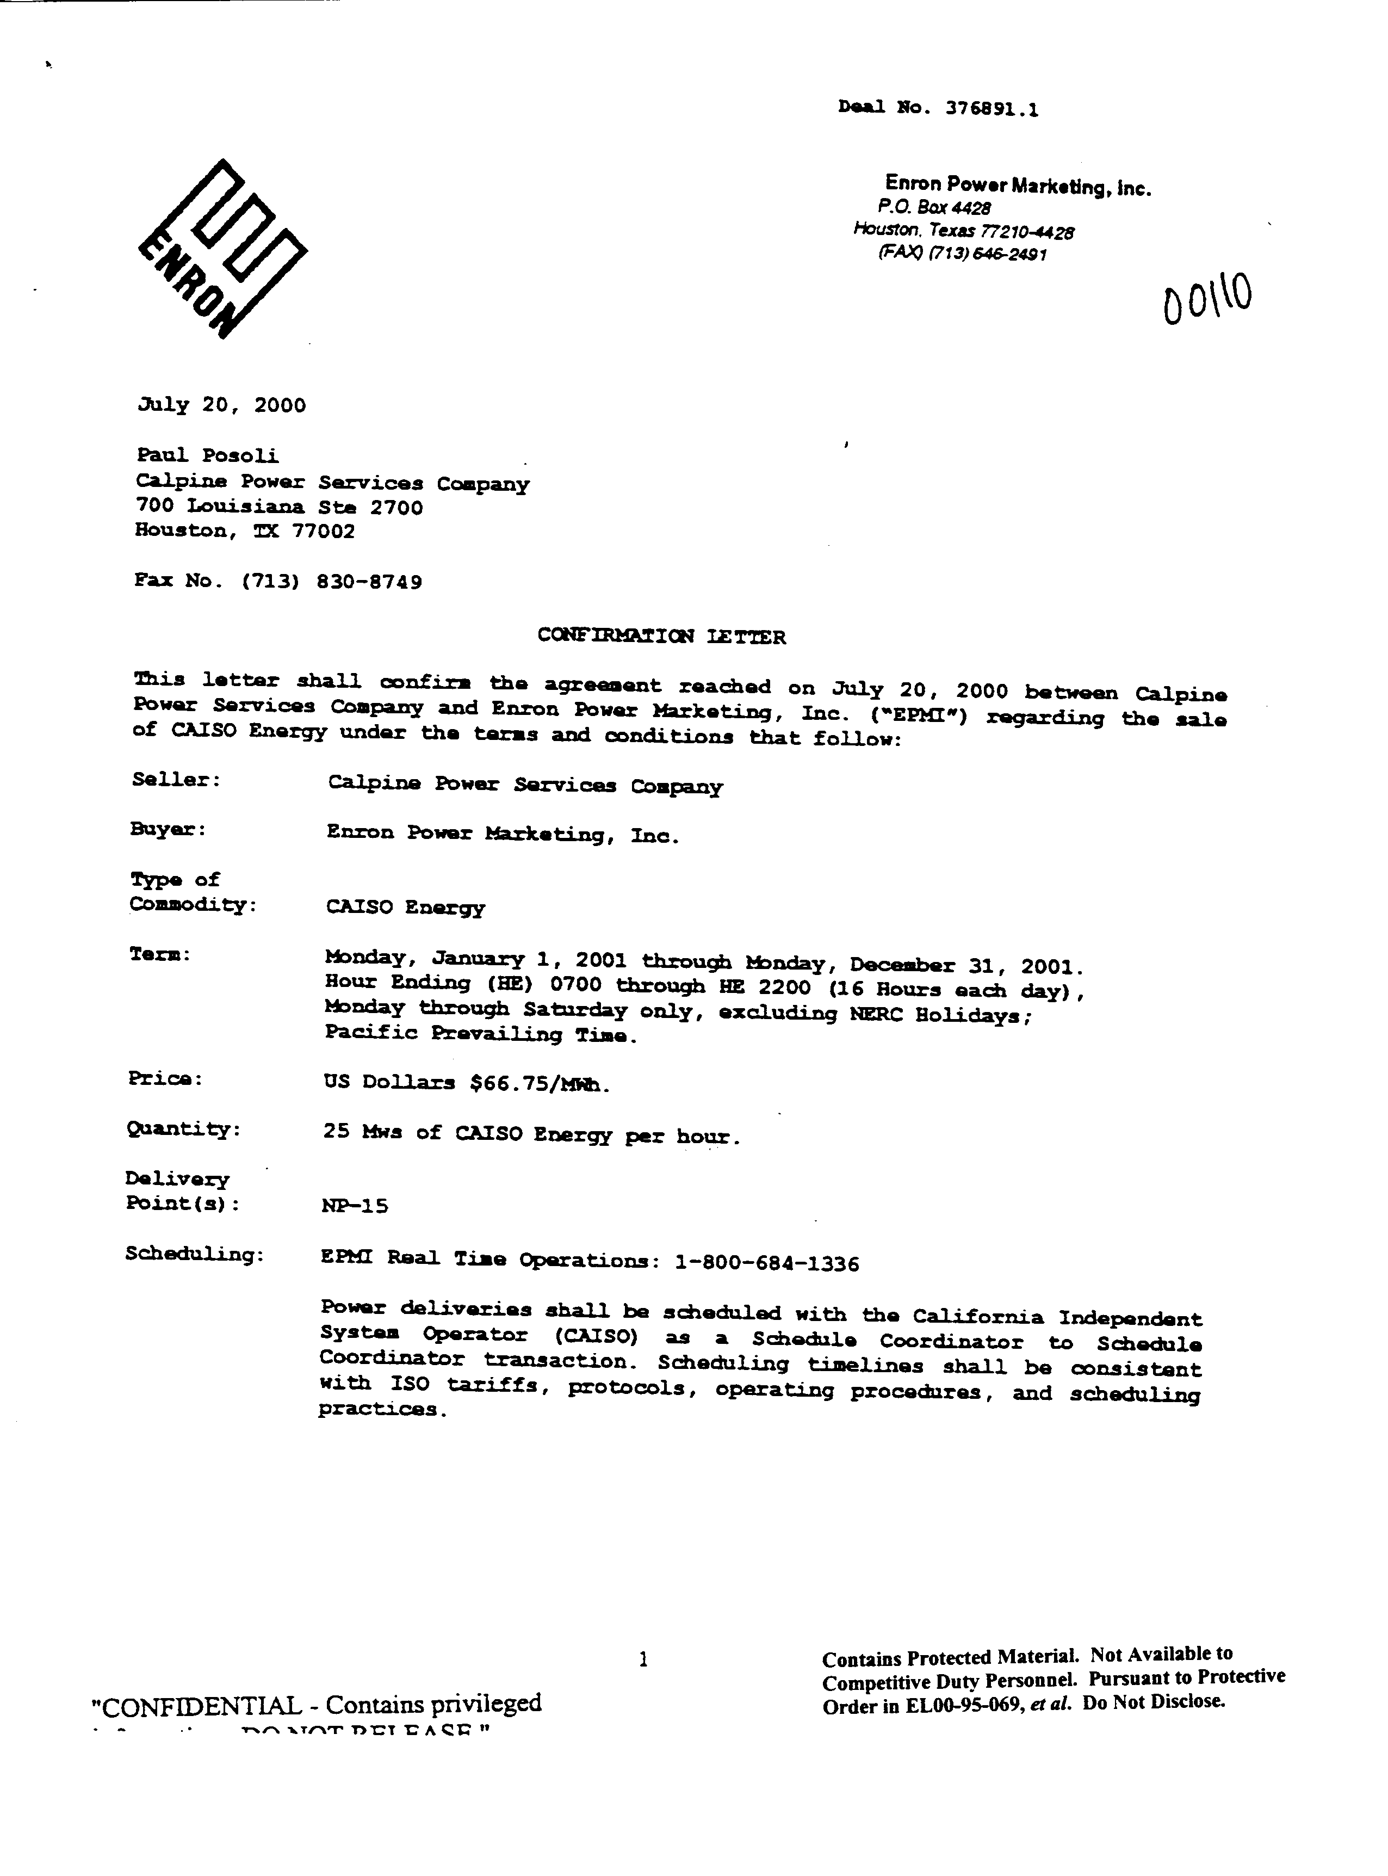

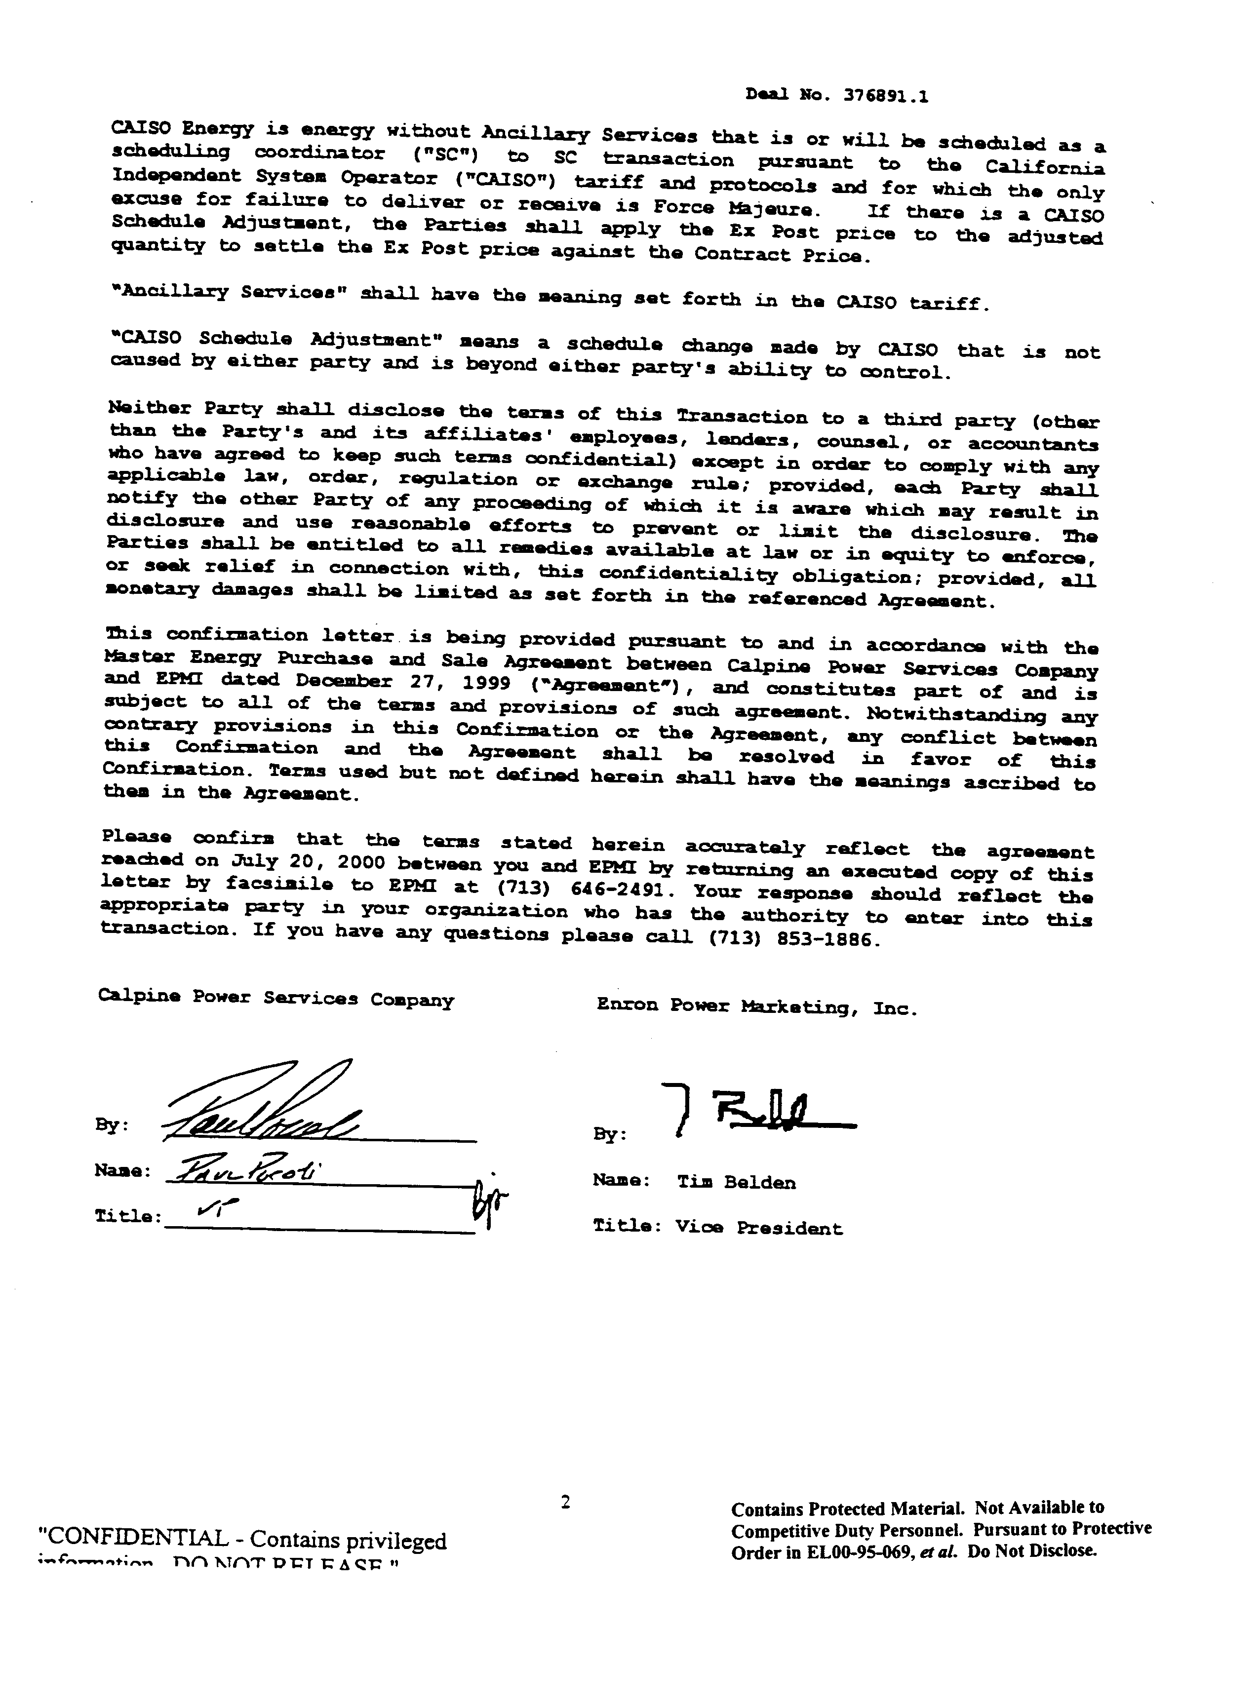

Commencing in January 1, 2001 Calpine and Enron began to exercise market power in the real time, day-ahead electricity markets and the gas market. Calpine and certain of its officers and directors issued false and misleading statements concerning its business and financial condition. This is the subject of ongoing litigation by Calpine’s shareholders.

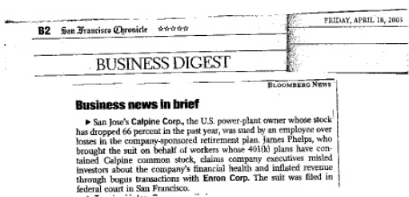
An April 18, 2003 San Francisco Chronicle article points to the fact that Calpine’s role in the energy crisis has repercussions beyond the ratepayers. Calpine has defrauded its employees with inflated stock prices buoyed by fake transactions with the admitted manipulators Enron and others. Even Calpine’s own employees were subject to exploitation.

CARE alleges that Calpine and Enron utilizing a scheme to manipulate the price of electricity and natural gas in the bilateral markets. CARE herein provides corroborative evidence of certain manipulative transactions with Enron commencing on or about November 16, 2000 to create market power through bilateral transactions between Enron and Calpine in Exhibit CARE-1.4. These exhibits provide a spreadsheet of Calpine’s short-term firm and non-firm wholesale transactions (up to one week) covering the time period 16-Nov-00 to 20-Jun-01.
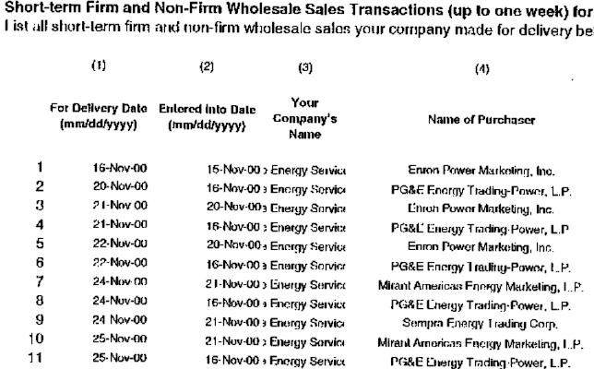
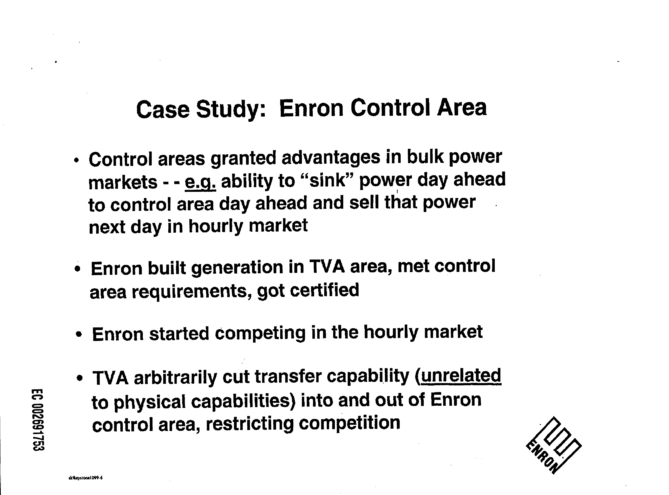
Exhibit CARE-2.4 Enron’s 10-99 Summer 99: Problems, Solutions, Lessons Learned, spells out Enron’s and Calpine’s market power scheme where it states “Control area granted advantages in bulk power markets – e.g. ability to “sink” power day ahead to control day ahead and sell that power next day in hourly market” and observes the consequences of such a strategy are to create “higher prices in short term markets” and “uncertainty of delivery, even on a handful of days, discourages competitors from bidding on longer term transaction ➔ less competition, fewer choices (higher prices) for customers”.
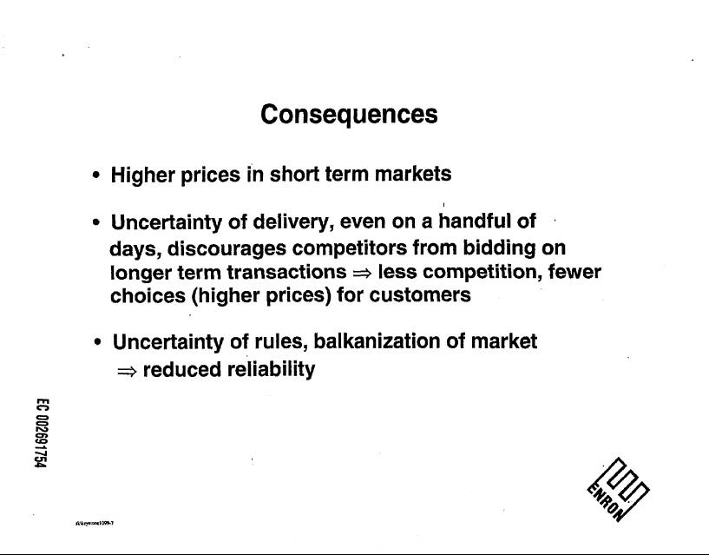
Clearly Enron and Calpine’s bilateral transactions scheme was to exercise market power through “long term transactions” by exercise of market power in the short term through manipulation of the real time energy and natural gas markets.
Exhibit CARE-1.5 illustrates that Calpine was able to transition it’s bilateral transactions scheme with Enron seamlessly into bilateral transactions with the California Energy Resource Scheduling division of the California Department of Water Resources, successfully transitioning its bilateral market power purportedly to the State’s control. This is further evinced by Calpine’s current control of a third of the thirty eight billion dollars remaining in long-term energy contracts with CERS, they have successfully locked up the State’s market power over energy markets for the foreseeable future, but at market power prices, which are currently at more than double the spot market price. Who could have imagined this was a scheme dreamed up by Calpine’s Peter Cartwright, Enron’s Timothy Belden, and maybe even California’s Governor Gray Davis?
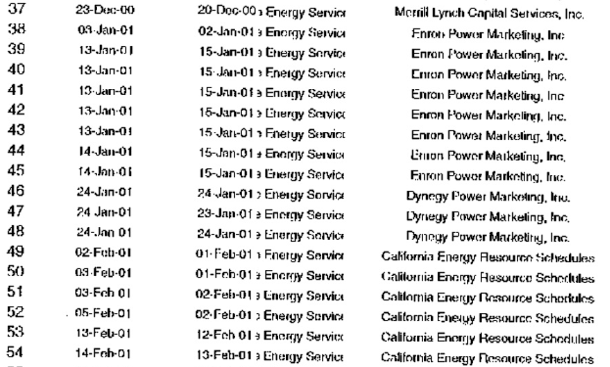
Calpine was also involved in manipulation in the natural gas markets, because fraud in one market taints both the energy and natural gas markets. A CBS MarketWatch report titled PG&E, Calpine admit 'wash' trades Reliant discloses one round trip deal, on June 1, 2002 reported,
In its review of over 72,000 transactions, Calpine (CPN: news, chart, profile) said it found 31 of these trades. It said the transactions were made for risk management reason, not for "the purpose of increasing volumes or revenue, impacting market prices, or for any other improper business purpose."

Here we have Calpine admitting publicly to fraud, CARE contends these are the same so-called “round trip” trades cited in California State Senator Dunn’s testimony before the US Senate Commerce, Science & Transportation Committee on May 15, 2002 on RICO. Reliant Resources and Duke energy where also involved in the same fraud according to the CBS MarketWatch report.
Additional Information
In CARE’s March 3, 2003 filing of Additional Evidence under docket EL00-95 we provided evidence that California Governor Gray Davis, his agents and employees must be “disqualified” from appearing before the FERC in these proceedings due to “conflict of interest” resulting from his acceptance of campaign contributions from IEPA, and its member sellers, Calpine, Dynegy, Reliant, Williams, and Enron.
The evidence supporting these allegations included exhibits by number listed with a brief description of each exhibit and its relevance to CARE’s allegation that Governor Davis has a “conflict of interest” in participating in these proceedings.
For example CARE Exhibit 3.4 is an Excel spreadsheet provided by the California Secretary of State of Calpine’s contributions during the 2000-2001 period, beginning with their first contribution of $2,000 to the Governor on 1/10/00. Calpine gave the Governor $19,000 and IEPA $10,500 in political contributions during this period. CARE Exhibit 3.5 provides a copy of Calpine’s check and backup documentation for its $10,000 contribution on 5/26/00, four days in advance of the 5/31/00 IEPA fundraiser for the Governor.
CARE provides additional information posted by the San Jose Mercury News on Tuesday May 7, 2002. It lists Calpine as Governor Davis’ eleventh largest campaign contributor at $254,244.
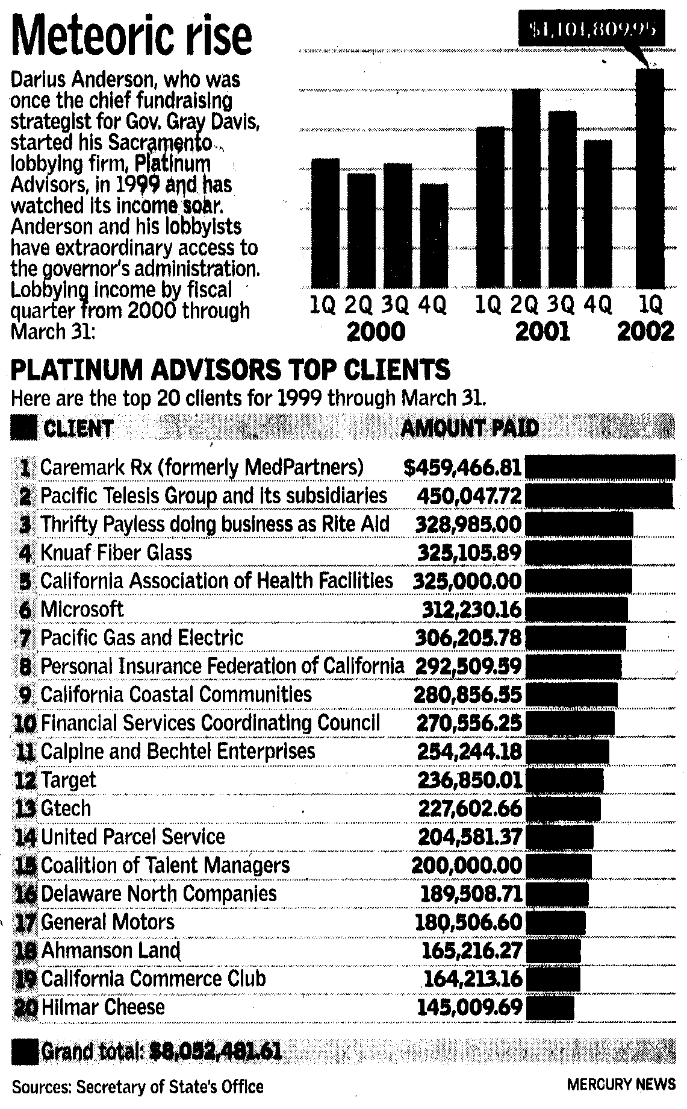
CARE doesn’t know if FERC is aware of the devastation, the energy and natural gas market’s manipulation, has caused to California’s State budget and economy. Teachers, students, and parents from school Districts across California are protesting school closures in the wake of California's 27 billion dollar deficit as shown in the picture from the 2-9-03 Santa Cruz Sentinel. The people of the state know that energy companies and the Governor Davis share the blame, but only through FERC remedies can we receive any just relief, based on refunds determined to meet the “public interest”. Therefore any transactions subsequent to exercise of market power have a direct bearing on the MMCP and therefore the relief CARE seeks is that any refunds owed to California are required to be based on the difference between the price charged and the cost of production, not the FERC’s “so-called” Mitigated Market Clearing Price (MMCP), because FERC’s issuance of market-based rate authority to all market participation are conditioned on market participants’ agreements not to exercise market power. This is a matter in the “public interest”; therefore the “just and reasonable” standard need not be applied.
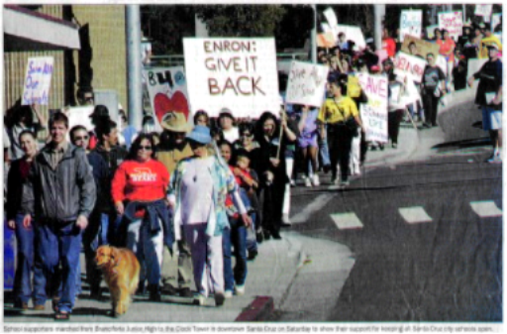
Wherefore, for good cause shown, Movant respectfully request the Commission approve CARE’s Motion to Deny the Motion for Partial dismissal of Calpine’s refund liability.
Respectfully submitted,
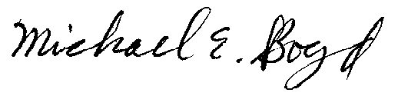
Filed Electronically 4-23-03
Michael E. Boyd – President, CARE
5439 Soquel Drive
Soquel, California 95073
(831) 465-9809
E-mail: michaelboyd@sbcglobal.net
Verification

I am an officer of the movant corporation herein, and am authorized to make this verification on its behalf. The statements in the foregoing document are true of my own knowledge, except matters, which are therein stated on information and belief, and as to those matters I believe them to be true.
I declare under penalty of perjury that the foregoing is true and correct.
Executed on this 23 rd day of April 2003, at Soquel, California
Michael E. Boyd – President, CARE
CAlifornians for Renewable Energy, Inc. (CARE)
5439 Soquel Dr.
Soquel, CA 95073-2659
Tel: (408) 891-9677
Fax: (831) 465-8491
michaelboyd@sbcglobal.net

Certificate of Services

I hereby certify that I have this day served the foregoing document upon each person designated on the official service list, via electronic mail, compiled by the Secretary in this proceeding until such time as the service list is established for the above captioned matter, and the ListServe for docket EL00-95-045. Rule 2010(f)(3) provides that you may serve pleadings by email. I further certify that those parties without electronic mail have been served this day via US mail.

Dated at this 23rd day of April 2003.

Respectfully submitted,
President, CARE
(831) 465-9809
5439 Soquel Drive
Soquel, CA 95073
(831) 465-9809
E-mail: michaelboyd@sbcglobal.net

This motion for dismissal is predicated on two sections of the Settlement Agreement: Section 4.3. “CEOB and CPUC – Refund Proceeding” and Section 4.4 “The AG 206 Complaint and the AG Subpoena and AG Investigation.” Section 4.3 provides a release by the CEOB and CPUC from claims in the refund proceeding or “any remedy concerning the operation and management of any generation facilities or the purchase, sale, ownership, or transmission of Electric Power from or to the CAISO, Cal PX, and CDWR prior to the effective date [April 22, 2002] except as provided below” Section 4.3, Settlement at 6. Section 4.4 releases Calpine for “any other acts or omissions related to the operation and management of generation facilities or the generation, purchase, sale or transmission of Electric Power prior to the Effective date, including but not limited to (a) requests for refunds, for contract reformation, or for any other relief in any proceeding before the FERC” Section 4.4, Settlement at 6. Given the unsettled nature of proceedings regarding the Western energy markets in 2000 and 2001, these releases could potentially be very broad, therefore our May 8th 2002 Protest is hereby incorporated as if fully set forth here.
Exhibit CARE-1.2 - LABORERS LOCAL 1298 PENSION v. CALPINE CORPORATION, ANN B. CURTIS and PETER CARTWRIGHT, Case No. C-02-1560, filed April 1, 2002 US District Court Northern California. In order to overstate its earnings in 2001, Calpine manipulated its results in violation of GAAP and SEC rules by recording revenue from reciprocal transactions with Enron in which Enron and Calpine sold energy to one another at inflated amounts. It has subsequently been disclosed that Calpine had sold 6.5 million megawatt hours of electricity to Enron at a price 58% higher than other Calpine customers paid. The reason for this is that Calpine had purchased natural gas from Enron at similarly inflated prices. Calpine reported the following financial results during the Class Period: 3/31/01 6/30/01 9/30/01 Revenues $1.23B $1.613B $2.916B Gross Profit $206.0M $304.2M $535.9M EBITDA $251.5M $317.2M $625.2M EPS $0.30 $0.39* $0.88 * Before non-recurring charges.
Independent Energy Producers Association

