UNITED STATES OF AMERICA
BEFORE THE
FEDERAL ENERGY REGULATORY COMMISSION
San Diego Gas & Electric Company,  Complainant, | )  )  ) | Docket Nos. | EL00-95-000  EL00-95-045  EL00-95-069
v. | )
 | )
Sellers of Energy and Ancillary Services Into Markets Operated by the California Independent System Operator Corporation and the California Power Exchange,  Respondents. | )  )  )  )  )
 | )
Investigation of Practices of the California Independent System Operator and the California Power Exchange | )  )  ) | Docket Nos. | EL00-98-000  EL00-98-042  EL00-98-058
 | )
Fact-Finding Investigation Into Possible Manipulation of Electric and Natural Gas Prices | )  )  ) | Docket No. | PA02-2-000
 | )
Reliant Energy Services, Inc. | ) | Docket No. | EL03-59-000
 | )
BP Energy Company | ) | Docket No. | EL03-60-000
 | )
Enron Power Marketing, Inc. and Enron  Energy Services, Inc. | )  ) | Docket No. | EL03-77-000
 | )
Bridgeline Gas Marketing, L.L.C.., Citrus Trading Corporation, ENA Upstream Company, LLC, Enron Canada Corp., Enron Compression Services Company, Enron Energy Services, Inc., Enron MW, L.L.C., and Enron North America Corp. | )  )  )  )  )  ) | Docket No. | RP03-311-000
 | )
El Paso Electric Company, Enron Power Marketing, Inc., Enron Capital and Trade Resources Corporation | )  )  ) | Docket No. | EL02-113-000
 | )
Portland General Electric Company | ) | Docket No. | EL02-114-000
 | )
Enron Power Marketing, Inc. | ) | Docket No. | EL02-115-001
 | )
Avista Corporation, Avista Energy, Inc.  CAlifornians for Renewable Energy, Inc.  ( CARE),  Complainant,  v.  Independent Energy Producers, Inc., and All  Sellers of Energy and Ancillary Services Into  Markets Operated by the California Independent System Operator and the California Power Exchange; All Scheduling Coordinators Acting on Behalf of the Above Sellers; California Independent System Operator Corporation; andCalifornia Power Exchange Corporation,  Respondents  Puget Sound Energy, Inc.,  Complainant,  v.  All Jurisdictional Sellers of Energy and/or Capacity at Wholesale Into Electric Energy and/or Capacity Markets in the Pacific Northwest, Including Parties to the Western Systems Power Pool Agreement,  Respondents | )  )  )  )  )  )  )  )  )  )  )  )  )  )  )  )  )  )  )  )  )  )  )  )  )  ) | Docket No.  Docket No.  Docket No. | EL02-115-000  EL01-2-000  EL01-10-000

CARE’S REQUEST FOR INVESTIGATION OF PACIFIC GAS AND ELECTRIC NATIONAL ENERGY GROUP AND PACIFIC GAS AND ELECTRIC THE IOU FOR PARTICIPATION AS CO-CONSPIRATORS IN ENRON’S NIGERIAN BARGE TRANSACTIONS
CARE is an Intervenor in the FERC initiated investigation in docket EL03-17, et al. the Investigation of Certain Enron-Affiliated QFs; et seq. As such on May 10, 2003 we received a copy of the Superseding Indictment of Andrew S. Fastow, Ben F. Glisan, Jr., and Dan Boyle for Conspiracy; Aiding and Abetting; Wire Fraud, Obstruction of Justice; Money Laundering; Securities Fraud; and filing False Tax Returns.
This Indictment included the specific charge Three of Wire Fraud, and Four of Falsifying Books, Records and Accounts, regarding to what has been referred to as the “Nigerian Barge Transactions” scheme by Enron, Merrill Lynch, Andrew S. Fastow, Ben F. Glisan, Jr., and Dan Boyle, and Enron’s “dummy corporation” LJM. Of special concern to CARE, and its members here is, charge Three lists overt act 59 k.

“In or about fall of 2000, GLISAN, BOYLE and others at Enron found a buyer for LJM’s interest in the barges.”
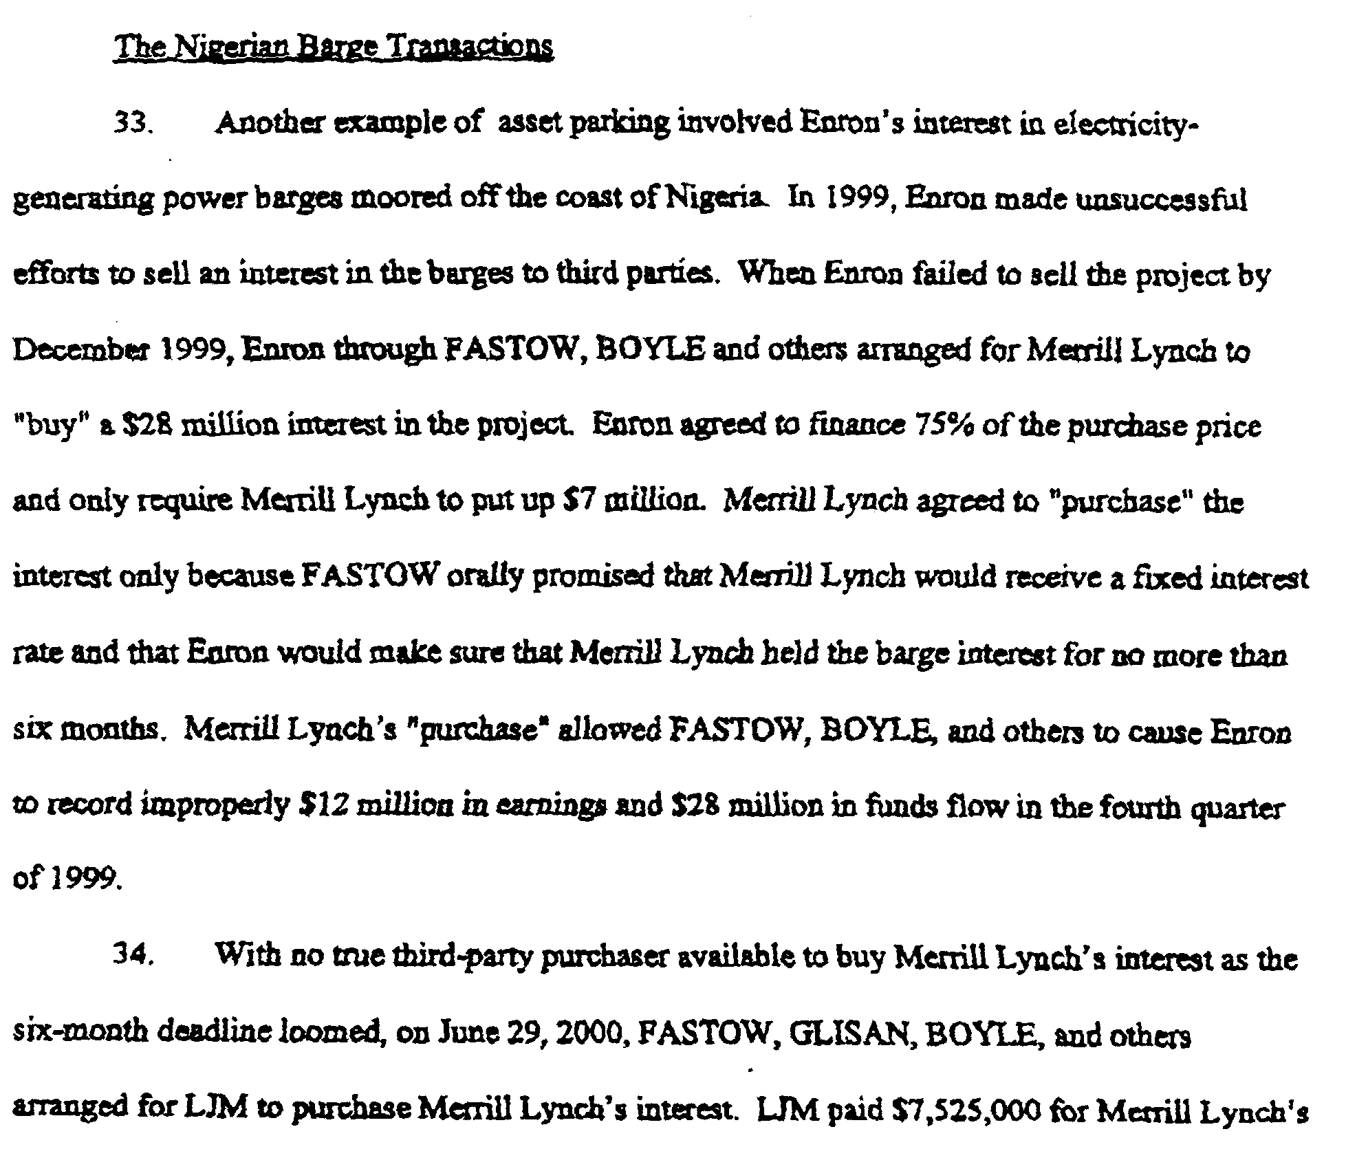
Our concern is that other co-conspirators in Enron’s scheme have yet to be identified.
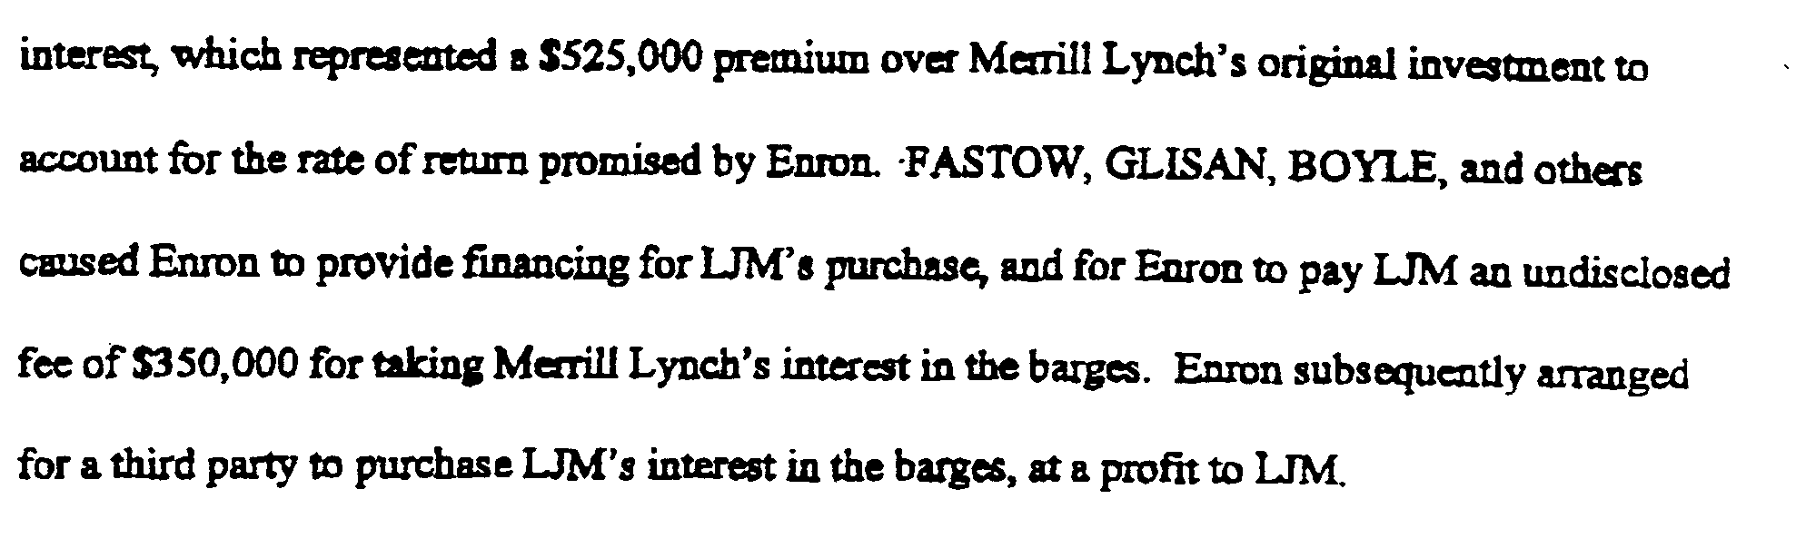
Figure 1 Page 11 to 12 of the Superseding Indictment of Andrew S. Fastow; Ben F. Glisan, Jr., and Dan Boyle dated April 30, 2003

What is the relationship between the “Rio Da Luz” and the “Nigerian Barge Transactions”?
On July 26, 2000 CARE Petitioned the California Energy Commission (CEC) to be an intervenor in the proposed “Rio Da Luz”, a floating 95MW power plant, presumed by P.G.& E. National Energy Group (PGENEG) to be sited in the San Francisco bay. The proposed emergency generation was a matter under consideration by the CEC as a Regular Business agenda item on its August 9th 2000 agenda. CARE’s attempt to Intervene was made moot by PG&E Corp’s announcement in an article announcing the project’s withdrawal on Saturday, August 5, 2000, in the San Jose Mercury News titled Bay plant dropped by PG&E Worried over environment, critics hail the decision by John Woolfolk, of the Mercury News.
PG&E Corp. hatched the plan with state grid operators after its utility June 14 had to temporarily cut power to nearly 100,000 Bay Area customers because of the region's chronic energy shortage.

The idea was to dock a plant on the bay and fire it up during days of critical electricity demand, such as during this week's heat wave, which threatened to overwhelm the state's power grid and lead to more blackouts.

PG&E National Energy Group bought a barge-mounted power plant from Brazil and began shipping it to San Francisco. The plant, named ``Rio Da Luz'' -- Portuguese for ``River of Light'' -- generates 95 megawatts, enough to power 95,000 homes. It rises five stories and sits on a barge as big as a football field.

The plan was to dock it at San Francisco International Airport or the Port of Redwood City. An earlier suggestion to put it near Pier 70 in San Francisco was dropped.

The plant, which was to arrive in a week, is now on the Pacific side of the Panama Canal, Hertzog said. It will be shipped to Mexico and moored while PG&E Corp. decides what to do with it, he said.

The cost of buying and transporting the plant, estimated at as much as $1.5 million, will be borne by PG&E Corp.'s shareholders, not by customers of the utility, PG&E Co., Hertzog said.
CARE cited this article in our August 8th letter to the CEC stating they should drop plans for the barge. This is also where we repeated information from an anonymous source that the source of the barge was Texas.
Following this letter from the Governor, calling for an investigation of the generators by the California Attorney General, P.G.& E. dropped their plans for the barge (already through the panama canal from Texas). According to John Woolfolk of the San Jose Mercury News in a August 5, 2000 article titled, Bay plant dropped by PG&E Worried over environment, critics hail the decision.
Nine months later in a Tuesday, June 26, 2001 article in the San Francisco Chronicle titled Supply Crisis or Not, Few Demand Barge's Dirty Power by chronicle staff writer David Baker it clarified the barge’s Texas origin stating:
As the threat of summer blackouts looms, a mobile power plant that could help save the Bay Area from blackouts sits at a dock in Oregon -- unused and unwanted.

State regulators and environmental groups scuttled plans to bring the PG&E-owned floating plant -- four turbines stuck on a barge -- through the Golden Gate last summer. Its 30-year-old equipment would foul the air and the jet fuel it burns could leak into the bay, environmentalists said.

Now the Rio Da Luz, capable of powering a city the size of Berkeley, is moored in Portland, PG&E spokesman Greg Pruett said yesterday. Its owner, PG&E National Energy Group, has not used the rig since buying it from Texas-based El Paso Energy last June.
In light of this information a question CARE would like to have the FERC investigate is who sold PG&E NEG the barge, El Paso Energy, Enron, Merrill Lynch, Andrew S. Fastow, Ben F. Glisan, Jr., and Dan Boyle, or Enron’s “dummy corporation” LJM?? Why is the barge being stored in Portland, where El Paso Electric Co, Enron Power Marketing, Inc & Enron Capital and Trade Resources Corp are being investigated by the FERC under docket EL02-113?
This is of special concern at this time because of the May 28th 2003 ALJ issuance of a Certification of Uncontested Settlement in reference to El Paso Electric Co, Enron Power Marketing, Inc & Enron Capital and Trade Resources Corp under EL02-113 which contains the following stipulated facts which are summarized as follows:
- On January 16, 1997, Enron Capital (“ECT” or “Enron”) and Trade, Inc. and El Paso executed a “Power Consulting Services Agreement” (“PCSA”).
- By virtue of the PCSA ECT would serve as El Paso’s consultant with respect to certain aspects of its wholesale and retail power supply obligations. ECT was to perform traditional economic dispatch analysis; during 7 a.m. to 3 p.m. or 7:30 a.m. to 3:30 p.m. ECT would make recommendations regarding fuel and electricity purchases and sales to El Paso’s power supply group; from 3:00 or 3:30 p.m. to 7:00 or 7:30 a.m. ECT would make real-time changes to energy schedules after contacting El Paso’s dispatchers. Practically, ECT operated El Paso’s real-time trading desk during these hours and on weekends or 75% of the time. During these hours, El Paso’s marketing division forwarded its phone lines to Enron’s 24 hours trading operations.
- El Paso submitted data to Enron on a daily basis. El Paso provided Enron with: projected and real-time load information; gas transportation contracts; gas commodity contracts; unit availability; unit heat rate curves; unit ramp rates and start-up costs; historical information regarding transmission constraints and transmission losses; reserve requirements; minimum unit operating requirements; Four Corners/Palo Verde operating agreements; unit outage schedules; Four Corners/Palo Verde marginal costs; and internal documents related to EPE’s operating guidelines for complying with the standards of conduct.
- The data (except for historical information on transmission constraints/losses) was competitive information.
- Services under the PCSA were performed by Enron Power Marketing, Inc. (“EPMI” or “Enron”). EPMI was a direct competitor with El Paso’s marketing division.
- Enron’s compensation was set forth in the PCSA.
- El Paso owns an undivided 600 MW interest in the Palo Verde Nuclear Generating Station located near Phoenix, Arizona, and an undivided 104 MW interest in the Four Corners Generating Station located near Farmington, New Mexico.
- El Paso’s tariff authorizes it to make sales in the western market either at a price up to its projected incremental cost plus $21.11/MWh or pursuant to its market-based rate authority.
- During the course of the PCSA, El Paso allowed Enron to dispose of the output of certain generation assets, while Enron operated El Paso’s real-time trading desk. This was done without Commission approval, in transactions governed by Commission-approved tariffs.
- At the time El Paso obtained its market-based rate authority in 1999, it did not disclose the fact that in 1997, its marketing division had entered into the PCSA with Enron. This PCSA was described by some El Paso employees as an alliance with Enron.
- Concerning the California Power Exchange (“Cal PX”) day-ahead market and the California Independent System Operator (“CAISO”) supplemental and ancillary services markets, El Paso granted Enron discretion on how, when and to whom Enron could buy and/or sell power on El Paso’s behalf. This also applied to all other real-time markets at Palo Verde, Four Corners and southern New Mexico.
- Enron was El Paso’s scheduling coordinator for selling to the Cal PX and the CAISO from July 1999 until March 2001.
- The primary benefit Enron obtained from its relationship with El Paso was the information it received.
- The PCSA allowed Enron to gain knowledge of El Paso’s operations, thus increasing its competitive advantage over El Paso.
- In 1997 and again in 1998, EPE provided parking services to Enron. El Paso also provided lending services to Enron. Lending activities can have an impact on the Southwest Reserve Sharing Group’s members’ system reliability. Parking and lending deals created conflict of interests for both companies. A tariff for these services was not approved by the Commission. Parking and lending was not provided to other customers in 2000 and 2001.
- Documents provided by Enron state that its “Fatboy” trading strategy included parking energy on El Paso’s system.
- El Paso states it did not know if Enron used power it parked on El Paso’s system as part of sales into California which involved false or fake information provided by Enron.
- Enron would sometimes purchase power from El Paso while it was operating El Paso’s real-time desk.
- Enron used power generated by El Paso in trading transactions called “Fatboys” and may have been “Ricochets.” These transactions may have been used to manipulate prices in California. Revenues from these transactions were profit-shared.
- EPE states it does not know whether Enron may have submitted false or fake information to the Cal PX or CAISO concerning transactions involving El Paso. Enron had informed El Paso that it kept track of its supplemental sales on a “Fatboy” spreadsheet. El Paso’s understanding of the term “Fatboy” was different from that described by Enron in its December 2000 memos.
- El Paso employees do not know whether Enron used, or could have used, power purchased form El Paso to replace power subject to price caps in California with non-capped power from outside California. El Paso identified 36 transactions (data response in Docket no. PA02-2-000) which may have been used by Enron as part of its “Ricochet” strategy (Enron bought energy form the Cal PX, exported it to El Paso, El Paso sold it back to Enron, and Enron resold it back to the CAISO in the real-time market.
CARE as an Intervener in FERC docket EL02-113 et al. and our collective members are vitally interested in securing and assisting the FERC investigation of this matter. Because we believe we do not have adequate technical or legal resources to uncover the true identity of the Seller of the barge to PG&E NEG and because it is reasonably foreseeable this information my help to disclose the relationship between the “Rio Da Luz” and the “Nigerian Barge Transactions” we are asking the FERC to investigate this matter as it serves the public interest.

What was the relationship between the between PG&E the northern California IOU, with PG&E NEG in the siting of the “Rio Da Luz” barge in San Francisco bay?
In regards to the relationship between PG&E the northern California IOU, with PG&E NEG, our concern here is for the fact that Commission Staff's interpretation, contained in Chapter VI of its Final Report on Price Manipulation in Western Markets (Docket No. PA02-2-000 March 26, 2003)(Final Report), of the California Independent System Operator's (ISO) and California Power Exchange's (PX) Market Monitoring and Information Protocol (MMIP). The Final Staff Report on Price Manipulation in the Western Markets Chapter VI at VI-35 to VI-36 demonstrates that specifically El Paso Electric Co, Enron Power Marketing, Inc & Enron Capital and Trade Resources Corp, and Pacific Gas and Electric Company, all have been identified by the Commission’s Trial Staff as Parties involved in Enron’s trading strategies. “We emphasize that the trading strategies—while bearing Enron’s name—were not limited to Enron but appear to have been widely engaged in by numerous parties. Indeed, it would appear to Staff that the majority of public utility entities, and some nonpublic utilities, engaged in at least some of the trading strategies some time during the 2-year review period.”
We ask FERC to investigate what was the relationship between PG&E the northern California IOU; with PG&E NEG in the siting of the “Rio Da Luz” barge in San Francisco bay? The answer to this question may be vital to determining northern California IOU PG&E’s role in the markets manipulation, thereby allowing California’s northern California ratepayers and consumers to recover in excess of $4 billion dollars in overcharges for the northern California IOU’s sales during 2000 and 2001.
CARE has been able to establish a connection between PG&E the northern California IOU, with PG&E NEG in the siting of the barge as listed in a July 28th 2000 staff report to the CEC titled Summary of Energy Commission Staff Meeting with PG&E National Energy Group on Informational Needs regarding the Proposed Power Plant Barge (00-SPPE-2) in which both Staff of PG&E the northern California IOU, took part in the meeting with Staff of PG&E NEG. It is clear from page 3 of this Summary that PG&E the northern California IOU was planning on connecting directly to PG&E NEG where it stated:
PG&E should provide sketches of the route and identify any electrical routing concerns.

The applicant [PG&E NEG] should provide electrical one line diagrams of the outlet, transformer installation and termination facilities. Ratings do not have to be included. Clearances do not have to be demonstrated via profiles. Provide a statement by PG&E that conformance with CPUC GO-95; GO 128 (if applicable) and PG&E’s [the northern California IOU’s] interconnection standard will be meet.
CARE request you investigate the relationship between PG&E the northern California IOU, with PG&E NEG, because we contend it reasonably foreseeable that their relationship was the same as that of Enron’s IOU affiliate Portland General Electric (PGE) to Enron Power Marketing Inc. (EPMI) as described in [more] detail in Commission Staff's Statement Of Asserted Violations under docket EL02-114 on November 15th 2002 (Accession Number: 20021021-3015). CARE provides a copy of the Summary of Energy Commission Staff Meeting with PG&E National Energy Group on Informational Needs regarding the Proposed Power Plant Barge (00-SPPE-2) below, and respectfully requests the FERC investigate the relationship between PG&E the northern California IOU, with PG&E NEG in the siting of the “Rio Da Luz” barge in San Francisco bay, and utilize such findings to determine whether or not the relationship of PG&E the northern California IOU, with PG&E NEG, was the same as that of Enron’s IOU affiliate Portland General Electric (PGE) to Enron Power Marketing Inc. (EPMI) as described in [more] detail in Commission Staff's Statement Of Asserted Violations under docket EL02-114. To do so we contend as it serves the public interest.

Respectfully submitted,

Dated: May 31, 2003
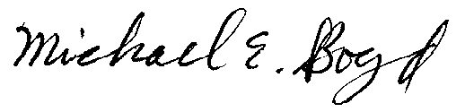
Filed Electronically 5-31-03
Michael E. Boyd – President, CARE
5439 Soquel Drive
Soquel, California 95073
(831) 465-9809
E-mail: michaelboyd@sbcglobal.net
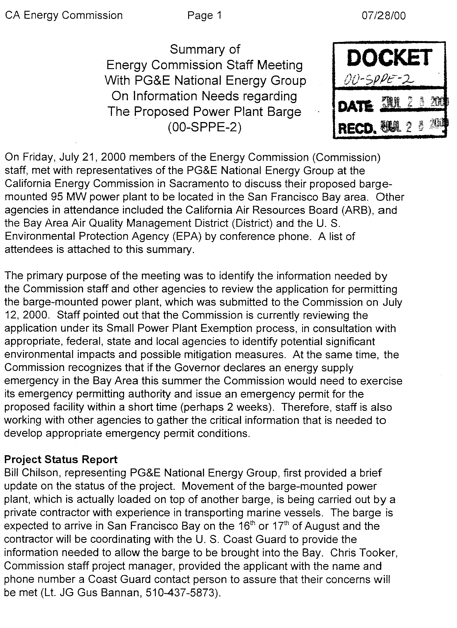
Exhibit 1
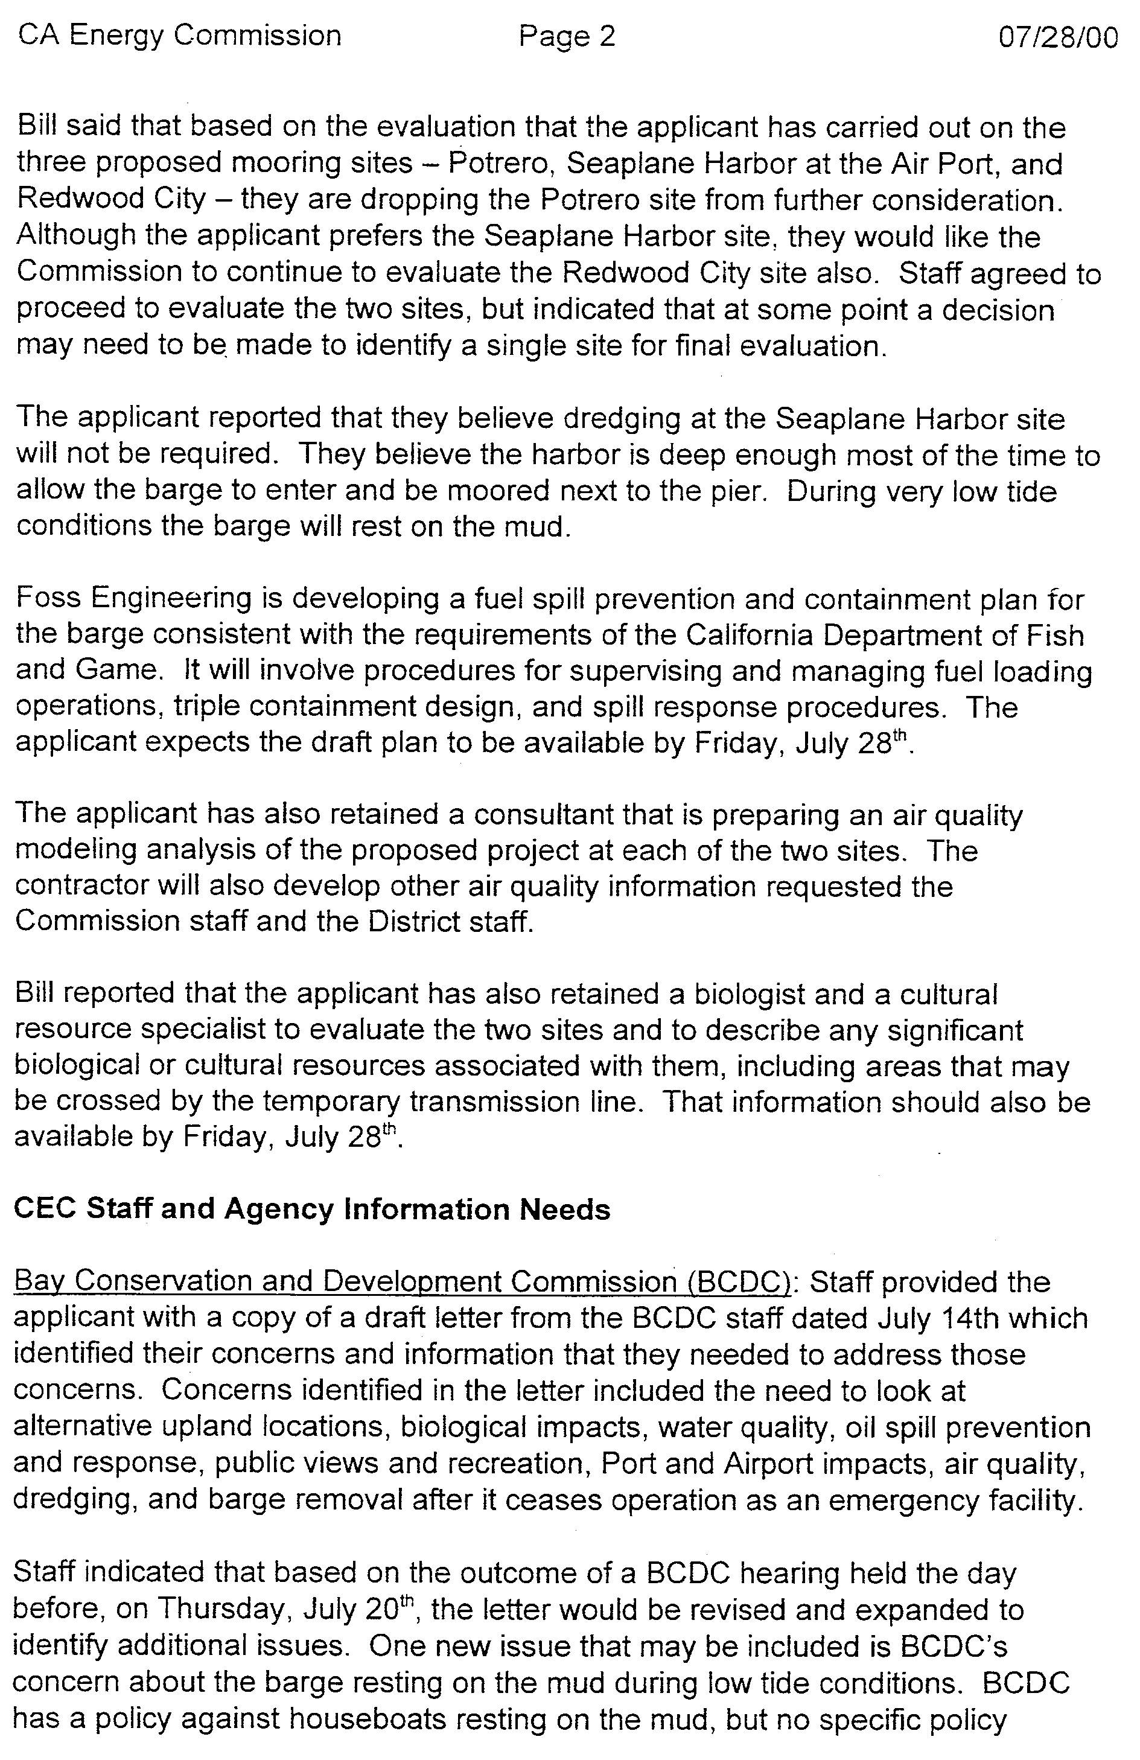
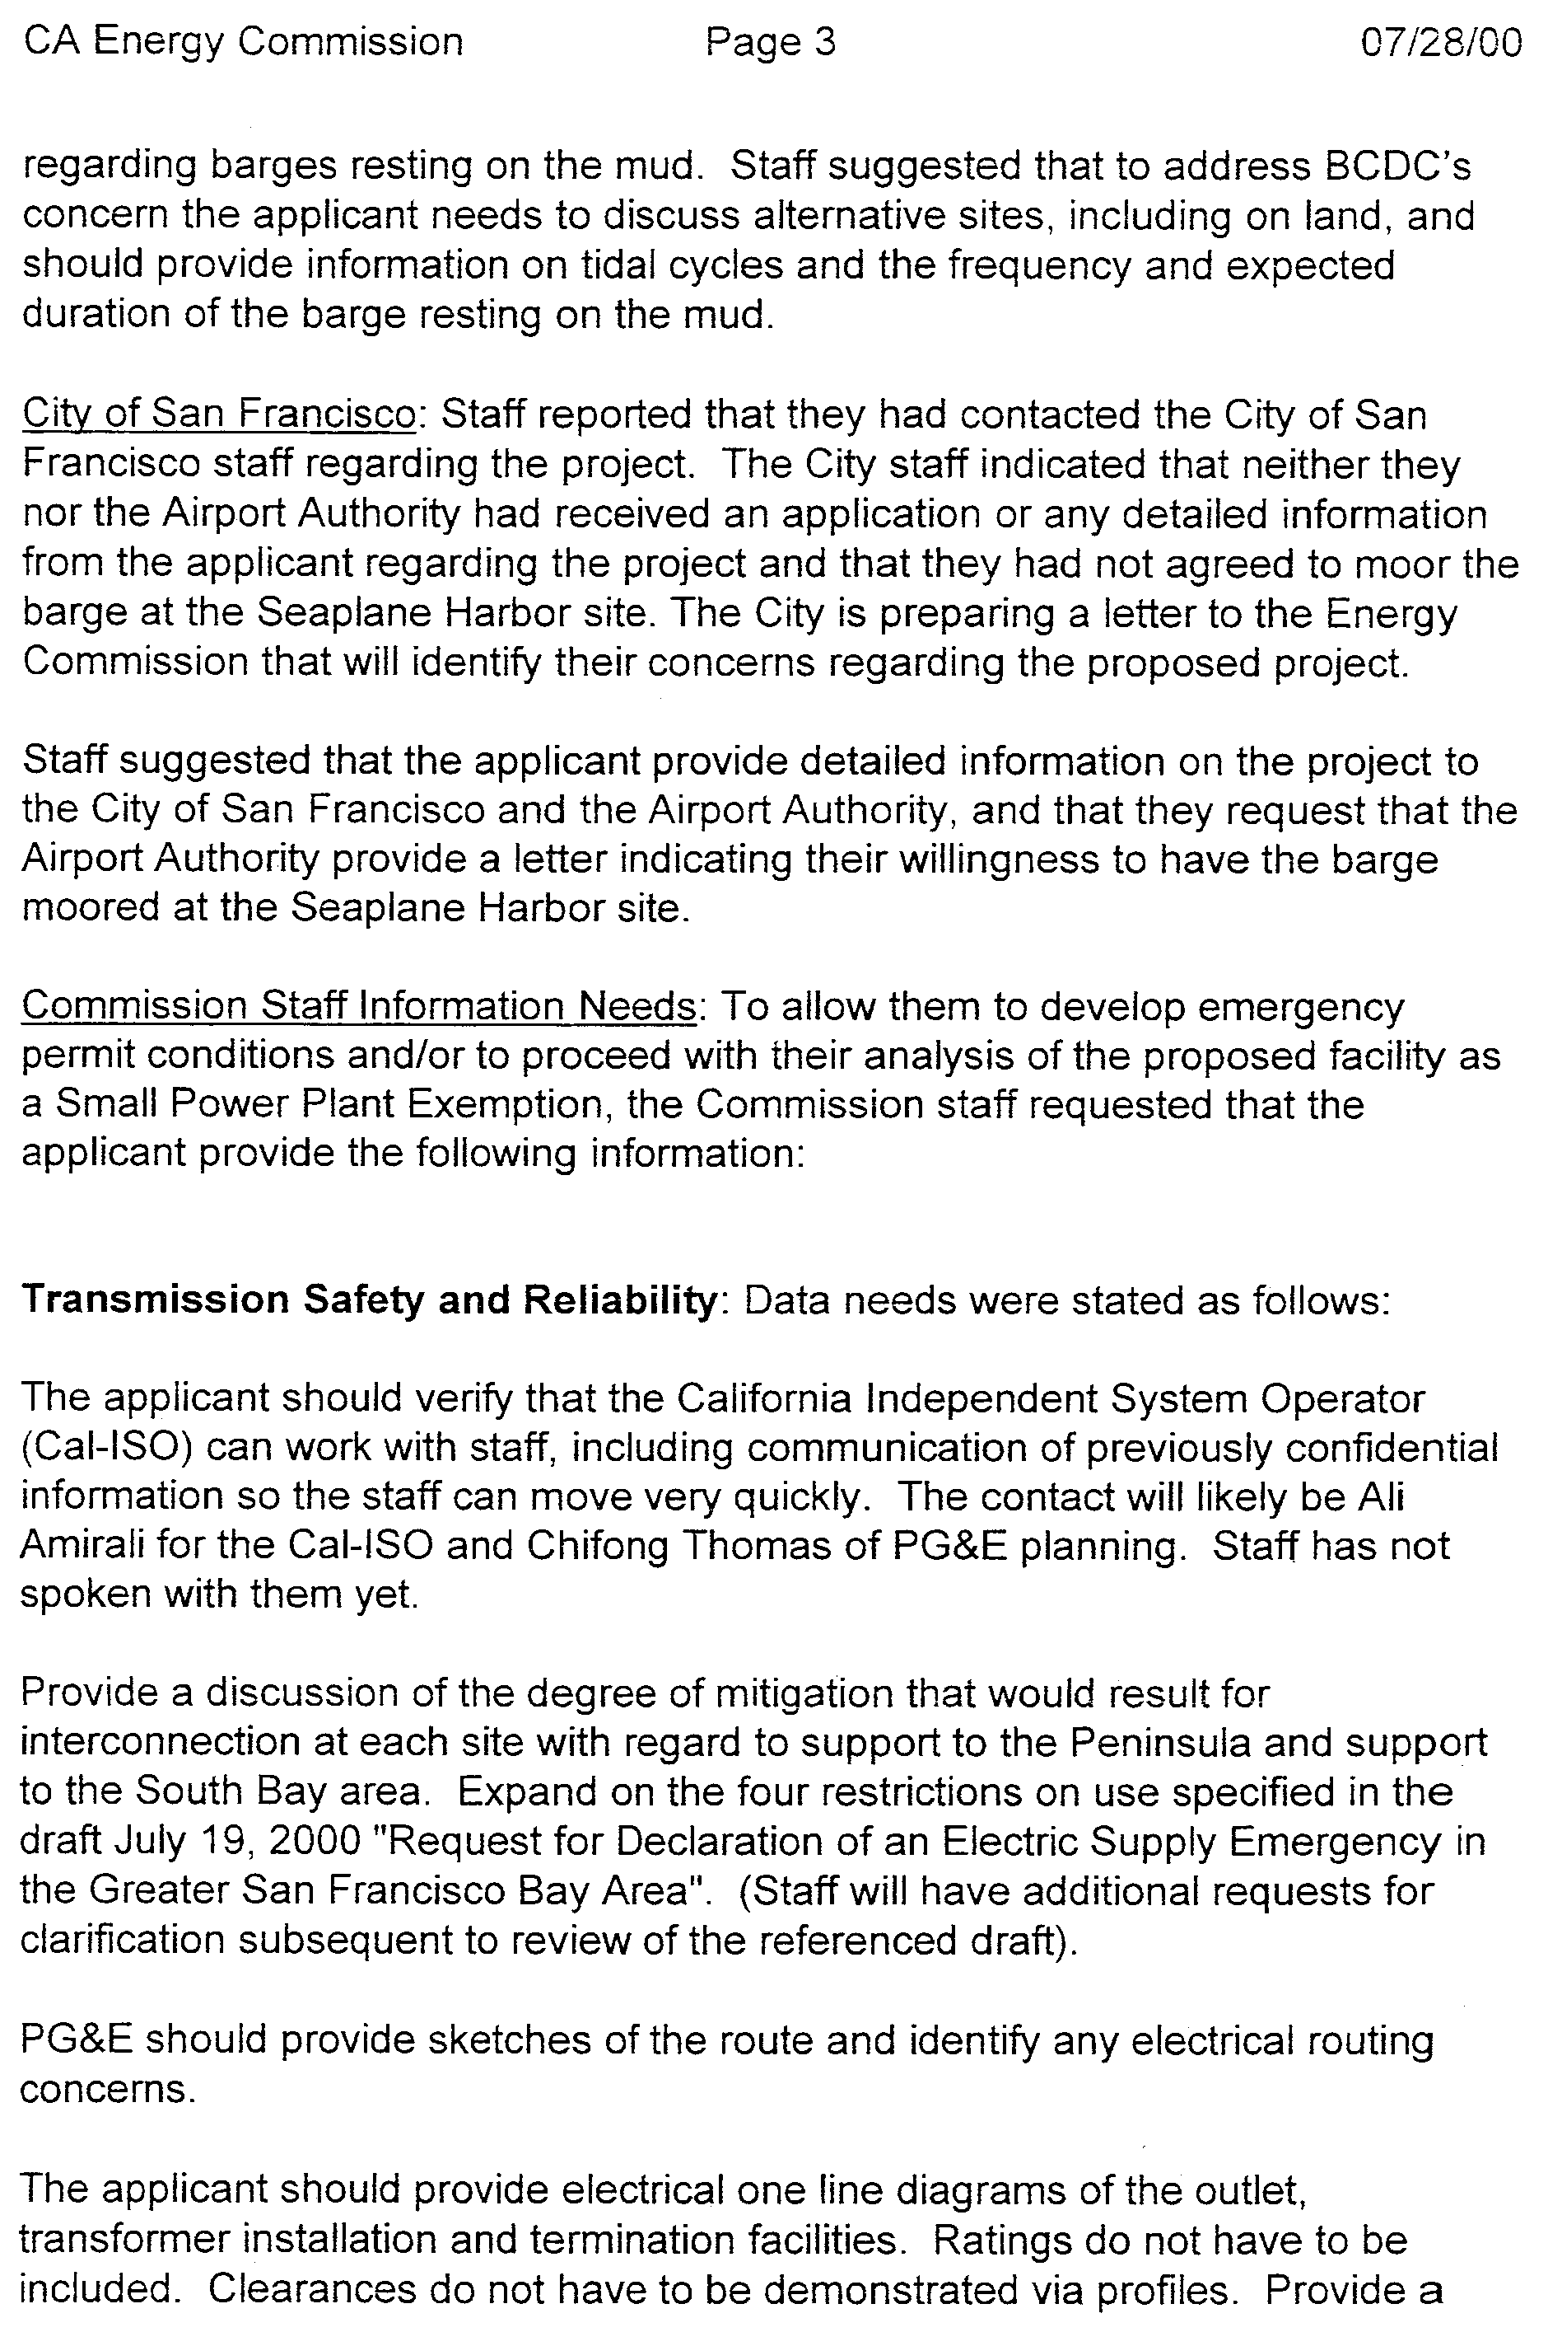
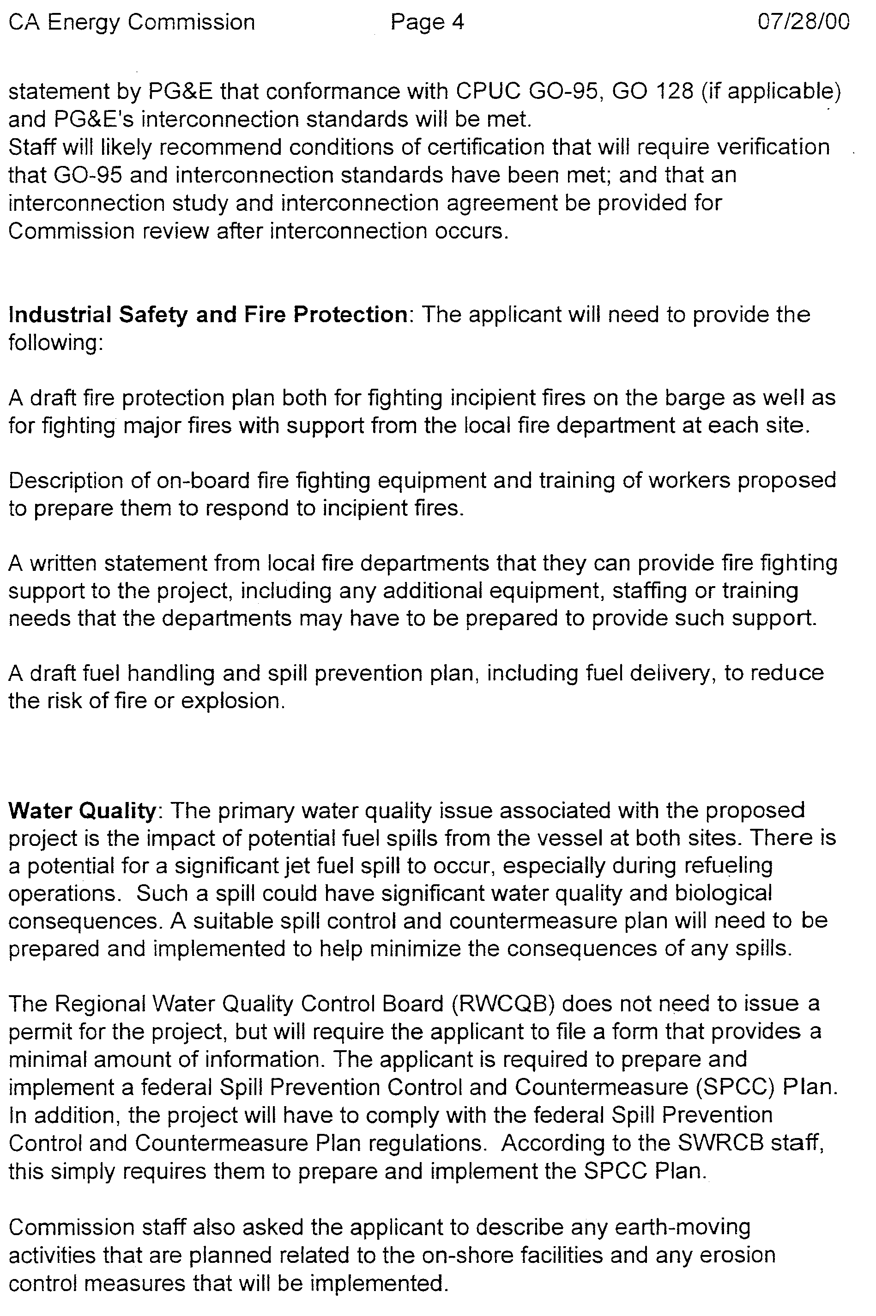
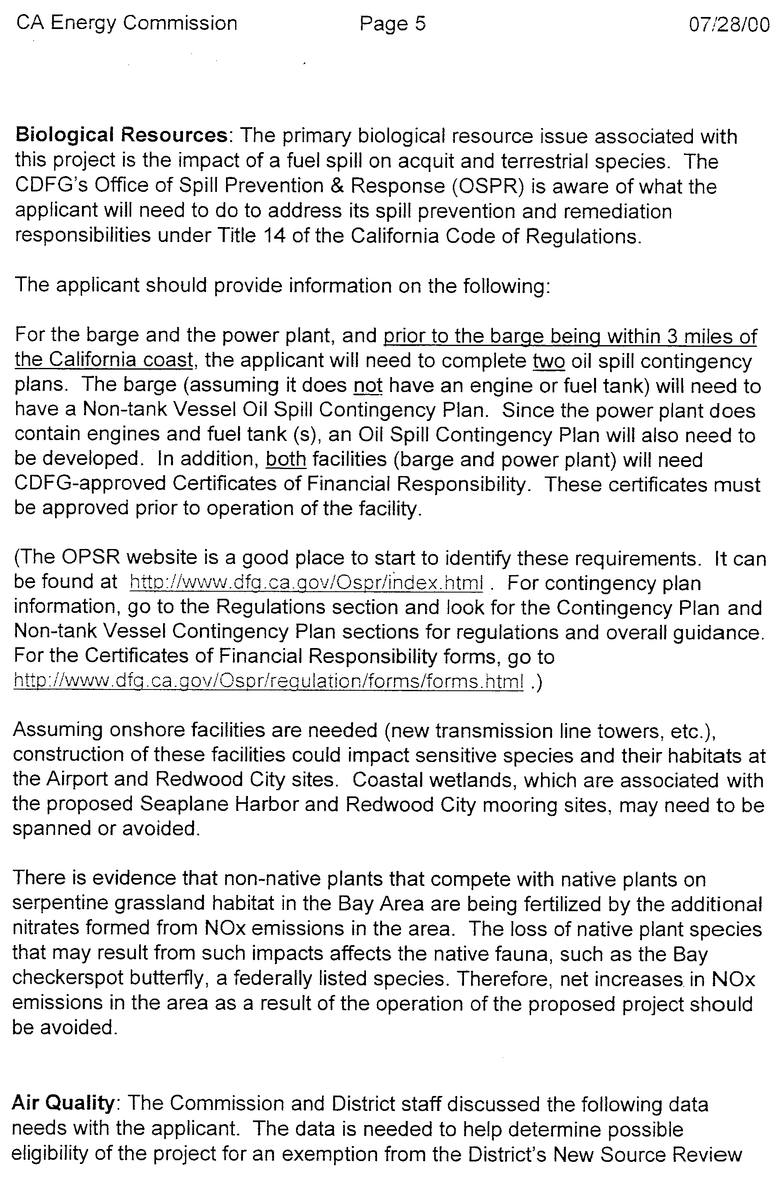
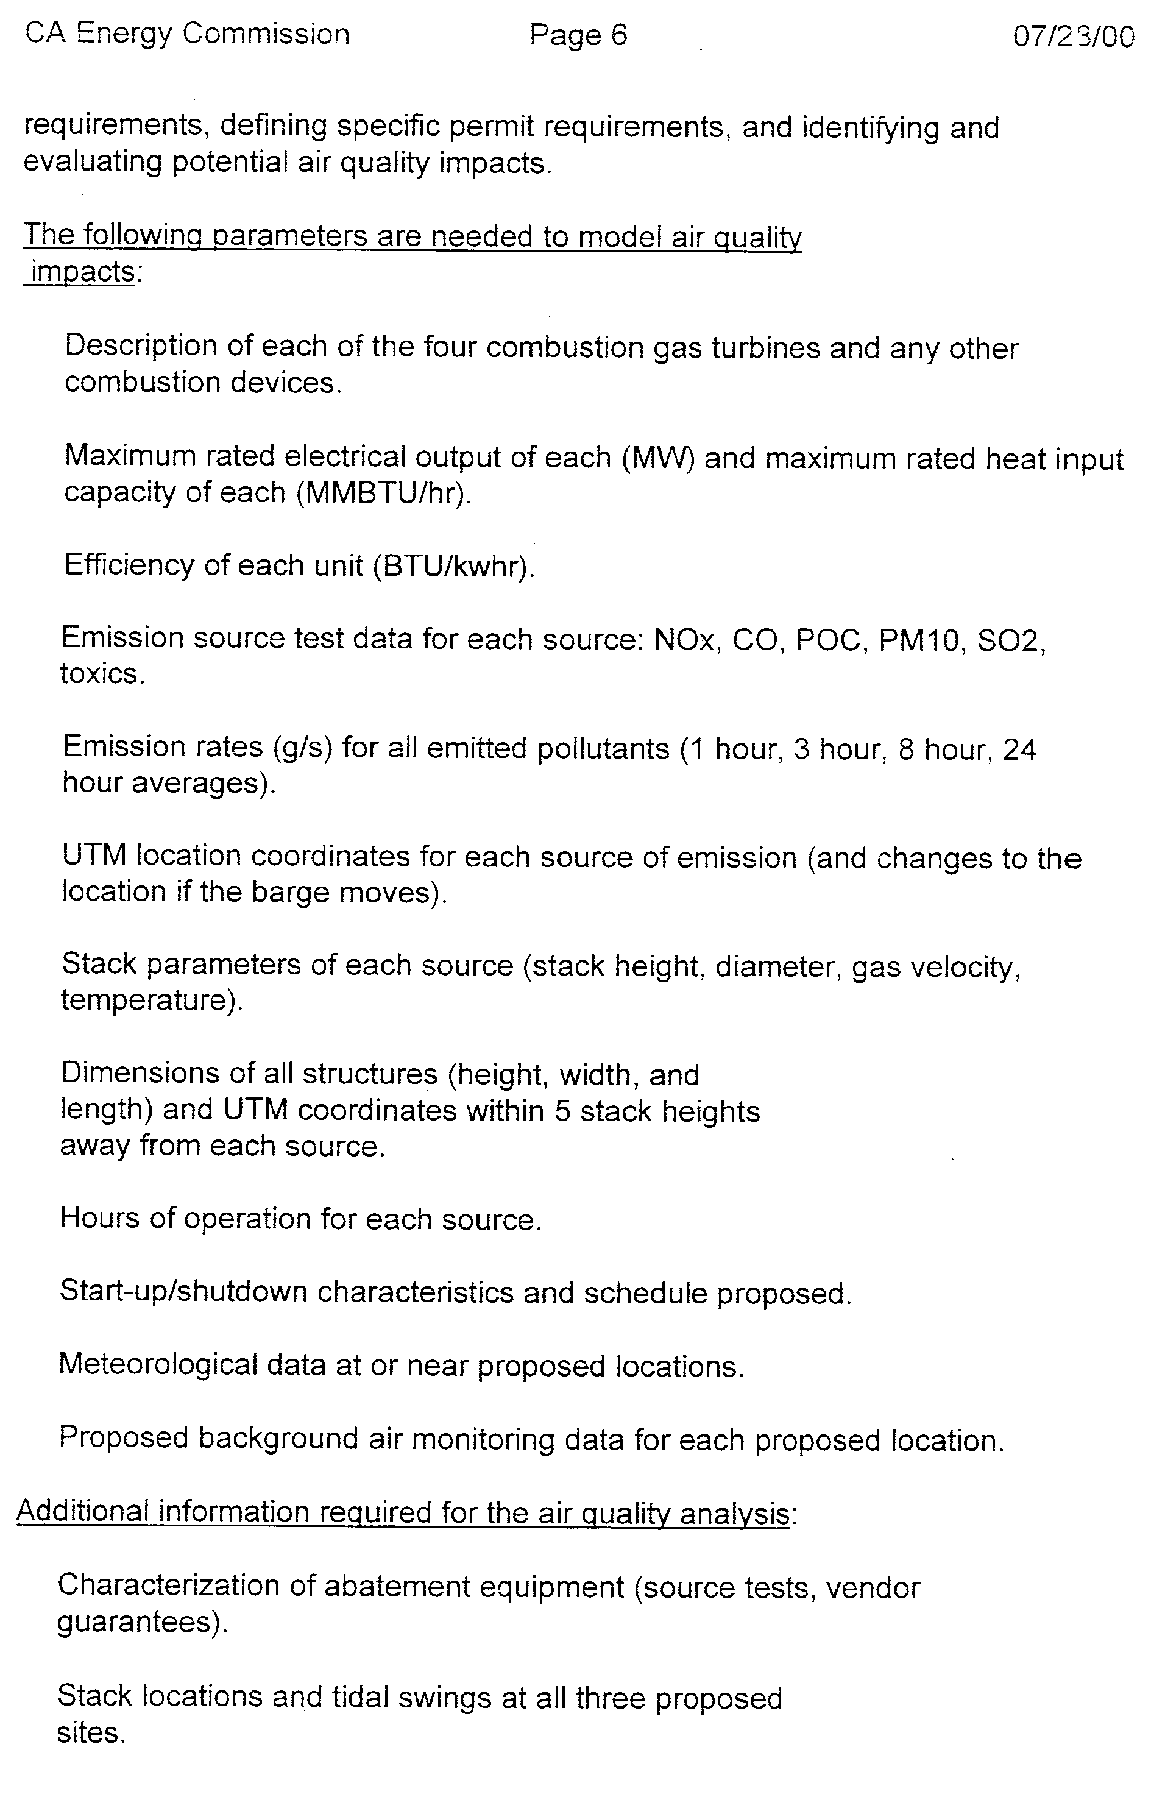
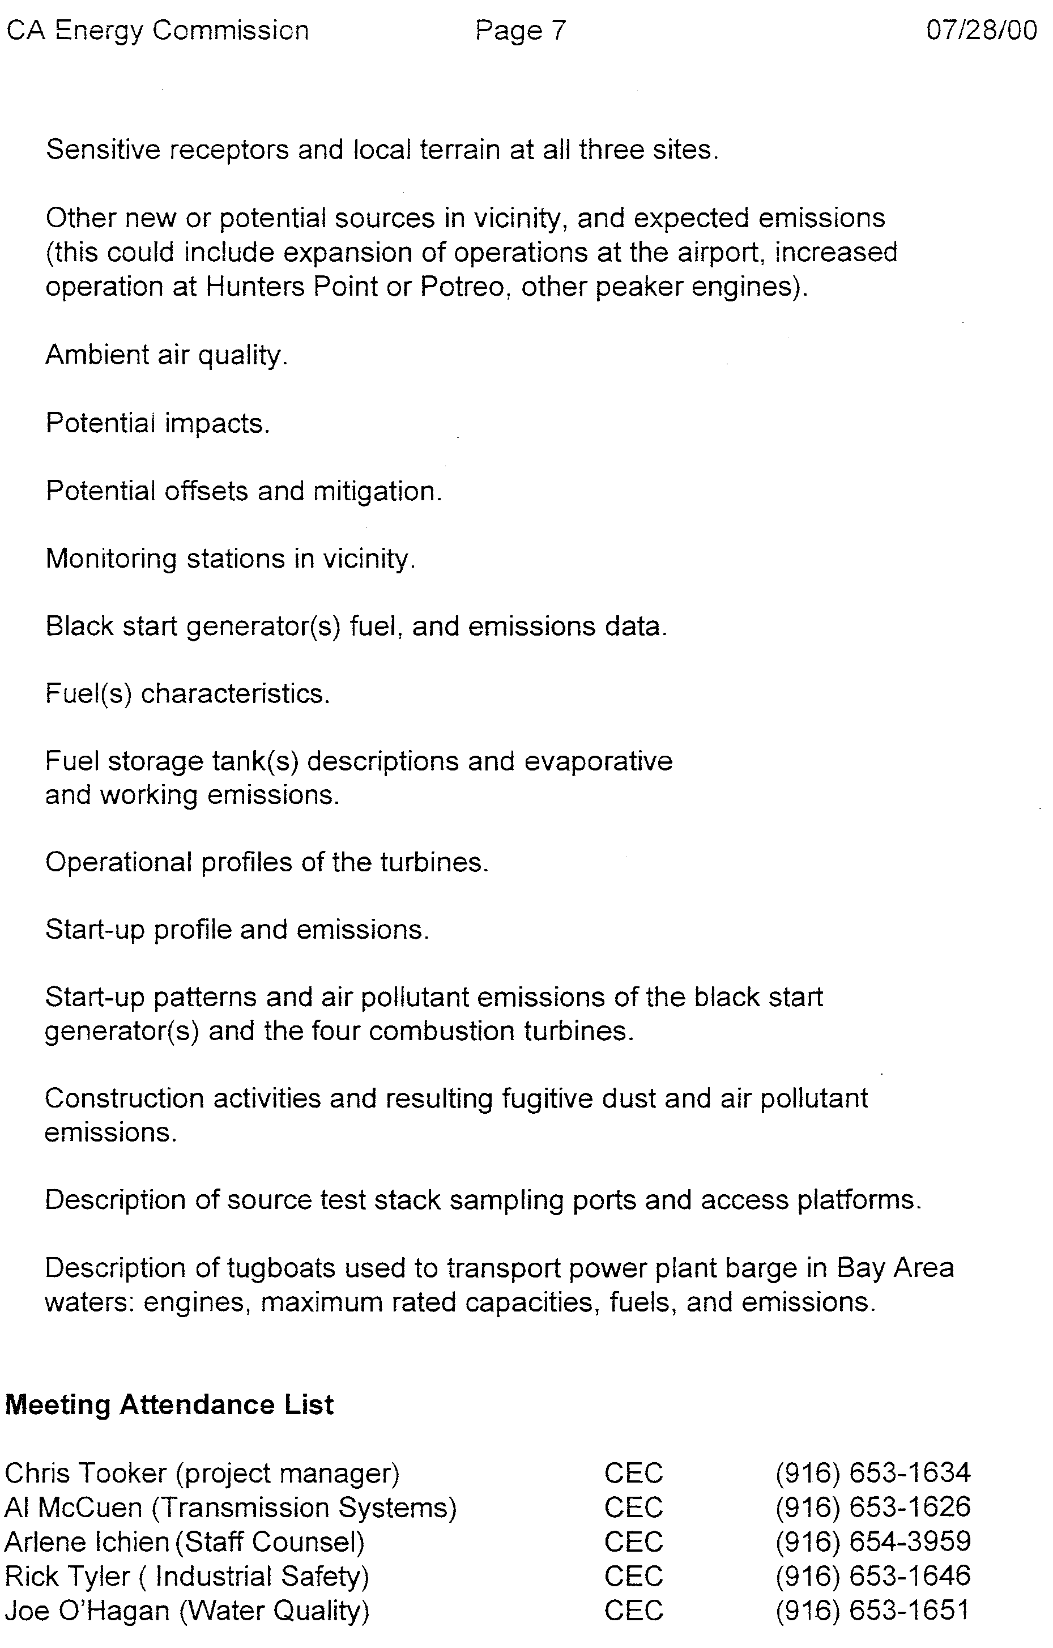
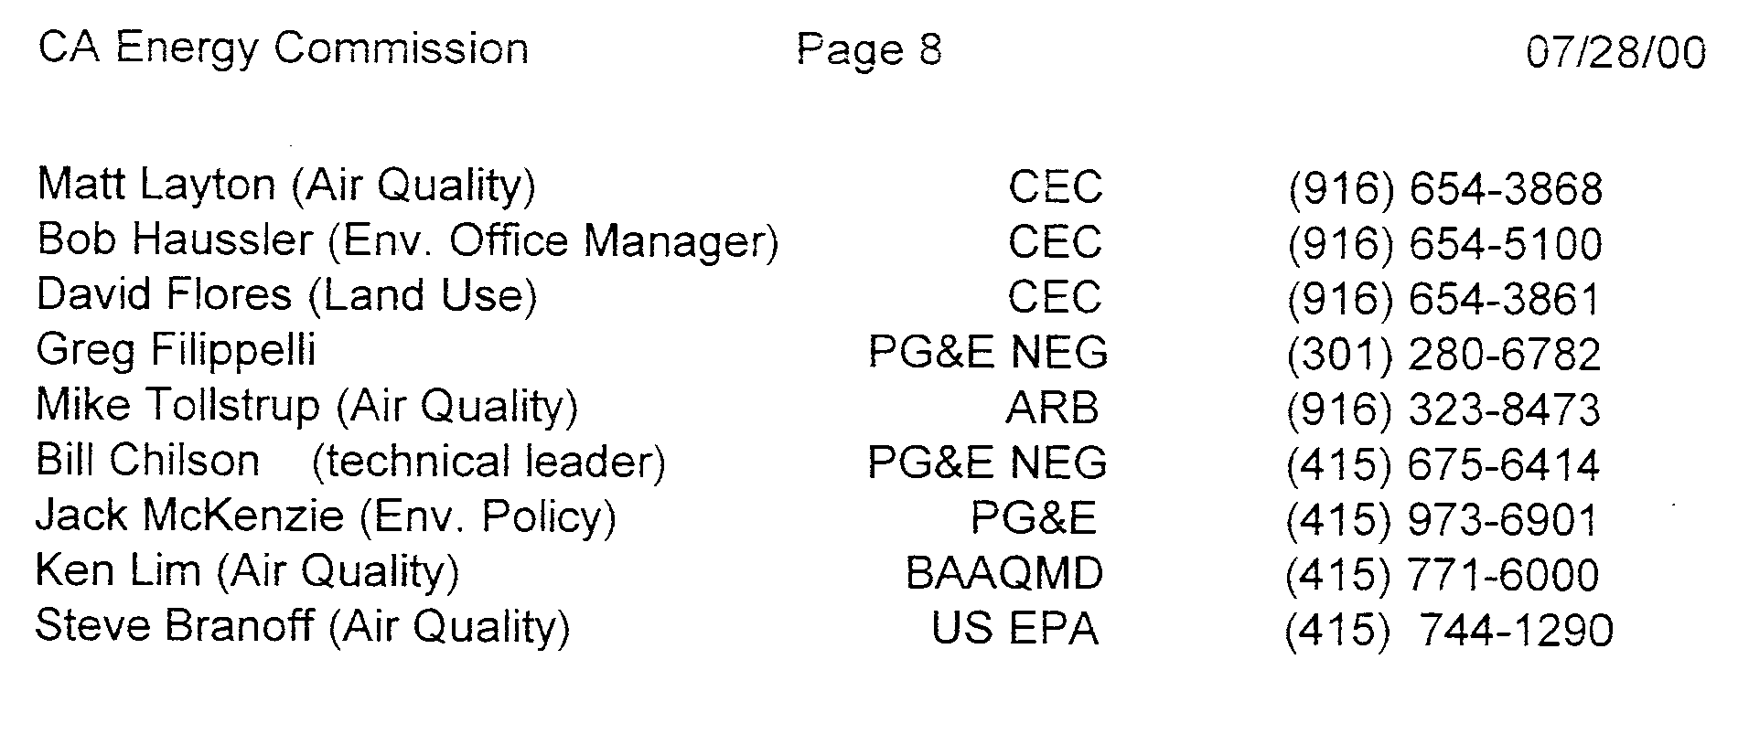
Verification

I am an officer of the intervening corporation herein, and am authorized to make this verification on its behalf. The statements in the foregoing document are true of my own knowledge, except matters, which are therein stated on information and belief, and as to those matters I believe them to be true.

I declare under penalty of perjury that the foregoing is true and correct.

Executed on this 31st day of May 2003, at Soquel, California.

Michael E. Boyd – President, CARE
CAlifornians for Renewable Energy, Inc. (CARE)
5439 Soquel Dr.
Soquel, CA 95073-2659
Tel: (408) 891-9677
Fax: (831) 465-8491
E-mail: michaelboyd@sbcglobal.net

Certificate of Services

I hereby certify that I have this day served the foregoing document upon each person designated on the official service list, via electronic mail, compiled by the Secretary in this proceeding until such time as the service list is established for the above captioned matter, and the ListServe for docket EL00-95-045. Rule 2010(f)(3) provides that you may serve pleadings by email. I further certify that those parties without electronic mail have been served this day via US mail.

Dated at this 31st day of May 2003.

Respectfully submitted,
President, CARE
(831) 465-9809
5439 Soquel Drive
Soquel, CA 95073
(831) 465-9809
E-mail: michaelboyd@sbcglobal.net

This is the parent company of Pacific Gas and Electric (PG&E) the northern California Investor Owned Utility (IOU)
This implies the CAISO had involvement in the project.
In an Order issued on October 10, 2002 in docket EL02-113, the following Parties were allowed to intervene: The California Electricity Oversight Board, People of the State of California, Ex. Rel. Bill Lockyer, Attorney General, the California Independent System Operator Corporation (“CAISO”), Pacific Gas and Electric Company, Dynergy Power Marketing, Inc., Californians for Renewable Energy, Inc., and Pioneer America LLC. In an Order Granting Motion to Intervene, issued on October 18, 2002, the City of Burbank, California (“Burbank”) was allowed to intervene.
In Paragraph 2 of the proposed Settlement between El Paso, the California Attorney General, and the California Electricity Oversight Board, the California State Parties release El Paso, in Docket EL02-113 and in any state or federal court proceeding which may be filed as well as before any state or federal agency, from any and all claims of any nature whatsoever that they have ever had, now have, or hereafter may have against El Paso based on the issues and allegations included in Docket No. EL02-113. When approved by FERC, the settlement will purportedly resolve all issues set for hearing in this Docket regarding El Paso’s liability. Also, El Paso agrees to relinquish any claim it may have for money owed to it by the CAISO, the California Power Exchange, or the California Parties for power sale transactions on or prior to June 20, 2001. CARE argues that in the absence of a complete evidentiary record it is premature to release El Paso from these claims for $15.5 million dollars, a pittance, when their role in the western energy and natural gas market’s manipulation and the economic repercussions nationwide are considered.
103 FERC ¶ 63, 036
A subsidiary of ECT.
Recommended Commission Responses The Enron trading strategies that were based on false information and that had an adverse effect on the markets are encompassed within the MMIP protocol of the Cal ISO and Cal PX tariffs. Therefore, Staff recommends that the Commission initiate show cause proceedings for the companies listed in this chapter, with disgorgement of unjust profits associated with the various transmission congestion strategies (e.g., non-firm exports, death star, and wheel-out), load shift, ancillary service sales without the necessary resources, megawatt laundering, and selling non-firm energy as firm energy. These proceedings should involve both public and nonpublic utilities that engaged in these strategies under the Cal ISO and Cal PX tariffs. We emphasize that the trading strategies—while bearing Enron’s name—were not limited to Enron but appear to have been widely engaged in by numerous parties. Indeed, it would appear to Staff that the majority of public utility entities, and some nonpublic utilities, engaged in at least some of the trading strategies some time during the 2-year review period. The cumulative effect of this prevalent alleged misconduct is that customers did not pay just and reasonable rates for wholesale electricity. This is because the trading strategies as a whole adversely affected the operations of Cal ISO or Cal PX markets and the calculation of the market-clearing price, which is dependent on participants engaging in bidding practices consistent with the Cal ISO and Cal PX tariffs and market rules, and not gaming the system or otherwise taking undue advantage of market rules. All of the market participants identified in the Cal ISO study by its initial screen should be required to show cause why their behaviors did not constitute gaming in violation of the Cal ISO and Cal PX tariffs, with disgorgement of unjust profits associated with the violations or other appropriate remedies. Those market participants are as follows: ♦ Sempra ♦ San Diego Gas & Electric ♦ Morgan Stanley Capital Group ♦ Coral Power, LLC ♦ Powerex or British Columbia ♦ Enron Power Marketing Inc. and its affiliate, Enron Energy Services Inc. ♦ Avista Energy Inc. ♦ Pacific Gas and Electric Company ♦ Puget Sound Energy ♦ Dynegy ♦ PGE Energy Services ♦ Bonneville Power Administration (BPA) ♦ Portland General Electric ♦ Los Angeles Department of Water and Power (LADWP) ♦ Southern California Edison ♦ Citizens Electric ♦ Constellation Power Service CARE alleged substantially the same Parties’ PG&E the northern California IOU, and PG&E NEG, where involved in these trading strategies that were based on false information that had an adverse effect on the markets encompassed within the MMIP protocol of the Cal ISO and Cal PX
This may be viewed at http://ferris.ferc.gov/idmws/file_list.asp?accession_num=20021021-3015 on the Commission’s web site.

